**Objective:**

The objective of the lab experiment was to introduce Amazon Elastic Block Store (EBS) and teach the user how to create EBS volume, attach and mount the volume to EC2 instance. EBS offers persistent storage for Amazon EC2 instances Amazon EBS volumes are highly available, highly reliable volumes that can be leveraged as an Amazon EC2 instances boot partition or attached to a running Amazon EC2 instance as a standard block device. During the lab, I learned the basics of EBS and how to create volume, snapshot and attach volume, snapshot to the EC2 instances.

Through this lab, I gained a comprehensive introduction to EBS and hands-on experience of creating, mounting volume, and snapshot in EBS. I learned how to create volume, snapshot and attach the snapshot, volume to the appropriate instance. I also learned how to mount the volume and restore the volume using snapshot.

**Procedure:**

The first step was to select the EC2 instance that was most suitable for the task. I had to create the new EBS volume from the volumes tab considering volume type as general-purpose SSD (gp2), size (GiB) as 1, availability zone same as in instance and adding tag along with Key as Name and Value as My Volume. After creating the volume, I was ready for attaching the volume to instance.

The next step was to attach the newly created volume to instance. In the volume tab, newly created volume named as My Volume was available. I had to attach the instance from the action button by choosing the appropriate instance. Once the volume is attached, I had to connect to Amazon EC2 instance by using SSH command. I had to download the “labsuser.pem” file and run the below command to connect to EC2 instance:

* chmod 400 labsuser.pem
* ssh -i labsuser.pem ec2-user@3.234.223.63

The next step was to create the ext3 file system and add directory in it to mount the new volume. Following commands were used to create file system, directory, file and mount the new volumne:

* sudo mkfs -t ext3 /dev/sdf
* sudo mkdir /mnt/data-store
* sudo mount /dev/sdf /mnt/data-store
* echo "/dev/sdf   /mnt/data-store ext3 defaults,noatime 1 2" | sudo tee -a /etc/fstab
* cat /etc/fstab
* df -h
* sudo sh -c "echo some text has been written > /mnt/data-store/file.txt"
* cat /mnt/data-store/file.txt

Furthermore, the next step was to create snapshot. I had to create snapshot from the new volume named My Volume. I was able to create snapshot by selecting create snapshot from the action dropdown button by adding tag key as Name and value as My Snapshot. I had to remove the file by using command “sudo rm /mnt/data-store/file.txt” and then I had to create volume from the snapshot. I had to select My Snapshot and then I had to select create volume from snapshot which was a dropdown option of action button.

Finally, the volume created from snapshot is attached to the appropriate instance and mounted the restored volume by following command:

* sudo mkdir /mnt/data-store2
* sudo mount /dev/sdg /mnt/data-store2

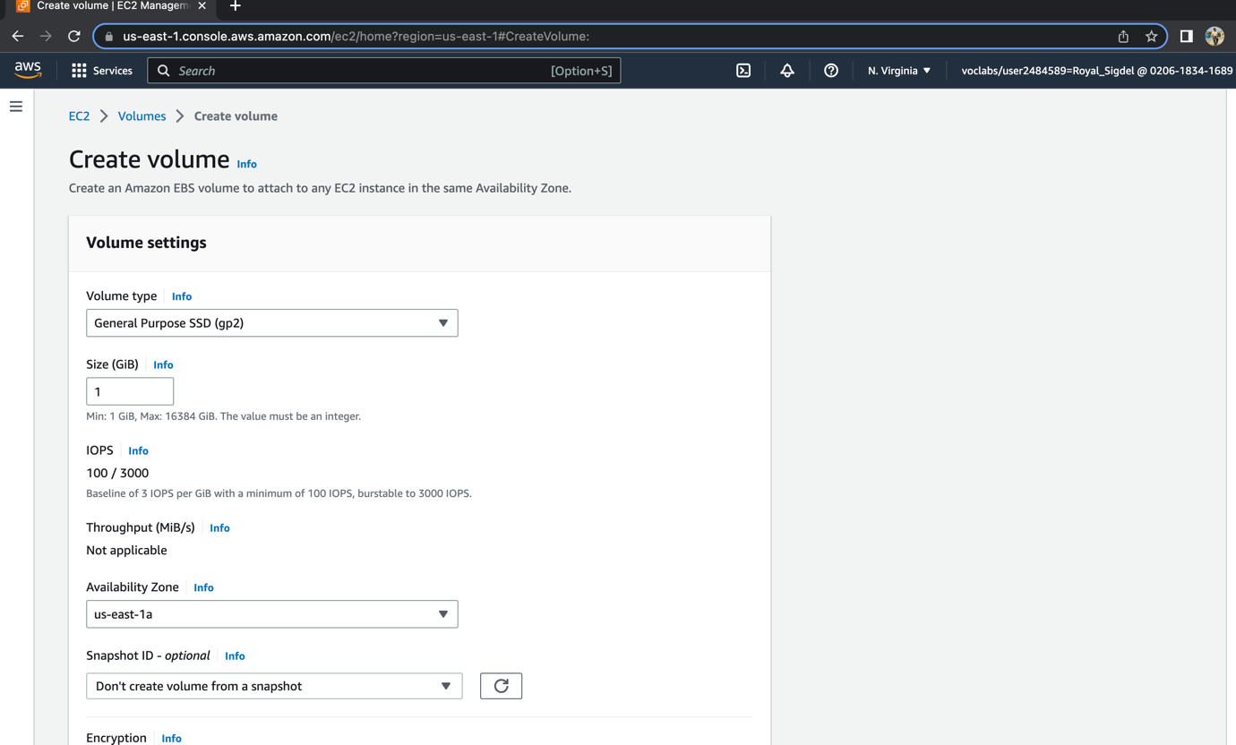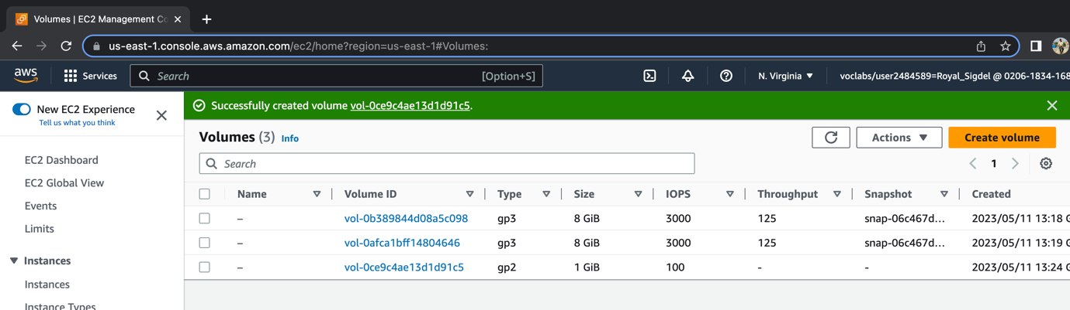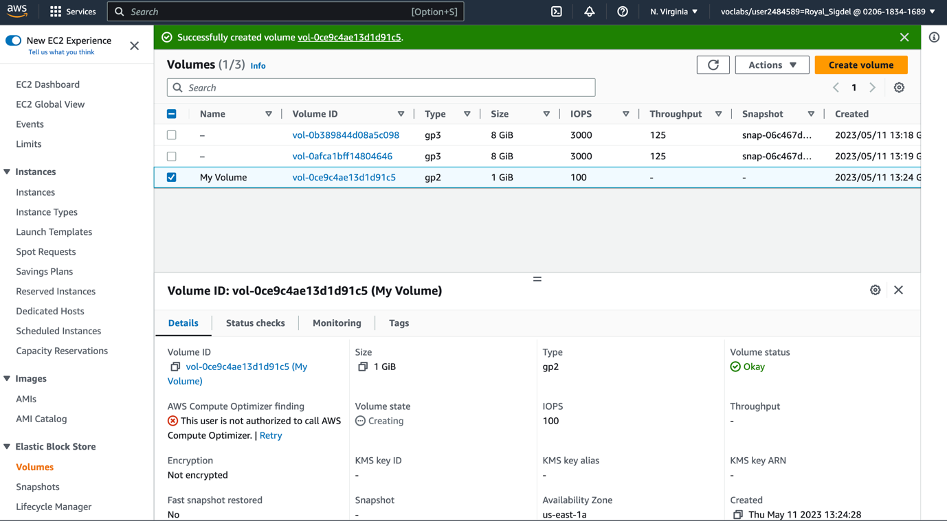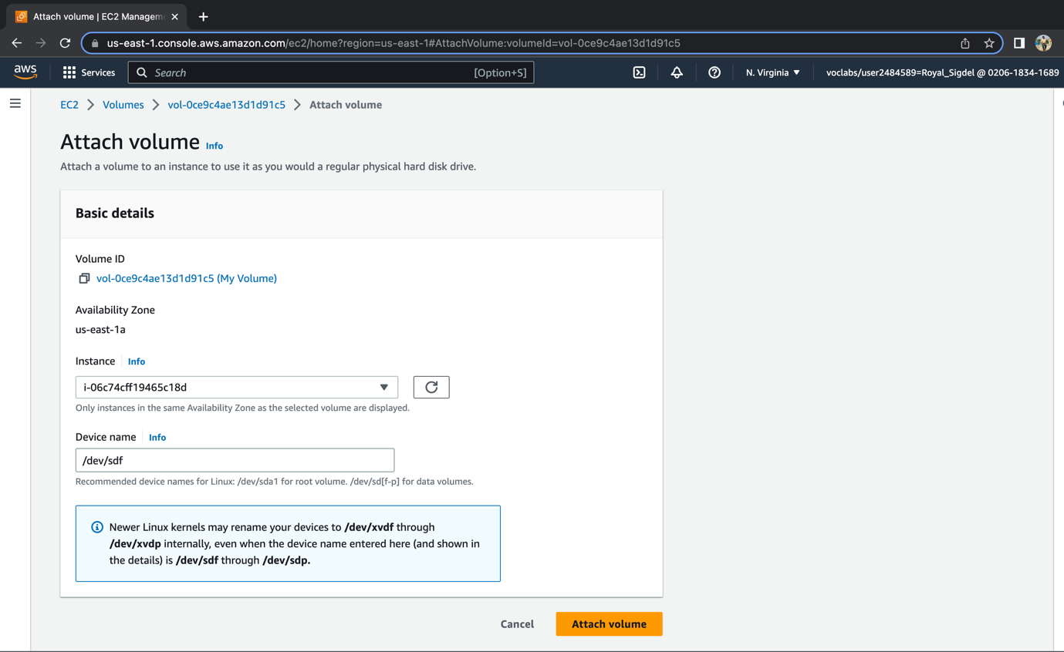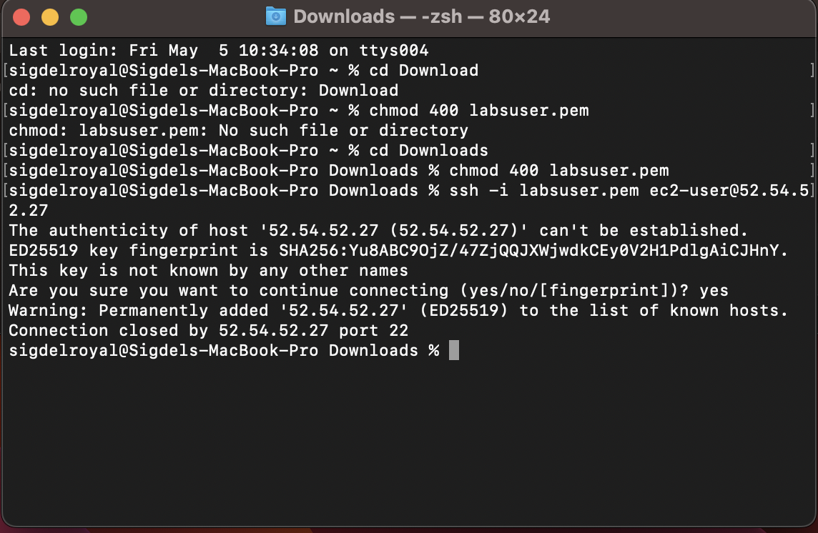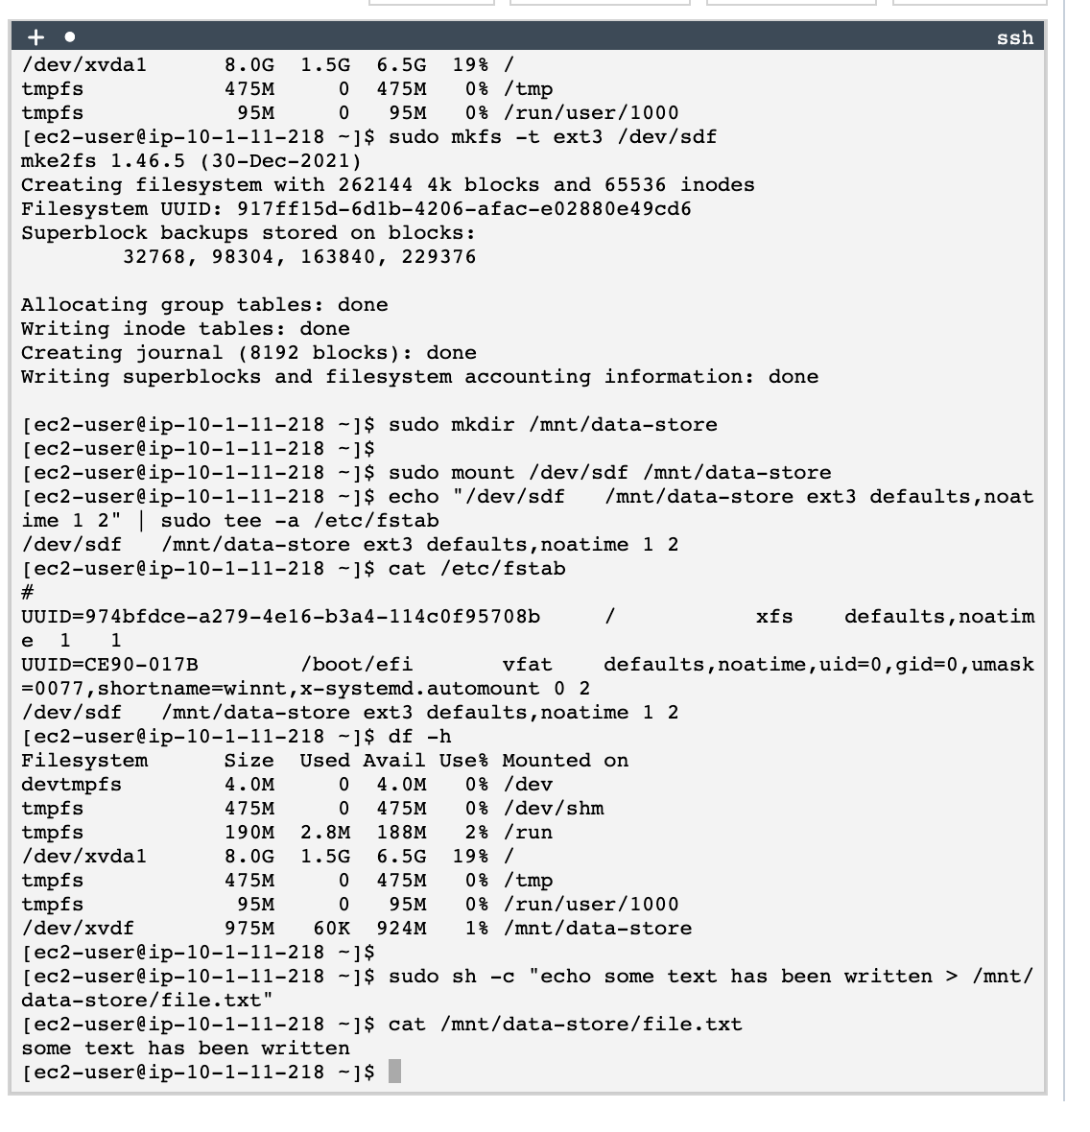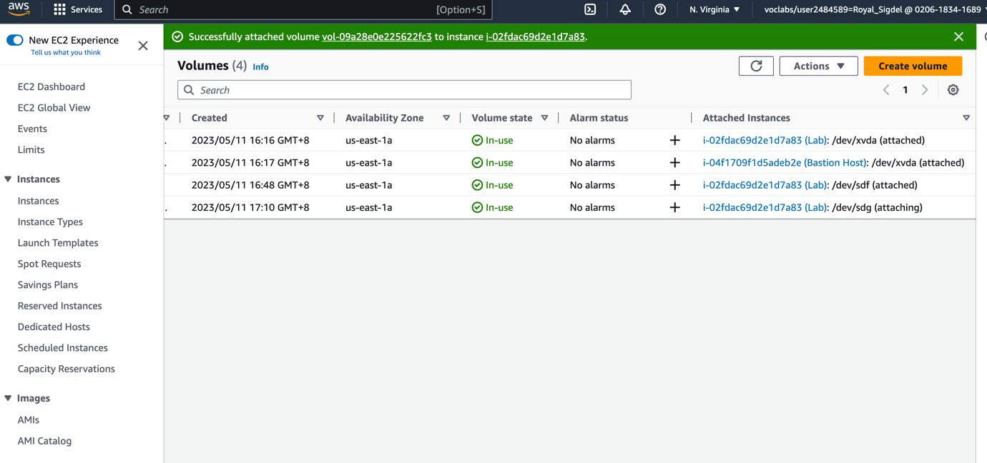

**Developing Knowledge:**

The part of the activity that helped me develop knowledge of the subject was formatting the EBS volume with a file system. This involved using the mkfs command to create a file system on the volume, which is an essential step for using the volume to store files.

**Difficulties and Incompleteness:**

I did not encounter any difficulties or sections that I was unable to complete during the activity. However, depending on the specific setup and configuration of the AWS environment, there may be some variations or differences in the process.