某某学校
毕 业 设 计(论文) 外 文 翻 译

外文题目：Differences explained: Private vs. public vs. hybrid cloud computing

中文题目：差异解释：私人vs.公共与混合云计算

外文题目：Cloud Computing:Public,Private,and Hybrid

中文题目：云计算：公共，私人和混合

学 院 名 称：
专 业：
班 级：
姓 名： 学 号
指 导 教 师： 职 称

定稿日期： 1970年1 月1 日

差异解释：私人vs.公共与混合云计算

几年前，IT世界专注于公共云计算。 在IT主管对公共云安全问题表示担忧之后，焦点转移到了私有云。 现在，因为每个人都希望操作灵活，所以混合云位于愿望清单的首位。 但是，通过所有这些相互矛盾的数据，您如何确定哪种云计算模型最适合您的组织？ 来自SearchCloudComputing.com的专家电子指南解释了私有云，公共云和混合云之间的主要区别。 通过权衡每种云类型的风险和收益，找出最适合您组织需求的方法。

混合云计算解释
几年前，IT世界专注于公共云计算。 在IT主管对公共云安全问题表示担忧之后，焦点转移到了私有云。 现在，因为每个人都希望操作灵活，所以混合云位于愿望清单的首位。 最近的一些云调查证实了对混合云的高度兴趣。 Unisys在2011年1月进行的一项调查显示，21％的IT组织专注于混合云，而Sand Hill Group对500多名IT经理的调查表明，未来三年混合云的使用量将增加两倍。

检查混合云架构
什么是混合云？ 对于初学者来说，它是至少一个私有云和至少一个公共云的组合。 私有云可以是位于企业数据中心外部的本地私有云或虚拟私有云。 在下图中，我们提供了混合云的最简单的宏视图之一 - 单个本地私有云和单个外部公共云：

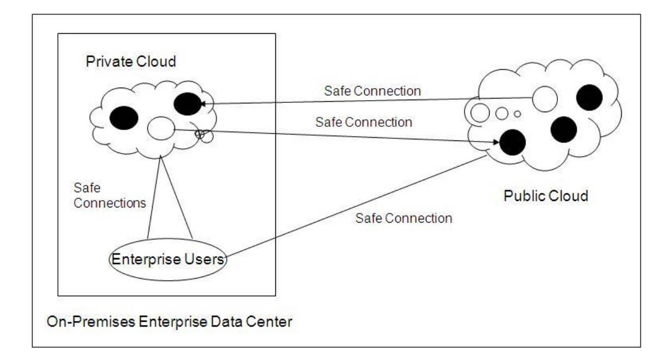

插图中的黑色圆圈表示活动的虚拟服务器图像，白色圆圈表示已迁移的虚拟服务器图像（使用安全连接）。 箭头表示迁移的方向。 企业用户使用安全连接连接到云，安全连接可以是虚拟专用网络（VPN）或安全HTTP浏览器。 理论上，混合云也可以由多个私有云和/或公共云组成。 图示中表示的企业数据中心可以具有未包括在私有云中的活动服务器（虚拟化或物理）。

什么是推动混合云计算？
混合云的兴趣来自于以无缝方式利用公共和私有云优势的愿望。 然而，与公共云和私有云相关的一些风险也可能是混合云中的问题。 公共云，私有云和混合云的优势和风险包括：

公共云的好处：
- 低投资障碍：支付您使用的费用
- 适用于可扩展到许多应用程序的良好测试/开发环境 服务器

公共云风险：
- 安全问题：通过Internet进行多租户和转移
- IT组织可能会对失去对数据中心的控制做出负面反应

私有云的好处：
- 现有数据中心安全性保持不变，安全问题较少
- IT组织保留对数据中心的控制权 私有云风险
- 私有云实施的高投资障碍以及购买 新的硬件和软件
- 需要新的运作流程;

解决混合云挑战
混合计算的挑战是跨平台，云应用程序编程接口（API）和管理程序提供无缝操作。 用户更喜欢使用他们的数据中心工具来管理混合云环境。 理想情况下，他们希望能够在混合云环境中创建应用程序或在云之间移动现有应用程序，而无需更改任何严重的内容，如网络，安全策略，操作流程或管理/监视工具。 这是一个问题，因为由于围绕互操作性，移动性和不同的API，工具，策略和流程的问题，混合云通常会增加复杂性。

公共云与私有云计算：哪种适合您的企业需求？

企业正在使用公共云服务，并开始尝试私有云计算，以充分利用产品上市时间和效率提升。这一发展促使IT高管围绕两种服务交付方式专注于投资和战略。据犹他州Midvale的Burton Group副总裁兼研究主管Drue Reeves称，到目前为止，大多数企业已经开始使用某种形式的软件即服务，例如电子邮件或客户关系管理。 “他们已经这样做，并且对基础设施即服务迅速感兴趣，这是市场中增长最快的部分，”里夫斯说。目前平台即服务的兴趣不大，因为痛点 - 身份管理，集成和服务水平协议（SLA） - 仍然存在于堆栈的较低层。尽管这些采用粗糙点，但新的云服务仍在不断涌现，例如业务流程即服务（BPaaS）。正如一份关于云计算市场发展的新报告所述，Forrester Research Inc.已将云堆扩展到BPaaS。 Reeves指出，公共云计算服务的最主要用户并不适用于IT，但对于其他部门，如营销和产品原型设计。然而，CIO和IT部门必须制定战略，以帮助指导这些外部服务用户，并制定管理公共和私有云计算的总体战略。

“通过规避IT，[业务部门]可以更快地完成工作。如果IT继续忽视这一点，他们将更频繁地被规避，”里夫斯说。 他的建议？ 帮助和鼓励使用：“与儿童一样，说”不要触摸它“是无效的。

疯狂（计算机）科学
IT主管确实正在制定计划并采取行动。哈佛医学院（HMS）首席信息官Marcos Athanasoulis博士说：“公共云迫使我们提供比[用户]在其他地方更有吸引力的服务。” “HMS就像是1000名CIO的土地，”Athanasoulis说。 “我们不能强制要求人们使用IT服务。” Athanasoulis指出，HMS的大多数人都接受过生命科学方面的培训，但不是IT最佳实践。他们编写自己的软件，但不知道源代码控制;或者他们购买服务器并将其粘在桌子下面而没有意识到电源和散热要求。 Athanasoulis能够通过阐明提供测量存储和CPU服务的私有云计算的愿景来控制疯狂的计算机科学。生物医学研究的性质与云计算服务的弹性相匹配，因此Athanasoulis从小型私有云开始：它的数量正在增长，他说。该过程发掘出了最佳实践，例如迭代和持续通信。 “你如何监控你有足够的容量？沿途的人们一起检查，”Athanasoulis说。 “IT领导者不会听到事情进展顺利，只有当事情进展顺利时 - 有时候甚至不会。如果用户不满意，你就冒着自己做事的风险。”事实是，“内部创建云实际上非常困难，”Forrester的首席分析师James Staten说。在他最新的融合基础设施研究中，他将IT部门与测试厨房进行了比较：企业拥有制作云基础设施的基本要素，但没有配方，许多成分也没有结合得很好。 “使故事复杂化的是服务器，网络和存储周围的传统基础设施孤岛，必须以一种全新的，真正集成的方式协同工作，”他说。 Staten说，最重要的一点是要了解云对现有虚拟基础设施的价值。 一个区别是自动化 - 将新工作负载放入云中并自动执行维护。 另一个价值是自助服务，因此用户可以快速将产品推向市场。 “[云计算]远远超出了传统的虚拟基础架构，”他说。 怎么开始？ “离开高吧，找出要放手的东西。”

公共和私有云计算：不同的野兽

根据Reeves的说法，公共云计算服务越有价值，Reeves建议人们考虑云，因为他们会在迈阿密出差时租车：在您的目的地，您可能会租车，即使成本远远超过回家车辆的每日费用。 “原因就是当你不在迈阿密时，账单为零，”里夫斯说。使用内部云，您总是为整件事付出代价。 “为了省钱，公众每次都胜过内部，”他说。即使在内部，一些部门 - 例如工程，人力资源，市场营销 - 也可以将他们的账单归零，但中央IT部门永远无法做到。 Reeves说，这就是为什么内部云是多重的，并且尽可能高度利用它是如此重要的原因。 “如果你为单个单位设置云，你将永远投资于没有弹性的云。假设工程云的运行容量为80％到90％：如果你可以说服他们分享资源与营销和人力资源基于使用的指标，IT增量由其他部门解决，“里夫斯说。因为它们旨在以极具吸引力的价格为最广泛的客户群提供服务，所以公共云具有高度结构化和自动化的特点。在大多数情况下，企业无法设置SLA的条款。公共云有SLA，接受或离开它。 “我总是告诉客户，'你适应云，云不适应你，'”Staten说。他说，对于习惯于根据需求量身定制解决方案的企业来说，这是一个很大的脱节。

例如，公共云建立了一种标准的安全手段，可以满足尽可能多的客户的需求，Reeves说。 这是掌握不均匀握手的问题，企业需要确定要添加什么来满足其安全定义。 他说，可以谈判的是更加注重业务的服务条款，例如能够随时切断服务。 随着企业被迫接受公共云，问题就变成了，应该将哪些应用程序保留在内部？ 根据里夫斯的说法，答案取决于组织的风险承受能力。 “数据越重要，保持内部就越重要，”里夫斯说。 “卸下世俗，而不是核心业务的一部分。”

Differences explained: Private vs. public vs. hybrid cloud computing

A few years ago, the IT world was focused on public cloud computing. After IT directors expressed concerns over public cloud security issues, the focus shifted to private clouds. And now, because everyone wants operational flexibility, hybrid clouds are at the top of the wish list. But with all this conflicting data how can you determine which cloud computing model is best for your organization? This expert e-guide from SearchCloudComputing.com explains the key differences between private, public and hybrid clouds. Find out which one best fits your organization’s needs by weighing the risks and benefits of each cloud type.

Hybrid cloud computing explained By Bill Claybrook, Contributor A few years ago, the IT world was focused on public cloud computing. After IT directors expressed concerns over public cloud security issues, the focus shifted to private clouds. And now, because everyone wants operational flexibility, hybrid clouds are at the top of the wish list. Several recent cloud surveys confirm these high levels of interest in hybrid cloud. A Unisys survey in January 2011 indicated that 21% of IT organizations are focusing on hybrid clouds, and a Sand Hill Group survey of over 500 IT managers indicates that hybrid cloud use will triple over the next three years. Examining hybrid cloud architecture So what is a hybrid cloud? For starters, it is a composition of at least one private cloud and at least one public cloud. The private cloud can be an on-premises private cloud or a virtual private cloud located outside the enterprise data center. In the illustration below, we provide one of the simplest macro views of a hybrid cloud -- a single on-premises private cloud and a single off-premises public cloud:

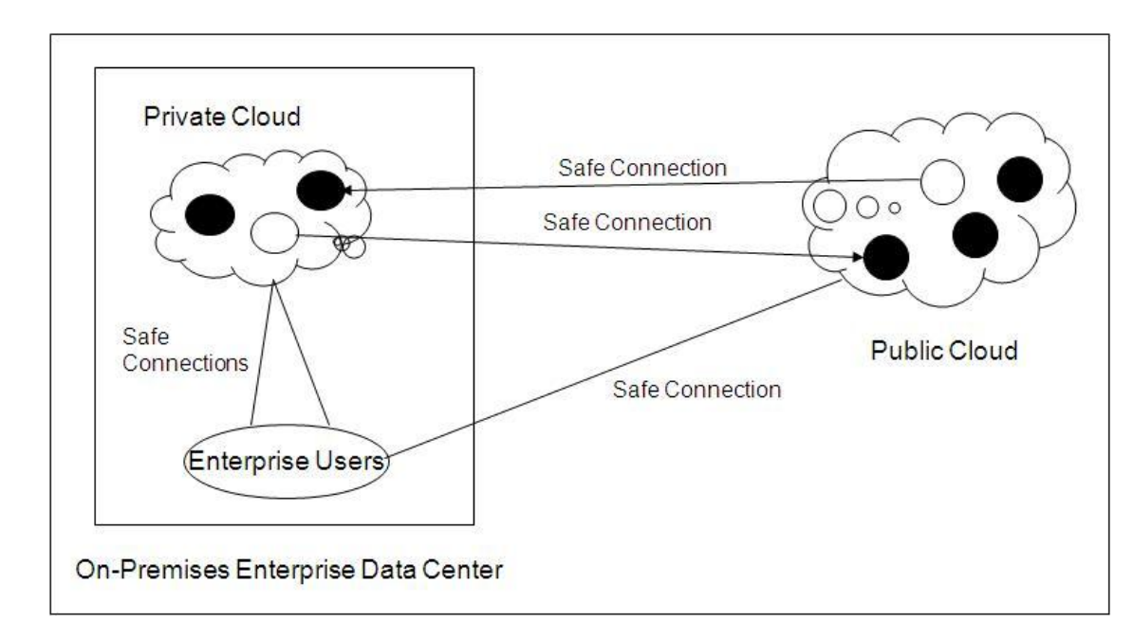

The black circles in the illustration represent active virtual server images and the white circles represent virtual server images that have been migrated (using safe connections). The arrows indicate the direction of migration. Enterprise users are connected to the clouds using safe connections, which can be virtual private networks (VPNs) or secure HTTP browsers. A hybrid cloud could also theoretically consist of multiple private and/or public clouds. The enterprise data center denoted in the illustration may have active servers (virtualized or physical) that are not included in the private cloud. What is driving hybrid cloud computing? Hybrid cloud interest is powered by the desire to take advantage of public and private cloud benefits in a seamless manner. Some of the risks associated with public and private clouds, however, can also be issues in hybrid clouds. The benefits and risks of public, private, and hybrid clouds include: Public cloud benefits: o Low investment hurdle: pay for what you use o Good test/development environment for applications that scale to many servers Public cloud risks: o Security concerns: multi-tenancy and transfers over the Internet o IT organization may react negatively to loss of control over data center function Private cloud benefits: o Fewer security concerns as existing data center security stays in place o IT organization retains control over data center Private cloud risks: o High investment hurdle in private cloud implementation, along with purchases of new hardware and software o New operational processes are required; old processes not all suitable for private cloud Hybrid cloud benefits o Operational flexibility: run mission critical on private cloud, dev/test on public cloud o Scalability: run peak and bursty workloads on the public cloud Hybrid cloud risks: o Hybrid clouds are still being developed; not many in real use o Control of security between private and public clouds; some of same concerns as in public cloud Addressing the hybrid cloud challenge The challenge of hybrid computing is to provide seamless operation across platforms, cloud application programming interfaces (APIs) and hypervisors. Users prefer to use their data center tools to manage hybrid cloud environments. Ideally, they want to be able to create applications, or move existing applications between the clouds in a hybrid cloud environment, without having to change anything serious like networking, security policies, operational processes or management/monitoring tools. This is a problem because, due to issues around interoperability, mobility and differing APIs, tools, policies and processes, hybrid clouds generally increase complexity.

Public vs. private cloud computing: Which fits your enterprise needs?
By Laura Smith

Features Writer Enterprises are using public cloud services and starting to experiment with private cloud computing to capitalize on time-to-market and efficiency gains. This development has prompted IT executives to focus on investments and strategy around two service delivery approaches. By now, most enterprises have begun to use some form of Software as a Service, such as email or customer relationship management, according to Drue Reeves, a vice president and research director at Burton Group in Midvale, Utah. "They're already doing that, and are rapidly interested in Infrastructure as a Service, which is the fastest-growing segment of the market," Reeves said. There's less interest currently in Platform as a Service, because pain points -- identity management, integration and service-level agreements (SLA) -- persist at the lower levels of the stack. Despite these adoption rough spots, new cloud services continue to pop up, such as Business Process as a Service (BPaaS). Forrester Research Inc., for one, has extended the cloud stack to BPaaS, as outlined in a new report on the evolution of cloud computing markets. The most dominant users of public cloud computing services don't work for IT, but for other departments such as marketing and product prototyping, Reeves pointed out. CIOs and IT departments nevertheless must formulate a strategy to help guide these users of external services, and develop an overarching strategy for managing public and private cloud computing. SearchCloudComputing.com E-Guide Differences "By circumventing IT, [business departments] get their job done faster. If IT continues to ignore this, they'll be circumvented more often," Reeves said. His advice? Help and encourage use: "As with children, it is not effective to say 'don't touch that.'" Mad (computer) science IT executives indeed are formulating plans and taking action. "The public cloud forces us to have more compelling services than [users] would find elsewhere," said Dr. Marcos Athanasoulis, CIO of Harvard Medical School (HMS) in Boston. "HMS is like the land of 1,000 CIOs," Athanasoulis said. "We cannot mandate that people use IT services." Most people at HMS are trained in life sciences but not IT best practices, Athanasoulis pointed out. They write their own software, but don't know about source control; or they buy a server and stick it under a desk without realizing the power and cooling requirements. Athanasoulis was able to bring the mad computer science under control by articulating a vision for private cloud computing that provides measured storage and CPU services. The nature of biomedical research matches the elasticity of cloud computing services, so Athanasoulis started with a small private cloud: It's growing by orders of magnitude, he said. The process has unearthed best practices, such as iteration and constant communication. "How do you monitor that you have enough capacity? Check in with folks along the way a lot," Athanasoulis said. "IT leaders don't hear when things are going well, only when they aren't -- and sometimes not even then. If users aren't happy, you run the risk of them doing their own thing." The truth is, "it's actually very hard to create a cloud internally," said James Staten, a principal analyst at Forrester. In his latest research on converged infrastructures, he compared the IT department with a test kitchen: Enterprises have the basic ingredients to cook up a cloud infrastructure, but there's no recipe and many of the ingredients don't combine well. "Complicating the story are traditional infrastructure silos around servers, networks and storage that must work together in a new, truly integrated way," he said. The most important point is to understand the value of the cloud over the existing virtual infrastructure, Staten said. One difference is automation -- putting new workloads into the cloud and automating maintenance. Another value is self-service, so users can bring things to market quickly. "[The cloud is] a step well beyond the traditional virtual infrastructure," he said. How to get started? "Step away from the high bar, and figure out what to let go." Public and private cloud computing: Different beasts Public cloud computing services are more valuable the less you use them, according to Reeves, who suggested that people think about clouds as they would a rental car on a business trip to Miami: At your destination, you're likely to rent a car, even though the cost far exceeds the daily costs of your vehicle back home. "The reason for that is when you're not in Miami, the bill is zero," Reeves said. With an internal cloud, you're always paying for the whole thing. "To save money, public trumps internal every time," he said. Even internally, some departments -- such as engineering, human resources, marketing -- can take their bills to zero, but central IT never can. That's why it's so important for internal clouds to be multitenant and as highly utilized as possible, Reeves said. "If you set up clouds for individual units, you'll always be investing in a cloud with no elasticity. Say the engineering cloud operates at 80% to 90% capacity: If you can convince them to share the resources with marketing and HR on a usage-based metric, the IT delta is solved by other departments," Reeves said. Because they aim to serve the widest possible customer base at an attractive price point, public clouds are highly structured and automated. In most cases, enterprises don't get to set the terms of an SLA. Public clouds have an SLA, take it or leave it. "I always tell clients, 'You adapt to the cloud, the cloud does not adapt to you,'" Staten said. It's a big disconnect for enterprises that are used to solutions being tailored to their needs, he said.

For example, public clouds establish a standard means of security that meets the needs of as many customers as possible, Reeves said. It's a matter of mastering the uneven handshake, and enterprises need to determine what to add to meet their definition of secure. What may be negotiable are terms of service that are more business-oriented, he said, such as being able to sever the service at any time. As enterprises are forced to embrace the public cloud, the question becomes, which applications should be kept internal? The answer depends on an organization's risk tolerance, according to Reeves. "The more critical the data, the more important it is to keep in house," Reeves said. "Offload the mundane, not part of the core business”.

云计算：公共，私人和混合

可能的云计算模型范围非常广泛。 为您的企业实施云计算的正确方法不一定与其他小型企业可能适用的方式相同。 此外，随着您的业务需求的变化，您可以从一种云计算转向另一种云计算。 例如，随着时间的推移，您可能会从内部私有云通过非现场托管虚拟私有云迁移到公共，多租户云应用程序或这些方法的组合。 在本文中，我们将更详细地讨论这些各种云中的每一种。 针对您的业务的正确模型的决定将取决于每种类型的云计算实施的优势和局限之间的权衡。 通过这些阶段的过程可能需要数月甚至数年，最好采取有步骤的步骤。 让我们首先讨论云计算的类型。

同样，云计算世界中有许多类型的云。 这些包括公共云，私有云和混合云。

公共云
公共云是公共互联网上可用的一系列计算服务。 它包括软件即服务应用程序，如Salesforce.com或Google的Gmail，软件开发平台即服务，如Microsoft的Azure，以及来自各种供应商的基础架构即服务。 公共云的主要好处是它可以：

- 减少开支
- 高度可扩展

但是，公共云根本不是每个小企业的最佳选择。除了一些新业务和少数已实施全新系统的现有公司外，今天没有任何业务的数据和计算机资源完全存在于公共云中。一个原因是大多数公共云应用程序在多租户的基础上运行。这意味着，虽然您的数据与其他人的数据隔离，但它正在由数十，数百甚至数千家其他公司使用的完全相同的应用软件代码实例进行处理。虽然这种架构提供了公共软件即服务的许多效率和优势，但它可能会引起一些企业的担忧。因此，领先的云服务提供商（如DynaSis）了解到，某些公司可能更愿意将某些应用程序或数据保留在本地。这种偏好可能源于内部安装遗留软件 - 特别是如果它需要专用硬件或公共云中没有的操作系统。这也可能是因为企业不愿意在场外进行研发或其他高度机密的数据。这就是为什么私有云对许多小企业来说是一个有吸引力的解决方私有云提供了更直接地管理资源的能力，这些资源需要比通常可从公共云获得的更高级别的控制。然而，它们仍然提供了云计算的许多好处。

私有云

私有云是专门为单个企业构建的云。对于许多考虑云计算的公司而言，私有云是一个很好的起点。它们允许组织在云中托管应用程序，开发环境和基础架构，同时解决有关公共云环境中可能出现的数据安全性和控制的问题。有两种私有云：一种私有云是内部部署私有云：此模型也称为“内部云”，托管在组织自己的数据中心内。虚拟化，可扩展，灵活的私有云基础架构的优势是不可否认的。通过构建和管理私有云，您可以集中硬件，存储，网络，Web和虚拟化资源，从而实现更具成本效益，灵活，动态和按需的要求。虚拟化和分布式计算的进步使公司网络和数据中心管理员能够有效地成为满足业务“客户”需求的服务提供商。

整个公司的用户可以拥有自助服务访问权限和更高的可扩展性。与公共云一样，私有云也可以提供自动服务请求，而不是IT处理的手动任务。与传统的内部IT基础架构相比，它提供了更加标准化的流程和保护。内部部署私有云对于需要完全控制和可配置基础架构和安全性的应用程序非常有效。传统上，在内部部署或内部私有云环境中，客户拥有为私有云提供动力的所有设备，对IT资源和数据负有全部责任，并且完全负责保护它。因此，与公共云不同，在私有云中开设商店需要具备网络集成以及复杂的虚拟化和云平台技术的专业知识;您必须运行自己的硬件，存储，网络，虚拟化管理程序和云软件。通常，内部IT部门设置，测试和管理云基础架构。因此，成本可能比选择公共云更大。您仍然需要为服务器付费并处理基础架构，安全性和备份，这些在公共云中是提供商的工作。结果是，大型企业最有可能同时拥有实施内部私有云的专业知识和预算。

第二种私有云是外部托管虚拟私有云：此私有云模型由第三方云服务提供商托管。 提供商创建专属私有云环境，负责实施，保护和管理云基础架构。

对于希望将其基础架构，系统和数据移出现场的优势的组织，建议使用此方法，但不希望将纯公共云基础架构与多租户共享应用程序结合使用。 外部托管虚拟私有云的一个很好的例子是DynaSis针对小型企业的ITility Cloud Solution。

混合云

您可以选择在内部维护一些系统和数据，同时使用外部服务，这些服务对您的业务更有效。这种组合解决方案称为混合云。混合云通常是最佳的。它将私有云的舒适度与公共云的灵活性和多功能性相结合。对于某些应用程序和进程，混合平台使用公共云或异地托管虚拟私有云。他们将这些与内部私有云合并为高安全性应用程序环境，以充分利用两者的优势。与私有模型一样，在混合云中，组织可以选择继续使用现有的数据中心设备，并将敏感数据保存在自己的网络上。与公共云一样，混合模型使组织可以利用云的可扩展性，可访问性，备份和灾难恢复。这是一种解决公共云的一些局限性的方法，同时仍然获得了许多公共云的好处。

针对小型企业的一种特别强大的混合云模型将外部托管虚拟私有云与内部私有云相结合。 在托管虚拟私有云中，基础架构已经过安全加固，可以与Internet进行互操作，但只允许识别的流量流。 这允许两个有价值的服务，这些服务很难或不可能在完全内部的IT基础架构中非常有效地执行 - 托管电子邮件和在线数据备份和灾难恢复，或业务连续性。
Cloud Computing: Public, Private, and Hybri

The spectrum of possible Cloud Computing models is very broad. The right way to implement Cloud Computing for your business is not necessarily the same as what might be right for other small businesses. Moreover, as your business’s needs change, you may benefit by moving from one kind of Cloud Computing to another. For example, over time, you might move from an in-house private cloud through an off-site Hosted Virtual Private Cloud to public, multitenant cloud applications, or a combination of these approaches. In this paper, we’ll discuss each of these various kinds of clouds in more detail. The decision on the right model for your business will depend on tradeoffs among the advantages and limitations of each type of Cloud Computing implementation. The journey through these phases can take months or even years, and it’s best to go in measured steps. Let’s start by discussing the types of Cloud Computing.

Similarly, there are many types of clouds in the world of Cloud Computing. These include public clouds, private clouds, and hybrid clouds.

The Public Cloud

The public cloud is a series of computing services available on the public Internet. It includes Software as a Service applications such as Salesforce.com or Google’s Gmail, software development Platforms as a Service, such as Microsoft’s Azure, and Infrastructures as a Service from a wide range of vendors. The major benefits of the public cloud are that it can:

• Reduce costs • It can improve cash flow by converting capital investments to operating expenses • It is highly scalable • It provides universal accessibility, and • Applications and data are automatically backed up and upgraded.

However, the public cloud simply isn’t the ultimate best choice for every small business. With the exceptions of some new businesses and a handful of existing companies who have implemented brand new systems – no business’ data and computer resources reside completely in the public cloud today. One reason is that most Public Cloud applications run on a multi-tenant basis. What this means is that, though your data is segregated from others’ data, it is being processed by the exact same instance of application software code that is also being used by dozens, hundreds, or even thousands of other companies. While this architecture provides many of the efficiencies and benefits of public Software as a Service, it may raise concerns for some businesses. So, leading Cloud Service Providers, such as DynaSis, understand that some companies may prefer to keep certain applications or data on premises. This preference may stem from having legacy software installed in-house – especially if it requires specialized hardware or operating systems not available in the public cloud. It also could result from having R&D or other highly confidential data which a business is reluctant to process off-site. This is why private clouds are an attractive solution for many small businesses. Private clouds provide the ability to more directly manage resources that require a higher level of control than is normally available from the public cloud. Yet they still offer many of the benefits of cloud computing.

Private Clouds
Private clouds are those that are built exclusively for a single business. For many companies considering cloud computing, private clouds are a good starting point. They allow the organization to host applications, development environments, and infrastructure in a cloud, while addressing concerns regarding data security and control that can arise in the public cloud environment. There are two kinds of private clouds: One kind of private cloud is an On-Premises Private Cloud: This model, also known as an “Internal Cloud,” is hosted within an organization’s own data center. The benefits of a virtualized, scalable, flexible private cloud infrastructure are undeniable. Building and managing a private cloud enables you to pool hardware, storage, network, Web, and virtualization resources for more cost effective, flexible, dynamic and on-demand requirements. Advances in virtualization and distributed computing have allowed company network and datacenter administrators to effectively become service providers that meet the needs of their “customers” within the business.

Users across the company can have selfservice access and increased scalability. Also like a public cloud, a private cloud also makes provisioning an automated service request rather than a manual task processed by IT. It provides a much more standardized set of processes and protection than a traditional inhouse IT infrastructure provides. On-Premises Private Clouds are very effective for applications that require complete control and configurability of the infrastructure and security. Traditionally, in an On Premises or Internal Private Cloud environment, the customer owns all of the equipment powering the private cloud, has complete responsibility for the IT resources as well as the data, and is fully accountable for securing it. So, unlike a public cloud, setting up shop in a private cloud requires expertise with network integration as well as with sophisticated virtualization and cloud platform technologies; you’ll have to run your own hardware, storage, networking, hypervisor for virtualization, and cloud software. Typically, the internal IT department sets up, tests, and manages the cloud infrastructure. Thus, costs can be larger than choosing a public cloud. You still need to pay for servers and to deal with infrastructure, security, and backup, which in a public cloud is the provider’s job. The result is that large enterprises are the ones most likely to have both the expertise and budget to implement internal private clouds.

A second kind of private cloud is an externally Hosted Virtual Private Cloud: This private cloud model is hosted by a third-party Cloud Service Provider. The provider creates an exclusive private cloud environment and takes responsibility for implementing, securing, and managing the Cloud infrastructure.

This approach is recommended for organizations that want the benefits of moving their infrastructure, systems, and data off site, but prefer not to use a pure public cloud infrastructure with the multi-tenancy sharing of applications. An excellent example of an externally Hosted Virtual Private Cloud is DynaSis’ ITility Cloud Solution for small businesses.

So, there are advantages and disadvantages to both public and private clouds. However, since cloud computing can use both internal and external services, there is also the option of not going completely to either a Public Cloud or an Internal Private Cloud.

Hybrid Clouds

You can choose to maintain some systems and data in-house while using external services where they will be more effective for your business. Such a combined solution is called a Hybrid Cloud. A hybrid cloud is generally best-of-breed. It combines the comfort level of a private cloud with the flexibility and versatility of the public cloud. Hybrid platforms use either public clouds or off-site Hosted Virtual Private Clouds for some applications and processes. They merge these with on premises private clouds for highsecurity application environments to leverage the best of both worlds. As with the private model, in a hybrid cloud, an organization may choose to continue to use their existing data center equipment and keep sensitive data secured on their own network. And like the public cloud, a hybrid model lets an organization take advantage of a cloud’s scalability, accessibility, backup, and disaster recovery. It’s a way to address some of the limitations of the public cloud while still gaining many of the public cloud’s benefits.

One particularly powerful hybrid cloud model for small businesses combines an externally Hosted Virtual Private Cloud with an on premises private cloud. In a Hosted Virtual Private Cloud, the infrastructure has been security-hardened to interoperate with the Internet but to permit only recognized traffic streams. This allows for two valuable services that are difficult or impossible to execute very effectively in a totally on premises IT infrastructure – hosted email and online data backup and disaster recovery, or business continuity.

