Task routing and expertise renewal in human AI teams
  - Who learns to recover
  - Perspective · Author-review version · 7 November 2026

Abstract
Generative AI changes not only how work is completed but also who encounters the problems from which expertise develops. This Perspective examines how diagnostic work, repair attempts and feedback are distributed within teams containing members with different experience. Building on research on automation, workplace learning and expertise renewal, we propose a measurement and testing framework centred on capability coverage: which members can detect, diagnose, repair or appropriately escalate which classes of error, under specified tool conditions. Its central comparison concerns whether teams with comparable resources can develop different distributions of capability that matter under particular member absences or changes in task requirements. We distinguish interventions that combine participation with additional support from tests of routing itself, and individual capability from collective recovery. AI-supported rehearsal, effective specialization and reliable external assistance provide competing pathways rather than exceptions to a decline narrative. Existing evidence motivates these comparisons but does not directly establish the proposed team-level relationships. The framework connects learning opportunities to explicit future responsibilities without presuming that every member must retain every skill.

Delivery and future responsibility
Consider two knowledge-work teams using the same AI system to complete comparable assignments. When generated code behaves unexpectedly, one team sends the problem to its most experienced developer. The other sometimes gives a suitably prepared colleague an initial diagnostic role, with supervision before changes are deployed. Both arrangements might produce an acceptable deliverable. Their delivery records alone would not show who could recognize a related failure next month, whether someone else could take over if the specialist were unavailable, or whether the team could judge when further help was necessary. This is a thought experiment, not a description of an observed organizational comparison.
Specialization, external tools and the coordination of distributed expertise are legitimate foundations of collective capability.^{⁠1,⁠2,⁠3} The developmental value of retaining a task therefore needs to be weighed against the reasons for delegating it. Some tasks will no longer be required; others may be learned more effectively through structured rehearsal. What matters is whether the arrangement supplies the capabilities needed for identifiable future responsibilities, at an acceptable cost.
We focus on teams that include less experienced and proficient members, perform knowledge work with assessable outcomes, and retain human responsibilities for diagnosis, correction or escalation. Software development and data analysis offer illustrative settings, but the argument does not assume that their error structures or learning demands are interchangeable. Expertise renewal here means developing and sustaining members' capacity to assume specified responsibilities as people, tasks and tools change.
This Perspective connects workplace learning and team cross-training to three linked observations in AI-mediated work: who encounters a diagnostic problem, what each member can subsequently do, and how the team recovers under a specified change in personnel or task demands. Its contribution is a coordinated measurement and testing agenda. The comparisons hold training resources and support as stable as practicable while varying the allocation of experience, allowing researchers to examine the developmental consequences of deployment choices alongside delivery costs.

What learning evidence establishes
The distinction between performance during practice and durable learning predates generative AI. Soderstrom and Bjork's integrative review emphasizes that conditions supporting immediate performance need not support retention and transfer.^{⁠4} AI assistance makes this distinction consequential without making it new. A completed assignment measures the performance of a particular configuration of people and tools. Subsequent tests address different questions, depending on their timing, novelty and permitted assistance.
Bastani and colleagues' mathematics experiment illustrates why these details matter. AI assistance improved performance during practice, but students using the less constrained system subsequently performed worse than controls on an unaided examination. The tutor-oriented condition did not show a statistically significant difference from controls on that examination; this is neither evidence of a positive independent-learning effect nor a demonstration of equivalence.^{⁠5} Shen and Tamkin's programming study, currently a preprint, similarly reports weaker immediate assessments of newly encountered programming material in the AI-assisted condition. Its analyses of interaction styles are observational within the experiment, rather than randomized tests of those styles.^{⁠6} In both cases, reduced acquisition relative to a comparison group should not be described as established long-term deterioration of previously possessed expertise.
Positive findings are equally important. Kestin and colleagues' structured AI tutoring intervention improved immediate post-instruction assessment performance in its educational setting. The treatment was a teaching arrangement, not an isolated test of a model or a single scaffolding component.^{⁠7} In customer support, Brynjolfsson and colleagues report that workers with prior AI experience continued to handle conversations more quickly during technical outages, a pattern consistent with learning retention. These outages were not randomized withdrawals, and the relevant analysis did not provide equivalent conversation-level measures of resolution quality.^{⁠8} Neither study establishes the long-term renewal of expertise within a team, but both constrain any account in which AI necessarily displaces useful learning.
The beneficiary of assistance must also be identified. Tutor CoPilot's working-paper evidence concerns students' lesson-level learning when human tutors receive AI support. It does not establish that those tutors subsequently teach more effectively without assistance.^{⁠9} Research on the human transmission of AI-discovered strategies demonstrates another positive possibility: machine-derived strategies can persist through social learning after the machine is removed. Strategy preservation in that setting is not itself evidence of transfer across workplace tasks.^{⁠10} These studies should not be combined into an undifferentiated estimate of “AI and learning”.
The organizational question also has substantial precedents. Bainbridge's account of automation describes the tension between reduced practice and demanding human intervention, including the role of training.^{⁠11} Billett connects workplace learning to afforded opportunities and individual engagement, while Beane's surgical ethnography examines how technology changes trainees' participation and how alternative practices enable some to acquire skill.^{⁠12,⁠13} More recent work discusses divergent individual and organizational learning, synthetic experience and human capital, and the joint production of current work and future expertise.^{⁠14,⁠15,⁠16} Catrinescu's recent theoretical preprint explicitly treats the allocation of work and consequences to learners, including circumstances in which senior approval redirects the learning loop, and considers whether assisted practice can substitute for other experience. It also recognizes multidimensional capability and the possibility that personnel losses or task shifts expose gaps concealed by aggregate measures.^{⁠17}
Cross-training research provides a direct precedent for linking experience across roles to team cognition and performance. In two experiments with human teams, Marks and colleagues reported stronger shared team-interaction models following cross-training, and relations among those models, coordination and performance; results concerning the required training depth varied.^{⁠18} The present agenda places these established questions within AI-mediated work and specifies the diagnostic experiences, later capabilities and deployment conditions to compare.

Routing experience and recording capability
A learning opportunity is not synonymous with exposure to information. For this framework, the observable unit is an opportunity for a particular member, at a particular stage of a case, to make a capability-relevant judgment or attempt and obtain feedback that could correct it. This definition is an operational proposal grounded in workplace participation, not a validated scale.^{⁠12} It separates opportunities to notice an anomaly, propose a diagnosis, attempt a correction, interpret its consequences and explain why the correction worked. A colleague who sees the final repair may receive useful instruction without having encountered the same uncertainty as its author.
Opportunity records should therefore distinguish what was available, what was assigned and what was enacted. A shared diagnostic record can be available to everyone while only one person attempts to interpret it. Conversely, someone who does not modify an artifact may conduct the decisive diagnosis. The record should identify the case, relevant task stage, information available before a response, feedback source and timing, and assistance provided. Its educational value cannot be defined retrospectively by whether the recipient later scores well; that would turn the proposed explanation into a restatement of its outcome.
Task routing introduces selection into this process. A team seeking reliable delivery may send a difficult exception to the person currently most likely to resolve it. Repeated assignment can then create further occasions for that person to refine relevant expertise, potentially reinforcing the original allocation. This is a proposed feedback loop, not an assertion that all AI-enabled organizations follow it. The same concentration may produce efficient specialization, while a different team may use AI to make diagnosis accessible to less experienced members. What distinguishes these possibilities is the distribution and use of consequential experience, not the presence of AI alone.
Selection also complicates observational inference. Members who receive difficult cases may already possess greater relevant skill, have more time, or be more willing to expose uncertainty. Their subsequent performance cannot simply be attributed to assigned experience. A further selection problem arises if AI changes which cases reach people: fewer routine cases do not necessarily mean that the remaining work offers better learning. A rare, opaque failure can be too difficult for productive participation, especially without interpretable feedback. Thus opportunity quantity, task composition and suitability to prior knowledge require separate measurement.
Generative AI makes production and instruction configurable within the same workflow: a system can supply a candidate artifact, propose a repair and provide practice material.^{⁠14,⁠16,⁠17} A deployment might deliver the repaired artifact directly or expose selected members to verifiable records of failed tests, actual revisions and feedback. These records document observable actions and outcomes; generated explanations alone do not supply that evidence. The deployment choices determine which diagnostic steps remain available to people and who encounters the uncertainty surrounding a correction. The same workflow can supply substitute rehearsal, whose value depends on transfer to unfamiliar cases. Holding the AI system fixed allows tests of these deployment arrangements. Identifying an additional effect attributable to AI itself would require an appropriate comparison with other tools or workflows.
The corresponding capability record is a matrix whose rows represent members and whose columns represent prespecified error classes. Each cell retains distinct observations of detection, diagnosis, correction, verification and appropriate escalation under stated conditions. It should not collapse them into a single score without validation. Error classes should reflect domain-relevant distinctions and be specified independently of observed learning gains. Tool availability, supervisory access and the responsibilities of the tested role are part of the cell's interpretation.
This representation makes two limitations visible. An average individual score can conceal whether the same few people cover every critical class or whether capability is distributed across members. Yet even complete-looking individual coverage does not establish collective reliability. Knowing where expertise resides and coordinating its use are separate requirements, as transactive memory research makes clear.^{⁠1} Figure 1 therefore separates experience allocation, individual capability and team recovery rather than treating them as interchangeable indicators.

Discriminating allocation from additional support
The first comparison concerns a practical configuration: repeated assignment to established specialists versus supervised rotation among members who meet eligibility criteria established before treatment. Under matched AI access, task sources and total person-hours, we expect suitably supported rotation to broaden the set of members able to handle the targeted error classes. The prediction is conditional on the responsibilities selected for development; it does not imply that rotation maximizes current throughput or that every class should be shared. Delivery quality, time and supervisory cost must be outcomes alongside later coverage.
Crucially, this comparison initially identifies a package. Rotation accompanied by expert feedback differs from expert-only completion in both who participates and what support is supplied. Equal person-hours do not guarantee equal diagnostic attempts, feedback, case difficulty or attention. An observed advantage could therefore be due to additional instruction rather than routing. A narrower test would predefine comparable cases and feedback opportunities, standardize the support protocol for the relevant roles, and randomize which eligible member receives an opportunity. Recipient-specific benefits of that opportunity remain part of the routing effect; an unplanned increase in instructional resources does not.
This distinction also sharpens the contrast with an account based only on total practice. Under a restricted account that treats recipient identity as irrelevant once cases and support are specified, redistributing the same opportunities should add little explanatory value. The allocation account instead predicts changes in particular member-error-class cells, potentially without a corresponding change in the aggregate score. It should therefore predict where capability changes, not merely that one intervention performs better. Aggregate models can, of course, incorporate heterogeneity and allocation; the proposal supplies a way to test that structure, not a claim that all aggregate theories omit it.^{⁠16,⁠17}
A particularly constrained test would hold each member's scheduled practice budget, the total frequency of each error class and the feedback protocol constant, while changing which eligible members encounter which classes. This holds the margins of an opportunity matrix fixed while varying its internal arrangement. Cases would need counterbalancing for difficulty, and actual time and assistance would still be recorded rather than assumed equal. The comparison asks whether recipient-case combinations explain subsequent capability beyond these totals. If arrangements produce equivalent capability distributions and recovery, or apparent advantages depend on extra feedback, that result would count against the proposed allocation-sensitive explanation within the tested range.
A second comparison concerns the stage at which the learner participates. Given comparable material and time, generating a diagnosis before receiving an answer may produce different later diagnostic performance from first observing the answer and reviewing it. The relevant contrast is the cognitive responsibility assigned, not whether someone opened a record or typed a response. The distinction between learning and immediate performance motivates this test but does not settle its direction; sequencing attempts, advice and rehearsal also has direct precedents in the expertise-renewal discussion.^{⁠4,⁠17} A worked example followed by practice may be more useful when an initial independent attempt would exceed a learner's preparation. Equivalent transfer from observation would reject any claim that an initial unaided attempt is necessary.
Routing and presentation order should consequently be manipulated separately where possible. If concentrated routing always provides finished answers while rotation always includes attempts and feedback, their contributions cannot be distinguished. Sequential studies can first test recipient allocation under a common support protocol and then examine presentation order. A combined intervention may still be worthwhile, but its estimated effect should retain that interpretation. Interaction logs alone do not retrospectively separate the treatments.
A third comparison asks whether substitute practice can restore capability when real diagnostic work remains concentrated. Members outside the specialist role could receive AI-supported cases with assessable feedback, matched difficulty and variation relevant to their future responsibilities. If they perform comparably on appropriate new cases, the claim that reduced workplace participation necessarily impairs renewal would fail. This possibility is central, given both historical discussion of simulation and contemporary evidence of beneficial AI-supported instruction.^{⁠11,⁠7} It also prevents a distinction between first-hand and synthetic experience from becoming an assumption that the former is always superior.^{⁠15}
Substitution, however, is an outcome to establish. Success on rehearsed examples cannot demonstrate transfer to unfamiliar failures, and failure to detect a difference cannot establish equivalence. Studies should specify a practically meaningful equivalence or non-inferiority margin, suitable outcome measures and adequate precision before examining results. The relevant comparison is between usable routes to a specified capability, including their costs. If rehearsal transfers reliably and costs less, preserving the corresponding workplace opportunity may be unnecessary. If it teaches recognition of familiar answers but not diagnosis under changed conditions, the substitution claim must be narrowed.

When capability coverage matters to recovery
The fourth comparison links the distribution of capability to a specified demand on the team. Two teams could have similar mean individual scores but differ in who can manage a consequential error class. Their performance might then diverge when a particular specialist is unavailable, even if both function well when everyone is present. Alternatively, a shift toward a different error class could favour the team whose experience had developed the relevant complementary expertise. This is a theoretical contrast between distributions, not a proposal to select experimental teams after treatment because their average scores happen to match.
A central prediction is that the recovery advantage of broader error-class exposure over concentrated specialization will be larger when a prespecified baseline specialist is unavailable than when the full team is present. This prediction concerns the error classes targeted by training and assumes sufficient preparation to benefit from both arrangements. The primary causal comparison is the interaction between randomized routing and independently assigned member availability. Researchers should estimate this interaction directly, with uncertainty on a prespecified outcome scale, rather than infer it from different within-condition significance tests. Capability assessments test whether the expected member-class changes occurred; recovery is measured separately. Concentrated specialization may remain faster with the complete team, and a precise absence of the predicted interaction would count against this account in the tested setting.
Figure 2 illustrates why an aggregate capability count leaves recovery under a specified absence unresolved. Both hypothetical matrices contain six qualifying cells, but only B retains coverage of every error class when member 1 is absent. The figure motivates separate tests of capability distribution and collective recovery.
Coverage is not a sufficient statistic for recovery. Team members might fail to recognize that an available colleague has the relevant knowledge, communicate an incorrect diagnosis, or defer to shared but mistaken advice. Common dependence on one AI system can also make ostensibly redundant individual responses less independent than they appear. These are alternative processes to measure, not reasons to assume that an individual capability matrix determines the team's outcome. Distributed expertise and the organization of its use must remain analytically separate.^{⁠1,⁠3}
Appropriate escalation is particularly important. A member may fulfil a role by detecting a limit, framing a diagnostic question and obtaining timely support, rather than personally repairing every failure. Assessments should record both missed escalation and unnecessary escalation, with the latter evaluated in relation to its cost and consequences. Whether a member can recover unaided, with a stable tool, or through an authorized specialist are different capabilities. Cognitive offloading is not synonymous with skill loss, and routine reliance on a dependable external service need not be treated as organizational weakness.^{⁠2}
The value of broader internal coverage is therefore conditional. When roles are stable, specialists reliably available and cross-training expensive, concentrated expertise may be preferable. When replacement or adaptation is necessary, some additional coverage may justify its cost. No universal number of backups follows from the framework. Expertise renewal should be evaluated against declared responsibilities and future scenarios, rather than an ideal in which everyone independently knows everything.

Testing renewal without assuming it
A useful study would separate records of opportunity from tests of capability and measures of collective recovery, rather than treating the illustrative matrices in Figure 2 as measurements. Before allocation, researchers would characterize relevant prior knowledge and define error classes, member eligibility and permitted tools. During work, they would record who encountered information, made an initial judgment, attempted a repair and received feedback. Later common assessments would use cases not used for training, with enough variation to distinguish repetition from transfer. Delayed measurement would address persistence, with the interval justified by the learning demands rather than presented as a proxy for an entire career.
Capability assessments should reflect role-specific tool conditions. An unaided condition can diagnose what a member retains, but it may be inappropriate as the sole measure of readiness for a role normally performed with reliable tools. A restricted-tool condition might instead test an explicitly anticipated interruption. Neither condition should be chosen after observing which arrangement looks favourable. Detection, diagnostic explanation, correction, verification and escalation should be assessed separately where they have different functional requirements. Self-confidence and satisfaction may help explain engagement but cannot stand in for demonstrated recovery.
Team-level randomization could estimate the total effect of alternative routing arrangements while accommodating learning and interaction among members. The initial comparison should hold the AI system, case source and total resource budget as stable as practicable, including supervisory time. A narrower routing experiment would additionally standardize opportunities and support, whereas a pragmatic package comparison would document the components that changed. Sample size planning would need to reflect the team-level effect, dependence among members, attrition and the smallest consequential difference; a nominal count of individual task responses is not an adequate substitute.
Collective recovery should then be tested directly. The identity of an unavailable member, or the rule for sampling absences, should be specified before outcomes are observed and randomized independently where feasible. Task shifts should likewise be defined in advance. These challenges permit tests of whether routing arrangements perform differently under particular disruptions. They do not by themselves establish that any difference is causally mediated by capability coverage. Measuring both a changed matrix and improved recovery is insufficient to isolate that pathway from changes in communication, motivation or task coordination.
The main analysis should preserve the assigned comparison. Matching teams on their post-treatment output, or mechanically adjusting for subsequent AI use and practice, could remove part of the intervention's effect or introduce selection. Instead, delivery costs and learning outcomes should be reported together, with baseline proficiency used to examine prespecified heterogeneity. A distributional prediction deserves distributional evidence: relevant member-class changes, uncertainty around coverage judgments and performance under the designated challenges. Null or contrary findings would refine the account, especially when estimated precisely enough to exclude an effect of practical interest.
Public materials can support preliminary measurement audits without supplying the full test. The materials associated with the mathematics and programming studies provide opportunities to inspect how assisted work and subsequent assessment were distinguished, subject to their actual available fields and reuse terms.^{⁠5,⁠6} Public repair discussions can help assess whether stages of a visible episode can be coded reliably. They do not reveal all private assistance or measure contributors' underlying capability. A newly created account is not evidence of occupational inexperience, and increased contribution volume is not a learning test.
The practical implication is therefore a question for work design, not a verified prescription to rotate every difficult case. Teams considering automation can specify who must later diagnose, repair or escalate, then examine whether current arrangements offer an adequate route to those responsibilities. Supervised participation, reliable rehearsal and deliberate specialization are alternatives to compare. The aim is to make the developmental consequences of work allocation visible alongside delivery, while keeping the transition from individual learning to collective recovery an empirical question.

Table 1 Evidence boundaries and proposed tests
Evidence domain | Bounded support | Inference not established | Implication for the proposed tests
Assisted practice and subsequent learning^{⁠4,⁠5,⁠6} | Immediate assisted performance and later assessments can diverge in specified settings. | Long-term deterioration of existing expertise or a team-level renewal effect. | Separate assisted output, acquisition, retention and transfer under explicit tool conditions.
AI-supported instruction and strategy preservation^{⁠7,⁠10} | Particular designs support immediate learning or preservation of strategies. | Universal superiority of AI instruction or transfer across workplace error classes. | Allow beneficial substitution and test it on common, unfamiliar cases.
Learning during work and assistance to tutors^{⁠8,⁠9} | Outage patterns are consistent with retention; assisted tutors can improve students' lesson-level outcomes. | Randomized proof of workers' comprehensive independent capability or tutors' later unaided teaching competence. | Identify whose capability is measured and distinguish speed, quality and teaching outcomes.
Automation and workplace participation^{⁠11,⁠12,⁠13} | Practice, access and participation are established concerns in expertise formation. | A generative-AI-specific effect of a particular routing policy. | Treat routing comparisons as operational tests of existing mechanisms.
Organizational learning and expertise renewal^{⁠14,⁠15,⁠16,⁠17} | Allocation, substitution, knowledge mediation and future capability gaps already have theoretical and qualitative treatments. | A demonstrated universal expertise crisis or the full causal chain proposed here. | Acknowledge close precedents; test member-error-class distributions and specified disruptions.
Team cross-training, distributed expertise and external support^{⁠1,⁠2,⁠3,⁠18} | Cross-training studies report shared team models and coordination-related findings; collective capability also depends on specialization and tools. | That the proposed routing-by-availability interaction has been demonstrated, or that internal coverage alone is sufficient for recovery. | Test the interaction directly and measure role-specific capability, coordination, escalation, tool access and costs separately.

Figure 1
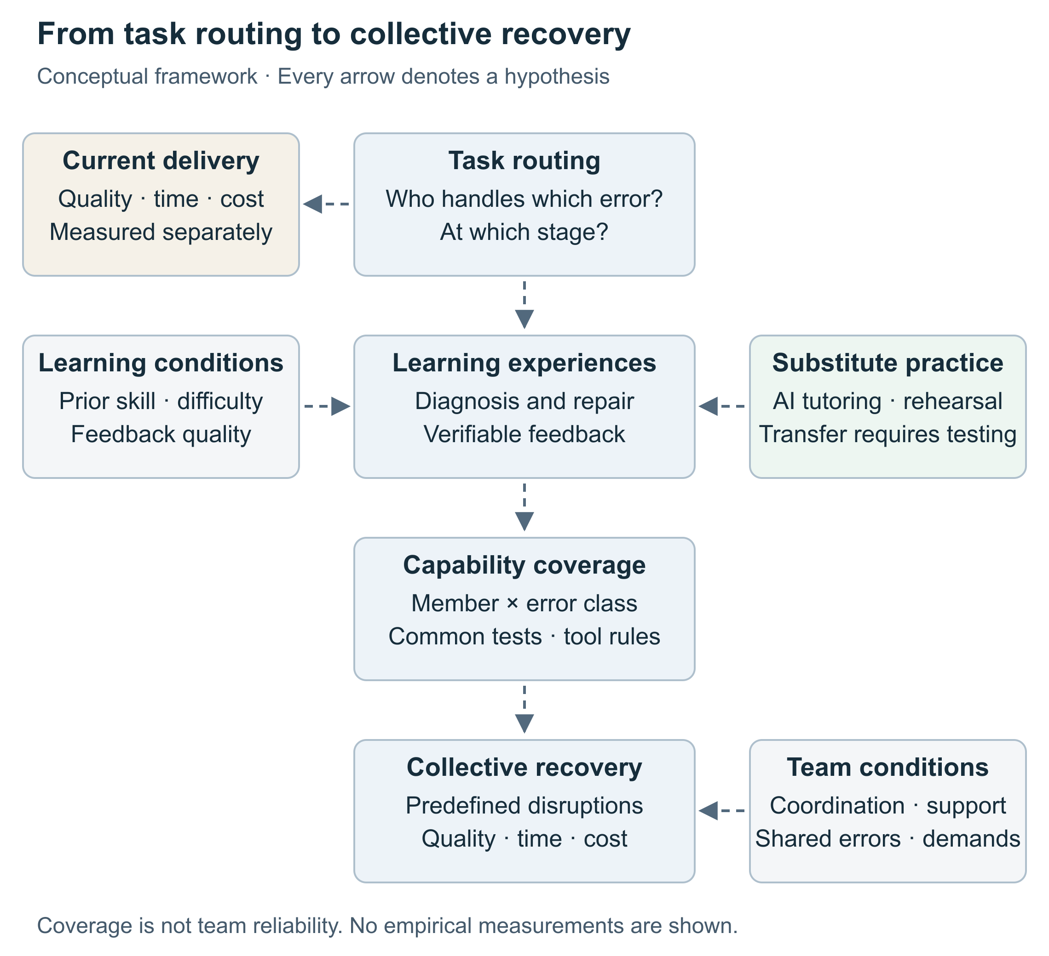
Figure 1 | Proposed links between task routing and expertise renewal. The conceptual framework separates current work performance, allocation of learning opportunities, members' subsequent capabilities and collective recovery. An opportunity comprises a defined stage of a case, its recipient, available information, an attempt or judgment, and feedback. AI-supported rehearsal and reliable external assistance are alternative pathways. Arrows connecting opportunities, capability and recovery indicate hypotheses; neither individual learning evidence nor an observed capability matrix establishes the full team-level causal pathway. Tests must distinguish bundled participation-and-support interventions from routing under standardized support.

Figure 2
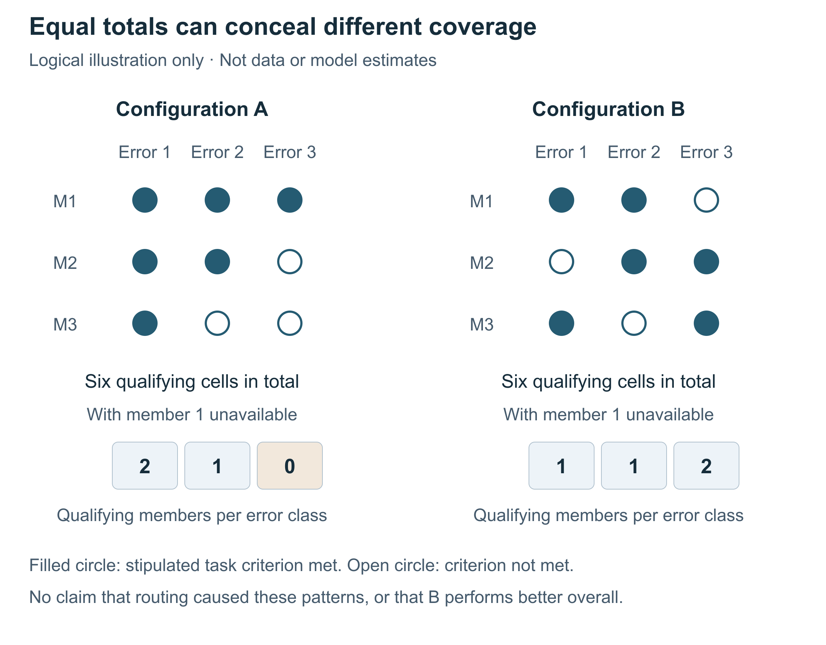
Figure 2 | Why aggregate capability does not determine coverage under a specified absence. This is a logical illustration, not empirical data, simulation output or a validated measurement instrument. Rows represent three hypothetical members and columns three hypothetical error classes. A value of 1 means that the stipulated capability criterion is satisfied under the stated assessment conditions; 0 means it is not. The illustrative matrices are A = [[1,1,1],[1,1,0],[1,0,0]] and B = [[1,1,0],[0,1,1],[1,0,1]]. Both contain six qualifying cells. Their column totals are respectively 3/2/1 and 2/2/2. Under the prespecified absence of member 1, A has no remaining qualifying member for class 3; B retains at least one for each class. No routing intervention is asserted to generate either matrix. Thresholds, tool conditions and relevant responsibilities would require independent specification in a real study. Coordination, correlated mistakes, external support and costs must be assessed separately; broader coverage alone does not establish greater team reliability.

References
1. Lewis, K. Measuring transactive memory systems in the field: Scale development and validation. Journal of Applied Psychology 88, 587-604 (2003). https://doi.org/10.1037/0021-9010.88.4.587
2. Risko, E.F.; Gilbert, S.J. Cognitive Offloading. Trends in Cognitive Sciences 20, 676-688 (2016). https://doi.org/10.1016/j.tics.2016.07.002
3. Puranam, P. Human–AI collaborative decision-making as an organization design problem. Journal of Organization Design 10, 75-80 (2021). https://doi.org/10.1007/s41469-021-00095-2
4. Soderstrom, N.C.; Bjork, R.A. Learning Versus Performance: An Integrative Review. Perspectives on Psychological Science 10, 176-199 (2015). https://doi.org/10.1177/1745691615569000
5. Bastani, H.; Bastani, O.; Sungu, A.; Ge, H.; Kabakcı, Ö.; Mariman, R. Generative AI without guardrails can harm learning: Evidence from high school mathematics. Proceedings of the National Academy of Sciences (2025). https://doi.org/10.1073/pnas.2422633122
6. Shen, J.H.; Tamkin, A. How AI Impacts Skill Formation. arXiv preprint arXiv:2601.20245, version 2 (2026). https://doi.org/10.48550/arXiv.2601.20245
7. Kestin, G.; Miller, K.; Klales, A.; Milbourne, T.; Ponti, G. AI tutoring outperforms in-class active learning: an RCT introducing a novel research-based design in an authentic educational setting. Scientific Reports (2025). https://doi.org/10.1038/s41598-025-97652-6
8. Brynjolfsson, E.; Li, D.; Raymond, L. Generative AI at Work. The Quarterly Journal of Economics 140, 889-942 (2025). https://doi.org/10.1093/qje/qjae044
9. Wang, R.E.; Ribeiro, A.T.; Robinson, C.D.; Loeb, S.; Demszky, D. Tutor CoPilot: A Human-AI Approach for Scaling Real-Time Expertise. EdWorkingPaper, revised November 2025 (2025). https://doi.org/10.26300/81nh-8262
10. Brinkmann, L.; Eisenmann, T.F.; Nussberger, A.; Derex, M.; Bonati, S.; Chirkov, V.; Rahwan, I. Propagation and preservation of AI-discovered problem-solving strategies in human culture. Nature Communications (2026). https://doi.org/10.1038/s41467-026-76113-2
11. Bainbridge, L. Ironies of automation. Automatica 19, 775-779 (1983). https://doi.org/10.1016/0005-1098(83)90046-8
12. Billett, S. Learning through work: workplace affordances and individual engagement. Journal of Workplace Learning 13, 209-214 (2001). https://doi.org/10.1108/EUM0000000005548
13. Beane, M. Shadow Learning: Building Robotic Surgical Skill When Approved Means Fail. Administrative Science Quarterly 64, 87-123 (2019). https://doi.org/10.1177/0001839217751692
14. Wiesenfeld, B.M.; Kellogg, K.C. Generative organizational learning: Affordances for new modes of knowledge search, creation, transfer, and forgetting with LLMs. Strategic Organization 24 (2026). https://doi.org/10.1177/14761270251408580
15. Lindebaum, D.; Nolan, E.; Swart, J. On the Dangers of Large-Language Model Mediated Learning for Human Capital. Human Resource Management Journal 36, 430-440 (2026). https://doi.org/10.1111/1748-8583.70036
16. Kolb, C.; Caron, J. Cheap, Fallible Cognition and the Political Economy of Expertise. arXiv preprint arXiv:2608.11512 (2026). https://doi.org/10.48550/arXiv.2608.11512
17. Catrinescu, I. The Capability Transfer: Cohort Reversal, Codified Expertise, and the Adaptability Tax of AI Transformation. arXiv preprint arXiv:2610.33102 (2026). https://doi.org/10.48550/arXiv.2610.33102
18. Marks, M.A.; Sabella, M.J.; Burke, C.S.; Zaccaro, S.J. The impact of cross-training on team effectiveness. Journal of Applied Psychology 87, 3-13 (2002). https://doi.org/10.1037/0021-9010.87.1.3

Manuscript transparency
This Perspective develops an argument and testing agenda from public literature and reports no new empirical data. OpenAI Codex assisted literature discovery and source-location checking, evidence organization, conceptual development and proposed tests, drafting, translation, editing, diagrams and document production. Figure 2 is an explicitly labelled logical example. Accountable authors must verify the sources and final claims and confirm authorship and submission declarations.

