Perspective

Building product judgment through
AI-assisted experimentation
  - Scientific learning and transfer across product projects
Richard T.Millian
Hangzhou Normal University

Abstract
Generative artificial intelligence makes product prototypes easier to build, but uncertainty about customer demand and further investment remains. A disappointing trial can reflect weak demand, a poorly chosen customer segment or barriers to adoption. Repeating such trials need not improve decisions in the next project. Drawing on scientific entrepreneurship, market opportunity identification, analogical transfer and AI-assisted decision research, this Perspective develops a framework for learning across product projects. It distinguishes production, evidence acquisition, project selection and transfer, and represents experience as provisional judgments with explicit conditions and competing explanations. The framework relates validation sequences to the uncertainty being investigated and develops testable propositions and a training design. Evaluation centres on customer-behaviour predictions, evidence choices and resource allocation in new projects, considering both unproductive continuation and premature termination. The framework requires behavioural validation; it provides a basis for investigating how rapid prototyping can support cumulative learning.

After the product is built
A product is ready to demonstrate, yet its team cannot decide whether to invest further. Consider a hypothetical team building a marketing tool for local merchants. AI produces attractive promotional posters. Trial users express interest, but payment and repeated use remain limited. The team could improve the layouts, approach another customer segment or end the project. Each action depends on an interpretation of the disappointing response. The difficulty is that the same observation admits several explanations. A more polished prototype does not automatically distinguish them.
The Tencent Research Institute report on AI-enabled individuals and teams describes rapid development, work across occupational boundaries and learning through action. In its account of flomo, product staff use AI to test working prototypes before handing them to engineers for release. Other cases describe designers and business staff taking on development work. The report also asks how increased capability should inform the choice of worthwhile work.[1] These observations motivate an inquiry into product selection, but the report's cases do not identify the causal effect of AI on market judgment. For a small team, the practical question is whether each attempt leaves knowledge that can improve its next decision.
Scientific entrepreneurship connects theories of value, hypotheses and experiments. Research on AI-assisted entrepreneurship has also begun to examine learning through conversations about business models.[2, 3] Building on these approaches, this Perspective focuses on transfer across projects. We propose that teams retain the conditions under which an inference holds, identify those conditions in a new project and make predictions that subsequent behaviour can test. This is a conceptual synthesis based on a targeted literature search. It develops a mechanism and research design without reporting new experimental findings.

Production speed and evidence quality
Prototype production, evidence acquisition and project selection can improve at different rates. Working software, a demonstration and a usable service each make certain questions easier to investigate, but none constitutes customer evidence on its own. A team needs to specify what a prototype tests: technical feasibility, successful task completion or a customer's willingness to change existing behaviour. Treating these questions as a single validation outcome leaves subsequent investment poorly grounded.
Research on digital experimentation already connects testing to the identification, expansion and abandonment of business opportunities. Koning and colleagues examine this relationship using variation in when start-ups adopted A/B testing. Their evidence supports treating experimentation as part of organizational learning, but does not establish an effect of AI adoption.[4] AI may also reduce the costs of organizing interviews, designing tests and analysing data. The relevant question concerns relative costs and the reallocation of effort, rather than an assumption that the technology only accelerates production.
Two pathways follow. Teams might redirect saved development time towards relevant customers and tests that distinguish competing explanations. Alternatively, they might add features and demonstrations while leaving their central market assumptions unchanged. Both pathways can produce more prototypes. Records of evidence acquisition and subsequent decisions are needed to distinguish them.
The effects of AI advice also depend on context. A field experiment by Otis and colleagues randomized access to an AI business assistant among Kenyan entrepreneurs. It did not detect a significant average improvement in business performance, but identified differences by baseline performance.[5] The study motivates separating access from the selection of advice; it does not directly measure product judgment across projects. We use product judgment as a working definition for the capacity to specify customers, explain value, select tests and allocate resources under incomplete evidence. We do not treat it as an already validated unitary scale.

Grounding customer segments in behaviour
A technology may serve several markets. Comparing candidate opportunities makes the basis of selection explicit. Gruber and colleagues connect entrepreneurial experience, the set of opportunities identified before market entry and subsequent performance, with diminishing returns to the number of opportunities.[6] In AI-assisted exploration, expanding the candidate set still leaves the task of identifying differences that matter for adoption and purchasing.
For the marketing tool, an owner who occasionally promotes a single restaurant may face different tasks and purchasing arrangements from an operator coordinating several branches. Customer specification should capture the use context, existing alternatives, user, payer and switching costs. Demographic characteristics can supplement this account. Finer segmentation is useful when it improves explanation and prediction for new customers.
Small samples can generate misleading segments. Repeatedly partitioning a few trial users can reveal a group that appears promising by chance. Segmentation rules developed during exploration therefore need evaluation with fresh customers, alongside records of recruitment channels and non-participation. Expressed interest, trial, repeated use and payment support different inferences. For infrequent tasks, the observation window must include realistic opportunities to use the product. Customer benefit, sustainable provision and short-term revenue also require separate consideration.
Simulated customers do not automatically resolve missing field evidence. In a working paper, Brand and colleagues find discrepancies between model-derived and human willingness-to-pay estimates, with limits to transferring improvements across product categories and customer populations.[7] AI can help generate alternative explanations and interview questions. However, personas, customer answers and business arguments produced by one system should not count as independent confirmations of market demand.

Diagnosing disappointing outcomes
In the opening scenario, low use may mean that customers rarely need posters. It may instead mean that interested customers cannot complete setup. The first explanation calls for reconsidering the segment or value proposition; the second may justify implementation support. Without observing the task, either explanation can enter a persuasive retrospective account without becoming better supported.
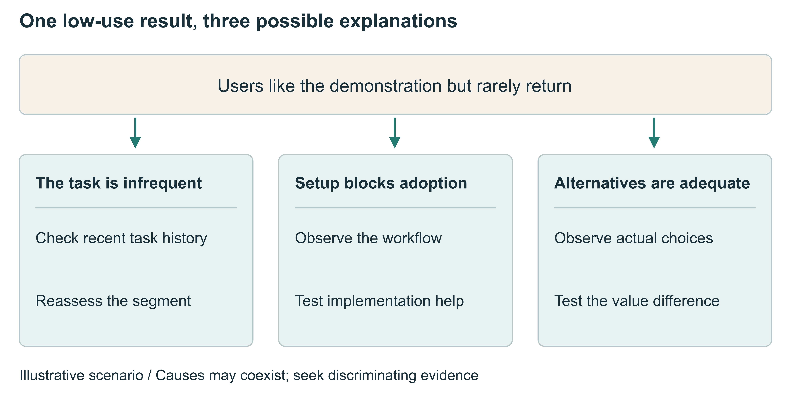
Figure 1 One disappointing outcome can imply different decisions. The merchant tool is an illustrative scenario, not a real company or experimental result. Each branch gives a candidate explanation and evidence that could help distinguish it. The branches are neither exhaustive nor mutually exclusive; several causes may operate together.
Diagnosis can be organized around the assumptions at stake. Demand assumptions concern the frequency and importance of a problem. Adoption assumptions concern whether customers can incorporate a solution into their work. Business-model assumptions concern the payer, price and cost of provision. Implementation failure and insufficient evidence should remain separate possibilities. An unreliable prototype cannot fairly test the full value proposition, and a trial that misses relevant occasions of use cannot adequately test demand.
Retrospective explanations can also shift with the outcome. Boso and colleagues relate prior failure, learning and subsequent venture performance in longitudinal observational research. That design does not establish that every failure produces learning or fully identify the causal process.[8] Recording predictions, sampling, observation windows, alternatives and decision conditions before a test makes later revision more inspectable. Where evidence cannot distinguish explanations, the appropriate record is unresolved uncertainty.
Ending an unpromising project is one part of selection quality; abandoning a valuable opportunity too early also carries a cost. Four randomized trials reported by Camuffo and colleagues show that scientific decision-making training affects termination and pivoting patterns, but termination counts should not become a training objective.[2] Continued investment should consider whether another test could change the decision and what obtaining that evidence would cost. Stopping requires checking whether negative evidence actually addresses a central assumption.

Choosing a validation sequence
The value of interviewing before prototyping depends on the evidence needed. Direct customer contact may be useful when task frequency or purchasing responsibility is unclear. A minimal prototype may be necessary when customers can recognize an interaction need only after experiencing it. Continuing participation may help both parties develop a problem and solution within a complex workflow.
Participation also has costs. Chang and Taylor's meta-analysis reports that its relationship with product outcomes varies across development stages and contexts, qualifying the idea that more involvement is invariably beneficial.[9] These aggregate relationships do not constitute a randomized comparison of exploration sequences under AI. Teams also need to examine whether active collaborators represent the intended market and whether new customers can use the resulting product.
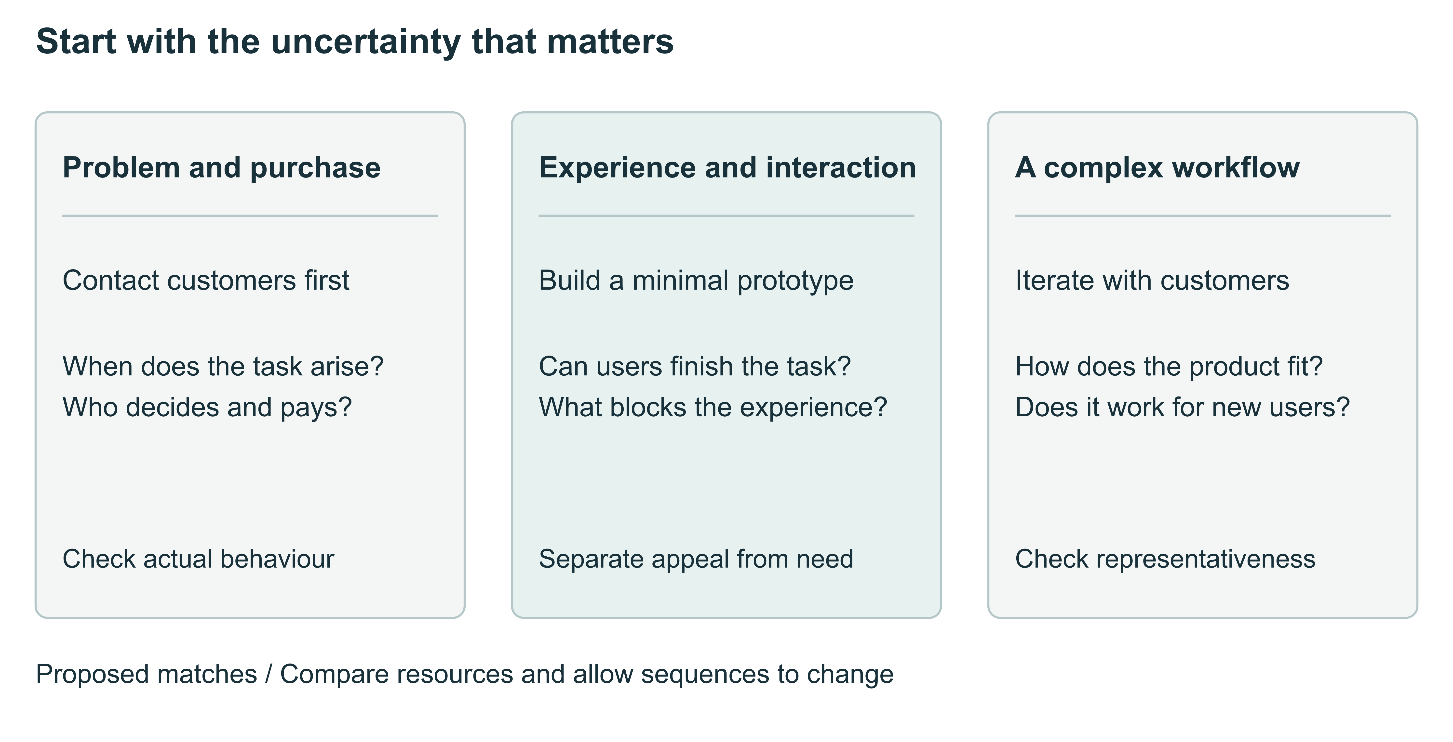
Figure 2 Select evidence around the uncertainty that matters. The three routes are proposed matches requiring comparative evaluation. They can be combined and revisited rather than followed as mutually exclusive routines. Comparing sequences requires control or measurement of time, budgets, customer contact and access to evidence, so resource differences are not mistaken for process advantages.
In a randomized training comparison among Tanzanian agribusiness entrepreneurs, Agarwal and colleagues find an economic-performance advantage for an approach combining a theory of value with evidence gathering.[10] This supports organizing tests around causal reasoning within the limits of that setting. A prototype should be evaluated by the explanations it can distinguish. A manually delivered service, task observation or purchasing-process interview may sometimes test a critical assumption before a complete system is built.

Testing experience in the next project
An experience that can travel needs a relationship and its conditions. The marketing-tool example might support a provisional inference: when tasks are infrequent and adequate free alternatives exist, better output quality may not sustain payment. It would not justify concluding that all small merchants are unattractive customers. A later project in another industry could still warrant testing that inference if the relevant conditions recur.
Analogical-transfer research suggests a training approach. Gentner and colleagues find that comparing relational structures across negotiation cases supports the abstraction and transfer of strategies.[11] This motivates cross-case comparison, but does not establish an effect on real product investments. Transfer requires detecting consequential differences as well as similarities. Searching only for resemblance can turn past experience into a source of error.
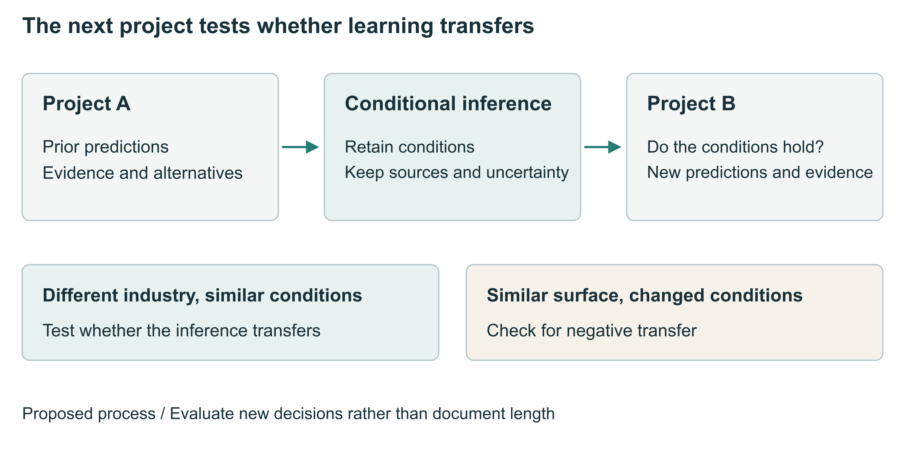
Figure 3 Transferring experience requires checking its conditions. Project A leaves a provisional judgment with sources and boundaries. Project B checks the relevant conditions before making predictions and revises the judgment as new evidence arrives. Arrows represent the proposed learning process, not estimated causal effects. Performance across projects is the target of evaluation; the volume of documentation is not a learning outcome.
A learning record can retain the original prediction, observations, weakened and surviving explanations, applicable conditions and a test in the next project. Such records are external supports. If a team still cannot identify a payer or choose an informative test in a new project, a thorough retrospective document does not establish improved judgment. Conversely, a team may learn through discussion while leaving little text. Research needs to observe both records and behaviour.
Three falsifiable propositions follow. First, under comparable resources, evidence choices guided by an explicit account of value should improve selection more than simply increasing prototyping. The difference may narrow when additional prototypes provide equally diagnostic feedback. Second, reflection that compares conditions and makes predictions for new contexts should improve transfer more than a general summary. Improvement confined to the current artefact or to confidence would not support this proposition. Third, transfer depends on condition matching. Mechanically applying experience when surface features persist but decisive conditions change may produce negative transfer.

Training observable decisions
Training can begin with deliberately paired cases. Two products in different industries may share a separation between users and payers; two superficially similar products may differ in task frequency and available alternatives. Participants first select customers and tests independently and explain their choices. After comparing evidence, they make predictions for a third case, moving assessment beyond understanding the training examples.
A proposed programme would cover customer and task identification, value explanation, test design, failure diagnosis, resource allocation and transfer. Each component should yield an inspectable decision. Test design requires specifying which result would change the next action. Diagnosis requires evidence that separates explanations. Resource allocation includes both opportunities worth pursuing and projects worth stopping. These components are practical implications of the framework, not a validated curriculum.
AI can help organize source material, suggest counterexamples, build minimal prototypes and retrieve earlier records. Kostis and colleagues already distinguish forms of learning through conversations with AI, while a Chinese research proposal examines AI throughout scientific entrepreneurial decision making.[3, 12] Our evaluation focus is behavioural change in a subsequent project. If improvement occurs only while the AI retains the original context, it should be described as assisted system performance and distinguished from independent human transfer.

Evaluating the framework
An initial experiment could cross AI access with structured training, providing the comparison group with equal instructional time and attention. Participants would complete project A and then a superficially different project B. New cases would include both stable and changed underlying conditions. Judgment in these new cases would be the primary target; delayed assessment would help separate short-term recall from more durable learning. Research on team decisions should randomize at team level and account for within-team dependence.
Customer-behaviour forecasts can assess calibration using prespecified events and observation windows. Project selection requires an independent outcome benchmark. Evaluation should count both mistaken continuation and mistaken termination and specify the consequences of each. Commercial outcomes depend on market timing, execution and chance, so a single revenue observation is not a sufficient measure of judgment. Evidence selection, belief updating, reasons and subsequent customer behaviour should complement one another.
Fair comparison also requires recording model versions, access conditions and customer-evidence sources, and using fresh cases with positive and negative outcomes. The same model should not generate customer ground truth, assist decisions and serve as the sole evaluator. Component studies could separate record keeping, condition comparison and prediction in new projects. Associations between process measures and outcomes alone would not establish causal mediation.
Public records can support preliminary inquiry within narrower limits. Successive launches, pricing changes and termination accounts may reconstruct parts of a decision trajectory. Votes do not establish demand, an operating website does not establish retention, and launch frequency does not identify AI use. Without earlier predictions or subsequent projects by the same team, analysis concerns visible narratives and associations rather than identified learning transfer. A formal empirical study would also preregister primary outcomes and analysis rules, with sample size based on meaningful effect sizes, clustering and attrition.

The limits of cumulative judgment
The framework emphasizes retaining revisable explanations between attempts. It builds on scientific entrepreneurship and analogical learning while placing evaluation in a new project. Current evidence does not determine an optimal training duration, how long benefits persist or which teams benefit most. Demand can also emerge through use and social interaction; limited early evidence need not imply that an opportunity has no value.
Product judgment therefore needs to accommodate uncertainty. It includes recognizing which assumption deserves the next test, what evidence could change a decision and when earlier experience no longer applies. An ended project may leave useful knowledge, while a growing project may conceal a mistaken explanation. The cumulative achievement worth investigating is a team's ability to ask more precise questions before its next investment and revise its decisions when relevant evidence arrives.

References
1. Tencent Research Institute. From Super Individuals to Super Teams: Emergent Pathways of Organizational Change in the AI Era. Research report (2026; in Chinese).
2. Camuffo, A., Gambardella, A., Messinese, D., Novelli, E., Paolucci, E. & Spina, C. A scientific approach to entrepreneurial decision‐making: Large‐scale replication and extension. Strategic Management Journal 45(6), 1209-1237 (2024). https://doi.org/10.1002/smj.3580
3. Kostis, A., Lidström, J., Nair, S. & Holmström, J. Too Much AI Hype, Too Little Emphasis on Learning? Entrepreneurs Designing Business Models Through Learning-by-Conversing With Generative AI. IEEE Transactions on Engineering Management 71, 15278-15291 (2024). https://doi.org/10.1109/tem.2024.3484750
4. Koning, R., Hasan, S. & Chatterji, A. Experimentation and Start-up Performance: Evidence from A/B Testing. Management Science 68(9), 6434-6453 (2022). https://doi.org/10.1287/mnsc.2021.4209
5. Otis, N.G., Clarke, R., Delecourt, S., Holtz, D. & Koning, R. The Uneven Impact of Generative Artificial Intelligence on Entrepreneurial Performance: Evidence from a Field Experiment in Kenya. Management Science (advance online publication) (2026). https://doi.org/10.1287/mnsc.2024.06909
6. Gruber, M., MacMillan, I.C. & Thompson, J.D. Look Before You Leap: Market Opportunity Identification in Emerging Technology Firms. Management Science 54(9), 1652-1665 (2008). https://doi.org/10.1287/mnsc.1080.0877
7. Brand, J., Israeli, A. & Ngwe, D. Using LLMs for Market Research. Harvard Business School Working Paper 23-062 (revised 30 April 2026). https://www.hbs.edu/ris/Publication%20Files/23-062_1f58623a-ee21-44b9-a262-276047bc5543.pdf
8. Boso, N., Adeleye, I., Donbesuur, F. & Gyensare, M. Do entrepreneurs always benefit from business failure experience? Journal of Business Research 98, 370-379 (2019). https://doi.org/10.1016/j.jbusres.2018.01.063
9. Chang, W. & Taylor, S.A. The Effectiveness of Customer Participation in New Product Development: A Meta-Analysis. Journal of Marketing 80(1), 47-64 (2016). https://doi.org/10.1509/jm.14.0057
10. Agarwal, R., Bacco, F., Camuffo, A., Coali, A., Gambardella, A., Msangi, H., Sonka, S., Temu, A., Waized, B. & Wormald, A. Does a Theory-of-Value Add Value? Evidence from a Randomized Control Trial with Tanzanian Entrepreneurs. Organization Science 36(2), 601-625 (2025). https://doi.org/10.1287/orsc.2023.17590
11. Gentner, D., Loewenstein, J. & Thompson, L. Learning and transfer: A general role for analogical encoding. Journal of Educational Psychology 95(2), 393-408 (2003). https://doi.org/10.1037/0022-0663.95.2.393
12. Tao, Y. & Yu, X. The effect of the AI-augmented scientific approach to entrepreneurial decision-making on new venture idea formation. Advances in Psychological Science 34(12), 2121–2138 (2026; online ahead of issue, in Chinese). https://doi.org/10.3724/sp.j.1042.2026.2121

