Health economic value and choice in the age of artificial intelligence
  - Richard T. Millian
  - Hangzhou Normal University

Supporting information
Supplementary Tables 1–3, Extended Data Figs. 1–4 and Supplementary References.

Supplementary Table 1 | Minimum comparison record. Proposed fields, not a validated scale. Health capability, ICF, WHO-5, MCDA and decision-quality research inform the distinctions^{1–4} (https://www.who.int/standards/classifications/international-classification-of-functioning-disability-and-health).
Domain | Record | Interpretation
Decision | Feasible options; ability to refuse; common horizon | Distinguish nominal options from real opportunities
Resources and time | Net income change; total work; displaced activities | Record where saved time is used
Health and functioning | Relevant symptoms, function or clinical outcomes | Interpret against baseline and clinical context
Experience | Enjoyment, relief or distress; during and after | Separate immediate responses from sustained change
Capabilities and agency | Independent performance; valued activities; discretion | Include accessibility gains from assistance
Evidence and appraisal | Population; comparator; horizon; uncertainty; goals | Retain unknowns and differences in priorities
ICF, International Classification of Functioning, Disability and Health; WHO-5, World Health Organization-Five Well-Being Index; MCDA, multicriteria decision analysis.

Supplementary Table 2 | Different levels of AI outcomes. Studies illustrate task efficiency, experience and judgement; their designs and endpoints differ.
Setting and design | Main finding | Interpretive scope
Professional writing⁵  Randomized; n = 453 | Faster task completion and better output quality | Full-day allocation and health not measured
Customer support⁶  Staggered rollout; n = 5,172 | About 15% higher resolutions per hour; outcome availability varies | Causal assumptions; allocation of saved time not measured
AI companionship⁷  Seven-day Study 3 | Immediate loneliness relief; persistent pre-interaction benefit not demonstrated | Differential attrition; control not time-matched
Medical scenarios⁸  n = 1,298 | Control versus pooled AI: identification OR 1.76 (95% CI 1.45–2.13) | Scenario performance, not clinical morbidity
AI, artificial intelligence; OR, odds ratio; CI, confidence interval.

Supplementary Table 3 | Testable propositions and disconfirming observations. Each comparison requires prespecified estimands and outcomes.
Proposition | Key comparison | Potentially disconfirming result
Discretion affects allocation of AI time savings | Similar task gains; credible differences in control over workload | No meaningful allocation difference, with sufficiently precise estimates
Immediate relief and sustained benefit may diverge | Matched comparator; repeated pre-use, post-use and follow-up measures | Stable pre-use improvement comparable to immediate relief
The module improves decision quality | Same guide, with or without the added module | No gain in understanding or transfer, or burden exceeds benefit

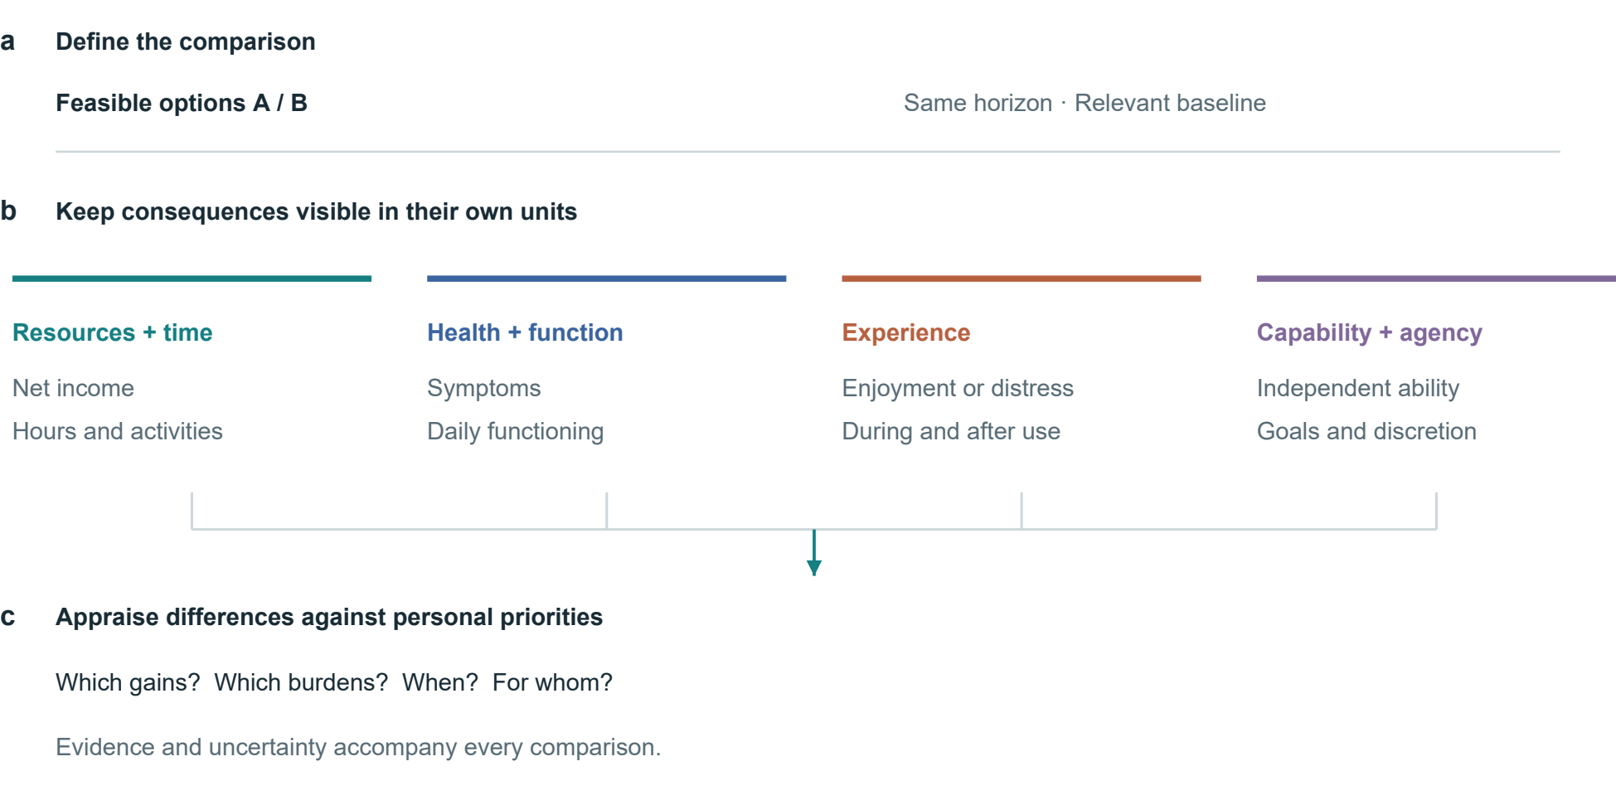
Extended Data Fig. 1 | A framework for comparing health-related consequences. Feasible alternatives and a common horizon define the comparison. Resources and time, health and functioning, experience, and capabilities and agency remain distinct. Priorities inform appraisal. Connections represent analytical steps, not estimated causal effects.

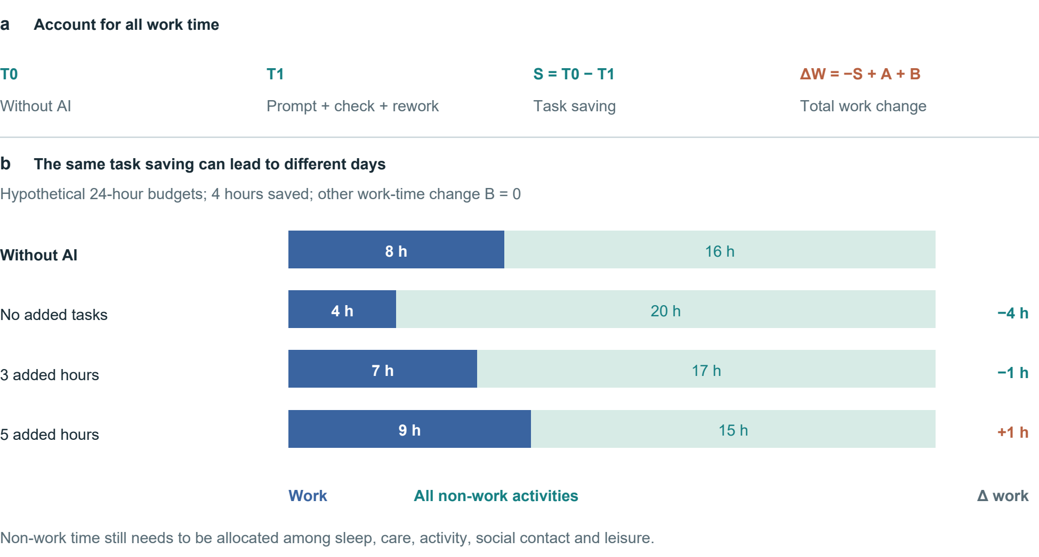
Extended Data Fig. 2 | Task savings and the allocation of a day. a, The accounting identity includes prompting, verification and rework in T1, additional tasks in A and other work-time changes in B. b, Hypothetical 24-hour budgets with an 8-hour baseline workday, a 4-hour task saving and B = 0. Non-work time is not assigned a health effect.

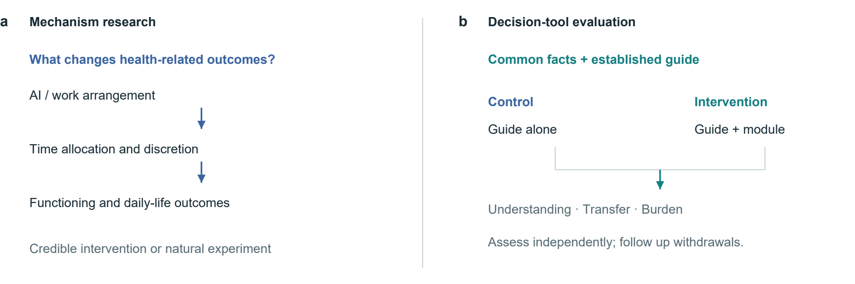
Extended Data Fig. 3 | Two research questions and their evaluation paths. Mechanism research explains how outcomes arise; tool evaluation tests the added comparison module. An active comparator gives both groups the same facts and established guide. The proposed design is not a completed trial.

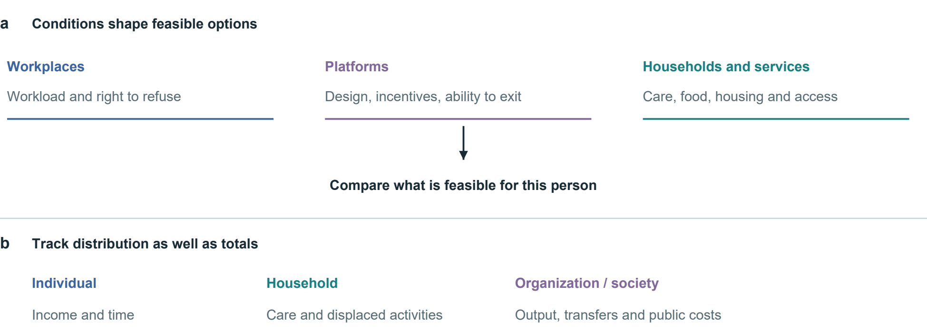
Extended Data Fig. 4 | Conditions of choice and distribution of consequences. Workplace, platform and household conditions shape feasible options. Income, time and care burdens may accrue to different people. Arrows organize evaluation questions rather than depict estimated causal effects.

Supplementary references
1. Ruger, J. P. Health capability: conceptualization and operationalization. Am. J. Public Health 100, 41–49 (2010). https://doi.org/10.2105/AJPH.2008.143651
2. World Health Organization. The World Health Organization-Five Well-Being Index (WHO-5) (World Health Organization, 2024). WHO/UCN/MSD/MHE/2024.01.
3. Thokala, P. et al. Multiple criteria decision analysis for health care decision making—an introduction: Report 1 of the ISPOR MCDA Emerging Good Practices Task Force. Value Health 19, 1–13 (2016). https://doi.org/10.1016/j.jval.2015.12.003
4. Sepucha, K. R. et al. Establishing the effectiveness of patient decision aids: key constructs and measurement instruments. BMC Med. Inform. Decis. Mak. 13 (Suppl. 2), S12 (2013). https://doi.org/10.1186/1472-6947-13-S2-S12
5. Noy, S. & Zhang, W. Experimental evidence on the productivity effects of generative artificial intelligence. Science 381, 187–192 (2023). https://doi.org/10.1126/science.adh2586
6. Brynjolfsson, E., Li, D. & Raymond, L. Generative AI at work. Q. J. Econ. 140, 889–942 (2025). https://doi.org/10.1093/qje/qjae044
7. De Freitas, J., Oğuz-Uğuralp, Z., Uğuralp, A. K. & Puntoni, S. AI companions reduce loneliness. J. Consum. Res. 52, 1126–1148 (2026). https://doi.org/10.1093/jcr/ucaf040
8. Bean, A. M. et al. Reliability of LLMs as medical assistants for the general public: a randomized preregistered study. Nat. Med. 32, 609–615 (2026). https://doi.org/10.1038/s41591-025-04074-y

