Health economic value in the AI era: a framework for intertemporal choice
Richard T. Millian
Hangzhou Normal University
Higher income, faster task completion and convenience are readily visible economic gains. Changes in health, recovery needs and time use are less consistently recorded. Artificial intelligence sharpens this problem: faster work need not create more rest, and better assisted performance need not improve independent ability. Drawing on health capital, time allocation, health capability and decision analysis, we propose a comparative health-consequence framework. It compares feasible alternatives over a common horizon across resources and time, health and functioning, experience, and capabilities and agency. Measurement, prediction and appraisal remain distinct. Selected experiments and field studies show why outcomes with different units, timing and evidential scope should remain visible rather than be reduced to compensation or a composite score. Applications to overtime, diet, sleep and AI use illustrate the comparisons required. We develop testable propositions about the distribution of time savings, persistence of benefits and decision quality, connecting health economic evaluation with everyday choice. The framework requires prospective evaluation against established decision support.
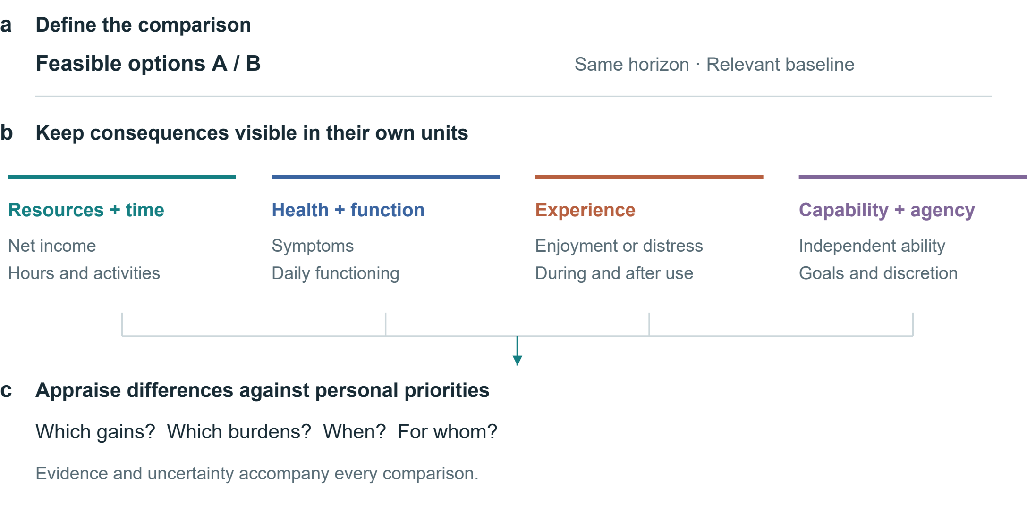
Fig. 1 | A framework for comparing health-related consequences. Feasible alternatives and a common horizon define the comparison. Resources and time, health and functioning, experience, and capabilities and agency remain distinct. Priorities inform appraisal. Connections represent analytical steps, not estimated causal effects.

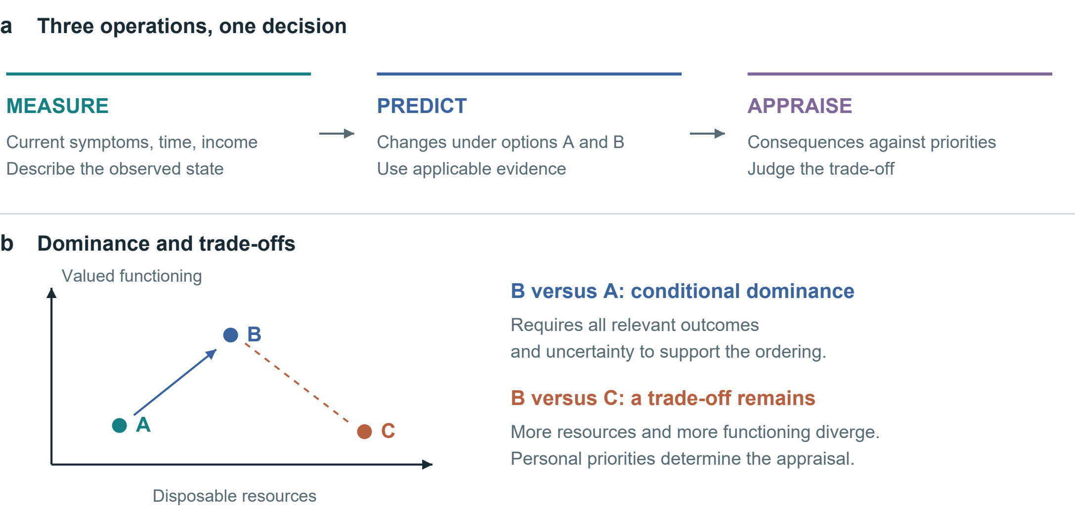
Fig. 2 | Linking measurement, prediction and appraisal. a, Three kinds of information address the same decision. b, Conditional dominance and trade-offs on qualitative axes without numerical units. Other relevant outcomes and uncertainty may change the ordering.

From economic returns to changes in daily life
An overtime payment and a faster AI-assisted task both offer measurable gains. Whether either improves a person's life depends on what changes with the gain: sleep opportunity, workload, symptoms, relationships, disposable income and the ability to pursue valued activities. The analytical problem is therefore the translation from an observable return into consequences experienced over time. A comparison that records only the payment or task output leaves this translation unexplained. Figure 1 locates the problem across everyday settings; Figure 2 separates the operations needed to address it.
The starting point is established economics. Grossman's health-capital approach treats health as a stock relevant to both well-being and productive time; Becker's allocation-of-time framework makes non-market time part of economic choice.[1, 2] Marx's discussion of the working day directs attention to bargaining, limits on labour and the reproduction of labour power.[3] These traditions motivate different questions rather than a single interchangeable theory. In particular, health losses cannot simply be appended to Marxian surplus value as an empirically measured quantity without a separate account of exposure, counterfactual outcomes and incidence.
Health capability approaches further distinguish achieved states from the real opportunities people have to maintain health and act on their goals.[4] This matters when an apparent choice cannot be refused without losing housing or essential care. Evidence on health-dependent utility also cautions against assuming that a given monetary increment has the same welfare significance in every health state.[5] Neither point makes income irrelevant. Resources can enable care, security and participation; the question is which consequences a particular increment enables or displaces under actual constraints.
We use health economic value to mean the decision-relevant significance of health and functioning within these trade-offs. It is not synonymous with total welfare, earning capacity or a person's worth. Money, time, experience and agency enter the comparison because they interact with health and carry value of their own. The proposed contribution is an integrative accounting procedure: specify a feasible counterfactual, trace consequences over time, attach evidence and uncertainty, and make the evaluative judgement explicit. A legitimate result can be a preference, a conditional choice or an unresolved comparison.

Table 1 | Minimum comparison record. Proposed fields, not a validated scale. Health capability, ICF, WHO-5, MCDA and decision-quality research inform the distinctions.[4, 6, 7, 8, 9]
Domain | Record | Interpretation
Decision | Feasible options; ability to refuse; common horizon | Distinguish nominal options from real opportunities
Resources and time | Net income change; total work; displaced activities | Record where saved time is used
Health and functioning | Relevant symptoms, function or clinical outcomes | Interpret against baseline and clinical context
Experience | Enjoyment, relief or distress; during and after | Separate immediate responses from sustained change
Capabilities and agency | Independent performance; valued activities; discretion | Include accessibility gains from assistance
Evidence and appraisal | Population; comparator; horizon; uncertainty; goals | Retain unknowns and differences in priorities

From measurement to appraisal
Measurement describes a state; prediction estimates what would happen under alternatives; appraisal asks how the difference matters. A blood test belongs to the first operation. Estimating how a dietary change affects a future outcome belongs to the second. Deciding whether that expected change justifies cost, effort or lost enjoyment belongs to the third. Collapsing these operations can turn a reference interval into a moral ranking, an association into a personal forecast, or a stated preference into proof of informed consent.
Monetary valuation can answer defined policy questions, but compensation is not biological restoration. Conversely, irreversibility does not logically make valuation impossible: people still compare prevention, mitigation and foregone opportunities. What fails is the inference that a payment necessarily neutralizes a loss. A stated minimum payment depends on income, alternatives and understanding; accepting dangerous work under severe deprivation does not establish that the health loss is trivial. Behavioural welfare analysis provides reasons to examine the conditions under which choices reveal evaluative preferences.[10]
The framework adapts the transparency of cost–consequence analysis and the explicit criteria of multicriteria decision analysis, while retaining their limitations.[8, 11] It adds no validated universal scale. An established decision guide already elicits options, uncertainty, values and support needs.[12] Our narrower proposal makes time reallocation, outcome trajectories, assisted versus unaided functioning and the distribution of consequences explicit within such support. Any advantage over existing tools must be demonstrated, not inferred from a new label.
Standardized health-status instruments can supply comparable information; preference-based measures such as EQ-5D can support health-economic evaluation when used with the appropriate valuation framework.[13] They do not exhaust autonomy, relationships or personally valued capability. Self-determination theory offers a complementary account of autonomy, competence and relatedness, without implying that every activity has the same meaning for every person.[14] Reading, gaming, exercise and companionship therefore enter as alternatives whose consequences require assessment, rather than predetermined categories of virtue or harm.
Table 1 provides a minimum record. Its purpose is comparability of the decision process, not uniformity of preferences. When meaningful consequences diverge, the analyst should show the conflict and examine sensitivity to priorities. A single index is optional only when its scales, weights, uncertainty and double-counting risks are defensible; declining to aggregate is often the more informative result.

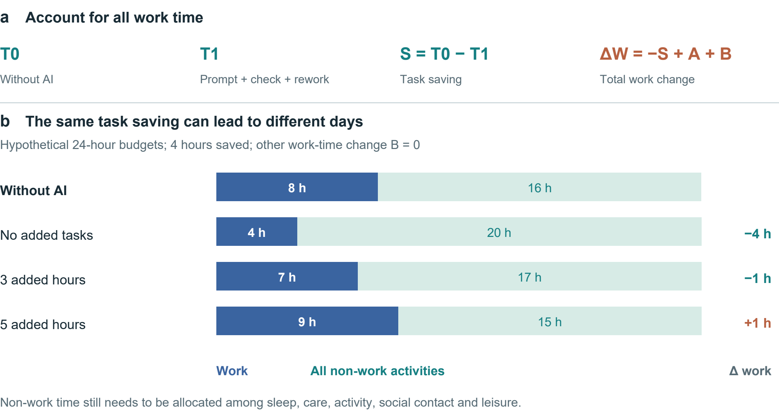
Figure 3 | Task savings and the allocation of a day. a, The accounting identity includes prompting, verification and rework in T1, additional tasks in A and other work-time changes in B. b, Hypothetical 24-hour budgets with an 8-hour baseline workday, a 4-hour task saving and B = 0. Non-work time is not assigned a health effect.

Intertemporal comparison and time constraints
Let x_{i}(a;τ) denote person i's consequence profile under feasible option a at time τ. Components retain their own units: disposable resources, time allocation, health and functioning, experience and capabilities. For components with a meaningful numerical difference, define:
$Δx_{i}(a,b;τ) = x_{i}(a;τ) − x_{i}(b;τ). (1)$
This is a contrast, not a causal prediction model. Categorical changes remain descriptive. Every estimated component requires a population, comparator, horizon, source and uncertainty statement. Timing may require a trajectory rather than an endpoint. Let z_{j} denote an appropriately oriented criterion, with larger values preferred within its applicable range. Conditional dominance requires:
$Δz_{j} ≥ 0 (∀j); Δz_{k} > 0 (∃k). (2)$
This ordering applies only if the criteria cover the relevant consequences and uncertainty does not overturn it. Many biomarkers are not monotonic, and omitted consequences can reverse an apparent ranking. Where trade-offs remain, personal appraisal is necessary; no universal exchange rate follows from equations (1)–(2).
For AI-assisted work, let S = T0 − T1 be time saved on a fixed task; T1 includes prompting, verification and rework. Let A be time added through additional tasks and B all other net changes in work time, defined to avoid overlap. Then:
$ΔW = −S + A + B. (3)$
Figure 3 illustrates the identity. Saving four task hours produces four fewer work hours if A = B = 0, one fewer if A = 3 and B = 0, and one more if A = 5 and B = 0. These are hypothetical allocations, not estimated AI effects. Even a fall in total work does not determine health: the activities replacing work, discretion over them and their subsequent consequences remain to be measured.

Table 2 | Different levels of AI outcomes. Studies illustrate task efficiency, experience and judgement; their designs and endpoints differ.
Setting and design | Main finding | Interpretive scope
Professional writing  Randomized; 453 [15] | Faster task completion and better output quality | Full-day allocation and health
Customer support  Staggered rollout; 5,172 [16] | About 15% higher resolutions per hour; outcome availability varies | Causal assumptions; who receives saved time
Companionship  Seven-day Study 3 [17] | Immediate loneliness relief; persistent pre-interaction benefit not demonstrated | Differential attrition; control not time-matched
Medical scenarios  1,298 people [18] | Control versus pooled AI: identification OR 1.76 (95% CI 1.45–2.13) | Scenario performance, not clinical morbidity

Three levels of AI benefit
AI can expand productive capacity. In a randomized study of 453 professionals, Noy and Zhang found improvements in writing-task speed and quality.[15] In a field study covering 5,172 customer-support agents, Brynjolfsson and colleagues used staggered deployment and difference-in-differences analysis; their preferred estimate implied about a 15% increase in issues resolved per hour.[16] This was not a randomized trial, and the field outcome was throughput, not health. Together these studies support productivity gains while leaving open who receives the time or income dividend.
The relevant distinction is also between performance with assistance and capability retained without it. Bastani and colleagues' educational experiment illustrates why an evaluation should include an unaided assessment rather than infer learning from assisted practice alone.[19] This does not establish that AI generally erodes cognition. It specifies a measurement requirement: immediate performance, transfer to unfamiliar tasks and independent performance answer different questions. Accessibility and supported functioning can be valuable even where unaided performance is unchanged.
AI companionship raises a temporal distinction. In the seven-day third study reported by De Freitas and colleagues, loneliness relief was most clearly immediate; a persistent improvement in pre-interaction loneliness was not demonstrated.[17] Differential attrition and a non-time-matched control limit interpretation. This is evidence for examining when benefit occurs, not grounds for dismissing companionship or diagnosing dependence. For short-form content and virtual interaction, useful records would include sleep displacement, enjoyment, relationships and the ability to disengage; content type or duration alone does not establish harm.
Information accuracy and user benefit also differ. Bean and colleagues found that people working through hypothetical medical scenarios did not reproduce the models' standalone performance; Figure 5d retains the reported control-versus-AI contrast.[18] The outcome was scenario interpretation, not clinical disease. Earlier Facebook-deactivation research likewise shows the value of measuring consequences beyond platform use, although social-media findings cannot simply be transferred to generative AI.[20] Health-literate AI already emphasizes comprehension, agency, accountability and proportionality.[21] Our proposal complements that agenda by specifying the consequences and time horizons to compare, rather than claiming these concerns as new.

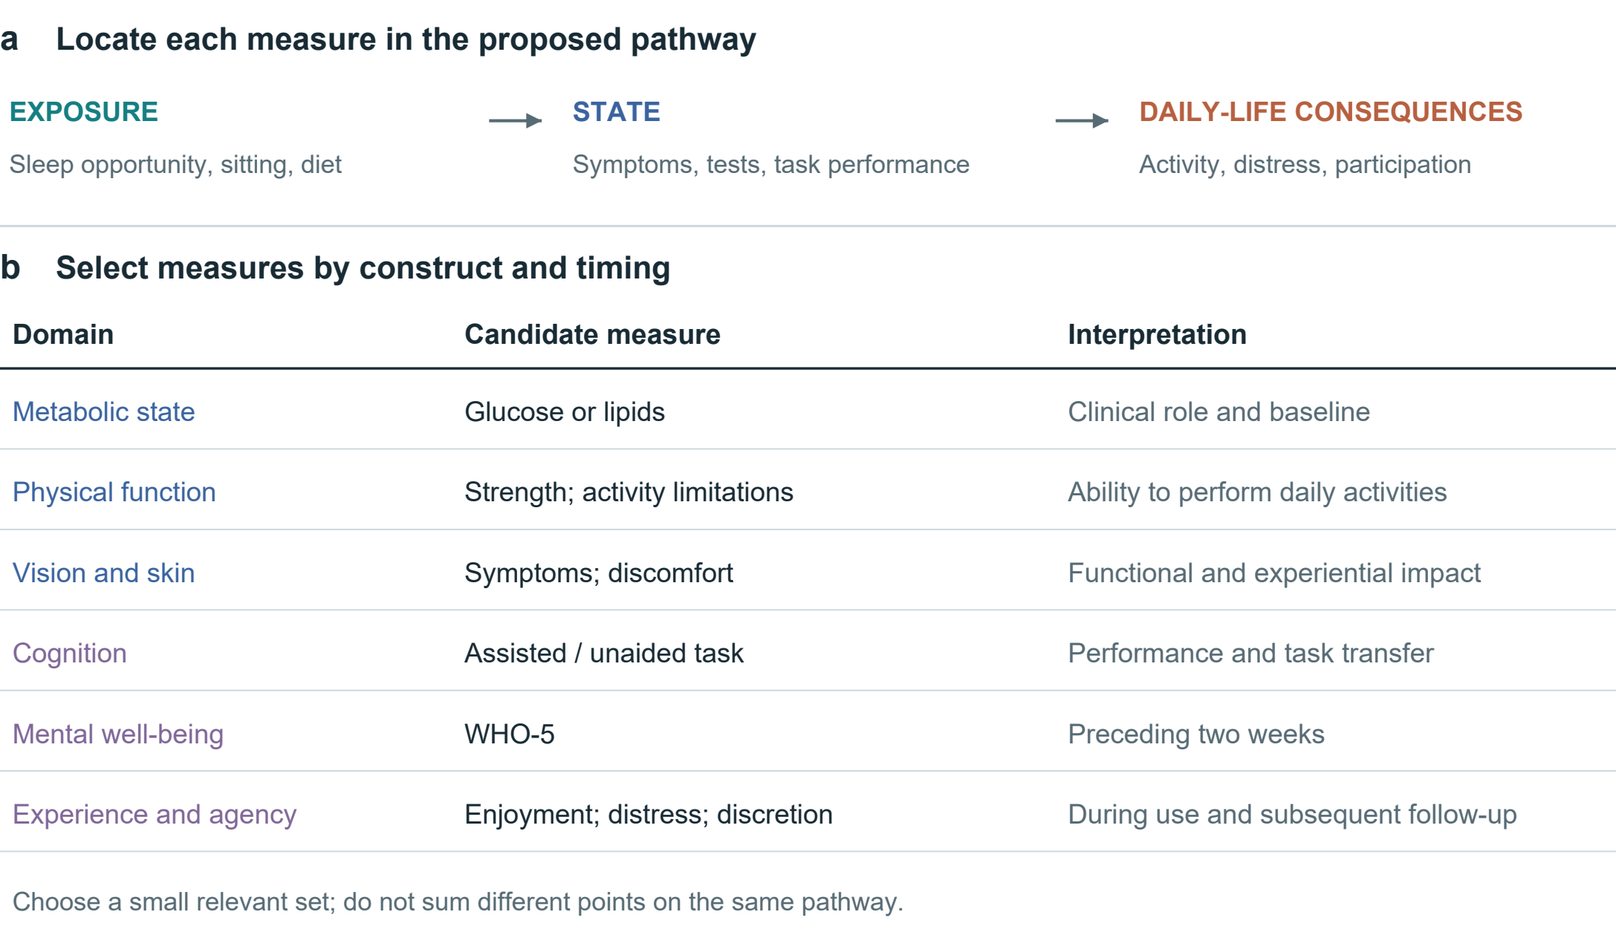
Fig. 4 | Measurement levels and their decision relevance. The upper pathway separates exposure, state and consequences in daily life; arrows indicate relationships to investigate. Candidate measures below are selected for the decision and its timing. ICF links functioning to context; WHO-5 covers mental well-being over the preceding two weeks.[6, 7]

Choosing measures for the decision
Measurement starts with the decision. Comparing a meal, a month of night work and an AI companion requires different information. Feasible alternatives and a common observation horizon should be established before choosing a small set of relevant measures. Figure 4 organizes candidate measures by their role in the comparison.
Separate exposures, states and consequences. Sleep opportunity, sitting time, diet and screen use describe behaviours or environments. Symptoms, laboratory measures and task performance describe selected states. Their significance depends on daily functioning, experience and valued activities. The ICF helps situate functioning in context.[6] Adding sedentary time, a correlated biomarker and a downstream disease risk into a single score can count the same pathway repeatedly. Candidate causal links should therefore be specified before aggregation or mediation analysis.
Clinical measures need clinical meaning. Glucose and lipid measures, blood pressure, muscle function, vision or skin symptoms may be relevant to a defined question; there is no coherent omnibus measure of blood quality or bodily superiority. Reference ranges depend on the measure and context. Appearance alone cannot establish internal health, and a change in appearance need not constitute disease. Physical and psychological outcomes may influence one another, but their association is not invariably positive or causal. Disability, body size or a mental-health diagnosis does not reduce a person's worth.
Experience and functioning should be observed at appropriate times. WHO-5 records mental well-being over the preceding two weeks; it is not a diagnostic test or an instantaneous response measure.[7] A brief attention task, an activity diary and a symptom report likewise capture different constructs. Selection should consider reliability, responsiveness, language, accessibility and burden. Repeated measurement may distinguish transient discomfort from a sustained trajectory, but collecting more data is not automatically better and can increase anxiety or exclusion.
Finally, attach uncertainty to each consequential claim. Distinguish observed findings from projections and unknowns; an unmeasured effect is not zero. Report absolute risks when defensible baseline estimates and applicable models exist, rather than translating relative effects into unsupported personal forecasts. Preserve the person's priorities alongside the evidence, and revisit the comparison if circumstances or outcomes change.

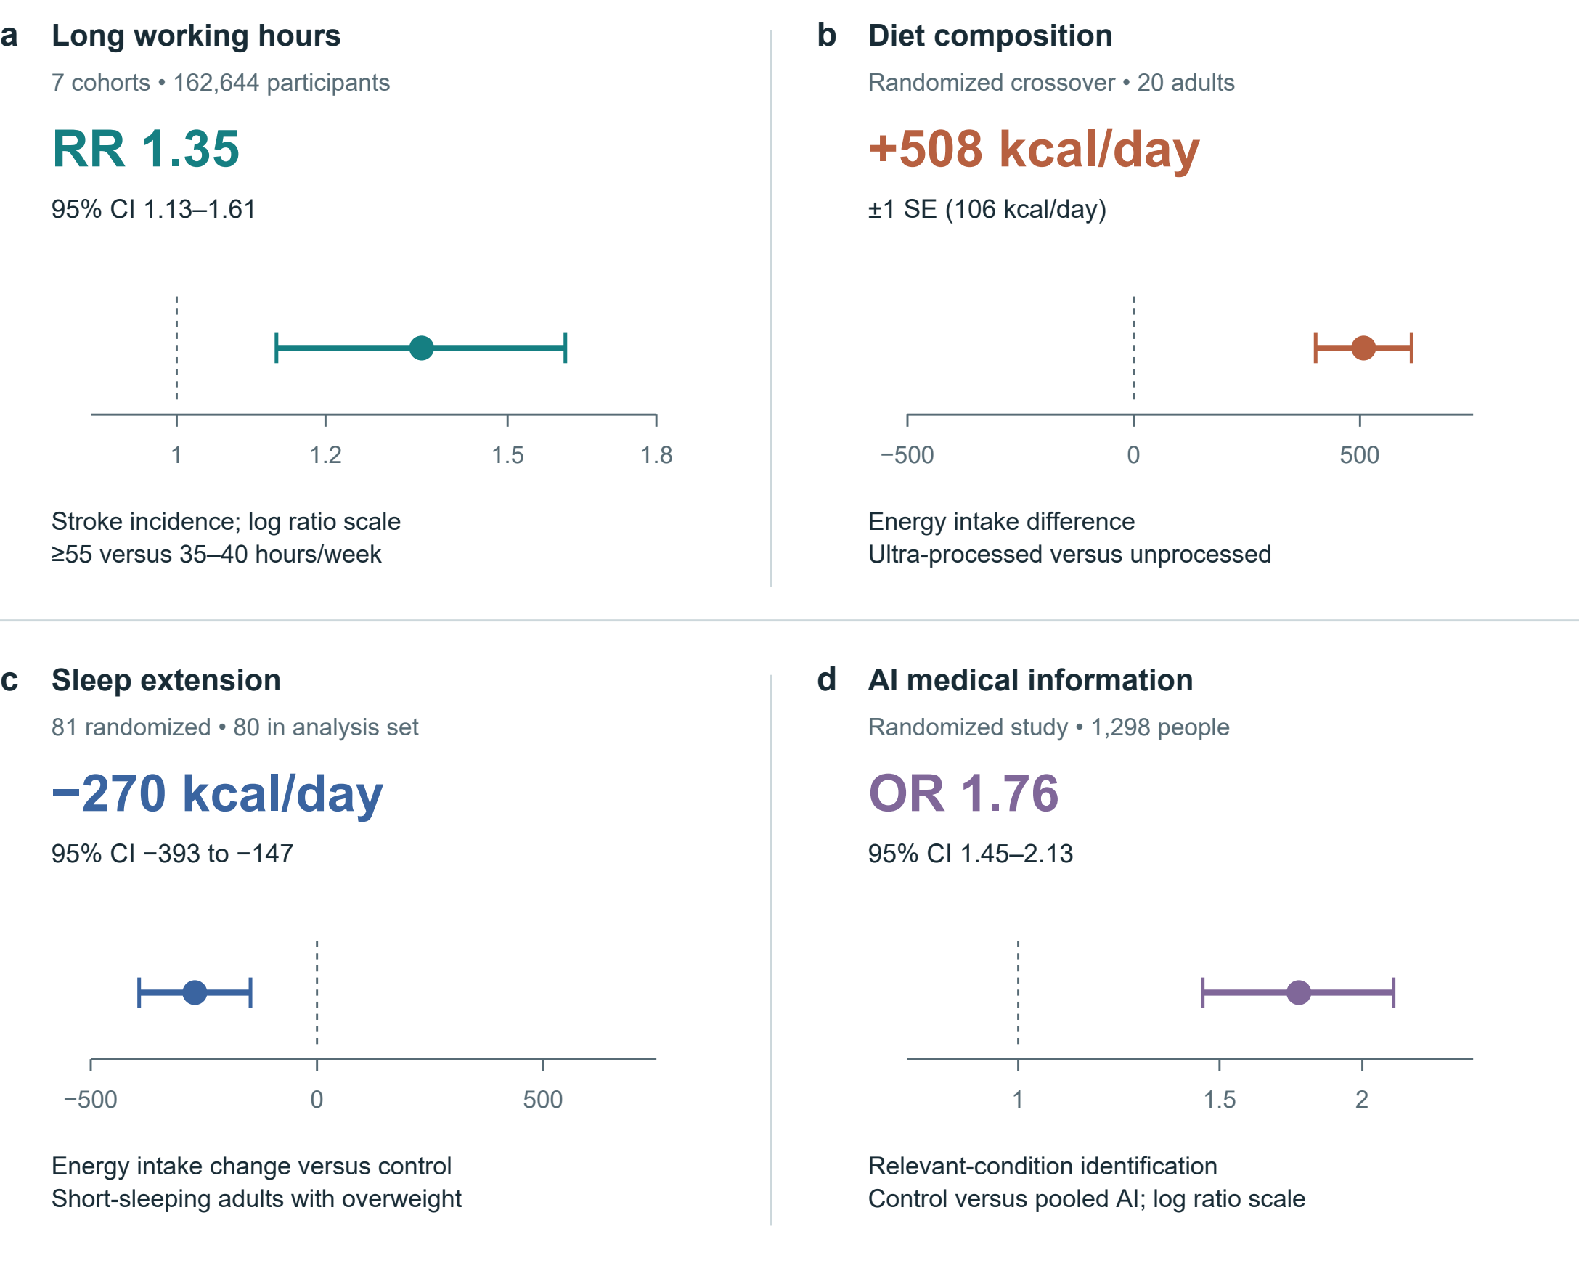
Figure 5 | Selected estimates with their original uncertainty. a, Stroke incidence from seven cohorts, follow-up 1–20 years.[22] b, Energy intake in a 20-person inpatient crossover diet trial.[23] c, Energy intake change versus control in a sleep-extension trial; 81 randomized, 80 in the reported analysis set.[24] d, Relevant-condition identification in hypothetical medical scenarios: control versus pooled AI assistance.[18] Bars denote 95% CIs in a, c and d; ±1 SE in b. Ratio axes are logarithmic. RR and OR are distinct; neither is an absolute probability change. No effects are pooled or converted to a personal health price.

Empirical estimates and their scope
Figure 5 preserves four different estimands. Long working hours were associated with stroke incidence in a cohort meta-analysis; this does not estimate the effect of one overtime week.[22] Hall and colleagues' 20-person inpatient crossover experiment found greater energy intake on the ultra-processed diet, whereas Tasali and colleagues' sleep-extension trial found lower estimated energy intake relative to control.[23, 24] The former interval is one standard error, not a 95% confidence interval. Bean and colleagues' odds ratio concerns identification in medical scenarios, not the probability of illness.[18]
These findings make particular consequences credible enough to investigate. They do not validate the entire framework, establish a universal lifestyle hierarchy or provide coefficients for pricing an individual's health. Transporting an effect requires attention to population, exposure, comparator, outcome and follow-up. The figure therefore keeps study designs, units and uncertainty visible instead of pooling unlike outcomes.

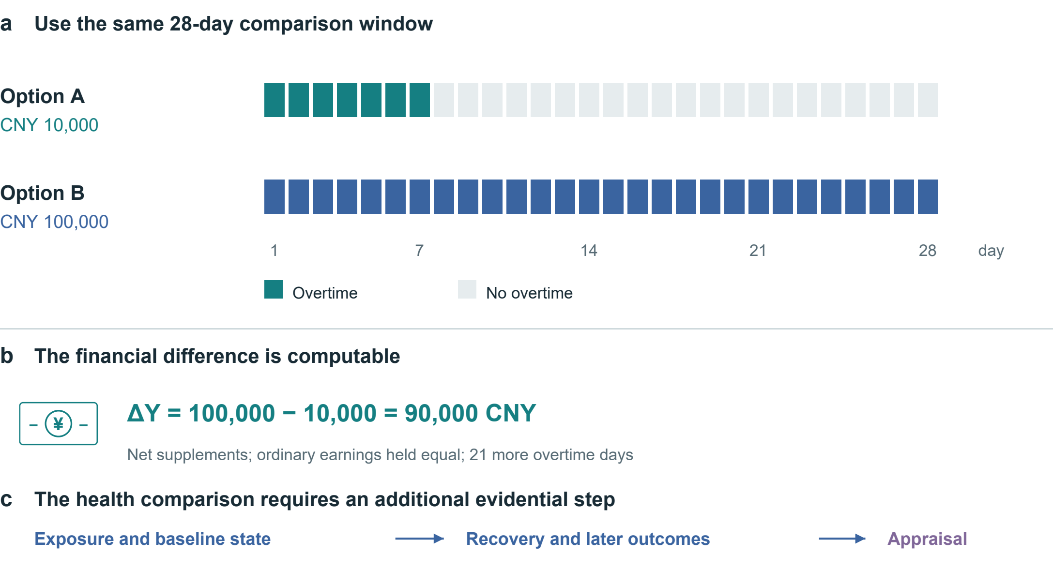
Figure 6 | Align the overtime alternatives. Both options cover 28 days; supplements are assumed net and ordinary earnings equal. Option B adds CNY 90,000 and 21 overtime days. The timeline and arithmetic are hypothetical. Exposure, baseline state, recovery and later outcomes require additional evidence before an overall appraisal.

Trade-offs in practice
Consider a hypothetical 28-day window. Option A offers a net supplement of CNY 10,000 for seven overtime days; option B offers CNY 100,000 for 28. Holding ordinary earnings equal, ΔY = 100,000 − 10,000 = 90,000 CNY (4), alongside 21 additional overtime days. Figure 6 aligns the denominators. It does not assign the remaining days in option A a health value automatically. Their activities, recovery opportunities and effects on family members must be recorded; effects extending beyond day 28 require a longer outcome horizon.
A disciplined appraisal asks about shift duration and timing, baseline symptoms, the ability to stop, essential financial needs and the next-best feasible option. The same schedule may be evaluated differently under different constraints without making its health consequences unreal. The framework cannot determine that CNY 100,000 is sufficient compensation. It can identify what is known, what remains uncertain and which conflicts drive the decision. A legally or contractually specified payment is an allocation of responsibility; it is not evidence that lost functioning has been restored.
Sleep restriction also shows why subjective adaptation and objective function should be distinguished. In Van Dongen and colleagues' laboratory programme, 35 adults were randomized to 4, 6 or 8 hours in bed for 14 nights; a separate total-deprivation experiment involved 13 adults. Performance deficits accumulated in the 4- and 6-hour groups, while reported sleepiness did not track their full progression.[25] These functional findings do not establish permanent neuronal destruction after one late night. Recovery and persistence require their own evidence.
For food choices, the comparator includes price, preparation, access, enjoyment and relevant health outcomes. A controlled feeding effect cannot by itself show that a feasible household substitution has the same effect or cost. For leisure and AI companionship, compare what the activity replaces and whether benefit persists, rather than presume outdoor activity always dominates gaming or virtual contact. The same procedure can recognize enjoyment and support while detecting displaced sleep, unwanted use or burden. It supports deliberation without prescribing a single ideal life.

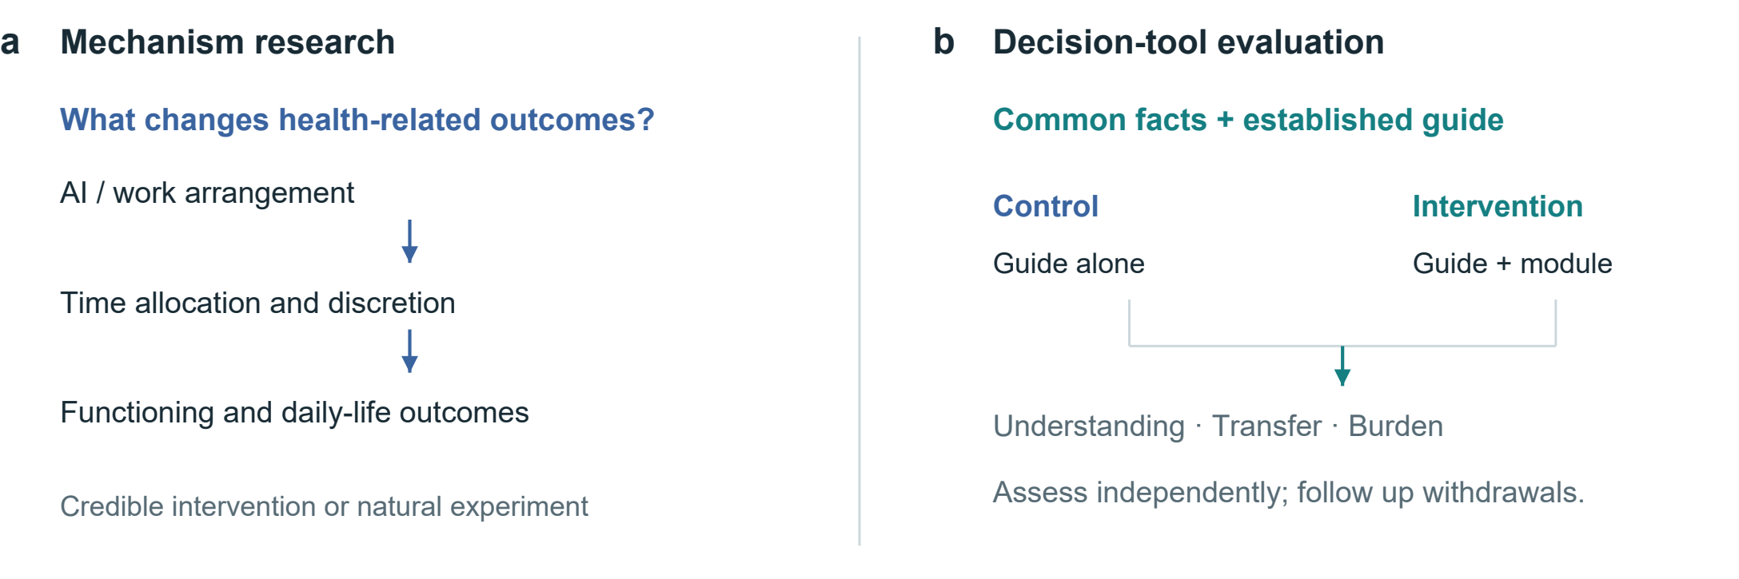
Fig. 7 | Two research questions and their evaluation paths. Mechanism research explains how outcomes arise; tool evaluation tests the added comparison module. An active comparator gives both groups the same facts and established guide. The proposed design is not a completed trial.
Table 3 | Testable propositions and disconfirming observations. Each comparison requires prespecified estimands and outcomes.
Proposition | Key comparison | Potentially disconfirming result
Discretion affects allocation of AI time savings | Similar task gains; credible differences in control over workload | No meaningful allocation difference, with sufficiently precise estimates
Immediate relief and sustained benefit may diverge | Matched comparator; repeated pre-use, post-use and follow-up measures | Stable pre-use improvement comparable to immediate relief
The module improves decision quality | Same guide, with or without the added module | No gain in understanding or transfer, or burden exceeds benefit

Testable propositions and evaluation
Validation involves two questions: which mechanisms change health-related outcomes, and whether the framework improves informed choice. The first provides evidence for its content; the second determines its practical value. Figure 7 separates these research questions, and Table 3 specifies three propositions and observations that could weaken them.
An AI workplace study could combine task logs with whole-day time diaries and repeated outcomes, while measuring authority over workload and schedules. A randomized organizational policy or a credible natural experiment would strengthen causal inference about who captures saved time. A simple association between AI use and well-being would remain vulnerable to job selection, workload, prior health and reverse causation. Mechanism analysis should be prespecified; controlling mechanically for post-treatment time use can obscure the total effect it seeks to explain.
For the decision tool, an active comparator is essential. Both groups should receive the same factual evidence and an established guide; the intervention adds the explicit time, consequence and uncertainty module (Fig. 7). Decision-quality research and the Cochrane review of patient decision aids inform the comparator and outcome selection.[9, 26] The primary outcome should be specified before recruitment, with independent scoring of understanding rather than agreement with the author's preferred lifestyle. Transfer to an unfamiliar decision, values–choice concordance and calibrated uncertainty can be secondary outcomes.
Evaluation must also capture completion time, attrition, anxiety, accessibility and the experience of people who stop using the tool. Repeated use may introduce learning, fatigue or changes in the decision itself. A preregistered protocol should specify the target population, effect of interest, analysis of missingness, multiplicity and sample-size justification. Interviews can explain comprehension or disagreement but cannot replace causal estimates. If the added module offers no meaningful benefit over the guide, or its burden outweighs benefit, it should be simplified or abandoned; a shift toward supposedly healthier choices alone would not demonstrate success.

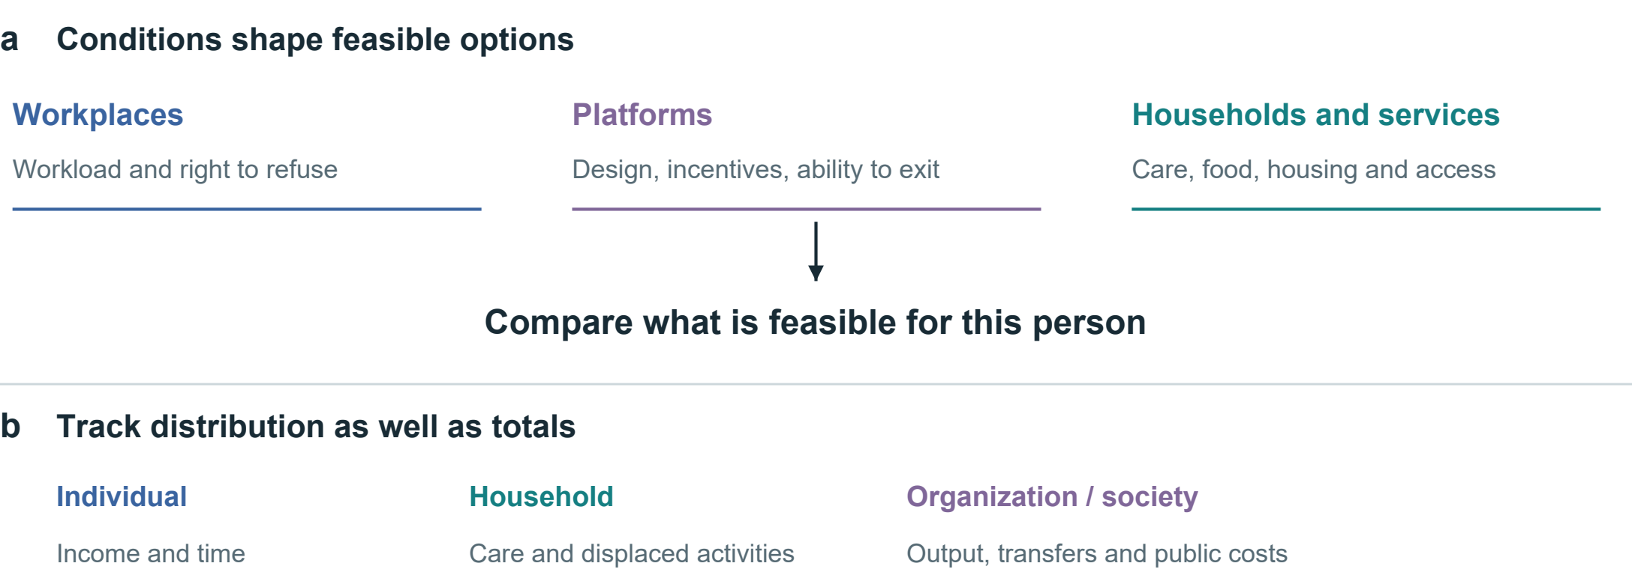
Fig. 8 | Conditions of choice and distribution of consequences. Workplace, platform and household conditions shape feasible options. Income, time and care burdens may accrue to different people. Arrows organize evaluation questions rather than depict estimated causal effects.

Institutions, distribution and research priorities
A consequence profile would be incomplete if it treated constrained behaviour as a failure of individual discipline. Workplace rules, platform design, housing, food access and caring responsibilities shape both available options and the capacity to act on a preference. Figure 8 places these conditions upstream of appraisal. Recording that someone would prefer rest is insufficient if income insecurity or workload rules prevent it. Decision support can reveal such a conflict; it cannot itself redistribute bargaining power or provide the missing option.
The perspective of the account must be stated. A worker's net payment, an employer's productivity, a family's unpaid care and public expenditure are distinct entries. A payment can compensate a recipient while representing a transfer between parties rather than a net social resource gain. Time saved for one person may be shifted to another through monitoring, correction or care. Comparing individual, household and societal accounts can expose these differences without assuming that their interests can be aggregated by a single unexamined weight.
Institutions can also use the framework to ask concrete questions: does a productivity policy return time to workers; does a platform permit meaningful disengagement; and does an intervention remain feasible for people with limited money, mobility or digital access? These are evaluative questions, not established effects of particular policies. The same information should not become a surveillance score used to penalize workers, deny opportunities or blame people for constrained choices. Purpose limitation and proportionate collection are part of making the proposed support usable.
The central claim is modest in form but consequential in practice: a gain is not fully characterized until the health-relevant consequences, their timing and their distribution are visible. AI strengthens the need for this accounting because task performance, independent capability and lived benefit can move differently. A common comparison procedure can make these divergences discussable without imposing a common preference. Its scientific value will depend on whether it improves explanation, prediction or decision quality beyond the methods on which it builds.
This conceptual Perspective integrates economic theory, measurement approaches and selected empirical studies through narrative synthesis. The framework remains to be validated. Its breadth may increase burden, population effects may not transfer to individuals, and preferences may change with circumstances. The next step is context-specific feasibility research followed by comparison with established decision support, assessing whether any gains in understanding and choice persist.

References
1. Grossman, M. On the concept of health capital and the demand for health. Journal of Political Economy 80, 223–255 (1972). https://doi.org/10.1086/259880
2. Becker, G. S. A theory of the allocation of time. The Economic Journal 75, 493–517 (1965). https://doi.org/10.2307/2228949
3. Marx, K. The working-day. Capital, Vol. I, ch. 10. Marxists Internet Archive (n.d.). https://www.marxists.org/archive/marx/works/1867-c1/ch10.htm
4. Ruger, J. P. Health capability: conceptualization and operationalization. American Journal of Public Health 100, 41–49 (2010). https://doi.org/10.2105/AJPH.2008.143651
5. Finkelstein, A., Luttmer, E. F. P. & Notowidigdo, M. J. What good is wealth without health? The effect of health on the marginal utility of consumption. Journal of the European Economic Association 11 (Suppl. 1), 221–258 (2013). https://doi.org/10.1111/j.1542-4774.2012.01101.x
6. World Health Organization. International Classification of Functioning, Disability and Health. WHO (n.d.). https://www.who.int/standards/classifications/international-classification-of-functioning-disability-and-health
7. World Health Organization. The World Health Organization-Five Well-Being Index (WHO-5). WHO, WHO/UCN/MSD/MHE/2024.01 (2024). https://www.who.int/publications/m/item/who-ucn-msd-mhe-2024.01
8. Thokala, P. et al. Multiple criteria decision analysis for health care decision making—an introduction: Report 1 of the ISPOR MCDA Emerging Good Practices Task Force. Value in Health 19, 1–13 (2016). https://doi.org/10.1016/j.jval.2015.12.003
9. Sepucha, K. R. et al. Establishing the effectiveness of patient decision aids: key constructs and measurement instruments. BMC Medical Informatics and Decision Making 13 (Suppl. 2), S12 (2013). https://doi.org/10.1186/1472-6947-13-S2-S12
10. Bernheim, B. D. & Rangel, A. Beyond revealed preference: choice-theoretic foundations for behavioral welfare economics. The Quarterly Journal of Economics 124, 51–104 (2009). https://doi.org/10.1162/qjec.2009.124.1.51
11. Office for Health Improvement and Disparities. Cost consequence analysis: health economic studies. GOV.UK (2020). https://www.gov.uk/guidance/cost-consequence-analysis-health-economic-studies
12. Ottawa Hospital Research Institute. Ottawa Personal Decision Guide. Patient Decision Aids (2025). https://decisionaid.ohri.ca/decguide.html
13. EuroQol Research Foundation. What is the difference between the EQ-5D descriptive system, the EQ VAS and the EQ-5D index values? EuroQol (2023). https://euroqol.org/faq/what-is-the-difference-between-the-eq-5d-5l-descriptive-system-the-eq-vas-and-the-eq-5d-index-values/
14. Ryan, R. M. & Deci, E. L. Self-determination theory and the facilitation of intrinsic motivation, social development, and well-being. American Psychologist 55, 68–78 (2000). https://doi.org/10.1037/0003-066X.55.1.68
15. Noy, S. & Zhang, W. Experimental evidence on the productivity effects of generative artificial intelligence. Science 381, 187–192 (2023). https://doi.org/10.1126/science.adh2586
16. Brynjolfsson, E., Li, D. & Raymond, L. Generative AI at work. The Quarterly Journal of Economics 140, 889–942 (2025). https://doi.org/10.1093/qje/qjae044
17. De Freitas, J., Oğuz-Uğuralp, Z., Uğuralp, A. K. & Puntoni, S. AI companions reduce loneliness. Journal of Consumer Research 52, 1126–1148 (2026). https://doi.org/10.1093/jcr/ucaf040
18. Bean, A. M. et al. Reliability of LLMs as medical assistants for the general public: a randomized preregistered study. Nature Medicine 32, 609–615 (2026). https://doi.org/10.1038/s41591-025-04074-y
19. Bastani, H. et al. Generative AI without guardrails can harm learning: Evidence from high school mathematics. Proceedings of the National Academy of Sciences 122, e2422633122 (2025). https://doi.org/10.1073/pnas.2422633122
20. Allcott, H., Braghieri, L., Eichmeyer, S. & Gentzkow, M. The welfare effects of social media. American Economic Review 110, 629–676 (2020). https://doi.org/10.1257/aer.20190658
21. Ivic, R. K., Ratzan, S. C. & Parker, R. M. Building health-literate artificial intelligence. Nature Human Behaviour, Advance online publication (2026). https://doi.org/10.1038/s41562-026-02595-1
22. Descatha, A. et al. The effect of exposure to long working hours on stroke: A systematic review and meta-analysis from the WHO/ILO Joint Estimates of the Work-related Burden of Disease and Injury. Environment International 142, 105746 (2020). https://doi.org/10.1016/j.envint.2020.105746
23. Hall, K. D. et al. Ultra-processed diets cause excess calorie intake and weight gain: An inpatient randomized controlled trial of ad libitum food intake. Cell Metabolism 30, 67–77.e3 (2019). https://doi.org/10.1016/j.cmet.2019.05.008
24. Tasali, E. et al. Effect of sleep extension on objectively assessed energy intake among adults with overweight in real-life settings: A randomized clinical trial. JAMA Internal Medicine 182, 365–374 (2022). https://doi.org/10.1001/jamainternmed.2021.8098
25. Van Dongen, H. P. A., Maislin, G., Mullington, J. M. & Dinges, D. F. The cumulative cost of additional wakefulness: dose-response effects on neurobehavioral functions and sleep physiology from chronic sleep restriction and total sleep deprivation. Sleep 26, 117–126 (2003). https://doi.org/10.1093/sleep/26.2.117
26. Stacey, D. et al. Decision aids for people facing health treatment or screening decisions. Cochrane Database of Systematic Reviews 1, CD001431 (2024). https://doi.org/10.1002/14651858.CD001431.pub6

