Health economic value and intertemporal choice in the age of artificial intelligence
Richard T. Millian
Hangzhou Normal University
Generative artificial intelligence changes how people produce, obtain information and spend time. Its value for individuals cannot be inferred from task efficiency or immediate satisfaction alone. We develop a conceptual framework for evaluating health-related trade-offs across work and everyday life, drawing on health capital, time allocation, health capability and decision science. The framework compares feasible alternatives over a common horizon, separates resources, health, experience and capabilities, and records uncertainty without imposing a universal monetary conversion. Its distinctive emphasis is the connection between task savings, control over time and subsequent activities, together with the distinction between assisted performance and independent capability. Examples from overtime compensation, food choices and digital companionship illustrate its boundaries. We propose evaluation against established decision support, using understanding, transfer and burden rather than a prescribed lifestyle as success criteria. This is a research agenda for informed choice, not a validated health valuation instrument.
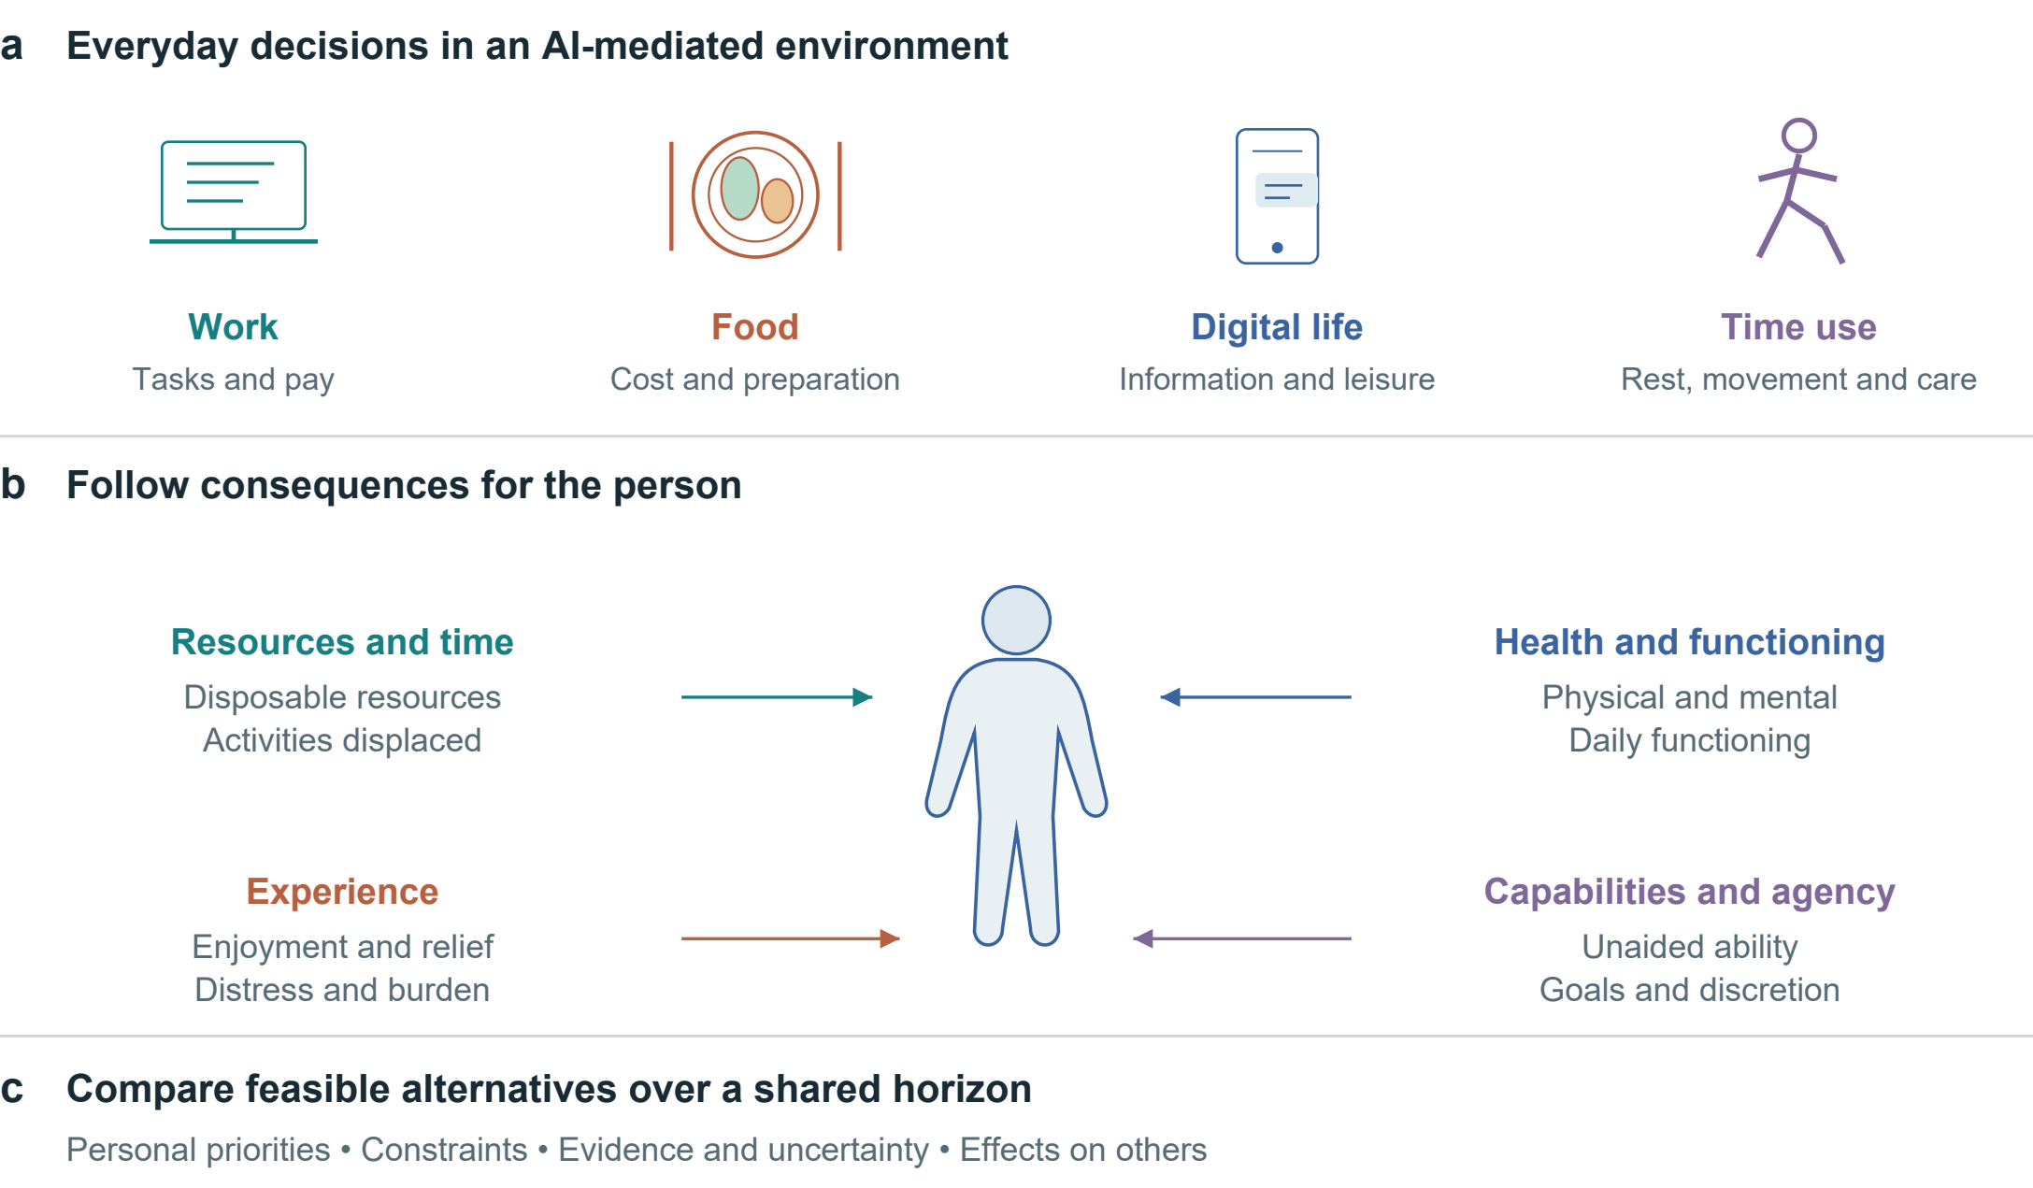
Figure 1 | Health economic value across everyday decisions. Work, food, digital life and time use enter a common comparison. Four consequence domains remain distinct. The figure organizes assessment; links do not represent estimated causal effects.

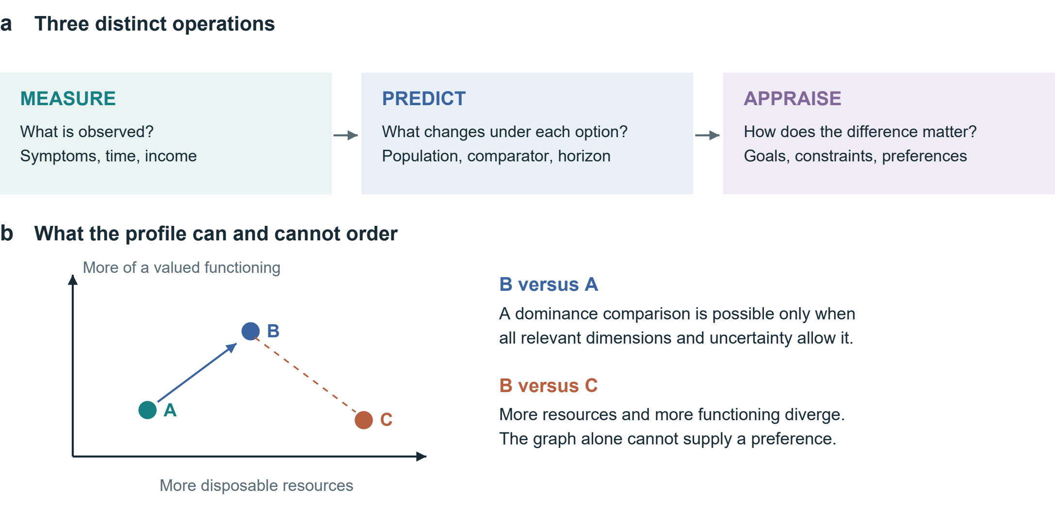
Figure 2 | Measurement, prediction and appraisal. a, Each operation asks a different question. b, A qualitative illustration of dominance and trade-offs. Positions are schematic and carry no numerical units. A two-dimensional picture cannot establish dominance if other relevant consequences or uncertainty overturn the comparison.

From market rewards to personal welfare
Consider a person offered additional pay for working late. The payment is visible, whereas the consequences for sleep, relationships and subsequent functioning require a different assessment. A larger payment can relieve material constraints while the work imposes burdens. Neither its size nor the presence of a health risk determines the person's overall welfare without information about alternatives, preferences and circumstances. AI-assisted work makes this comparison more complex: completing a task faster may change earnings, workload, discretionary time or the kinds of activity that remain. The relevant question is how these changes enter a person's life over time.
Economic theory already provides substantial foundations for this question. Grossman's health capital model treats health as both consumption and investment, while Becker's time allocation framework incorporates time alongside market goods.[1, 2] The present argument therefore does not rest on a supposed absence of health or non-market activity from economics. Marx's discussion of the working day provides a complementary political-economic motivation: the reproduction of labour-power and the physical and social limits of work make control over time and the distribution of burdens central questions.[3] We use that motivation without treating a measured health decrement as a unit of surplus value.
A second foundation concerns what individuals are able to do. Ruger's health capability approach combines health functioning with health agency and explicitly considers personal and contextual conditions; it already proposes a multidimensional profile.[4] Health-state-dependent utility research also examines how health can alter the value derived from consumption.[5] These contributions rule out a claim that multidimensional assessment, or the interaction of money and health, is new. The narrower contribution proposed here is a procedure connecting AI-related changes in tasks and information to feasible options, time allocation and consequences, with an explicit test of whether this procedure improves decisions.
Figure 1 locates the comparison across everyday settings. Figure 2 separates the observation of a state, prediction under alternatives and appraisal of what those consequences mean to the person.

Table 1 | Minimum comparison record. Proposed fields, not a validated scale. Health capability, ICF, WHO-5, MCDA and decision-quality research inform the distinctions.[4, 9, 18, 19, 23]
Domain | Minimum record | Interpretation
Decision | Feasible alternatives; refusal; shared horizon | Nominal options may be unavailable
Resources and time | Incremental money; total work; displaced activities | Task savings do not imply health gains
Health and functioning | Relevant symptoms, function or clinical outcomes | Biomarkers do not rank human worth
Experience | Enjoyment, relief or distress; during and after | Immediate benefit may not persist
Capabilities and agency | Unaided ability; valued goals; actual discretion | Assistance is compatible with autonomy
Evidence and appraisal | Population; comparator; horizon; uncertainty; goals | Unknown is distinct from zero

Valuation without a universal price
We define health economic value as the contribution of health states and their changes to a person's experiences, feasible activities and welfare over a specified horizon, evaluated relative to an alternative. This is an organizing definition, not a newly identified physical quantity. Health, welfare and the worth of a person are distinct. Equal human dignity and respect for informed choice are normative commitments of the framework; neither productivity nor health status measures a person's moral standing.
Measurement, prediction and appraisal must be separated. Measurement describes a state or resource use. Prediction estimates what would occur under an alternative, with uncertainty. Appraisal concerns how those consequences matter to the person. Receiving compensation does not establish biological restoration. Conversely, limited reversibility does not logically prevent risk comparison or preference elicitation. Any monetary valuation would be conditional on information, resources, baseline circumstances and the decision being evaluated. This framework neither requires such a valuation nor prohibits it when its assumptions are justified.
Observed choice alone is also an incomplete basis for deciding which information or options should count in welfare evaluation. Behavioural welfare analysis makes the relation between choice conditions and welfare an explicit theoretical problem.[6] Our proposed response is to record whether an option can actually be refused, what the person understands, and which goals the decision serves. Autonomy should not be equated with self-sufficiency: self-determination theory distinguishes a sense of volition from independence.[7] Assistance from AI, another person or a clinical service can therefore be compatible with autonomy; its effects require assessment rather than classification by the presence of assistance.
The assessment methods are likewise established. Cost-consequence analysis presents different costs and effects separately, including effects outside health.[8] Multicriteria decision analysis can support aggregation, but criterion overlap, preference assumptions and the meaning of weights require attention.[9] The Ottawa Personal Decision Guide already helps people consider options, benefits, harms, values and support for health or social decisions.[10] Our profile is intended as a candidate extension for AI-related time and information problems. Merely adding columns or asking people what matters to them would not demonstrate an advance.
Preference-based health measurement also provides an established route to aggregation. EQ-5D distinguishes a descriptive health profile, a person's own health rating and an index based on population preferences; the latter can support quality-adjusted life-year calculations.[11] These quantities answer different questions. A self-rating should not be substituted for a preference-weighted index, and a predicted QALY change requires defensible health trajectories over time. Our proposal retains such measures where appropriate while recording other consequences separately. It does not claim to replace them or to infer a QALY loss from a single night of lost sleep.

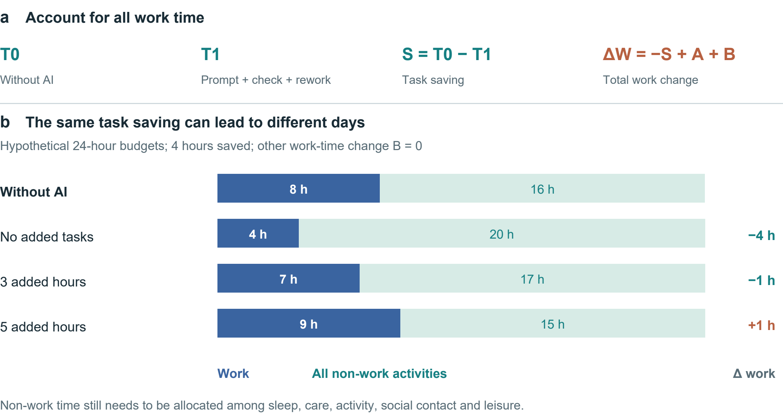
Figure 3 | Task savings and the allocation of a day. a, The accounting identity includes prompting, verification and rework in T1, additional tasks in A and other work-time changes in B. b, Hypothetical 24-hour budgets with an 8-hour baseline workday, a 4-hour task saving and B = 0. Non-work time is not assigned a health effect.

Formal representation of the comparison
For compact notation, let x_{i}(a;τ) denote the consequence profile for person i under feasible option a at time τ. Its components record resources, time allocation, physical and mental functioning, experience and capabilities in their own units. For components with a defensible numerical scale, define the contrast with alternative b:
$Δx_{i}(a,b;τ) = x_{i}(a;τ) − x_{i}(b;τ). (1)$
Equation (1) defines a contrast, not a prediction model. Categorical changes remain descriptive. The record attaches a source, uncertainty description and observation horizon to each component. A trajectory can be retained where timing matters; an endpoint alone need not represent the full experience. Table 1 lists the minimum record.
If all relevant criteria can be oriented so that larger values are preferred, a strictly dominates b in the Pareto sense if and only if the resulting vector z satisfies:
$Δz_{j} ≥ 0 for all j; Δz_{k} > 0 for some k. (2)$
This ordering is conditional on the completeness of the criteria, defensible preference directions and uncertainty that does not overturn the inequalities. It does not assign a universal favourable direction to blood-test values. When dimensions conflict, or the assumptions fail, a trade-off or unresolved ordering remains. No weights, price or estimated health coefficient are supplied by these definitions.

Why AI changes the comparison
Three distinctions organize the proposed AI application. First, task efficiency differs from control over the resulting time. Noy and Zhang's randomized study of professional writing found improved task productivity with ChatGPT.[12] Such evidence establishes a task-level benefit in a defined setting; it does not establish the destination of any saved time or a subsequent health gain. Verification, corrections, learning to use the tool and additional assignments must enter the accounting. The same technical gain could be followed by more rest, more production or a different activity mix, depending on constraints and preferences.
For matched tasks with comparable quality, let T0 denote time without AI and T1 all time with AI, including prompting, checking and rework. Let S = T0 − T1, A denote time for additional tasks, and B other changes in work time within the same calendar window. Then:
$ΔW = −S + A + B. (3)$

Table 2 | AI outcomes at different levels. Selected studies; no pooled effect or participant-level reanalysis. OR is an odds ratio, not a probability increase.
AI setting | Finding in the cited study | Limit of inference
Professional writing  453 participants [12] | Shorter task time and improved output quality | No full-day time-use or health estimate
Companionship  Seven-day Study 3 [14] | Immediate loneliness relief; no demonstrated persistent pre-interaction improvement | Differential attrition; non-time-matched control
Medical information  1,298 people [15] | Control versus pooled AI: relevant-condition identification OR 1.76 (95% CI 1.45–2.13) | Up to two scenarios per person; no clinical morbidity outcome

Equation (3) is an accounting identity, not an estimated behavioural relationship. Under the additional assumption of a fixed total time budget, non-work time changes by −ΔW; its composition remains undetermined. In a hypothetical example, saving 240 minutes while adding 300 minutes of work, with B = 0, increases total work by 60 minutes. Figure 3b displays three hypothetical allocations. This example contains no health coefficient. Establishing a health pathway requires observing what activities change and the relevant outcomes, rather than converting minutes saved directly into health gains.
Second, assisted performance and independent capability may diverge. A classroom experiment comparing different generative AI tutoring arrangements showed that the design of assistance matters for later unaided mathematics performance.[13] The outcome concerns learning in a particular educational setting, not general cognitive deterioration. The implication for assessment is to distinguish successful performance with assistance, retained ability without it, and the person's reasons for delegating a task. Delegation can be valuable even when independent mastery is not the objective.
Third, immediate experience and lasting functioning answer different questions. In the longitudinal component of research on AI companions, interaction relieved loneliness immediately, but the reported pattern did not establish persistent improvement before subsequent interactions.[14] In medical information tasks, evaluating the user matters as much as evaluating the model: a randomized study found that ordinary information sources outperformed pooled AI-assisted users in identifying relevant conditions in hypothetical scenarios.[15] Neither finding supports a general conclusion that AI is beneficial or harmful. Table 2 compares the levels at which these AI outcomes are assessed. Earlier research on Facebook deactivation likewise illustrates that different welfare-relevant outcomes can move in different directions, although that study is not evidence about generative AI.[16]
These distinctions motivate a common comparison procedure across work, information use and leisure. They do not imply that all digital activities share an exposure or mechanism. Recommendation feeds, conversational companions, clinical prediction tools and writing assistants should be recorded separately, with their versions, uses and alternatives.
Recent work on health-literate AI already emphasizes comprehension, agency, accountability and proportionality.[17] This closely related argument reinforces the need to define a narrower contribution. The proposed profile focuses on the economic comparison of feasible activities over time and on whether an additional comparison module improves decisions. Supporting understanding or invoking agency alone would not distinguish it from existing work.

A comparative health consequence profile
The proposed profile begins with a feasible decision, not a health score. For an individual i, an option a is compared with an available alternative b over horizon T. The record contains changes in disposable resources, the allocation of time, physical and mental functioning, experience, and relevant capabilities, together with constraints and the provenance of each prediction. Figure 1 summarizes these stages. Table 1 specifies a minimum record rather than an item bank that every study must administer.
The first step is to make the counterfactual complete. A week of overtime followed by three weeks of ordinary activity cannot be compared with four weeks of overtime while ignoring the remaining weeks in the first option. Costs should be incremental and attributable to the option: total income is different from an overtime supplement, and a medical expenditure is different from a health loss. The profile should also identify effects on other people. An individual account and a household or societal account may require different perspectives; they should not be silently merged.

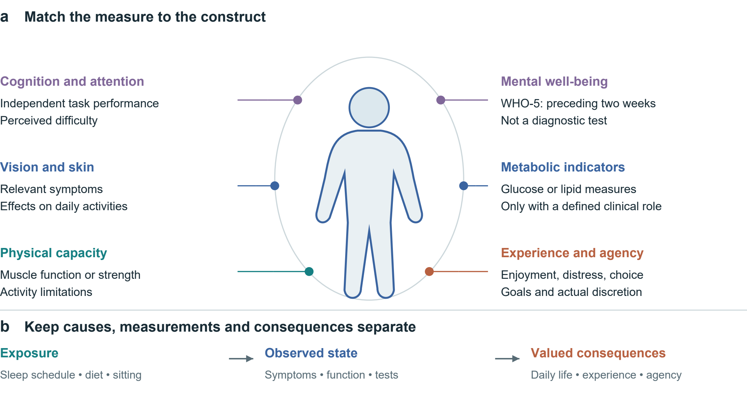
Figure 4 | A map of candidate measurement domains. a, The silhouette organizes examples; it does not localize psychological constructs or diagnose organs. Measures are selected for the decision and population, not administered as a universal panel. WHO-5 concerns two-week mental well-being.[19] b, Exposure, observed state and valued consequences occupy different roles; summing them can double-count a pathway. ICF informs the distinction between functioning and context.[18]

The second step is to distinguish outcomes from their determinants. Sleep schedules, diet and sedentary time can be exposures or intermediate variables; symptoms, functioning and clinical outcomes belong to other parts of the causal account. Counting each stage as an independent welfare loss can duplicate the same consequence. WHO's ICF framework provides a useful distinction between functioning and its environmental context.[18] For this application, skin symptoms, vision, muscle function or metabolic measures should be included when they have a defined role in the decision, not because a larger testing panel appears more comprehensive. There is no universally favourable direction for every laboratory value. Figure 4 maps examples of distinct constructs, including symptoms, metabolic indicators and independent task performance; these are candidate domains, not a recommended universal screening panel.
The third step is to match measures to their constructs and time scales. For example, WHO-5 measures mental well-being over the preceding two weeks; it is not a measure of total health value or a diagnostic conclusion.[19] Independent task performance, perceived autonomy and immediate enjoyment require their own interpretation. A person can value an activity's pleasure without claiming that it improves long-term health. Equally, a short-term functional change should not be described as permanent damage without evidence of persistence and mechanism.
The fourth step is to make uncertainty visible. Each predicted consequence should specify its source population, comparison, outcome, horizon and uncertainty, and distinguish an observed finding from an extrapolation. Unknown is an admissible entry, distinct from zero. Where probabilities cannot be defended, transparent scenarios are preferable to invented precision. Recovery should be described by the outcome actually observed and the time needed to observe it; irreversibility is an empirical property to investigate, not a default label for every burden.
Finally, appraisal belongs to the person within the stated normative and institutional boundaries. Dominance may resolve a comparison only when relevant dimensions are sufficiently complete, directions of preference are defensible and uncertainty does not overturn the ordering. Otherwise, the profile supports an explained trade-off or an explicitly unresolved choice. It does not force complete rankings. If aggregation is requested, the value functions, ranges and preference assumptions must be elicited and tested; weights cannot be justified merely because they sum to one.[9] Population policy decisions additionally require a stated distributional perspective rather than extrapolation from one person's willingness to accept a risk.

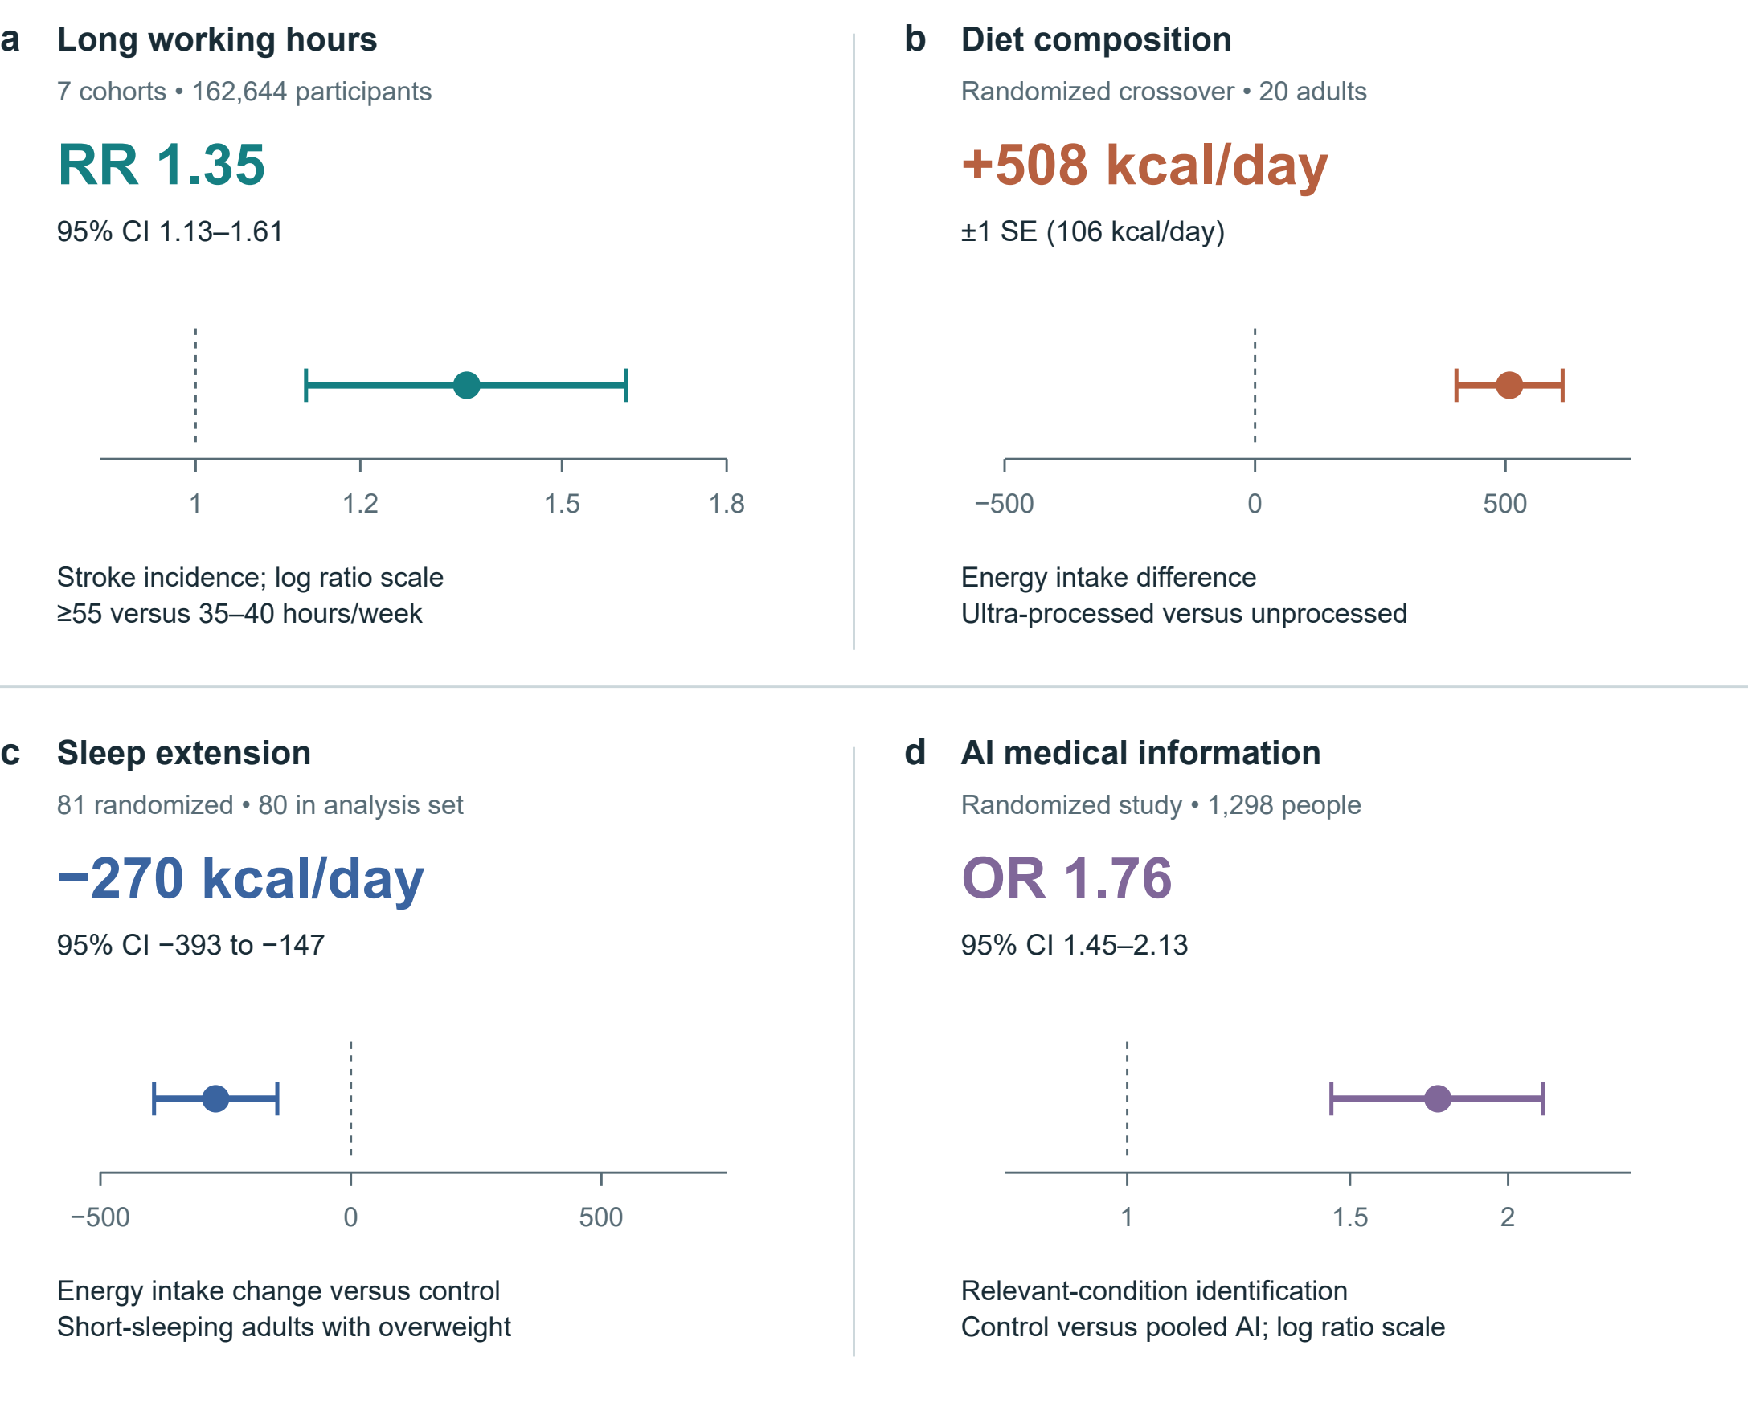
Figure 5 | Selected estimates with their original uncertainty. a, Stroke incidence from seven cohorts, follow-up 1–20 years.[20] b, Energy intake in a 20-person inpatient crossover diet trial.[21] c, Energy intake change versus control in a sleep-extension trial; 81 randomized, 80 in the reported analysis set.[22] d, Relevant-condition identification in hypothetical medical scenarios: control versus pooled AI assistance.[15] Bars denote 95% CIs in a, c and d; ±1 SE in b. Ratio axes are logarithmic. RR and OR are distinct; neither is an absolute probability change. No effects are pooled or converted to a personal health price.

Applications and limits of inference
The overtime example shows why a decision can be important without having an immediately computable answer. A WHO/ILO systematic review reported a relative risk of stroke incidence of 1.35 (95% confidence interval 1.13–1.61) for working at least 55 rather than 35–40 hours per week in the selected cohort synthesis.[20] The evidence warrants attention to long working hours, but the estimate does not quantify an individual's risk from a particular month of late nights. Applying it to that problem would require a defensible exposure model, baseline risk and appropriate time horizon. Income can be compared under stated assumptions; overall welfare remains conditional on health consequences, alternatives and the person's goals.

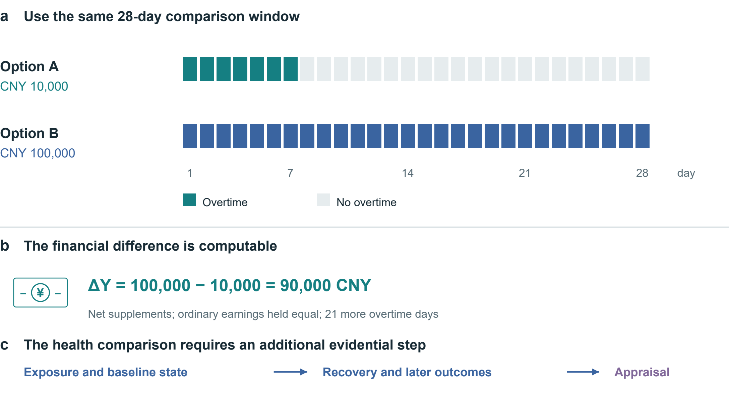
Figure 6 | Align the overtime alternatives. Both options cover 28 days; supplements are assumed net and ordinary earnings equal. Option B adds CNY 90,000 and 21 overtime days. The timeline and arithmetic are hypothetical. Exposure, baseline state, recovery and later outcomes require additional evidence before an overall appraisal.

Suppose, purely illustratively, that an extra CNY 10,000 is offered for seven days of overtime and CNY 100,000 for 28 days. Assume that these are net supplements, ordinary earnings are otherwise equal, and the first option is followed by 21 days without overtime. Over the shared 28-day window, the second option adds CNY 90,000 and 21 overtime days. Figure 6 aligns the comparison window. Under these assumptions, the financial contrast is ΔY = 100,000 − 10,000 = 90,000 CNY (4). The financial increment is calculable under those assumptions; neither its health cost nor its welfare advantage is supplied by the arithmetic. The comparison should record daily exposure, recovery opportunities and later consequences, extending follow-up beyond the payment period when necessary. No amount is labelled adequate compensation without those additional judgements.
Food choices expose a different limitation. A controlled crossover trial found higher energy intake during an ultra-processed diet than an unprocessed diet, while a sleep-extension trial found reduced energy intake relative to control in adults with overweight and habitual short sleep.[21, 22] These studies support attention to interactions among everyday activities. They do not supply household food budgets, preparation costs or a universal ranking of people who choose differently. Free meal provision, available time and actual purchasing conditions affect the relevance of feeding-study results to daily decisions. Figure 5 shows selected estimates with their reported uncertainty.
Digital companionship provides a third application. Immediate relief may matter even if it does not persist after an interaction.[14] The relevant alternative could be another form of entertainment, human contact, unwanted isolation or sleep; assuming that everyone is replacing a beneficial outdoor activity prejudges the comparison. A useful record would distinguish what the person gains during the activity, what happens afterwards, and which activities are displaced. Increasing or decreasing screen time is not by itself an adequate success criterion.
Together, these examples show why health-related choices can be economically meaningful without a common currency. They also delimit the proposed contribution: a profile organizes the comparison; it does not generate missing medical knowledge or establish that people have overlooked consequences. That latter claim requires direct evidence of omission or misunderstanding in the target population.

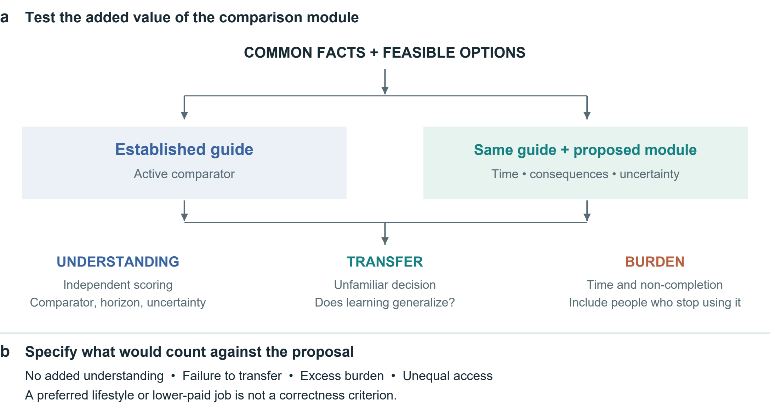
Figure 7 | An active-control evaluation of the proposed module. Both groups receive common facts and an established guide. The added package would be evaluated through understanding, transfer and burden, with follow-up of people who discontinue use. These are proposed procedures and outcomes, not trial results.

Testing whether the framework improves decisions
The framework needs two distinct tests. A mechanism study would investigate how access to a specified AI system changes task time, total work, control over time, activity allocation and subsequent outcomes. Randomizing access could identify an assignment effect in that environment; it would not automatically randomize actual use, organizational practice or each mediator. A credible analysis must distinguish the total effect of assignment from additional assumptions required for mediation. Recording task quality and activities outside the software prevents platform telemetry from being mistaken for a complete account of life.
A decision-support study addresses a different question: whether the proposed comparison procedure adds value. We propose an active-control comparison between an established guide with a common factual information pack and the same guide and facts supplemented by a separate module on time allocation, intertemporal consequences and uncertainty. The original Ottawa guide would remain intact.[10] Figure 7 summarizes the comparison. This design tests the added package, including its burden. It cannot attribute an effect to each component; a component study would require a separate design.
Decision quality should be distinguished from the process of deciding and from what happens afterwards.[23] The proposed primary outcome is independently scored understanding of the common information, including the comparator, horizon and limits of inference. An unfamiliar transfer task would assess whether any benefit extends beyond the presented layout. Confidence calibration, time required, non-completion and follow-up participation are important additional outcomes. A change towards a lower-paying job, less AI use or a preferred diet would not be scored as intrinsically correct. People may rationally revise their priorities after receiving information.
Evidence from treatment and screening decision aids supports the feasibility of improving knowledge, but it does not determine the incremental effect of this module over an active comparator.[24] Sample size should therefore follow a justified target difference and a pilot assessment of outcome variability and retention, rather than importing a favourable pooled effect. Outcome collection should invite all randomized participants, including those who stop using the tool. Missing data, multiple outcomes, subgroup analyses and departures from the analysis plan should be addressed prospectively. Initial fixed materials can keep information constant; introducing a generative interface would create an additional intervention requiring separate evaluation.

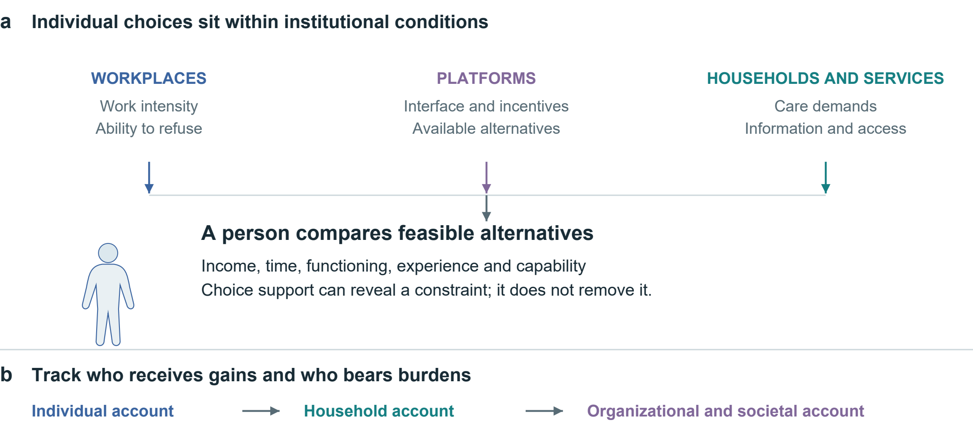
Figure 8 | Conditions of choice and the distribution of consequences. Workplace, platform, household and service conditions enter the available choice set. Individual, household and societal accounts can answer different questions. The diagram organizes institutional questions; arrows do not establish causal estimates or a hierarchy of whose interests count.

The framework should be revised if it adds burden without improving understanding, fails to transfer, obscures important trade-offs or systematically excludes people with fewer resources. A positive understanding result would support a decision aid, not establish a new theory of all health value. Conversely, a null tool effect would not show that health consequences are irrelevant to welfare. These distinctions make the programme capable of yielding informative negative findings.

Structural implications and boundaries
Individual decision support has a limited remit. Figure 8 places the person within institutional conditions and separates the accounts of different actors. Recording that someone cannot refuse overtime identifies a constraint; it does not remove it. Studying how employers, platforms, households and workers share gains and burdens requires evidence about those actors and the available institutional alternatives. The Marxian motivation is retained as a question about control and distribution, rather than treated as an empirical conclusion produced by the profile. Making health consequences more visible must not become a way of transferring responsibility for structural conditions to individuals.
This Perspective is based on purposive reading across economic theory, decision support and selected health and AI studies. It is not a systematic review, and the examples do not estimate a common effect. Their populations, interventions and horizons differ. The proposed measures have not been validated together, preferences may change, and longer-term predictions can be weak even when short-term causal evidence is strong. Restricting the record to what can be measured may itself omit valued aspects of life; expanding it indefinitely can make it unusable. Both problems need participatory development and empirical assessment.
Health economic evaluation in the AI era should make the relation between technical gains and lived consequences explicit. The proposed framework standardizes the questions, comparisons and evidence requirements while leaving room for different defensible choices. Its contribution will depend on whether it improves understanding and makes constraints visible at an acceptable burden. Productivity, enjoyment and health can each matter; the scientific task is to establish how they change under feasible alternatives, and the evaluative task is to explain how those changes bear on the lives people seek to lead.

Data and code availability. No new participant-level data were collected or analysed. Numerical findings are attributed to the original studies. Hypothetical examples, figure data and the scripts used to prepare the illustrations accompany this article.
Funding. This work was supported by Altman in a personal capacity. The sponsor had no role in research design, manuscript preparation or the decision to seek publication.
Competing interests. The author declares no competing interests.
AI assistance. OpenAI Codex assisted public-source retrieval, evidence organization, drafting, language revision and document preparation. Scientific Agent Skills workflows informed this process.[25] No AI system is listed as an author.
Contact. Administrative contact: Mason Matthew, assistant; e1237966@outlook.com.

References
1. Grossman, M. On the concept of health capital and the demand for health. Journal of Political Economy 80, 223–255 (1972). https://doi.org/10.1086/259880
2. Becker, G. S. A theory of the allocation of time. The Economic Journal 75, 493–517 (1965). https://doi.org/10.2307/2228949
3. Marx, K. The working-day. Capital, Vol. I, ch. 10. Marxists Internet Archive (n.d.). https://www.marxists.org/archive/marx/works/1867-c1/ch10.htm
4. Ruger, J. P. Health capability: conceptualization and operationalization. American Journal of Public Health 100, 41–49 (2010). https://doi.org/10.2105/AJPH.2008.143651
5. Finkelstein, A., Luttmer, E. F. P. & Notowidigdo, M. J. What good is wealth without health? The effect of health on the marginal utility of consumption. Journal of the European Economic Association 11 (Suppl. 1), 221–258 (2013). https://doi.org/10.1111/j.1542-4774.2012.01101.x
6. Bernheim, B. D. & Rangel, A. Beyond revealed preference: choice-theoretic foundations for behavioral welfare economics. The Quarterly Journal of Economics 124, 51–104 (2009). https://doi.org/10.1162/qjec.2009.124.1.51
7. Ryan, R. M. & Deci, E. L. Self-determination theory and the facilitation of intrinsic motivation, social development, and well-being. American Psychologist 55, 68–78 (2000). https://doi.org/10.1037/0003-066X.55.1.68
8. Office for Health Improvement and Disparities. Cost consequence analysis: health economic studies. GOV.UK (2020). https://www.gov.uk/guidance/cost-consequence-analysis-health-economic-studies
9. Thokala, P. et al. Multiple criteria decision analysis for health care decision making—an introduction: Report 1 of the ISPOR MCDA Emerging Good Practices Task Force. Value in Health 19, 1–13 (2016). https://doi.org/10.1016/j.jval.2015.12.003
10. Ottawa Hospital Research Institute. Ottawa Personal Decision Guide. Patient Decision Aids (2025). https://decisionaid.ohri.ca/decguide.html
11. EuroQol Research Foundation. What is the difference between the EQ-5D descriptive system, the EQ VAS and the EQ-5D index values? EuroQol (2023). https://euroqol.org/faq/what-is-the-difference-between-the-eq-5d-5l-descriptive-system-the-eq-vas-and-the-eq-5d-index-values/
12. Noy, S. & Zhang, W. Experimental evidence on the productivity effects of generative artificial intelligence. Science 381, 187–192 (2023). https://doi.org/10.1126/science.adh2586
13. Bastani, H. et al. Generative AI without guardrails can harm learning: Evidence from high school mathematics. Proceedings of the National Academy of Sciences 122, e2422633122 (2025). https://doi.org/10.1073/pnas.2422633122
14. De Freitas, J., Oğuz-Uğuralp, Z., Uğuralp, A. K. & Puntoni, S. AI companions reduce loneliness. Journal of Consumer Research 52, 1126–1148 (2026). https://doi.org/10.1093/jcr/ucaf040
15. Bean, A. M. et al. Reliability of LLMs as medical assistants for the general public: a randomized preregistered study. Nature Medicine 32, 609–615 (2026). https://doi.org/10.1038/s41591-025-04074-y
16. Allcott, H., Braghieri, L., Eichmeyer, S. & Gentzkow, M. The welfare effects of social media. American Economic Review 110, 629–676 (2020). https://doi.org/10.1257/aer.20190658
17. Ivic, R. K., Ratzan, S. C. & Parker, R. M. Building health-literate artificial intelligence. Nature Human Behaviour, Advance online publication (2026). https://doi.org/10.1038/s41562-026-02595-1
18. World Health Organization. International Classification of Functioning, Disability and Health. WHO (n.d.). https://www.who.int/standards/classifications/international-classification-of-functioning-disability-and-health
19. World Health Organization. The World Health Organization-Five Well-Being Index (WHO-5). WHO, WHO/UCN/MSD/MHE/2024.01 (2024). https://www.who.int/publications/m/item/who-ucn-msd-mhe-2024.01
20. Descatha, A. et al. The effect of exposure to long working hours on stroke: A systematic review and meta-analysis from the WHO/ILO Joint Estimates of the Work-related Burden of Disease and Injury. Environment International 142, 105746 (2020). https://doi.org/10.1016/j.envint.2020.105746
21. Hall, K. D. et al. Ultra-processed diets cause excess calorie intake and weight gain: An inpatient randomized controlled trial of ad libitum food intake. Cell Metabolism 30, 67–77.e3 (2019). https://doi.org/10.1016/j.cmet.2019.05.008
22. Tasali, E. et al. Effect of sleep extension on objectively assessed energy intake among adults with overweight in real-life settings: A randomized clinical trial. JAMA Internal Medicine 182, 365–374 (2022). https://doi.org/10.1001/jamainternmed.2021.8098
23. Sepucha, K. R. et al. Establishing the effectiveness of patient decision aids: key constructs and measurement instruments. BMC Medical Informatics and Decision Making 13 (Suppl. 2), S12 (2013). https://doi.org/10.1186/1472-6947-13-S2-S12
24. Stacey, D. et al. Decision aids for people facing health treatment or screening decisions. Cochrane Database of Systematic Reviews 1, CD001431 (2024). https://doi.org/10.1002/14651858.CD001431.pub6
25. Kassis, T., Agarwal, V., He, Y., Patel, D. & Brueckner, A. M. Scientific Agent Skills: A Library of Procedural Knowledge for Research Agents. arXiv, 2609.00065 (2026). https://doi.org/10.48550/arXiv.2609.00065

Source notes
Hall et al. has a meal-level correction (doi:10.1016/j.cmet.2019.05.020), retaining the quoted total-intake result. Bean et al. has an axis-label correction (doi:10.1038/s41591-026-04404-8), without changing the quoted OR. Tasali et al.’s analysis set includes one post-randomization exclusion and outcome-specific missingness. The published Noy–Zhang sample is used.

