**Practical 1: Demonstration of preprocessing on any sample Dataset with WEKA.**

**Step 1: - First create data table and save with .csv extension**

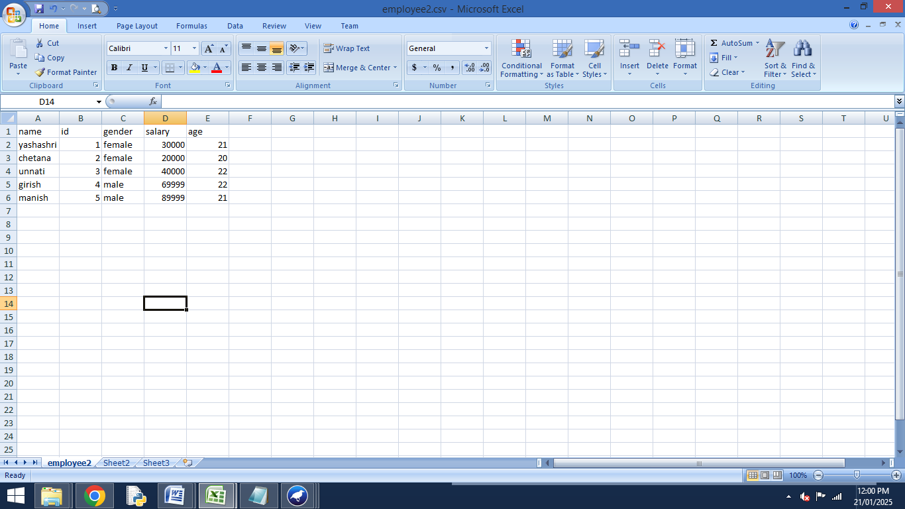

**Step 2:- Create .arff file in notepad**

@relation emp

@attribute name{yashashri,chetana,unnati,girish,manish}

@attribute id numeric

@attribute gender{male,female}

@attribute salary numeric

@attribute age numeric

@data

yashashri,1,female,30000,21

chetana,2,female,20000,20

unnati,3,female,40000 ,22

girish,4,male,69999,22

manish,5,male,89999,21

**Step 3:- Open Weka 3.6 software ->> click Explorer**



**Step 4:- Then choose option ->> Open File ->> Select .arff data file.**

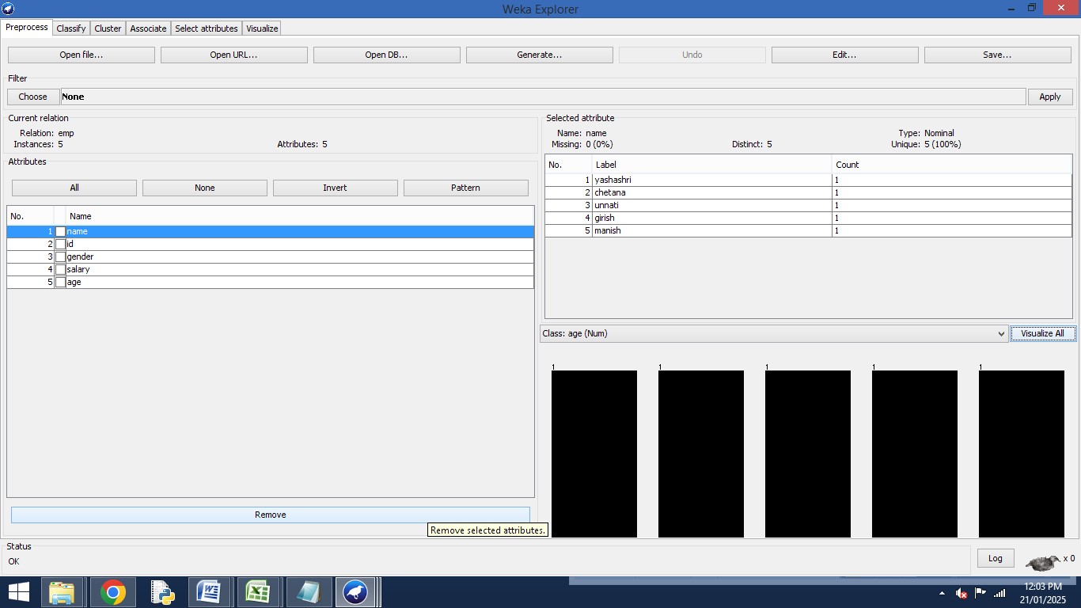

**Step 5:- Then choose ->> Visualize All**

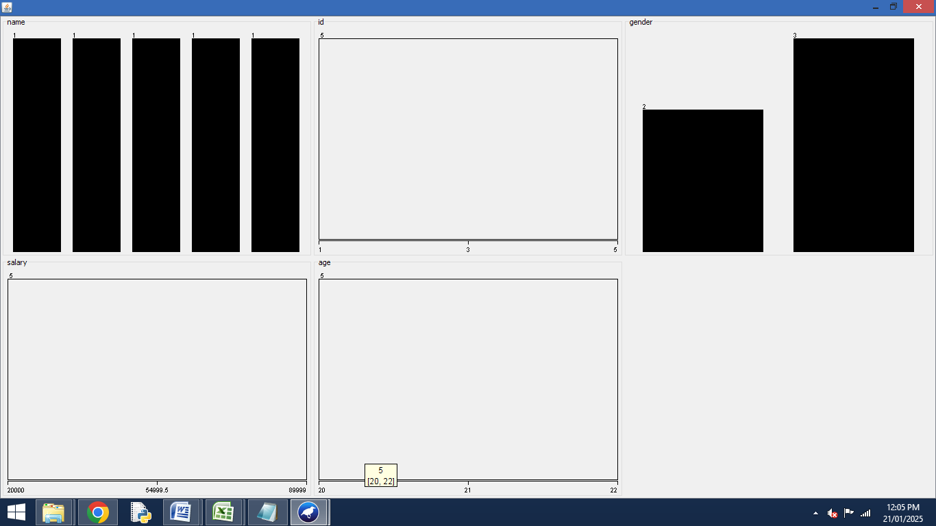

**Practical 2. Demonstration of association rule process on dataset test.arff using apriori algorithm**

@relation computer

@attribute T_id{100,200,300,400}

@attribute Num1{0,1}

@attribute Num2{0,1}

@attribute Num3{0,1}

@attribute Num4{0,1}

@attribute Num5{0,1}

@data

100,1,1,1,0,0

200,1,1,0,1,1

300,1,0,1,1,0

400,1,0,1,0,0

**OUTPUT**

**Step 1: Start Weka Software and then click on the Explore Button**



**Step 2:-Click on the Open Files and Upload Sample File From Weka folder**

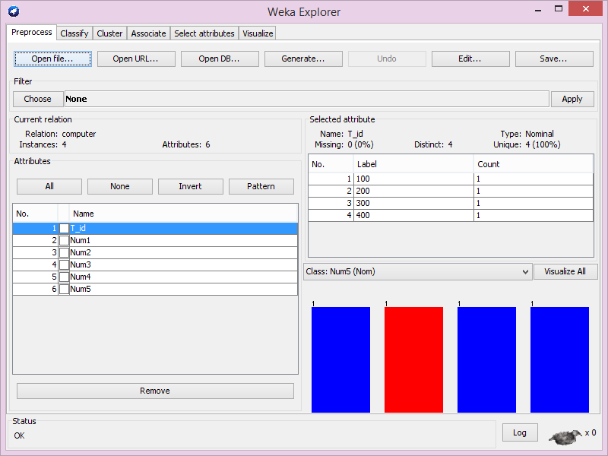

**Step 3:- Visualize All**

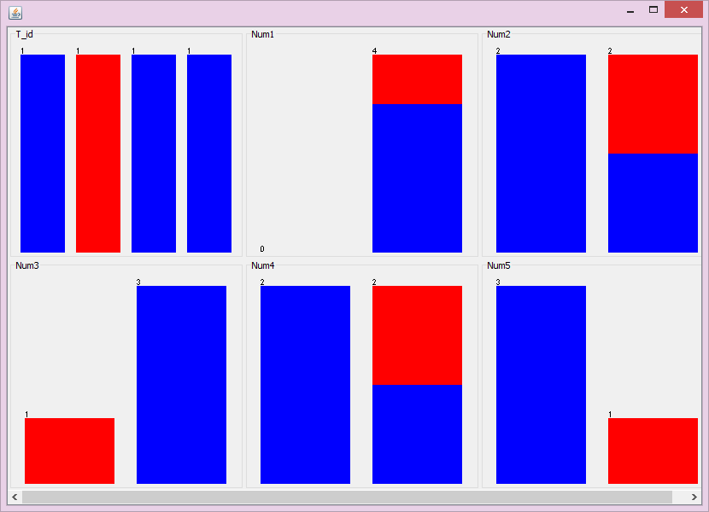

**Step 3:- click on associate and choose the apriori and click on start button**

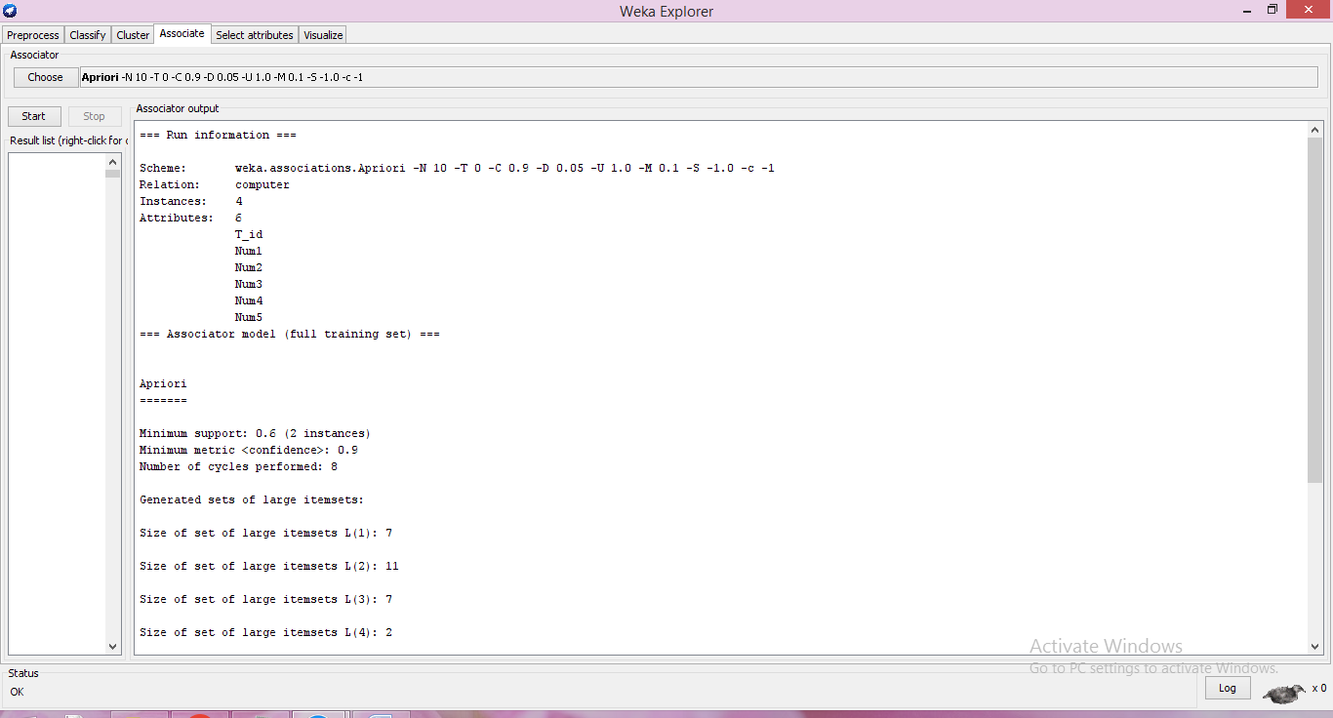

**Practical 3:- Demonstration of association rule process on dataset employee .arff using j 48 algorithm.**

@relation employee

@attribute age{25,27,28,29,30,35,48}

@attribute salary{10k,15k,17k,20k,25k,30k,35k,32k}

@attribute performance{good,avg,poor}

@data

%

25,10k,poor

27,15k,poor

27,17k,poor

28,17k,poor

29,20k,avg

30,25k,avg

29,25k,avg

30,20k,avg

35,32k,good

48,35k,good

48,32k,good

**Step1: Start Weka 3.6%**

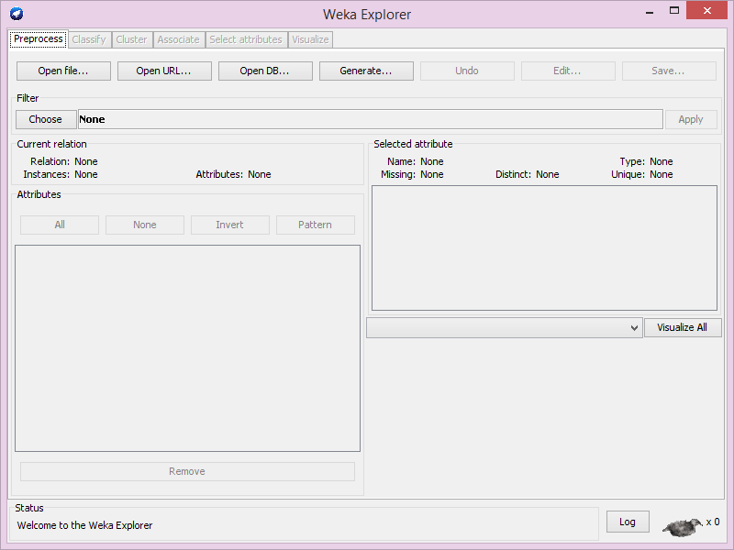

**Step 2:-Click on Open file and select empj48.arff file.**

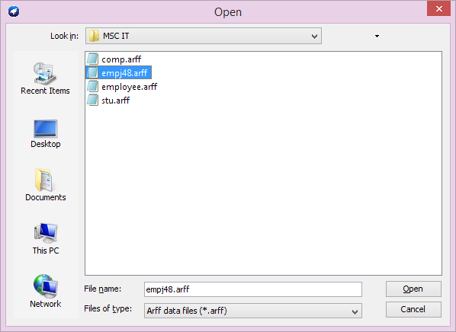

**Step 3:-After Opening File**

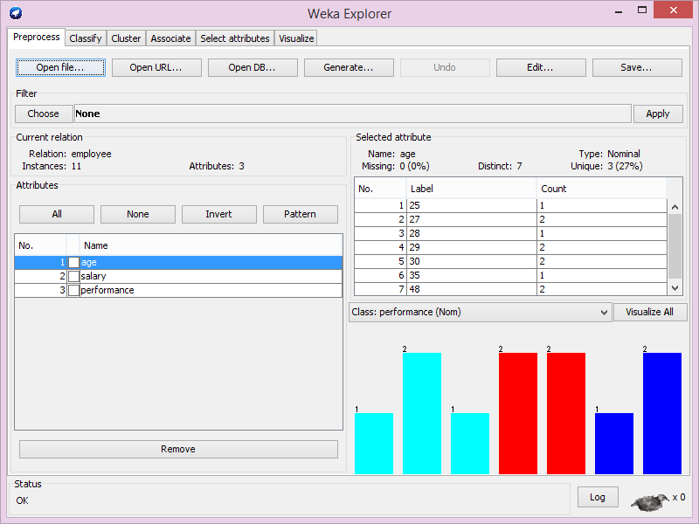

**Step 4:- Click on classify goes into the choose right click on trees select J48. And start on click**

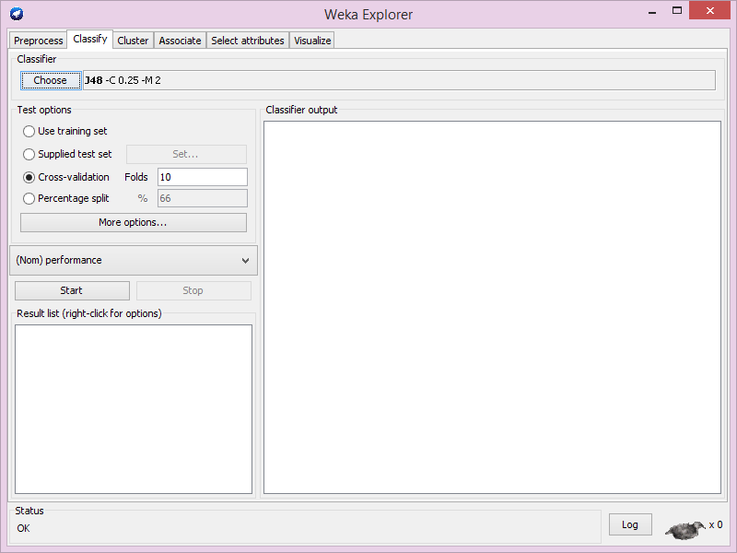

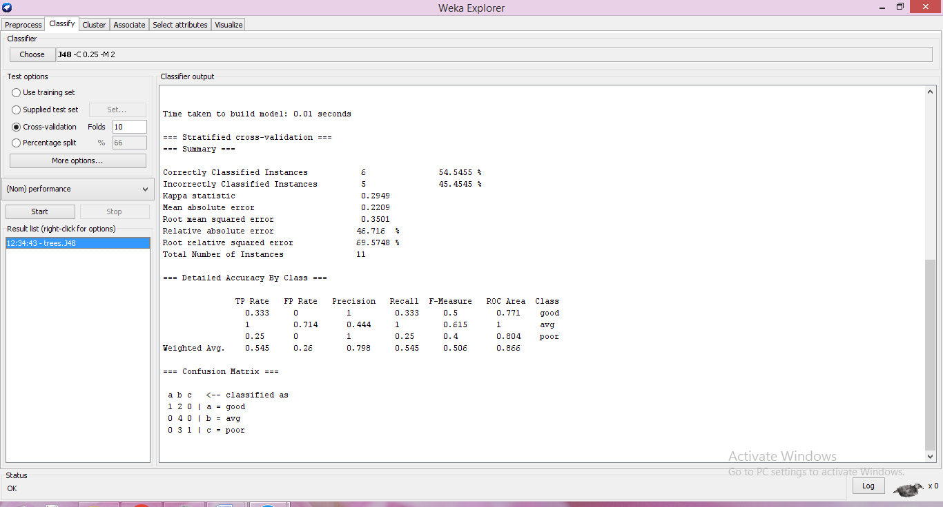

**Step 6:- Right click on J48 and click on visualize tree**

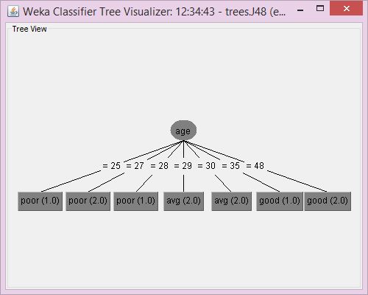

**Practical 4. Demonstration of Clustering rule process on dataset Student. arff Using Simple K-means.**

@relation student

@attribute sid numeric

@attribute name{yashashri,chetana,unnati,charu,shraddha,sachin}

@attribute DM numeric

@attribute WT numeric

@attribute CN numeric

@attribute AI numeric

@attribute STM numeric

@attribute total numeric

@attribute result{pass,fail}

@data

1,yashashri,?,55,45,50,40,250,pass

2,chetana,60,55,45,40,40,240,pass

3,unnati,60,55,40,50,40,240,pass

4,charu,60,55,30,50,40,235,pass

5,shraddha,60,55,45,60,40,260,pass

6,sachin,60,55,65,50,40,210,pass

**OUTPUT:**

**Step 1:- Start Weak Software And then click on the Explorer Button.**



**Step2 :- Click on the Open Files and Upload Sample File from Weka Folder**

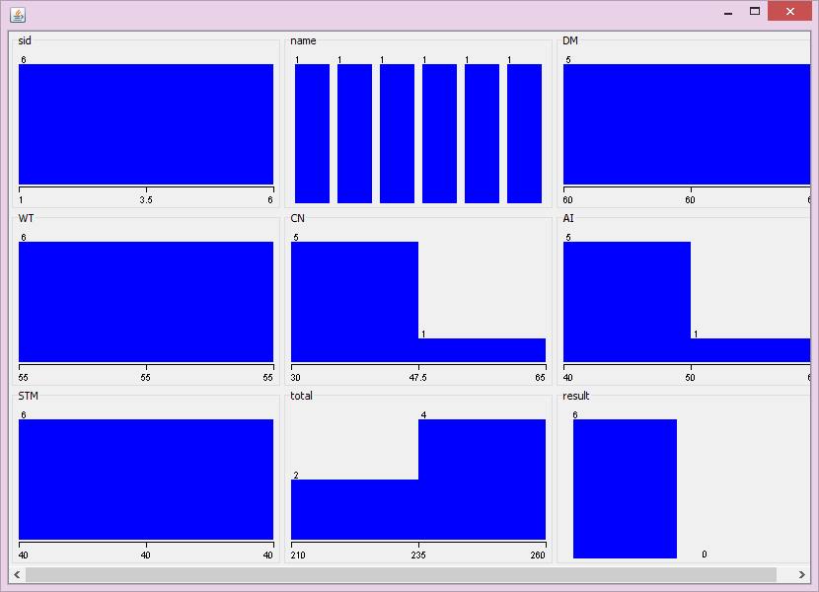

**Step3- Go to Cluster then click pon the choose Button-> Click SimpleKmeans**

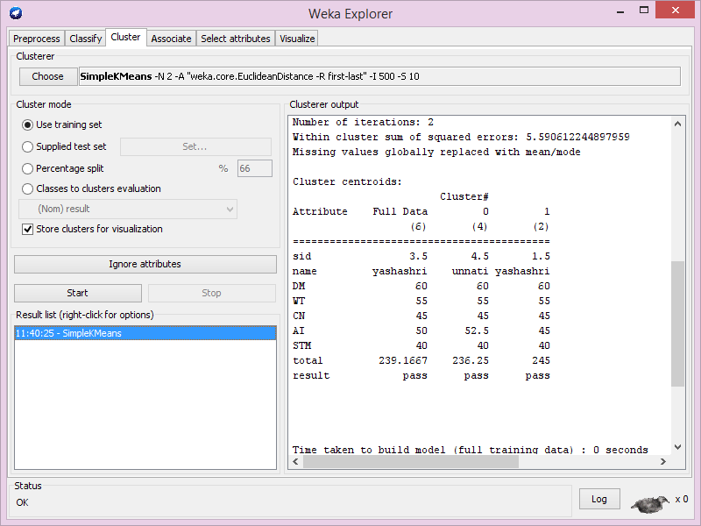

**Step 5:-Click on the start button and Click Right button on result list -> clusture visualize**

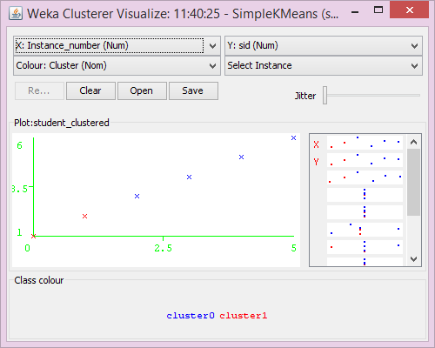

**Practical 5:- Demonstration of classification rule process on dataset employee. arff Using naïve bayes algorithm.**

**Step 1:- Create .arff file in notepad**

@relation employee

@attribute age numeric

@attribute salary numeric

@attribute department{HR,IT,Sales,Finance}

@attribute experience numeric

@attribute performance{Low,Medium,High}

@attribute promotion{Yes,No}

@data

25,35000,IT,2,Medium,No

30,45000,Sales,5,High,Yes

28,40000,HR,3,Medium,No

35,55000,Finance,8,High,Yes

40,60000,IT,10,High,Yes

22,32000,Sales,1,Low,No

50,70000,HR,15,High,Yes

27,38000,IT,3,Medium,No

45,65000,Finance,12,High,Yes

33,50000,Sales,6,Medium,No

**Step 2:-Open Weka 3.6 Software ->> Click Explorer**



**Step 3:-Then choose option ->> Open File ->> Select .arff data file.**

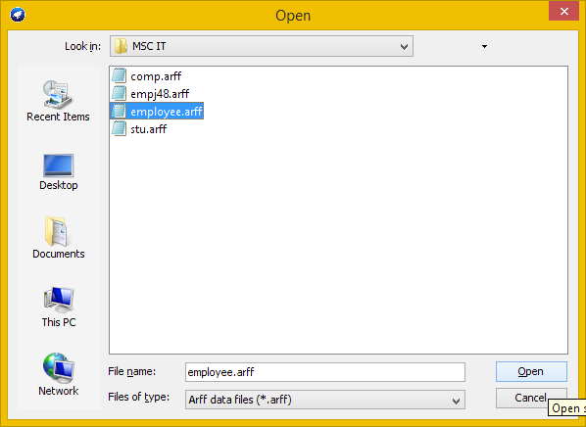

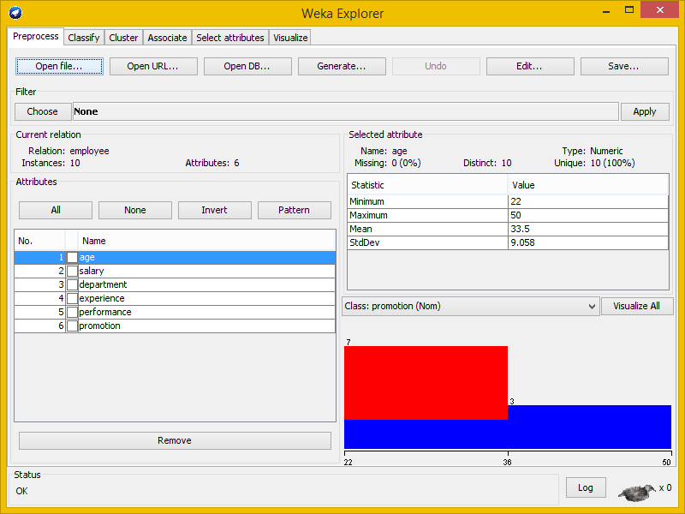

**Step 4:- Click on Visualize All**

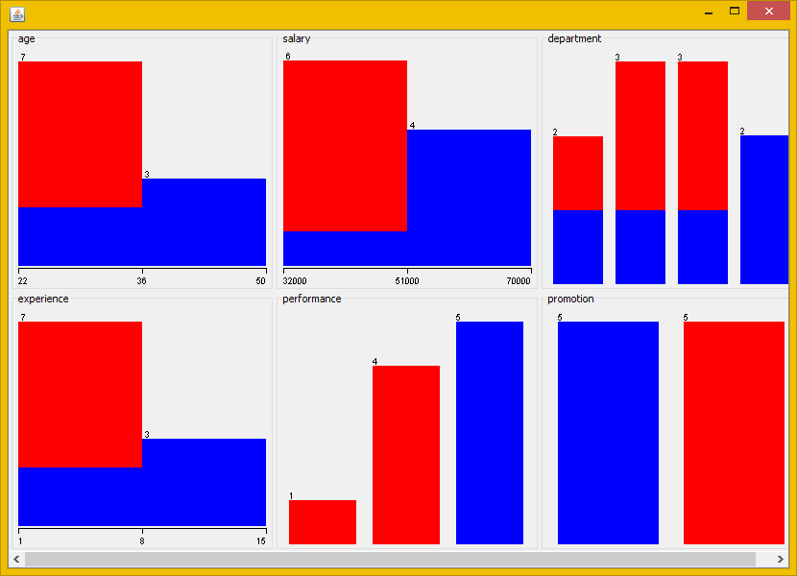

**Step 5:- Click on Classify ->> select Choose Option ->> Select Bayes ->> click on start option**

