**SIMULATION OF A DRIVE-THRU OF A FAST FOOD RESTAURANT**

**ABSTRACT**

A model was developed for the simulation of a Drive-Thru system of a fast food restaurant. A discrete, non-continuous, stochastic simulation has made it possible to create data to optimize and maximize the operational efficiency of the Drive-Thru system within a fast food restaurant. Performance measures such as the number of customers processed through the system, the total time of customers spent time in both server queues, the average waiting time for the customers, the average queue length on both servers could be determined.

The results of our simulation could serve as basis to give recommendations on how to improve efficiency for the fast food chain industry. The modeling methodology could also prove useful and helpful for the manufacturing or other service industries that use similar queuing techniques.

**1. INTRODUCTION**

In simplest term, computer simulation is the process of designing a mathematical-logical model of a real system and also a computer program that simulates an abstract model so that it can be studied and analyzed. Thus, simulation encompasses a model building process as well as the design and implementation of an appropriate experiment involving that model. These experiments or simulations allowed conclusions to be drawn about the systems and their operation without actually constructing a system.

Given that it's nearly impossible to accurately predict when customers will arrive at the order window (server 1) to place an order and/or how much time will be required to provide service, (since these variables largely come down to the time of day, popularity of the establishment and complexity of the menu amongst other influencing factors), it is always difficult to decide what exactly are the capacity requirements. Miscalculating the appropriate need of resources by overestimating or possibly even underestimating and not providing enough resources can potentially increase operational costs, inefficiencies and increase customer wait times (queue size) thereby reducing customer satisfaction. A simulated system in which these multiple variables can be tested and changed to achieve a more optimized real world application can be of great benefit to a myriad of establishments.

It is important to note that there are multiple possible configurations for drive thru systems consisting of multiple possible windows and lines. For our purposes, we will be making use of one of the most popular arrangements which is comprised of one pre-sell window in which the customer first places their order and makes any requests that go along with ordering followed by an additional window where payment is made and food is given. Therefore our goal is to achieve the optimized, economic balance waiting time on both service windows (servers).

In the Drive-Thru operation, customers arrive at the station, place an order, form a queue before placing an order if there are customers seeking service, receive the order, form a queue before picking up the order if there are customers waiting to pick up the order, and then leave the system. This paper presents the modeling of the above scenario. Operation recommendations have been made to optimize operation, improve quality, and increase efficiency.

**2. COMPARING TO REAL WORLD STATISTICS**

Numerous real world studies have been conducted on the matter by fast food chains in order to determine the ideal wait times for customers and their businesses. Quick Serve Restaurant (QSR) has been monitoring the changes in drive thrus for the past 16 years and have shown the real world statistical data that this computer simulation provides. In their reports, many of the major fast food chains are studied and accounted for quickness and accuracy of the service. According to their reports, the longest wait times were in 2013 with an average time of 203.29 seconds per customer (approximately 3 minutes and 23 seconds). QSR does a more in depth study by researching the average wait times according to time of day, type of food being served, and day of the week; all of which are not accounted for in our computer simulation.

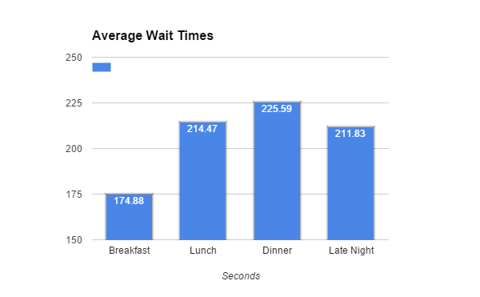

The QSR study also includes a very vital part to our computer simulation, the Pre-Sell window. By adding a second window in a drive thru environment, QSR was able to determine how much faster the service was with and without. Surprisingly, in some cases, having two windows actually slowed the process down; however it did result in higher accuracy in orders. Unfortunately, since this is a comparison of different configurations between one and two window systems, testing for this particular quirk is beyond the scope of our focus.

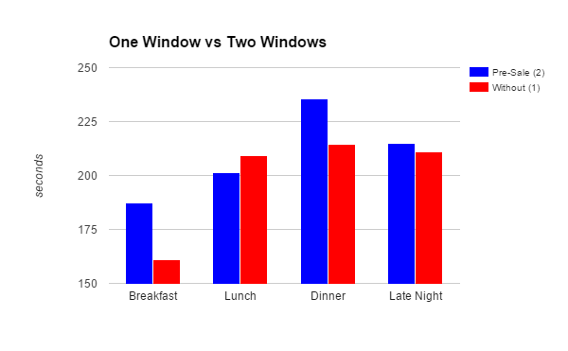.

The graph below shows the simulation being run for 300 customers and taking a total of 19 hours to complete. This would be typical for a restaurant that is open from 6 am to 1 am and assuming no customers in line nor at the windows at the time of the simulation start. The results are similar to those in the results achieved in the QSR report. The maximum delay time was 228 seconds, while the lowest wait time was 90 seconds. While the simulation does not account for different times of the day, on average the time to finish an order was 174 seconds, compared to the 2015 real world average of 197 seconds.

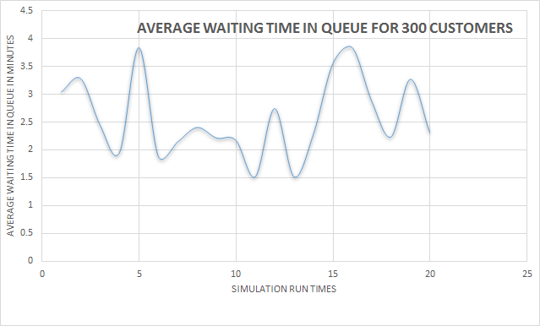

Something of interest, was that given the variables used, queue wait times never exceeded the max allotted, and in fact rarely increased beyond five customers. this all could be due to the close ranges between window one service times and window two where increasing the number for window two would likely also increase the load on the system.

**3. AREAS FOR DEVELOPMENT**

There are a number of areas for improvement of the simulation system. Among them is the random number generation for customer arrival times, window one, and window two service times all of which are currently normally distributed given a max and min range which is not reflective of the real world object of our simulation. Accounting within the code for situations in which the simulation start part way through a shift with customers having already been serviced or being in the process is another area to look into. being able to modify the number of windows (by increasing servers in the system) would allow us to test other systems and make comparisons between them to analyze which system better suits certain establishments.

**4. CONCLUSION**

The average waiting time of each customer in the system does not depend on the waiting time on either servers. Both servers are independent of each other. This observation can be seen on the graph above. For every simulation run time, the average waiting time in queue was not being consistent. The graph is fluctuating, moving up and down over period of a time. The results are concurrent with real world statistics.