Taking Scientists to School:

Using Nevada’s Climate Research for K-12 Science Curriculum

This series of lessons focuses on some of the exciting climate change research that is the result of the multidisciplinary research conducted through the Experimental Program to Stimulate Competitive Research (EPSCoR) program created by the National Science Foundation (NSF).

There are so many people working to understand climate change in Nevada: how we affect it and how it affects us. Within these lessons, students get to learn about research taking place now in Nevada and, more importantly, will be able to use the research they learn about to spark their own interest and understanding in areas related to climate change.

Each lesson is designed so that students can explore information related to climate change and form their own ideas about research questions they are presented with. They will then use the EPSCoR researcher’s expertise to evaluate their explanations before sharing their ideas with their classmates.

For this lesson, students will explore ideas related to data and how we use visualizations like graphs and images to help us understand it. They will use their critical thinking skills to answer the question:

**HOW DO VISUALIZATIONS HELP US UNDERSTAND COMPLEX CLIMATE CHANGE DATA?**

**Time to complete:** 4 to 6 class periods

**Grade level:** 9th-12th grade

**Standards:**

**NGSS**:

*Science and Engineering Practices*:

* Asking questions
* Planning and carrying out investigations
* Constructing explanations
* Engaging in argument from evidence
* Obtaining, evaluating, and communicating information

### Developing and Using Models

### Analyzing and Interpreting Data

### *Disciplinary Core Ideas*:

### HS-ESS3-4: Use a model to describe how variations in the flow of energy into and out of Earth’s systems result in changes in climate.

### HS-ESS3-5: Analyze geoscience data and the results from global climate models to make an evidence-based forecast of the current rate of global or regional climate change and associated future impacts to Earth systems.

### *Crosscutting Concepts*:

### Patterns

### Stability and Change

**INTRODUCTION**

When we think about climate change, there is A LOT of information out there. Not only is there a lot of information, but it comes in so many different forms: articles in a newspaper, numbers in a data table, a news story on TV. Sometimes it is very hard to process all of this *data* because it is technical and specialized information that might be easy for its researchers to digest, because…well, they created it. But we the public might need a little help *visualizing* what it all means.

Likhitha Ravi and the research team she works with at the University of Nevada in Reno are trying to help both scientists and laypeople help visualize data better. She and others are researching and developing the best ways to represent data visually, so that the relationships between numbers are more meaningful and easier to understand.

For this lesson, you will be exploring the same ideas and collecting data to make claims about the value of visualizations and how they help us understand complex issues like climate change.

**How This Lesson Works**

This lesson is focused on a **Big Question.** The activities are divided into different sections or features.

1. With feature one of the lesson, you will be asked to respond with your initial ideas related to the Big Question. In every additional feature of the lesson, you have the opportunity to provide any further thoughts or questions that arise.
2. Feature two of the lesson is an activity where you are required to collect and explore some evidence related to the science content of the Big Question. This evidence is used throughout the remaining features of the lesson.
3. Feature three of the lesson involves analyzing your evidence and using it to generate an explanation (also called a claim) about the scientific ideas of the lesson. Typically, your analysis will produce an artifact that you will describe and justify to your peers and teacher at Research Council (see Feature 5 below).
4. The accepted scientific understanding of the lesson is presented in feature four. In addition to demonstrating a thorough understanding of the scientific knowledge of the content, you will be asked to compare and contrast your explanation from feature two.
5. Finally, feature five of the lesson involves sharing and justifying your explanation and artifact from feature three among your peers and with your teacher at Research Council. The culminating activity of the lesson is to reflect on the Big Question of feature one and synthesize your understanding by using your evidence to compare and contrast your ideas with those of your peers and teacher.

**The Big Question**

In this lesson you will explore the **Big Question** below and work through five different steps to address it. At certain points, you will be asked to complete a few activities like: reading, responding to some thoughtful questions, and adding to your research brief. You should take your time and think carefully about each step and your work and feel free to revisit any step at any time. We will review the concepts in class.

**The Big Question:**

HOW DO VISUALIZATIONS HELP US UNDERSTAND COMPLEX CLIMATE CHANGE DATA?

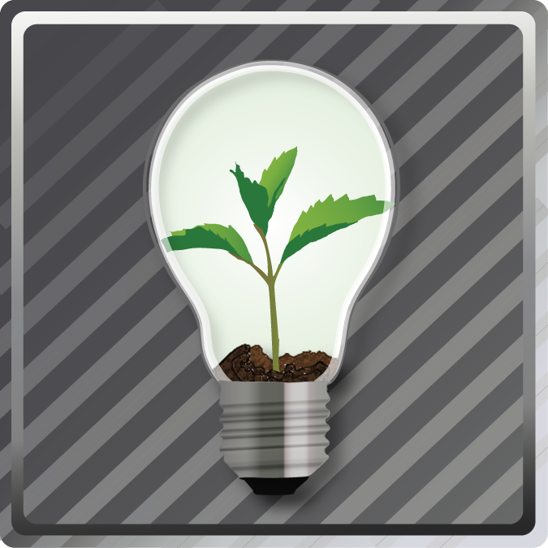**FEATURE 1: YOUR INITIAL IDEAS**

In order to think about visualizations and how they help us understand climate change, we have to first address some smaller questions: What are visualizations? What are data and how are data represented?

**What is a visualization?**

Watch the two videos by following the links below to get an idea for how some experts in different fields use visualizations to convey the story that raw data might not.

DATA VISUALIZATION:

<https://www.youtube.com/watch?v=xekEXM0Vonc>

HANS ROSLING AND POPULATION CHANGE: <https://www.youtube.com/watch?v=jbkSRLYSojo>



Research Brief: Getting Started

Use the following prompts to discuss some of your initial ideas about visualizations and how they might be useful.

1. What is the purpose of using a visualization for representing data?

I think that the purpose of using a visualization is to….

1. What are some features that make a visualization help us understand raw data?

I think a good visualization will help me understand raw data because it has…

1. Data and visualization are related because…

=================================================================

** FEATURE 2: EXPLORE THE EVIDENCE**

**Task 1: What do expert visualizations look like?**

Now work with a partner and use the website below to explore several effective visualizations related to climate change. As you look at each visualization, discuss each of the following questions with your partner, then use your research brief to record your thoughts.

1. What is the main message this visualization is meant to convey?
2. How are data represented?
3. Why did the person who created the visualization choose to represent it the way that they did?
4. From your perspective is this representation clear or confusing and why?

[**http://www.yaleclimatemediaforum.org/2011/09/visualizations-on-climate-change-issues-2/**](http://www.yaleclimatemediaforum.org/2011/09/visualizations-on-climate-change-issues-2/)

**Task 2: Getting to know our data**

Now it’s your turn. To get a better idea for what it means to create a visualization from a data set, you will give it a try yourself.

The Nevada Data Portal provides access to data that are collected right here in Nevada, on factors related to climate change, like temperature, precipitation and solar radiation. There are data collection sites all over the state, thanks to funding from the National Science Foundation. These are the data you will be using. To begin to understand the data that we are going to be working with, the videos below will introduce you to both the sites from which the data are measured and the data portal on the internet, where the data are collected and accessed from. Finally, the link below the videos will let you explore a data collection site and all of the instrumentation there.

**a. Description of the data collection sites and how the data are collected**

[**https://www.youtube.com/watch?v=frxqQ0DLaBs**](https://www.youtube.com/watch?v=frxqQ0DLaBs)

**b. Introduction to the Nevada Climate Change Portal**

[**https://www.youtube.com/watch?v=JF_5-ROmchI**](https://www.youtube.com/watch?v=JF_5-ROmchI)

**c. Climate data collection instrumentation**

[**http://sensor.nevada.edu/NCCP/Climate%20Monitoring/Equipment.aspx**](http://sensor.nevada.edu/NCCP/Climate%20Monitoring/Equipment.aspx)

**d. Where your data come from**

The data you will be working with are temperature data from the Sheep Mountain Range in the Desert National Wildlife Refuge, north of Las Vegas. The maps below show you 1) where this range is in relation to Las Vegas, and 2) the sites within the Sheep Range where the data come from and each site’s elevations. Take a minute to look at the maps and situate where your data sets will come from, both in the state and in relationship to each other.

1. Sheep Range in relation to Las Vegas



2. Sheep Range data sites and their elevations

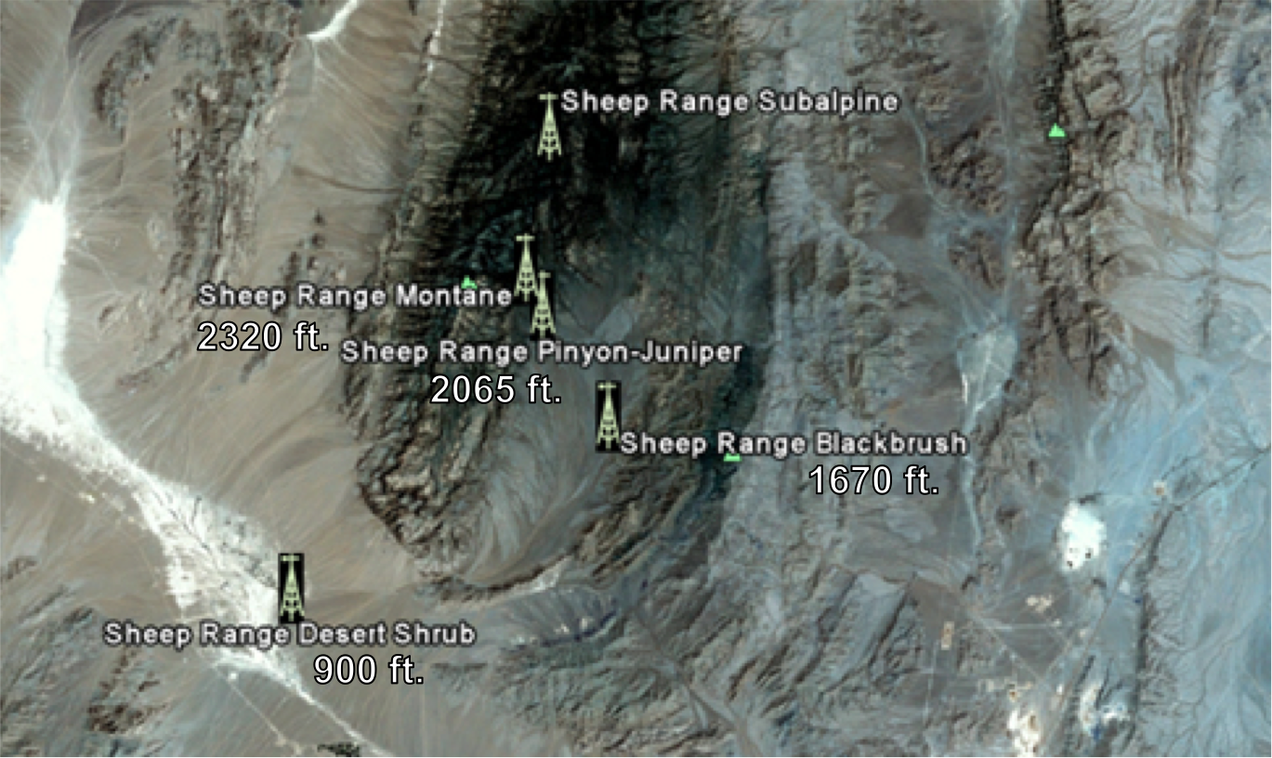



Research Brief: Getting Started

Use the following prompts to describe the data that we will be creating a visualization from and the tools used to collect the data.

1. The data we will be using is collected by…
2. Some of the things that can be measured at the data collection sites are…
3. Why might we be interested in collecting and representing this data?

I think it is important and useful to represent the data I see here because…

**Task 3: Creating a visualization from data**

Now you are going to use a prepared data set to create you own visualization so that you can notice the differences between raw data and a visualization and begin to understand why a visualization might be useful. The data set below is real information about the Sheep Mountain Range. The table below contains temperature data for various location for a 3-year time period. Take a look at the information and think about some questions you might have or things that you notice. These are usually good places to start when deciding what data to represent with a visualization. Then, create your visualization and include it in your research brief, with answers to questions and prompts below.

Some examples are provided to get you started. You may use these to create your visualizations or you can come up with your own.

|  |  |  |  |  |
| --- | --- | --- | --- | --- |
| **Site Name:** | **Sheep Range Mojave Desert Shrub** | **Sheep Range Blackbrush** | **Sheep Range Pinyon-Juniper** | **Sheep Range Montane** |
| Site elevation | 900 feet | 1670 feet | 2065 feet | 2320 feet |
| Units of measurement | degrees Fahrenheit | degrees Fahrenheit | degrees Fahrenheit | degrees Fahrenheit |
| Measurement Type | Average temperature at midnight for a 1- month period | Average temperature at midnight for a 1- month period | Average temperature at midnight for a 1- month period | Average temperature at midnight for a 1- month period |
| Month and year | Value | Value | Value | Value |
| 11-Apr | 58.7 | 48.2 | 46.2 | 43.7 |
| 11-May | 61.9 | 50.4 | 47.4 | 44.2 |
| 11-Jun | 67.3 | 55 | 51.6 | 48.4 |
| 11-Jul | 80.8 | 68.4 | 65.1 | 61.6 |
| 11-Aug | 87.1 | 74.7 | 71.5 | 68 |
| 11-Sep | 88.7 | 76.6 | 74.2 | 70.4 |
| 11-Oct | 79.7 | 69.5 | 66.9 | 62.6 |
| 11-Nov | 66.7 | 57.5 | 55.9 | 52.3 |
| 11-Dec | 50.8 | 42.2 | 41.3 | 38.6 |
| 12-Jan | 43.1 | 37.1 | 37 | 34.3 |
| 12-Feb | 47.3 | 41.5 | 42.1 | 40 |
| 12-Mar | 49.4 | 39.5 | 37 | 34.1 |
| 12-Apr | 56.9 | 45.4 | 42.6 | 39.6 |
| 12-May | 65.2 | 53.4 | 50 | 46.6 |
| 12-Jun | 76 | 64 | 60.7 | 57.2 |
| 12-Jul | 84.6 | 72.3 | 69.6 | 66.3 |
| 12-Aug | 86.7 | 75 | 71.5 | 67.9 |
| 12-Sep | 87.2 | 75.6 | 71.8 | 67.7 |
| 12-Oct | 80.8 | 69.6 | 66.8 | 62.5 |
| 12-Nov | 67.3 | 57.8 | 56.4 | 53 |
| 12-Dec | 55.9 | 48 | 47.2 | 43.8 |
| 13-Jan | 44.7 | 36.7 | 34.5 | 32.2 |
| 13-Feb | 42.4 | 35.9 | 34.4 | 31.9 |
| 13-Mar | 47.2 | 37.4 | 35.4 | 32.5 |
| 13-Apr | 59.2 | 48.5 | 45.8 | 42.4 |
| 13-May | 64.9 | 53.3 | 49.8 | 45.7 |

**Example 1: Temperature for one location, over a 3-year period**

For this visualization, you could take a look at just one location, to note how the temperature has changed over the past three years. It might be interesting to note if there has been an increase, a decrease, or if it has changed in about the same pattern over the seasons. An example grid is provided below.

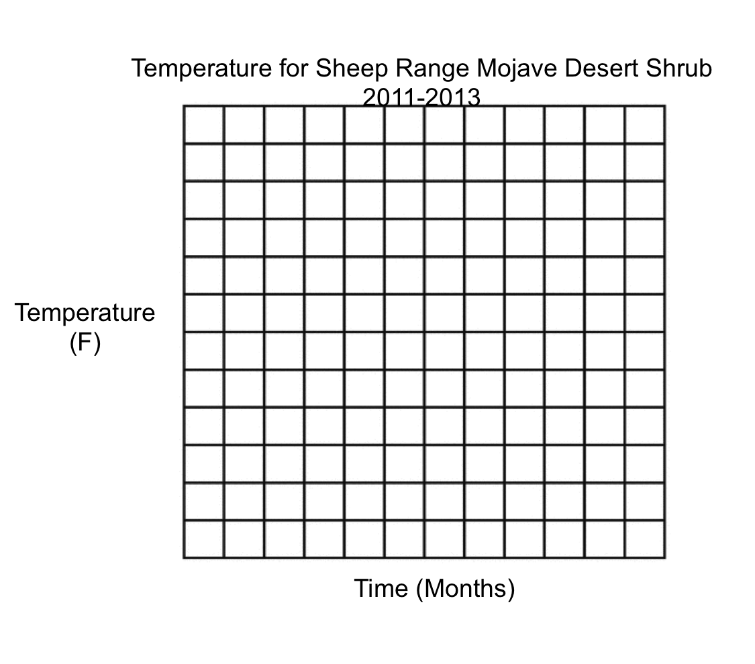

**Example 2: Temperature for four locations, for just one year**

For this visualization, you could take a look at all four locations to see how the temperature for these locations are different for a given month. Why might they be different? An example grid is provided below.



Research Brief:

1. My visualization is included here…
2. Some things that I notice now about my data, that I couldn’t see before are…
3. Some benefits to creating a visualization are…
4. Some challenges to creating a visualization are…

**FEATURE 3: YOUR SCIENTIFIC CLAIMS**

You have examined and represented data on temperature for the Sheep Range. You now must develop claim-evidence-reason statements, addressing the Big Question, “HOW DO VISUALIZATIONS HELP US UNDERSTAND COMPLEX CLIMATE CHANGE DATA?” The evidence you cite should come from your experience examining data and creating a visualization of your own. Use the Evidence-Claim-Reason table below to develop your claims. An example is provided.

|  |  |  |  |
| --- | --- | --- | --- |
|  | **As evidenced by…** | **I claim…** | **Because…** |
| 1. | The temperature differences I noticed in my visualization, that I could not see in the raw data | That visualizations help us notice patterns in our data | They provide a picture that data does not. |
| 2. |  |  |  |
| 3. |  |  |  |
| 4. |  |  |  |

Use your completed ECR Table to create a claim statement for each action item you propose.

Example: As evidenced by the temperature differences I noticed in my visualization, that I could not see in the raw data, I claim that visualizations help us notice patterns in our data, because they provide a picture that the data do not.

**FEATURE 4: SCIENTIFIC UNDERSTANDING**

Use the link to the website below to better understand why we use visualization to represent data and some interesting ways to do it. You don’t have to read the entire document, but at least read up to and including section 35.2 Pictures for the Eyes and Mind. How do these ideas compare to you own?

[Data Visualization](http://www.interaction-design.org/encyclopedia/data_visualization_for_human_perception.html)



Research Brief:

Now that you have completed the activity and considered the how visualizations affect our understanding of data, look back to your initial response to the big question: HOW DO VISUALIZATIONS HELP US UNDERSTAND COMPLEX CLIMATE CHANGE DATA? and describe how your ideas have changed. Include how your collected evidence from the four tasks used in this lesson influenced your ideas.

**FEATURE 5: RESEARCH COUNCIL**

In this investigation, you explored how visualizations of climate related data change our understanding of the raw data itself. Your preparation required you to review sources of information on how other people collect and visualize data, as well as create your own visualization from a provided data set.

Present your Research Brief at a Research Council comprised of your classmates. Explain and defend your findings. Critique the claims presented by other students and ask them to defend their understanding of visualizations and how they might be useful to our understanding of climate change.

Compare your ideas with others, critically evaluate your understanding of the connection between data and visualizations, then make any changes or update your research brief as you feel is appropriate. Record the specific evidence and reasoning that caused you to want to make any changes.



Research Brief:

After Research Council, complete your Research Brief by finishing the following statements:

My ideas are similar to others because . . .

My ideas are different because . . .

Note: Use your experience in this lesson and the evidence you collected to support your claims.