TIMA/MLA Analysis Report
- Sample
One sample was analyzed using TIMA. The sample is mainly composed of feldspar and quartz, and the analysis focused on their phase distribution and grain-size characteristics.
The following points should be noted:
1. MLA or TIMA analysis can only capture energy-dispersive spectroscopy (EDS) and backscattered electron (BSE) contrast data. Since phase identification and content estimation are based on EDS data, when certain phases exhibit complex elemental substitution, their BSE contrast may not differ significantly, but the content differences between different elements fluctuate significantly. This can lead to overlap and errors in the classification of different phases, such as isomorphous phases or phases with complex cation migration.
2. Since the acquisition step size is approximately 8 micrometers, it is impossible to accurately determine whether multiple very small grains exist within that 8-micrometer range. If a mixed EDS spectrum is acquired, it becomes impossible to precisely distinguish between different particles, and errors may also occur in phase identification at particle (crystal edge) boundaries.
3. Energy dispersive spectroscopy (EDS) analysis is semi-quantitative; therefore, even a 5% variation in elemental content within a phase cannot be precisely characterized. As a result, phases such as magnetite and hematite may not be reliably distinguished, which may affect data accuracy.
4. The presence of voids or cracks can cause missing EDS data or result in a very high EDS background, making it impossible to identify phases or leading to incorrect phase classification.
The primary characterization results include phase composition, grain size information, and phase distribution maps.
2.1 Mineral Composition
1. Modal mineralogy was determined based on whole-map analysis; some unidentifiable phases or areas (total weight < 1%) were assigned to quartz.
2. Feldspars are subdivided into plagioclase, K-feldspar, and albite; however, there may be overlap between these categories, meaning the subdivision may not be entirely accurate.
3. “Others” refers to phases such as zircon, monazite, apatite, and fluorite, with a total content of <0.3%, grouped into a single category.
4. There may also be some overlap between mica, chlorite, and feldspar, leading to classification errors.
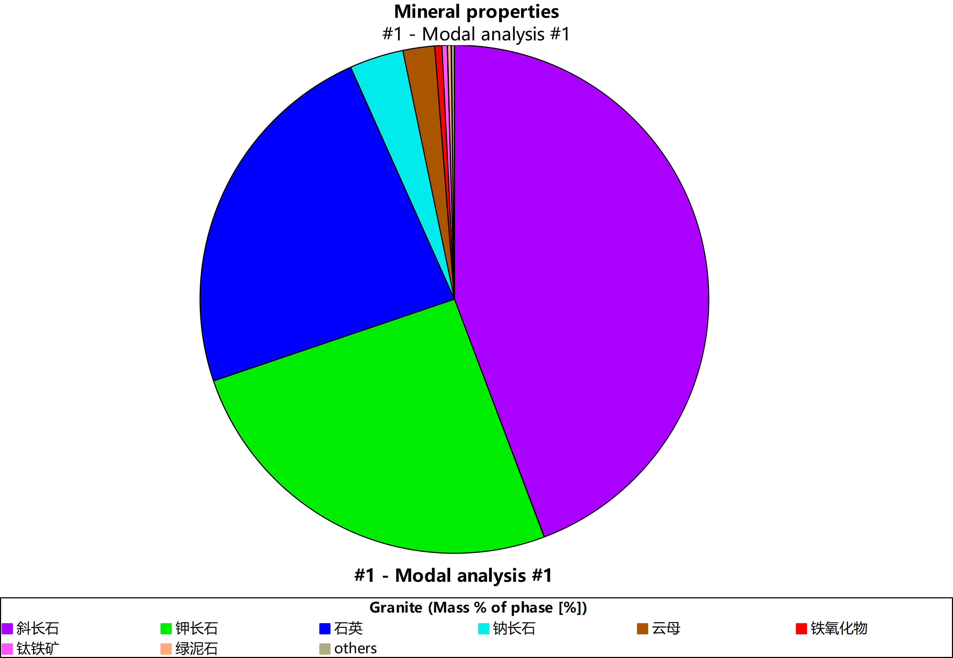
2.2 Mineral Grain Size Distribution (mass percentage)
Grain size distribution corresponding to various mineral phases
For a massive rock sample, particle-size analysis is not strictly applicable, as the entire specimen represents a single continuous body.
2.3 Mineral Liberation and Association Relationships
The primary distinction between “Free particle” and “Free surface” lies in whether co-occurrence or dissociation analysis is performed based on the “area” or “perimeter” dimension. Since TIMA and MLA systems can only collect two-dimensional planar data, results can only be estimated using either the area or perimeter dimension. This is particularly true for inclusions, where results derived from area and perimeter differ significantly; there is no single “correct” result, as both are based on different dimensions.
Additionally, the data obtained represents the volume percentage, i.e., the volume % of phases.
(1) Calculated based on free “particles” (phase area dimension)
Particles that have dissociated into individual units are characterized as Free particles.
(2) Calculated based on the “free surface” (surface area/perimeter dimension)
For a given mineral phase, the data no longer represents free particles but rather free surface results, which indicate the extent of contact or association with surrounding mineral phases.
The issue is that quartz, for example, is distributed at the outermost edge of the sampling area, resulting in a very high free surface value for quartz. This is because the system determines that the outermost layer of quartz is not intergrown with any other minerals and is therefore interpreted as liberated.
2.4 Mineral Distribution Maps and BSE Images
Note: The exported images are at the highest resolution and can be zoomed in for closer inspection.
2.4.1 Overall Mineral Phase Distribution Map
2.4.2 Overall BSE Image of the Sample
(See attachment)

