DC-1 Vulnhub 08-12-2025

1. Downloaded the vm from the vulnhub and installed it in the Oracle Vbox.
2. Using netdiscover found the vulnhub vm over the local network.

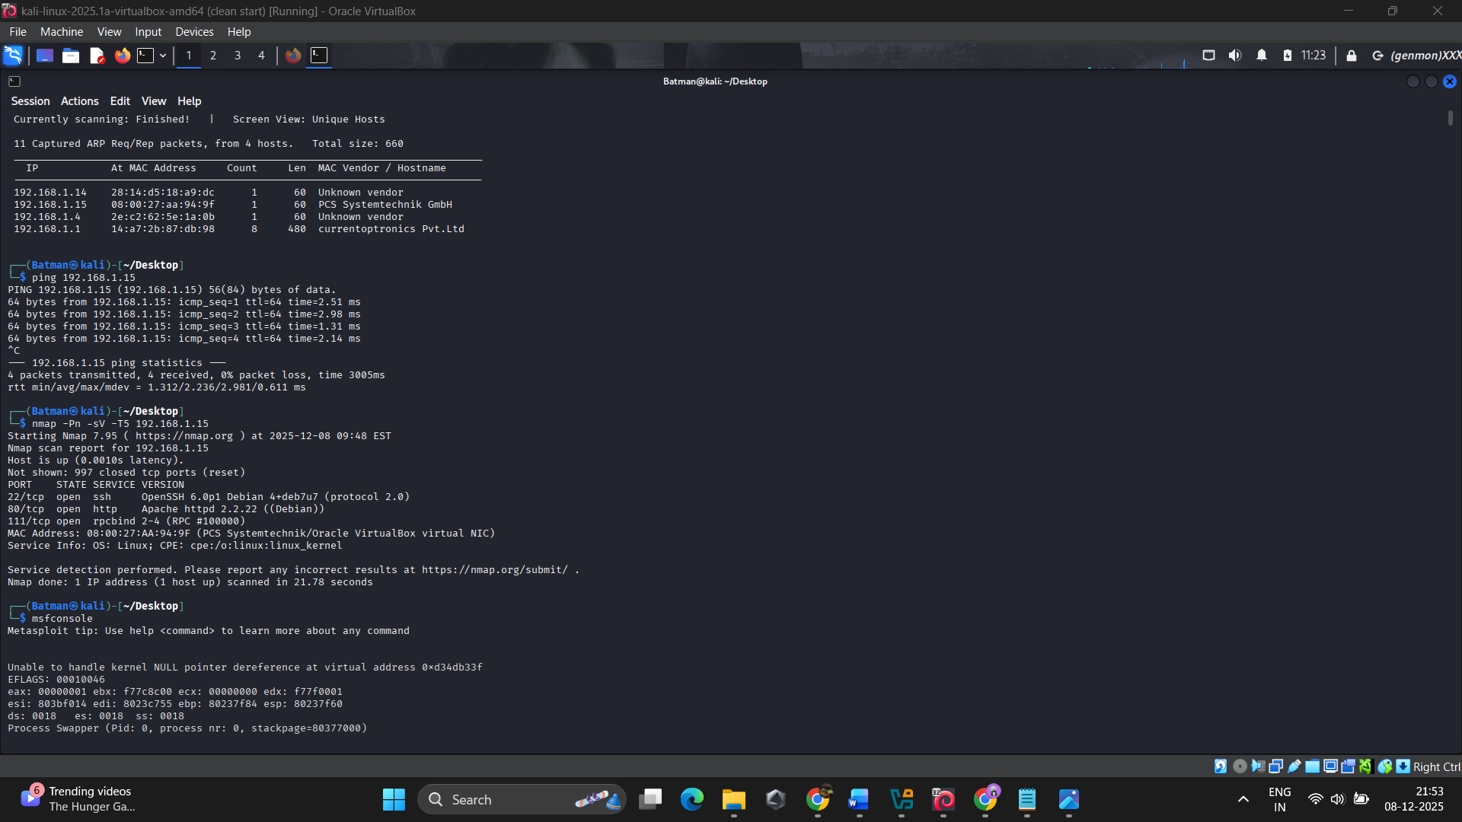

3. pings using the ip-address of the vm(pcs system)
4. Using Nmap – scanned for open ports and services running on that machine.
5. searches for Draupal in MSFconsole.

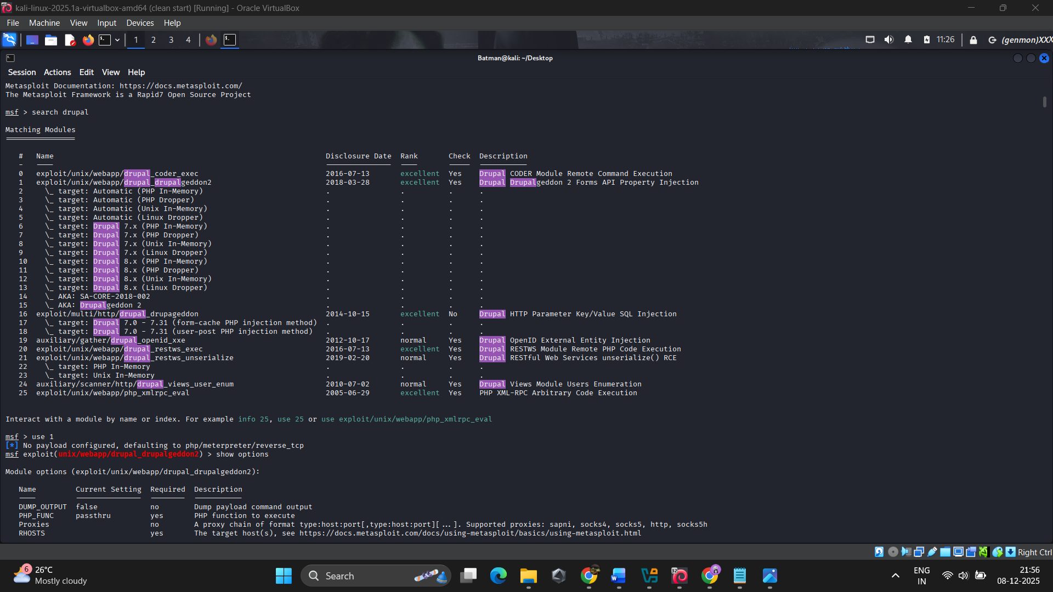
6. choosing the first exploit payload from it.

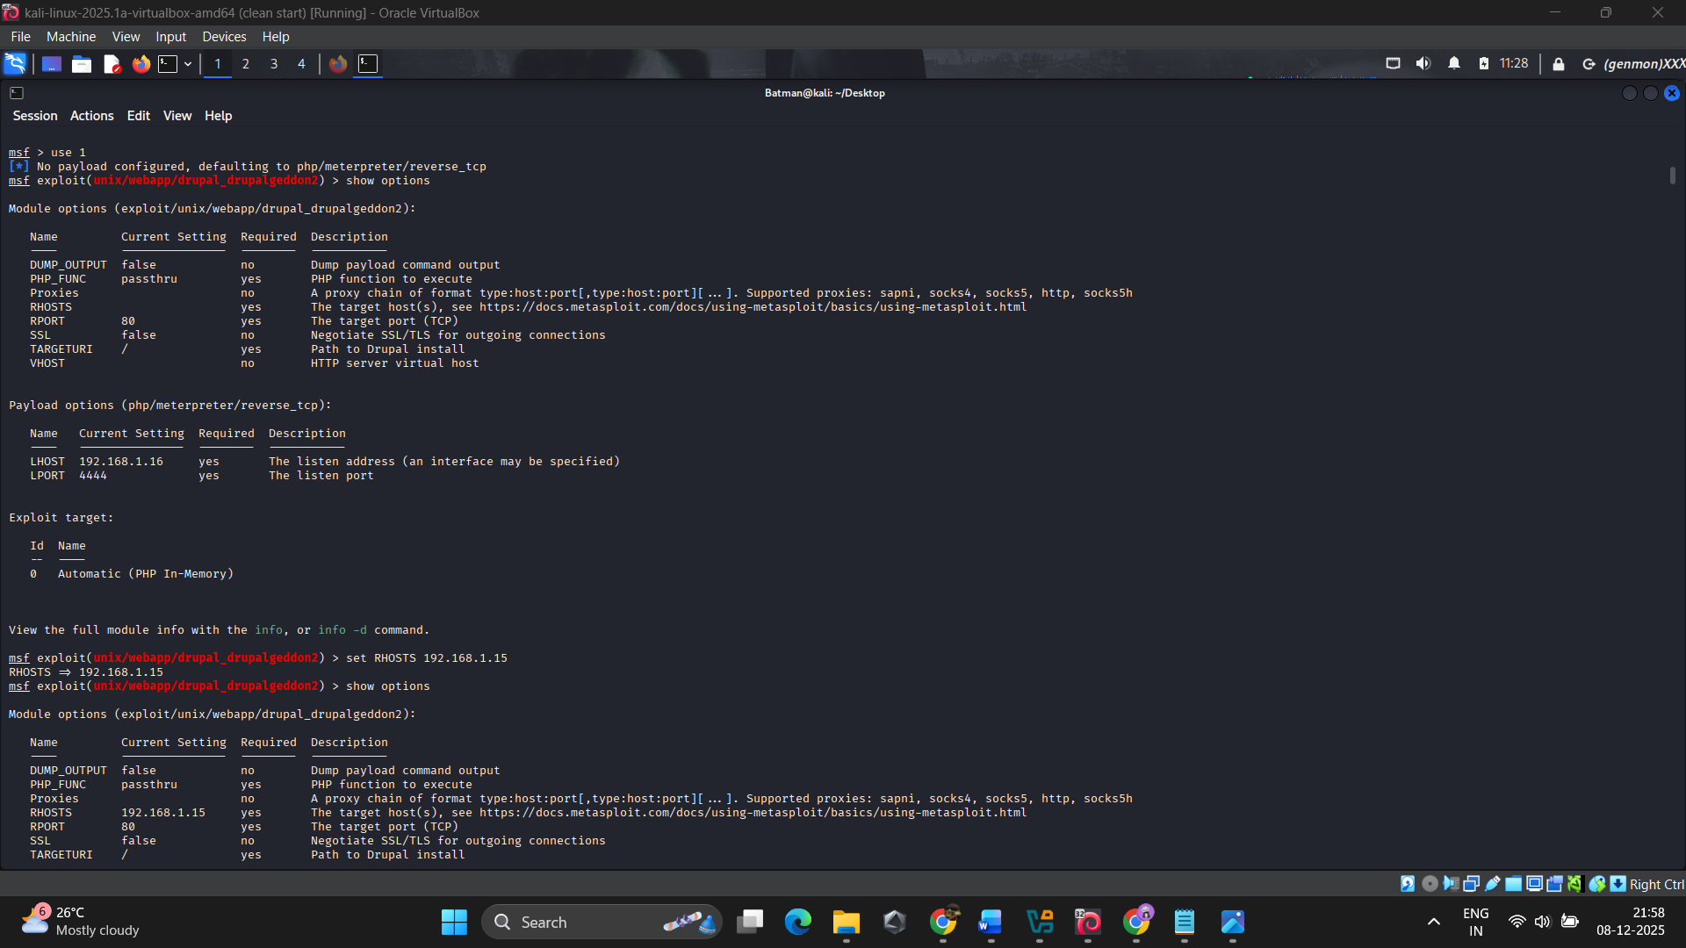
- sets the Rhosts as the dc-1(vulnhub) ipaddress
- run the payload to get the meterpreter session
- used “pwd” and came to know it was at “/var/www”
7. create a shell in it using “shell” command.

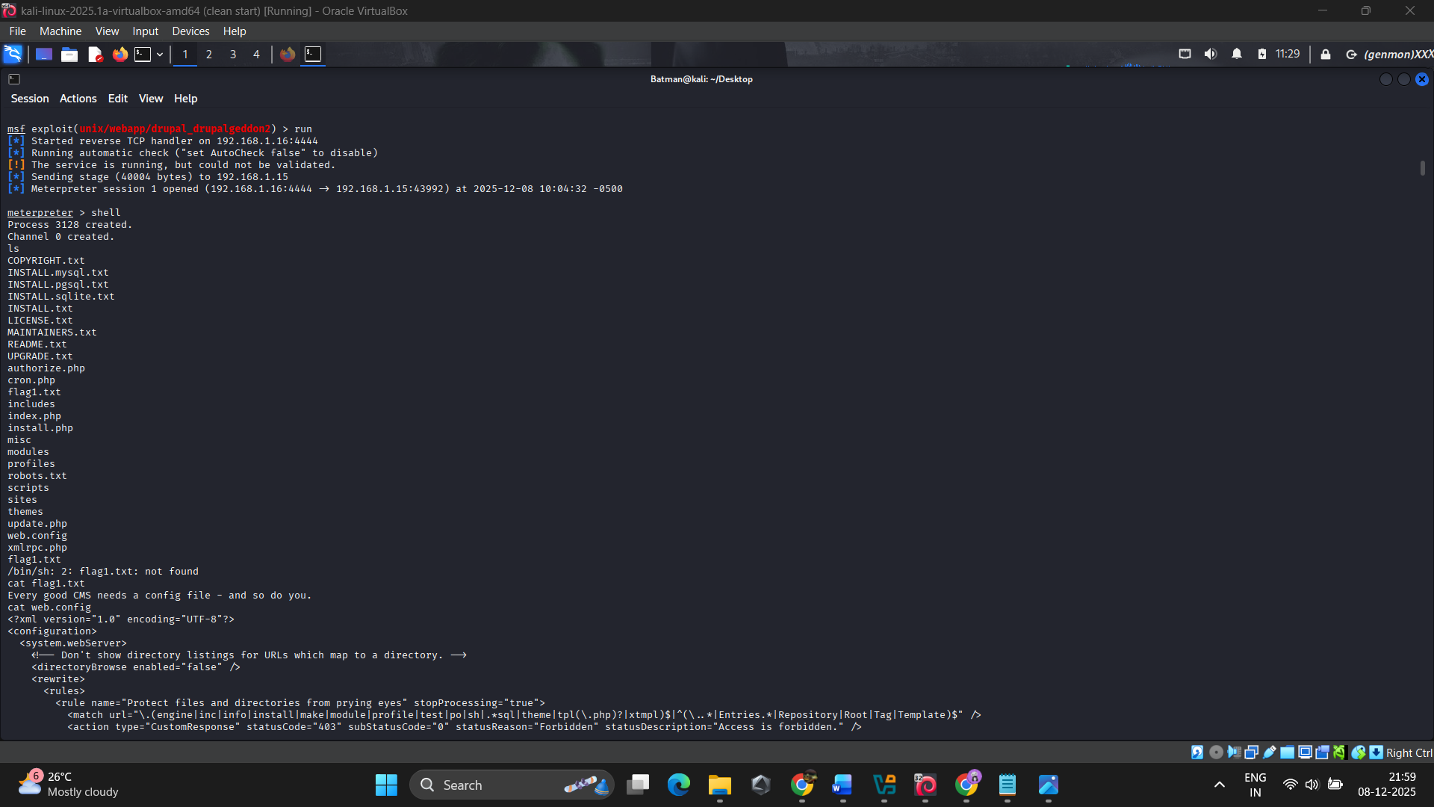

8. we can see many files in it and also we can find the first flag – “flag1.txt”
- Every good CMS needs a config file - and so do you.

9. Searching for a config file through each files and directories - at last we found a “settings.php” inside the sites/default directory.

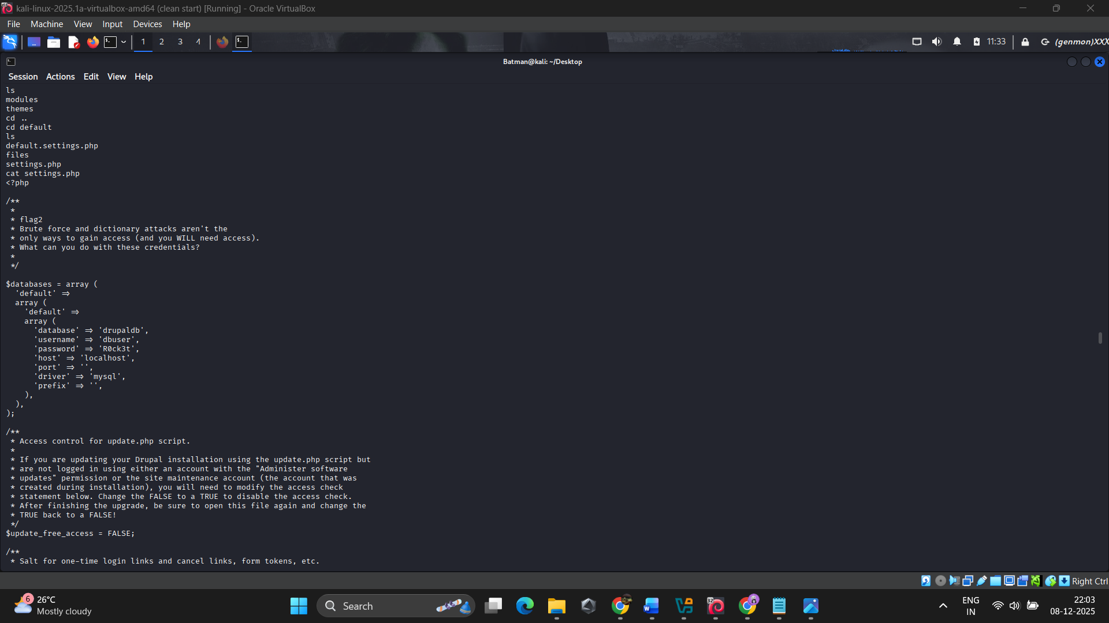

10. There we found the second flag :
flag2
* Brute force and dictionary attacks aren't the
* only ways to gain access (and you WILL need access).
* What can you do with these credentials?
*
*/

$databases = array (
'default' =>
array (
'default' =>
array (
'database' => 'drupaldb',
'username' => 'dbuser',
'password' => 'R0ck3t',
'host' => 'localhost',
'port' => '',
'driver' => 'mysql',
'prefix' => '',
),
),
);

11. while scrolling in “/var/www” directory searching for that config file, found a file named “INSTALL.mysql.txt”
- there we found some useful mysql querys !.

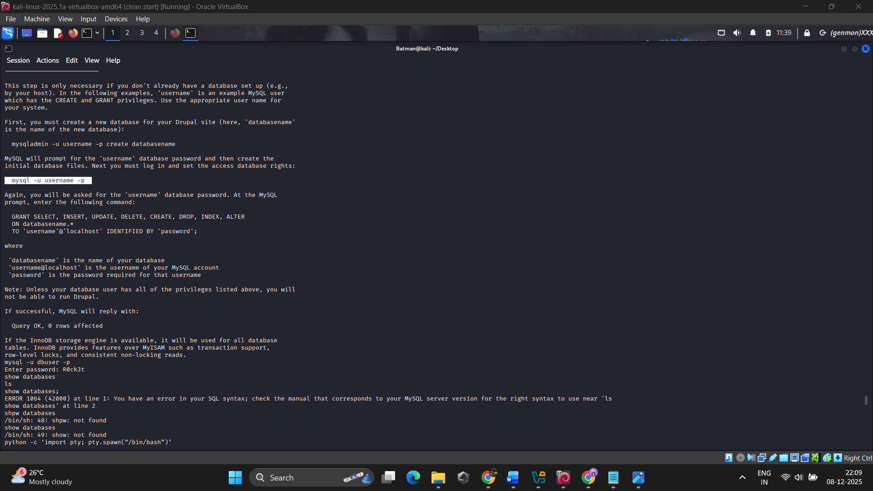

- but we need a interactive shell to use those querys!.

12. So we created a TTY shell using “python -c 'import pty; pty.spawn("/bin/bash")'.”

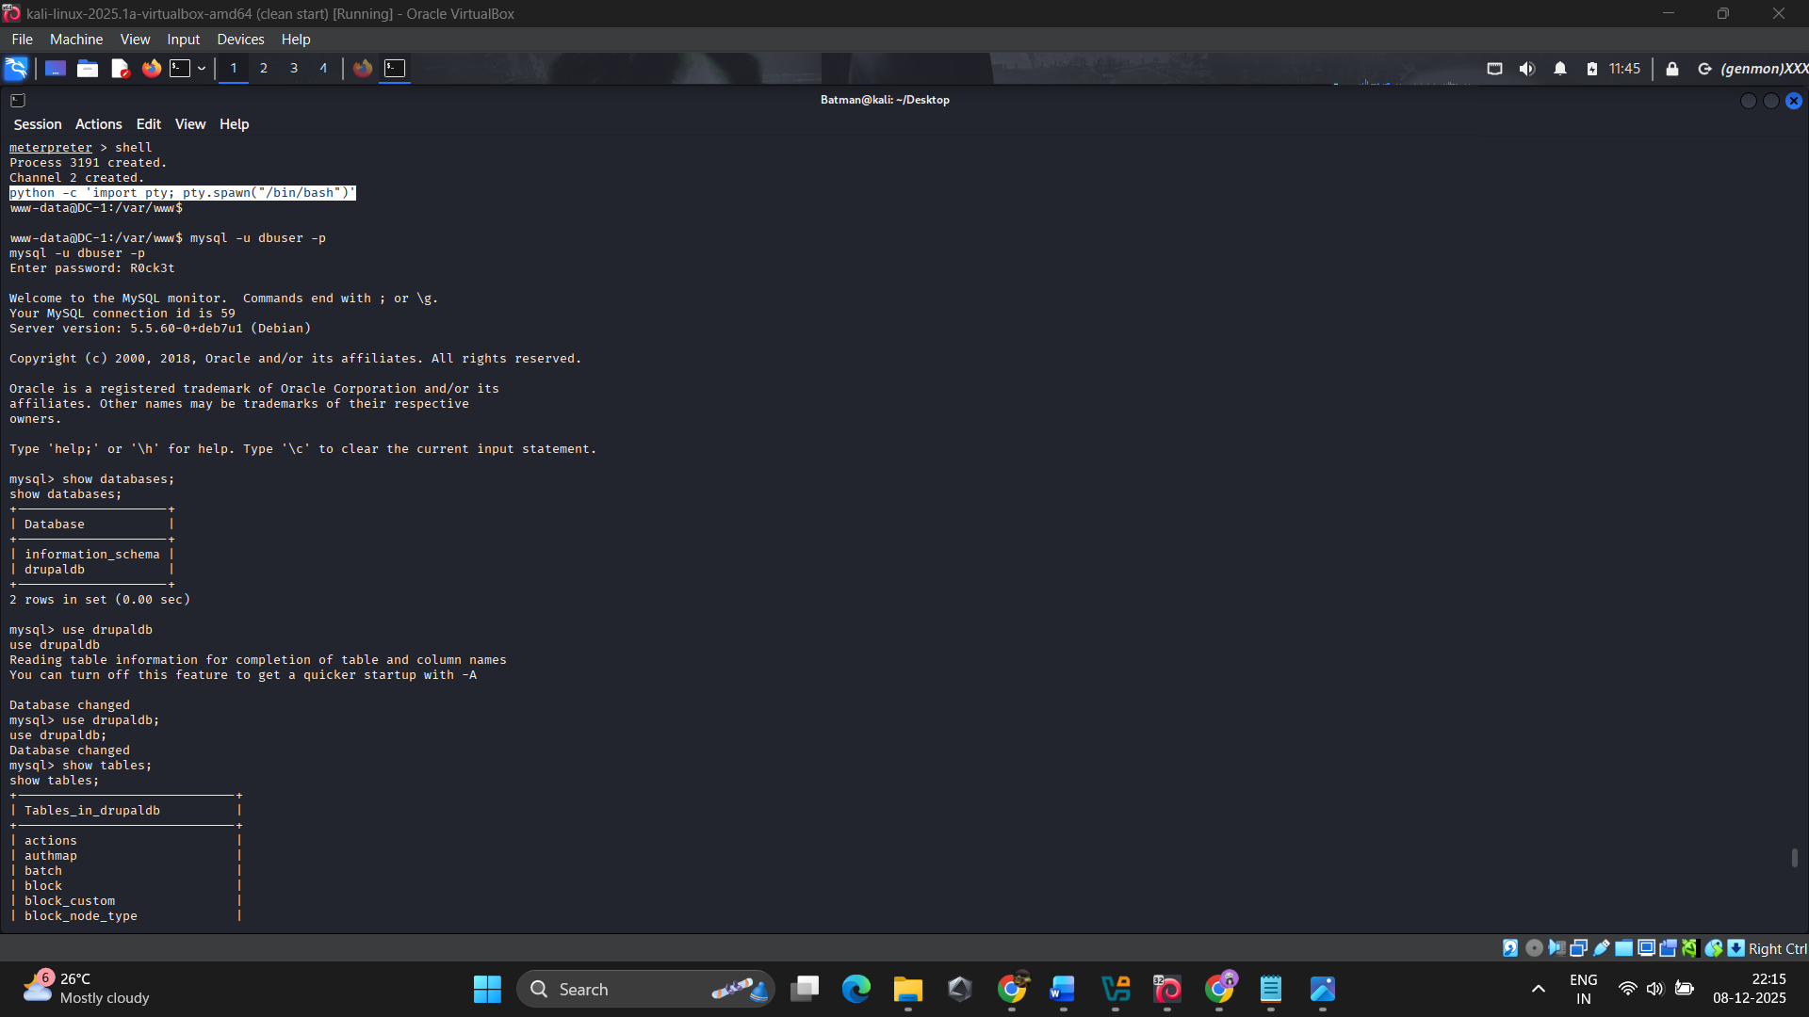

13. Now we can use querys to access the database of the draupal webserver!.
- Task is to find the admin(User) and Password of the admin.
- first gets into the database using “mysql -u dbuser -p”.
- Using the password “R0ck3t”.
- Gets into the DB, then find the database name and retrive the user name and their password.

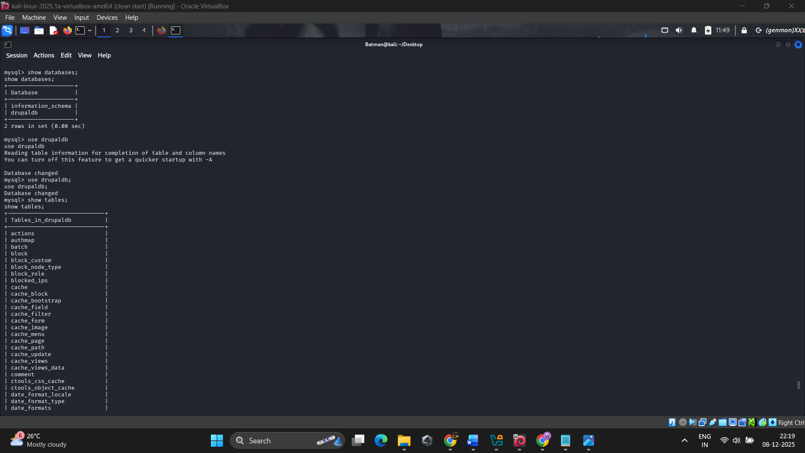

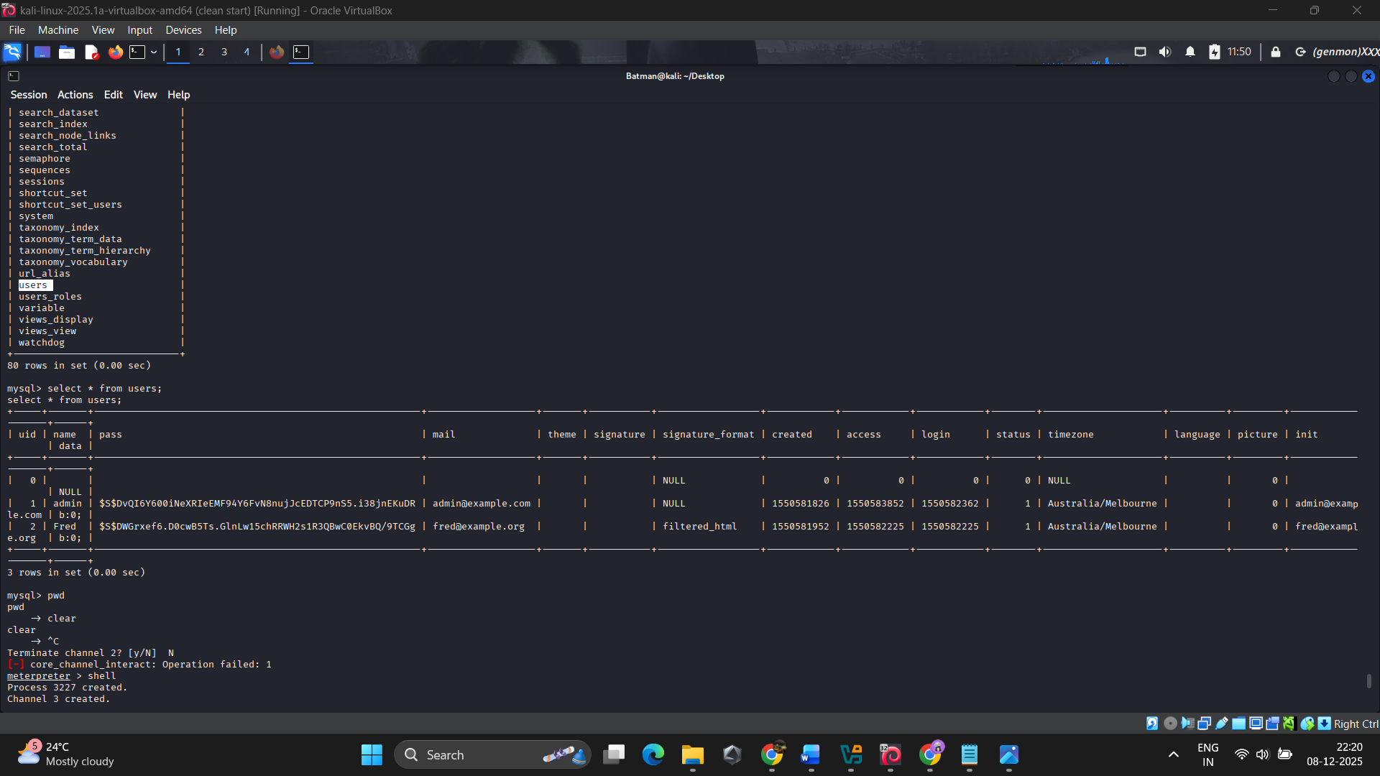

- Bravoo!. Here the admin password hash, lets crack it!.

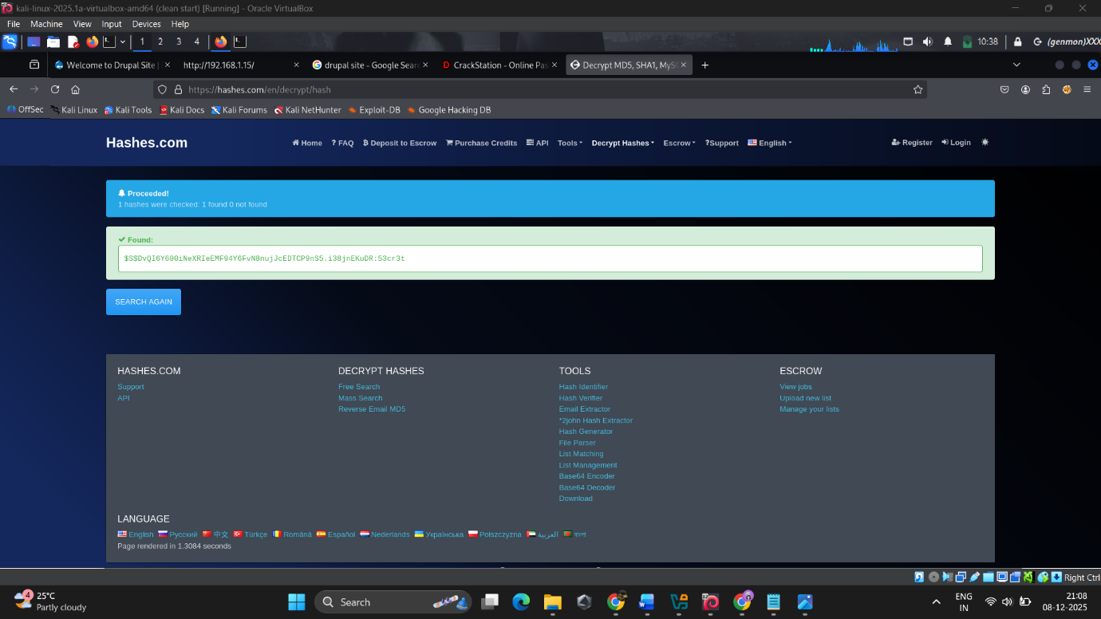
- $S$DvQI6Y600iNeXRIeEMF94Y6FvN8nujJcEDTCP9nS5.i38jnEKuDR:53cr3t

- Cracking it we get the password as “53cr3t”.\
- Now lets navigate into the website running on the http(80) port.
- Using the username “admin” : password “53cr3t”, login into the draulpal site as admin user.!

14. We can find the next flag at dashboard !.

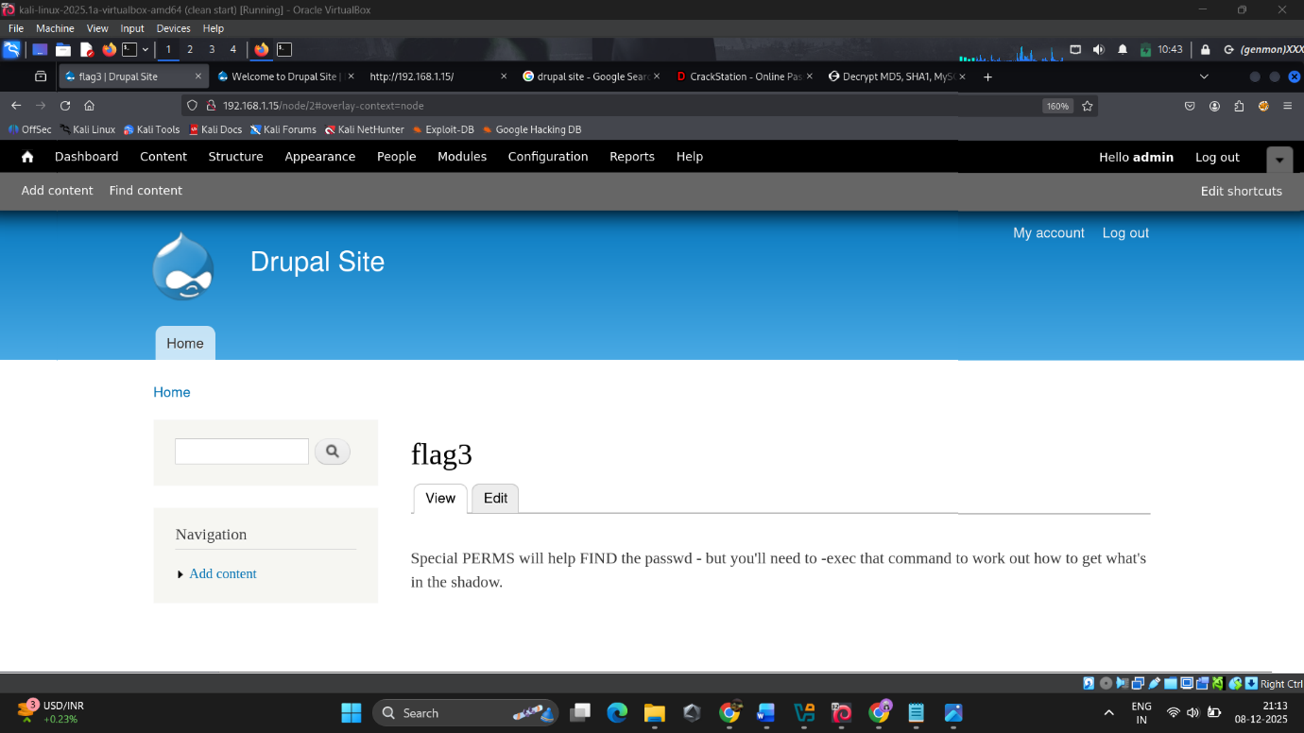
15. So as of this flag we need to get privilege to get the next flag.

16. Scrolling through the /home directory, found that there was the fourth flag inside the /flag directory.

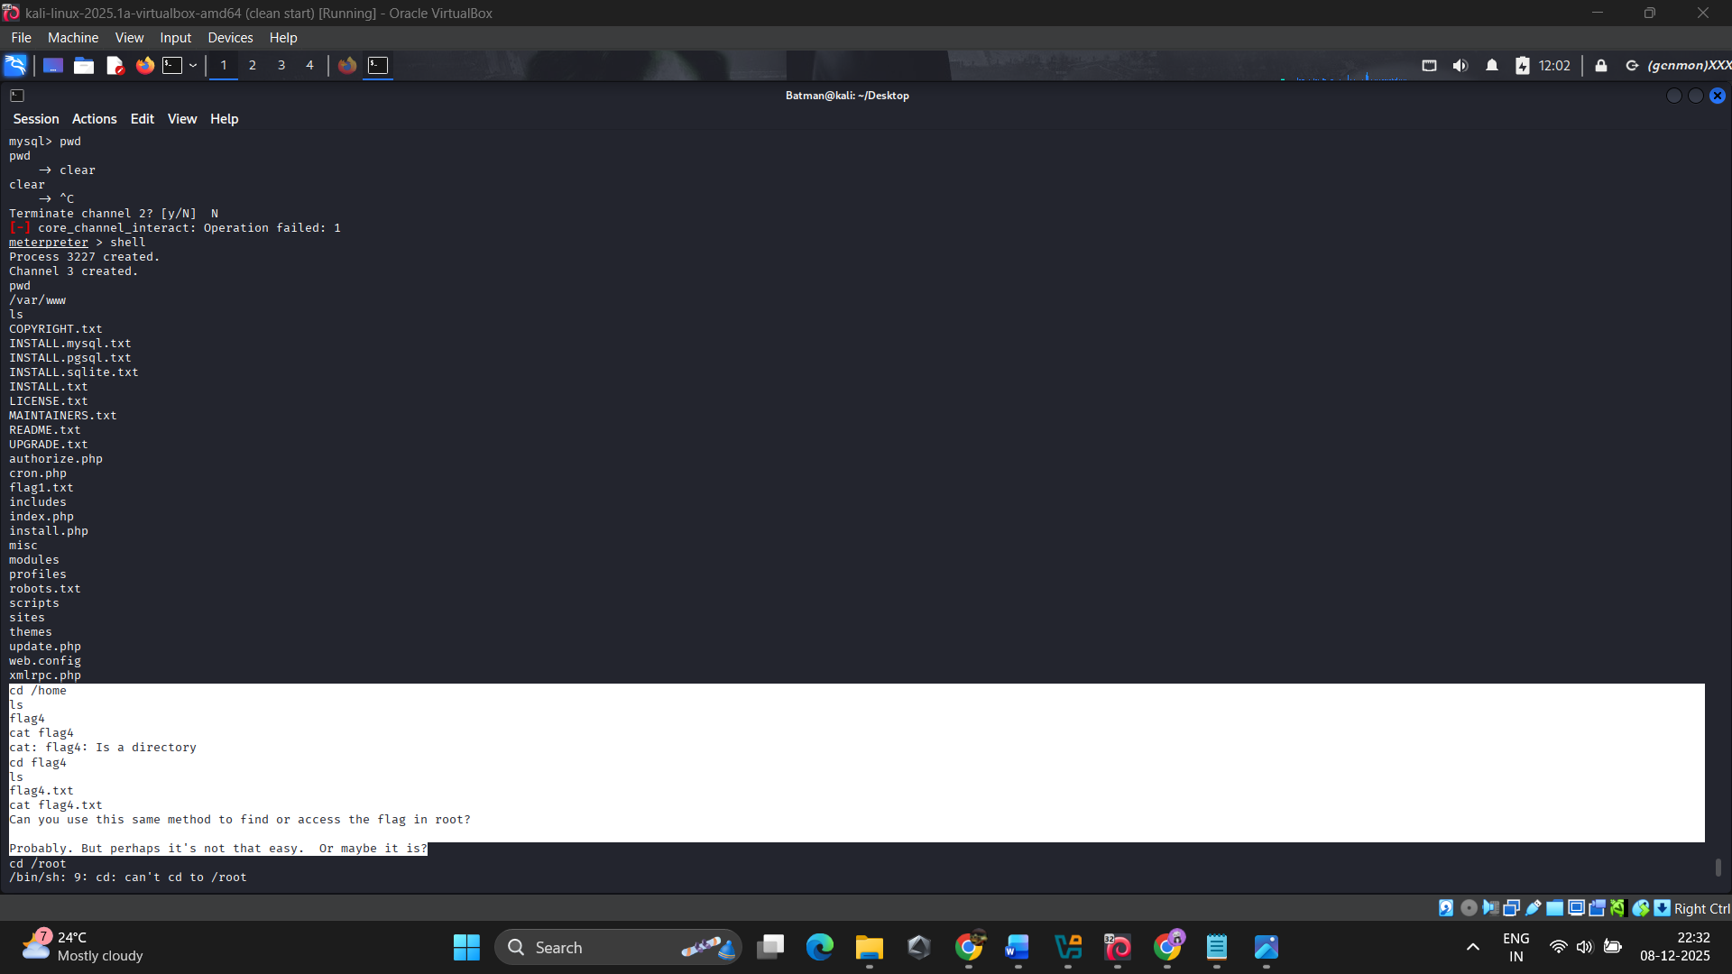

- So the final flag was in /root directory, but we can’t access the root directory.

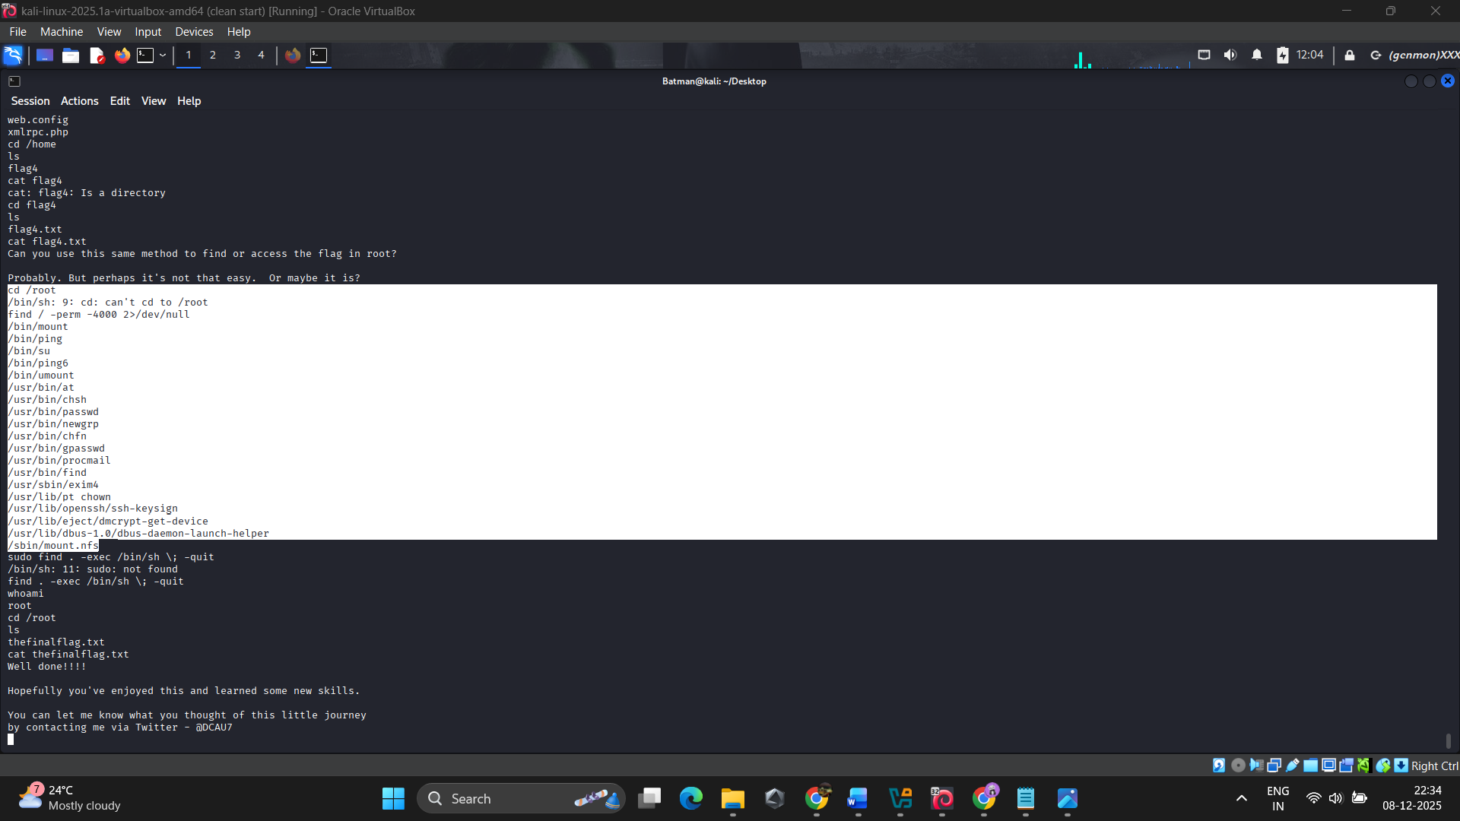
- To find the root privileged command or file we use the command “find / -perm -4000 2>/dev/null”
- It will show all the files/cmmnds in /bin has the root privilege.
- Found that “find” command has the privilege access.

16. Searched for “find” cmmnd privesc in GTFobins, and found :

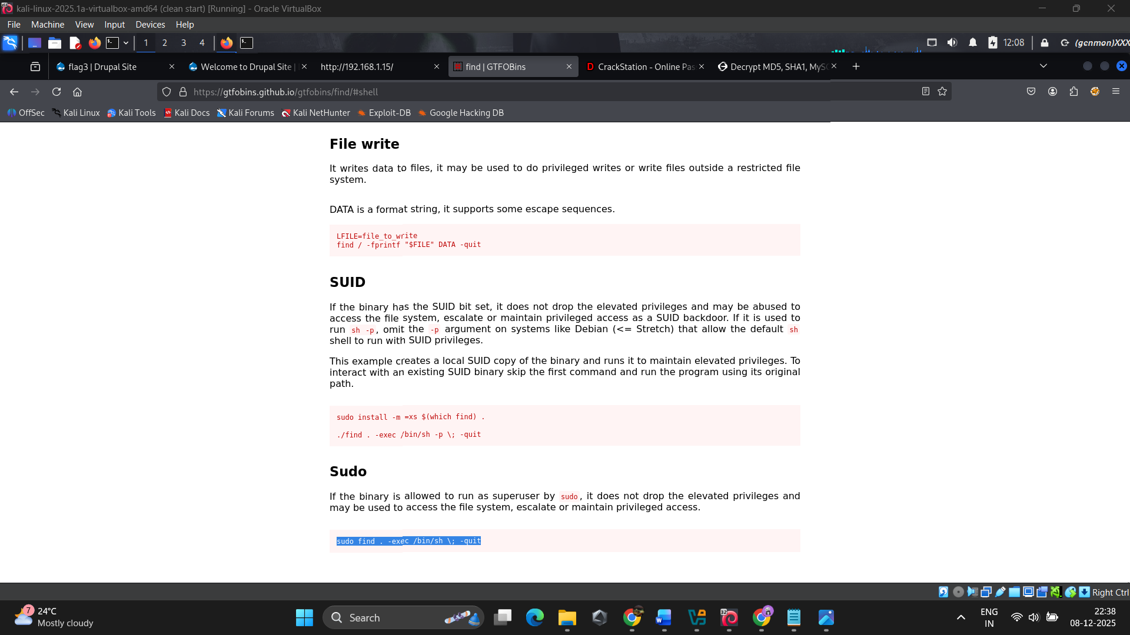

17. Using that sudo privesc command, easily got the root access in the victim machine.

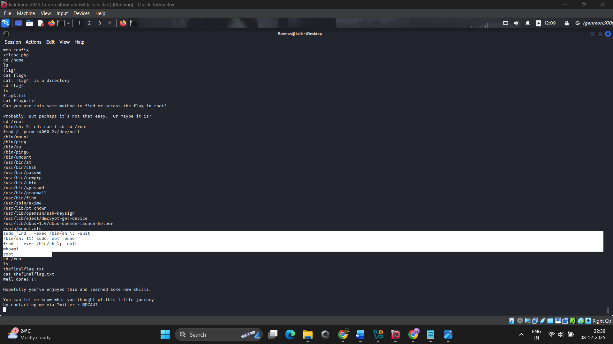

18. Gets into the /root and finds “thefinalflag.txt”.\

