REAL-TIME AI-POWERED ONLINE INTERVIEW SYSTEM
Name: K. Chennakesava Reddy
Roll. No: 1304-24-862-146
Group: 2nd year (MCA)
College: Aurora’s PG College
Sections: C1
ABSTRACT
In the modern digital era, the recruitment process has become increasingly complex due to the growing number of candidates applying for various technical and non-technical roles. Organizations require efficient and intelligent methods to evaluate candidate skills, knowledge, and performance in a structured manner. Traditional interview processes often rely on manual evaluation or basic online tools, which lack automation, consistency, and real-time performance tracking. To overcome these limitations, the Real-Time AI-Powered Interview System is proposed as a web-based platform that automates and streamlines the interview process.
The main problem addressed in this project is the inefficiency and lack of structure in traditional interview systems. Manual evaluation consumes significant time and may lead to inconsistent results due to human bias. Additionally, there is no centralized platform to manage candidate data, conduct structured interview rounds, and generate instant results. This creates difficulties for both recruiters and candidates in ensuring fair and accurate assessment.
The scope of the Real-Time AI-Powered Interview System is to develop a web-based application that enables candidates to participate in structured interviews remotely. The system supports multiple interview rounds such as aptitude and technical questions, evaluates responses automatically, and generates real-time results. It also provides a user-friendly interface for both candidates and administrators, making it suitable for educational institutions and organizations.
The plan of action for developing this system begins with requirement analysis and system design. The application is developed using Python with the Flask framework for backend processing and HTML, CSS, and JavaScript for frontend design. A database is used to store user data, questions, and results. The system is implemented module-wise, including user management, interview processing, and evaluation. After development, the system is tested to ensure proper functionality before deployment.
INTRODUCTION
In today’s rapidly evolving digital world, the demand for skilled professionals has increased significantly across various industries. Organizations are continuously seeking efficient methods to identify and recruit candidates who possess strong technical knowledge, problem-solving abilities, and communication skills. The interview process plays a crucial role in this selection, as it serves as the primary means of evaluating a candidate’s capabilities. However, traditional interview methods often struggle to keep up with the increasing scale and complexity of recruitment processes.
Conventional interview systems, whether conducted face-to-face or through basic online platforms, are often time-consuming and lack standardization. Recruiters are required to manually assess candidate responses, which can lead to inconsistencies and potential bias in evaluation. Additionally, managing a large number of candidates becomes challenging without a centralized system, resulting in inefficiencies in scheduling, tracking performance, and maintaining records. Candidates also face difficulties in adapting to real interview environments due to limited access to structured practice platforms.
With the advancement of web technologies and artificial intelligence, there is a growing opportunity to modernize and automate the interview process. Intelligent systems can now be developed to provide real-time evaluation, structured question delivery, and automated result generation. These systems not only reduce the workload of recruiters but also ensure fair and consistent assessment of candidates based on predefined criteria.
The Real-Time AI-Powered Interview System is designed to address these challenges by providing a comprehensive web-based solution for conducting interviews. The system enables candidates to register, log in, and participate in structured interview rounds such as aptitude and technical assessments. It incorporates intelligent evaluation mechanisms to analyze responses and generate results instantly, thereby improving accuracy and efficiency.
SYSTEM ANALYSIS
The system analysis phase focuses on understanding the limitations of the existing interview process and identifying the requirements for an improved solution. In traditional systems, interviews are conducted manually or through basic online platforms without proper structure or automation. Recruiters evaluate candidates based on individual judgment, which may lead to inconsistencies and inefficiencies. Additionally, managing multiple candidates and maintaining records becomes difficult without a centralized system. These challenges highlight the need for a more organized and automated approach.
The proposed Real-Time AI-Powered Interview System addresses these issues by providing a structured and intelligent platform for conducting interviews. It automates candidate evaluation, manages interview rounds efficiently, and generates real-time results. The system ensures accuracy, reduces manual effort, and maintains proper data records. By integrating modern web technologies and AI-based logic, it improves the overall efficiency and transparency of the recruitment process. This makes the system more reliable and scalable for handling large numbers of candidates.
EXISTING SYSTEM :
In the existing system, interviews are typically conducted through manual processes or basic online platforms such as video conferencing tools. Recruiters ask questions directly to candidates and evaluate their responses based on personal judgment. While this method allows communication between interviewer and candidate, it lacks a structured approach for conducting interviews and assessing performance.
Candidates are often required to take separate tests for aptitude or technical evaluation, which are not integrated into a single platform. This leads to a fragmented process where recruiters must manage multiple tools and manually track candidate performance. Additionally, there is no automated system for storing responses or generating results instantly.
The absence of real-time evaluation and centralized data management makes the process time-consuming and inefficient. Recruiters must spend additional time reviewing answers and calculating scores, which may result in delays and inconsistencies. Overall, the existing system does not provide a scalable or efficient solution for handling large numbers of candidates.
DISADVANTAGES:
- The interview process is manual and time-consuming, requiring significant effort from recruiters to evaluate each candidate individually.
- Lack of a structured system leads to inconsistent evaluation, as different candidates may be assessed using different criteria.
- There is no centralized platform to manage candidate data, interview rounds, and results efficiently.
- Absence of real-time evaluation delays result generation and affects the overall recruitment process.
- High chances of human error and bias during manual assessment of candidate performance.
- Difficulty in handling a large number of candidates simultaneously.
- Limited use of technology results in reduced efficiency and poor candidate experience.

PROPOSED SYSTEM
The proposed Real-Time AI-Powered Interview System is designed to provide an automated and structured platform for conducting interviews efficiently. The system allows candidates to register, log in, and participate in multiple interview rounds such as aptitude and technical assessments. It records candidate responses and evaluates them automatically using predefined logic, ensuring consistency and accuracy. This eliminates the need for manual evaluation and reduces the overall time required for the recruitment process.
In addition, the system maintains a centralized database to store candidate information, responses, and results. Administrators can manage interview questions, monitor candidate performance, and generate reports easily. The system also provides real-time result generation and a user-friendly interface, improving both candidate experience and administrative control. Overall, the proposed system enhances efficiency, ensures fair evaluation, and provides a scalable solution for modern recruitment needs.
ADVANTAGES
- Provides automated evaluation, reducing manual effort and saving time.
- Ensures accurate and consistent assessment of candidates using predefined logic.
- Generates results instantly, improving the speed of the recruitment process.
- Maintains a centralized database for efficient data management and tracking.
- Supports structured interview rounds for better organization and fairness.
- Reduces human error and bias during evaluation.
- Easy to use with a user-friendly interface for both candidates and administrators.
- Scalable system that can handle a large number of candidates simultaneously.

HARDWARE REQUIREMENTS
Component | Minimum Requirement | Recommended System
Processor | Intel Dual Core | Intel i3 / i5 or higher
RAM | 2 GB | 4 GB or higher
Hard Disk | 20 GB free space | 50 GB or higher
System Type | Desktop / Laptop | Laptop with Internet
Camera | Basic Webcam | HD Webcam (for face recognition)
Network | Internet Connection | High-speed Internet

SOFTWARE REQUIREMENTS
Software | Description
Operating System | Windows 10 / Windows 11
Programming Language | Python 3.x
Backend Framework | Flask
Frontend Technologies | HTML, CSS, JavaScript
Database | MySQL / SQLite
Development Environment | Visual Studio Code
Web Browser | Google Chrome / Microsoft Edge

MODULES
USER MODULE
The User Module is designed for candidates who participate in the interview process. It allows users to register, log in, and access the interview platform. After authentication, candidates can attend interview rounds such as aptitude and technical assessments. The system displays questions, records responses, and processes them for evaluation.
    - Aptitude
    - Technical
    - Coding
    - HR Voice
    - AI proctoring
    - Results

ADMIN MODULE
The Admin Module is responsible for managing and controlling the entire system. Administrators can manage candidate data, create and update interview questions, and monitor the overall interview process. This module ensures that the system runs efficiently and all interview activities are properly organized.
- Manage user data
- Add, update, or delete questions
- Control interview rounds
- Monitor candidate performance
- Generate reports and view results
ALGORITHM
- Face Detection (AI proctoring module)
- Rule-Based proctoring (Monitoring System)
- Speech Recognition (HR Voice Module)
- Scoring (Aptitude+Technical+Coding)
- State Management (Interview Flow)
- Attempt Management (Multiple Attempts Feature)
- Authentication (Login System)

SYSTEM ARCHITECTURE
The system architecture of the Real-Time AI-Powered Interview System is designed using a three-layer structure consisting of the presentation layer, application layer, and database layer. The presentation layer acts as the user interface where candidates and administrators interact with the system through web pages. It is developed using HTML, CSS, and JavaScript, providing a simple and user-friendly experience for conducting interviews and managing data.
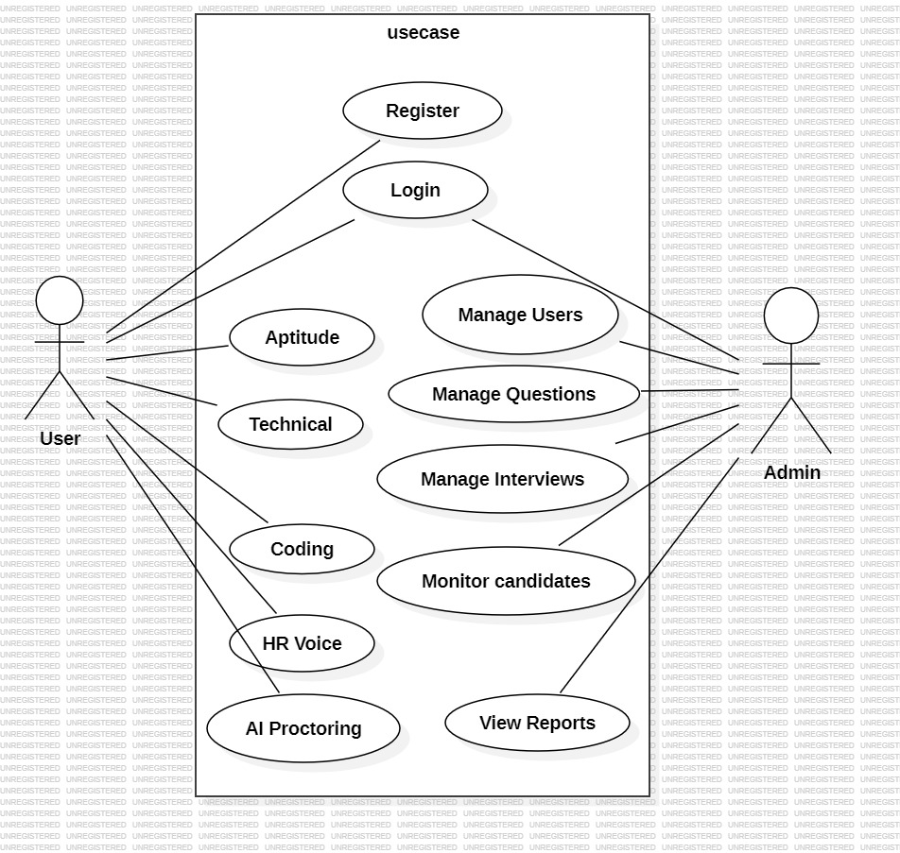
The application layer is implemented using Python with the Flask framework, which handles the core logic of the system such as user authentication, interview management, response evaluation, and result generation. The database layer stores all necessary information including user details, questions, responses, and results. These layers work together to ensure smooth communication, efficient data processing, and reliable system performance.

Use Case

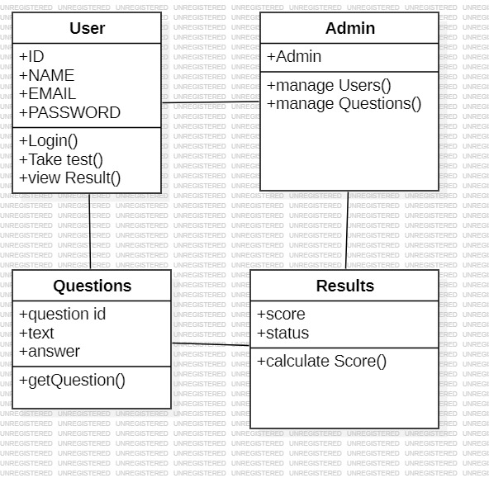
Class diagram

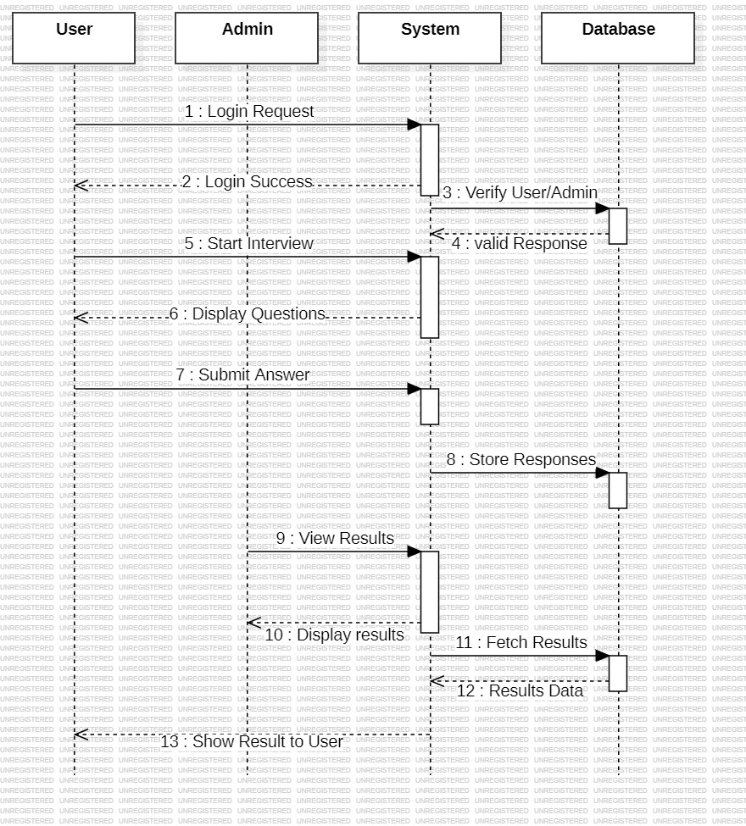
Sequence Diagram

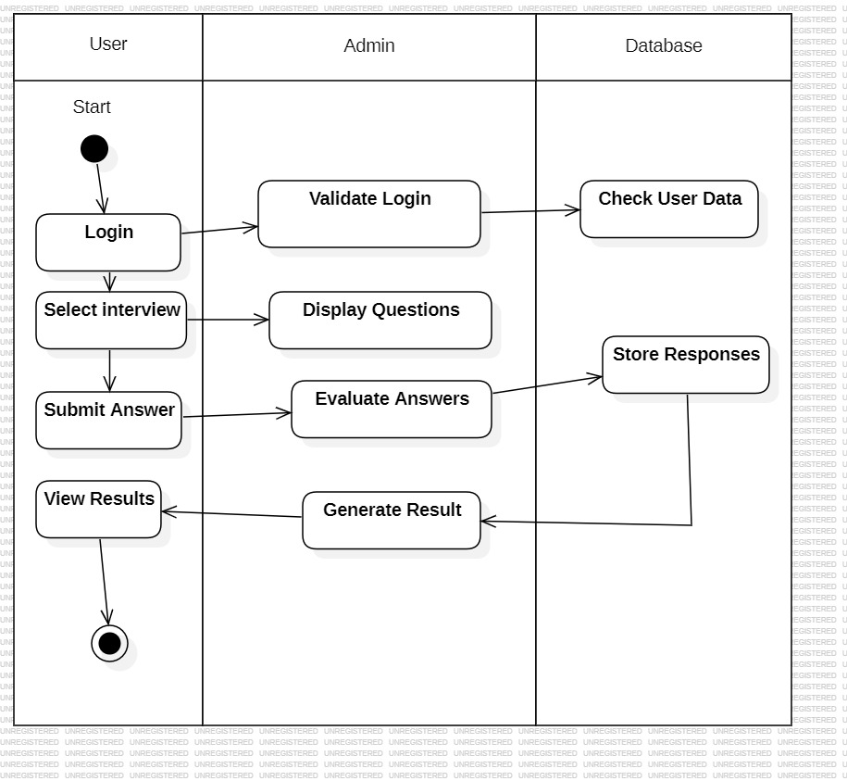
Active diagram

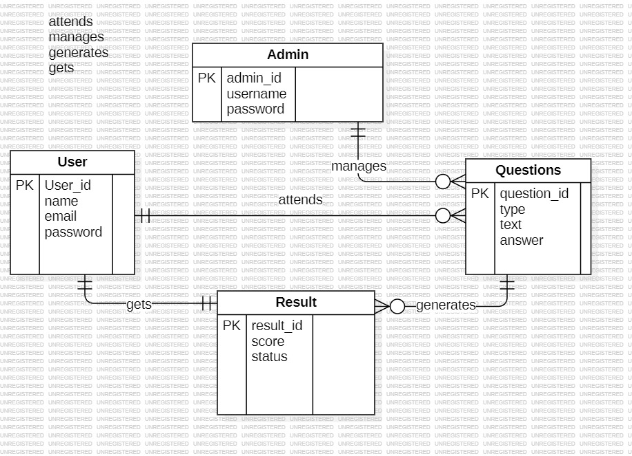
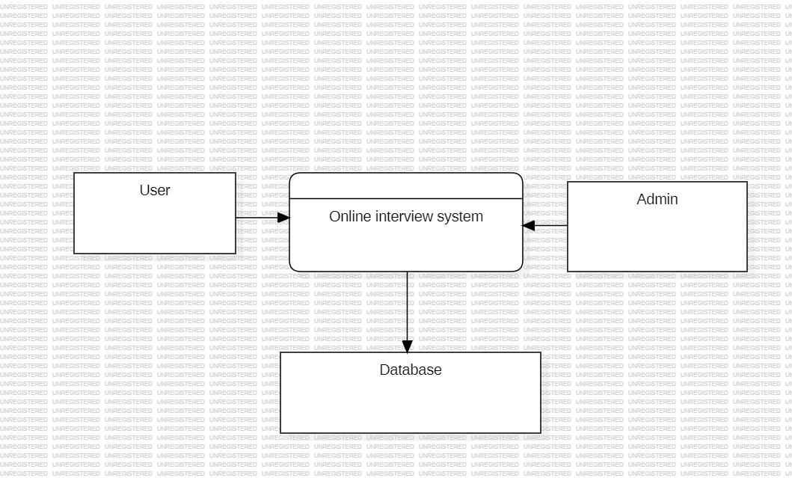
Data flow diagram
ER diagram

