Software-Defined Networking (SDN) DDoS Detection, Analytics, and Mitigation
Proposed Methodology, Architecture Design, Multi-Model ML Implementation & Benchmark Results
Project Title | SDN DDoS Detection and Closed-Loop Mitigation Framework
Domain / Subject | Big Data Analytics & Network Security (OpenFlow 1.3, Ryu, PySpark)
Core Focus | Proposed Methodology (System Architecture) & 4-Algorithm ML Evaluation
Target Platform | Mininet Emulated Fabric + Ryu SDN Controller + PySpark Feature Pipeline
Evaluated Models | Random Forest, Decision Tree, Logistic Regression, K-Nearest Neighbors
Threat Coverage | 13 Traffic Classes (1 Benign Baseline + 12 Multi-Vector DDoS Attacks)
Dataset Scale | 39,000 Observation Windows (Balanced Controlled Telemetry)

1. Executive Summary & Problem Formulation
Distributed Denial of Service (DDoS) attacks represent one of the most severe operational threats to modern enterprise networks, cloud datacenters, and telecommunications backbones. By saturating bandwidth or overwhelming state tables with maliciously crafted traffic, attackers render critical digital services inaccessible to legitimate users.
Software-Defined Networking (SDN) fundamentally transforms network architecture by decoupling the control logic (Control Plane) from packet-forwarding hardware (Data Plane). This separation affords network operators centralized global visibility, programmatic traffic engineering, and real-time flow management via standardized protocols like OpenFlow 1.3. However, this same centralized architecture introduces acute security vulnerabilities:
- High-volume transport-layer floods can create OVS flow-table pressure and saturate emulated links. Hardware TCAM capacity is not measured in this software-emulated lab.
- Control Plane Starvation: Unmatched malicious packets trigger asynchronous OFPPacketIn messages, inundating the southbound control channel and exhausting the controller's CPU and memory.
- Reactive Processing Bottlenecks: Traditional signature-based intrusion detection fails against zero-day volumetric surges, dynamic spoofing, and low-rate application stress (e.g. Slowloris).
This project presents a proposed end-to-end framework. The currently implemented scope is the emulated SDN topology, telemetry collection, synthetic dataset generation, analytics, and offline model evaluation; streaming feature extraction and automated mitigation are planned:

2. Proposed Methodology & System Architecture
The proposed methodology bridges low-level OpenFlow switch telemetry with machine learning inference through a modular, six-tier architecture designed for high throughput, minimal control-plane overhead, and automated closed-loop defense.
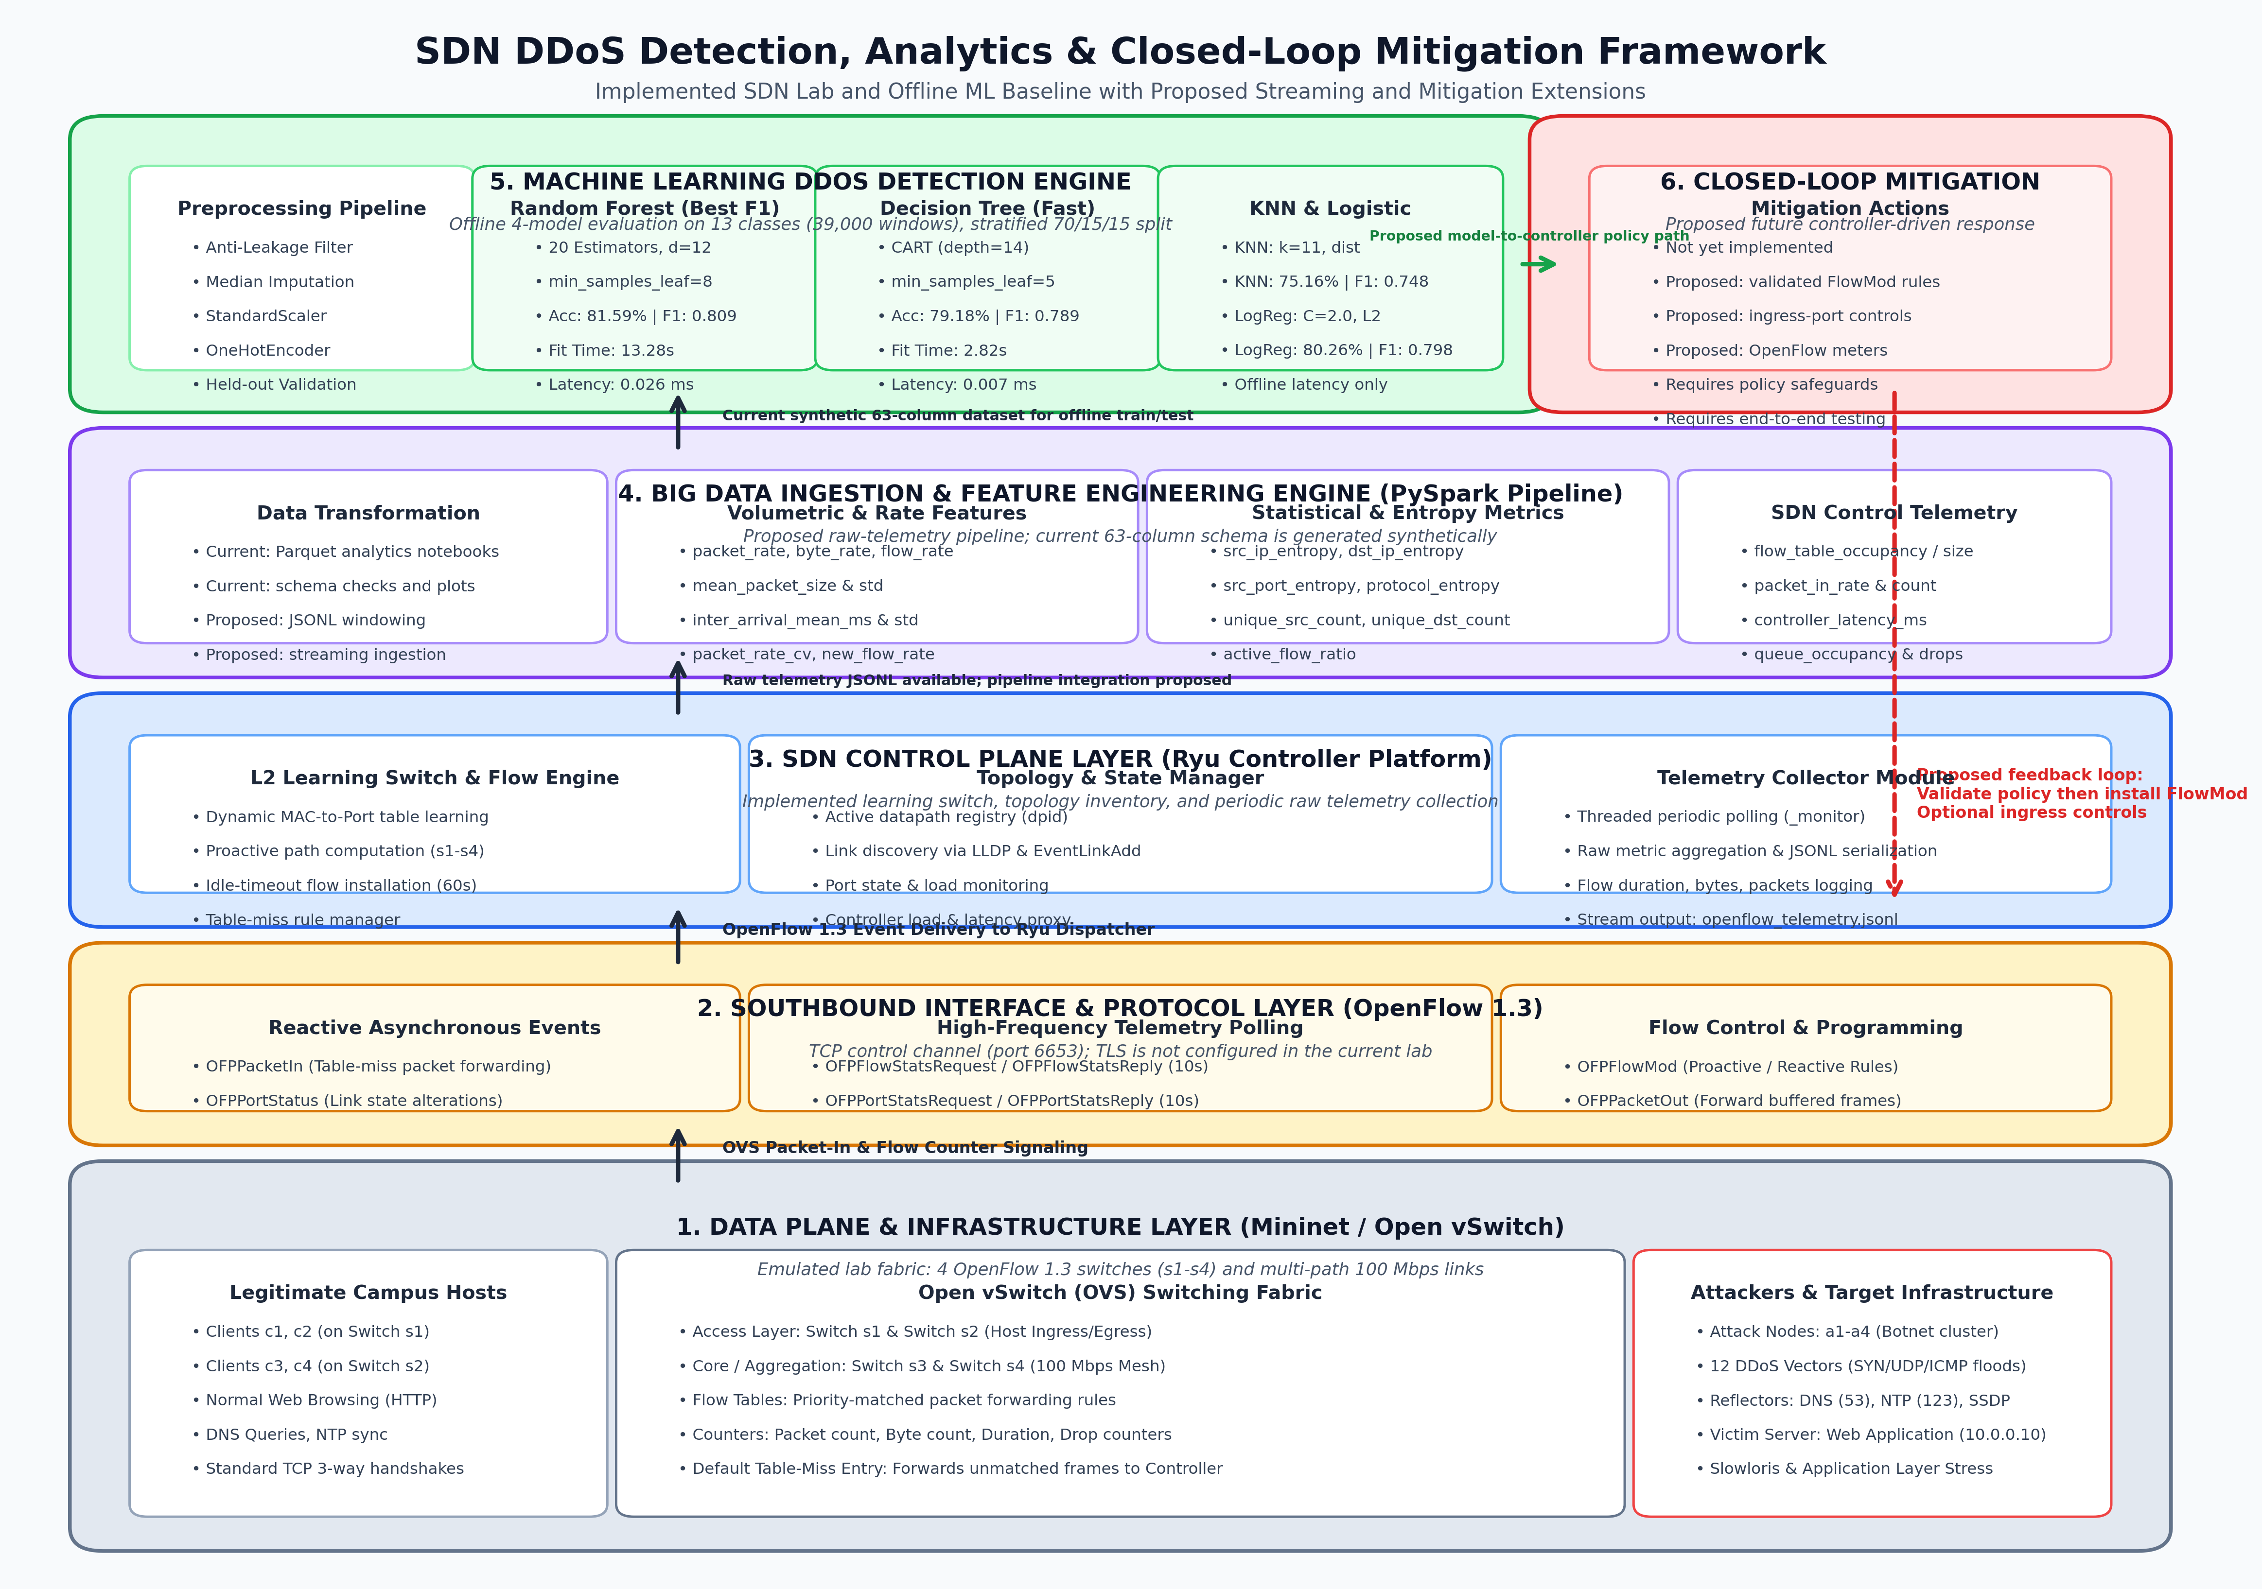
Figure: End-to-End SDN DDoS Detection, Analytics & Closed-Loop Mitigation System Architecture

2.1 Detailed Architectural Component Breakdown

Component 1: Data Plane & Infrastructure Emulation Layer (Mininet / Open vSwitch)
The emulated laboratory network is implemented in Mininet using Open vSwitch (OVS) switches configured with OpenFlow 1.3. The laboratory topology (SdnDdosLabTopology) is a switched campus network:
- Access Layer (Switches s1, s2): Directly terminate host connections. Endpoints are allocated addresses across 10.0.0.0/16, allowing OVS to operate as an L2 forwarding plane while preserving host-switch ingress associations.
- Core / Aggregation Layer (Switches s3, s4): Interconnected with access switches in a resilient mesh topology utilizing 100 Mbps links (TCLink) to enable multi-path forwarding, trunking, and path diversity.
- Legitimate Endpoints (c1 - c4): Generate normal operational traffic including HTTP web browsing, DNS name queries, and NTP time synchronization with standard TCP 3-way handshakes.
- Attacker Cluster (a1 - a4): Coordinated botnet agents capable of launching 12 distinct attack vectors ranging from raw packet floods to subtle protocol-state exhaustion.
- Target Services & Reflectors: Victim application servers hosting HTTP (10.0.0.10:80), DNS (10.0.0.53:53), NTP (10.0.0.123:123), and SSDP (10.0.0.190:1900).

Component 2: Southbound Interface & Protocol Layer (OpenFlow 1.3 Channel)
over a TCP control channel on port 6653. TLS is not configured in the current laboratory code:
- When an access switch receives a frame that misses installed OVS flow entries
- OFPFlowMod: Enables the controller to modify switch flow tables proactively or reactively. Each rule defines match criteria (ingress port, Ethernet/IP headers), priority levels (0 to 65535), timeouts (idle_timeout=60), and actions (OUTPUT, DROP).
- capturing byte counts, packet counts, active flow durations, and port-drop counters. This collection does not measure hardware or line-rate performance.

Component 3: SDN Control Plane Layer (Ryu Framework)
The centralized network operating system is implemented as a specialized Ryu application (SdnDdosController):
- L2 Learning Switch: Maintains dynamic MAC-to-Port tables per datapath. Once host locations are learned, explicit flow entries are installed with 60-second idle timeouts to prevent redundant controller interventions.
- Topology & Link State Manager: Tracks active datapath IDs (dpid) and maintains global network topology using LLDP discovery and switch enter/exit event listeners.
- Telemetry Collector Thread (_monitor): Executes an asynchronous polling daemon that queries every connected switch for flow and port statistics every 10 seconds. Collected records are serialized and appended to data/raw/openflow_telemetry.jsonl.

Component 4: Big Data Ingestion & Feature Engineering Engine (PySpark Pipeline)
The current Python dataset generator produces a 63-column controlled synthetic telemetry schema. PySpark notebooks currently analyze the generated Parquet dataset; raw JSONL-to-window feature extraction is a proposed next step:
Feature Category | Count | Representative Extracted Telemetry Metrics
Temporal & Contextual | 15 | timestamp_utc, window_id, switch_id, ingress_port, egress_port, protocol, window_seconds, hour_of_day
Volumetric & Rates | 15 | packet_rate, byte_rate, flow_rate, mean_packet_size, packet_size_std, inter_arrival_mean_ms, packet_rate_cv
Entropy & Statistics | 6 | src_ip_entropy, dst_ip_entropy, src_port_entropy, protocol_entropy, unique_src_count, unique_dst_count
Protocol & TCP Dynamics | 9 | tcp_syn_count, tcp_ack_count, tcp_rst_count, tcp_syn_ratio, tcp_handshake_completion_ratio, udp_fragmentation_ratio
SDN Control Telemetry | 11 | flow_table_size, flow_table_occupancy, packet_in_rate, packet_in_count, controller_latency_ms, dropped_packet_rate
Metadata & Ground Truth | 7 | attack_intensity, attacker_count, background_traffic_level, label, attack_family, data_source, schema_version

Component 5: Machine Learning DDoS Detection Engine
The offline machine learning notebook consumes generated feature records, applies median imputation, standard scaling, and one-hot encoding, and classifies traffic into one of 13 categories. It excludes identifiers, simulation constants, protocol/application fields, and generated time fields (day_of_week and hour_of_day) to reduce synthetic-data leakage.

Component 6: Closed-Loop Automated Mitigation & Feedback Mechanism
The following closed-loop defense is proposed for the next implementation stage; it is not yet connected to the current Ryu controller:
- In the proposed deployment, the classifier would extract the offending ingress switch, port, source identity, and predicted attack class before handing the decision to a policy module.
- The proposed controller would transmit high-priority OFPFlowMod DROP rules only after the model-to-controller policy path and safeguards have been implemented and tested.
- The proposed controller could temporarily isolate or throttle an ingress port for spoofed floods, subject to a policy that protects legitimate traffic.
- The proposed controller could use OpenFlow 1.3 Meter Tables for rate limiting after meter support and enforcement logic are implemented.

3. Implementation: The Four Machine Learning Algorithms
To evaluate detection effectiveness on the controlled synthetic dataset, we implemented and evaluated four algorithms representing different learning paradigms. Model settings are fixed in the notebook rather than selected through a hyperparameter search:

3.1 Mathematical Formulations & Hyperparameters

1. Random Forest Classifier (Ensemble Bagging)
Random Forest builds an ensemble of B=20 decorrelated decision trees with bounded depth, each trained on a bootstrap sample of the training data. At each node, the split is chosen from a randomly sampled feature subspace (max_features=0.7), maximizing Gini impurity reduction. Final classification is determined by majority voting. Hyperparameters: n_estimators=20, max_depth=12, min_samples_leaf=8, max_features=0.7, class_weight='balanced_subsample', random_state=42.

2. Decision Tree Classifier (CART Algorithm)
Decision Trees are interpretable, but a trained tree cannot be mapped directly to the current OpenFlow rules without a separate policy-translation and validation step.

3. Logistic Regression (Multinomial / Softmax)
Multinomial Logistic Regression models class probabilities with a softmax function and is optimized using regularized cross-entropy loss. Hyperparameters: C=2.0, max_iter=400, class_weight='balanced', solver='lbfgs', random_state=42.

4. K-Nearest Neighbors (KNN - Distance Metric Classifier)
KNN is an instance-based non-parametric classifier that assigns labels based on the local geometric density of training samples in the standardized metric space. Given query vector x, KNN computes the Euclidean distance to all stored instances and assigns the label with the highest inverse-distance weighted vote among the k=11 nearest neighbors. Hyperparameters: n_neighbors=11, weights='distance', n_jobs=-1.

3.2 Dataset Profile & 13-Class Threat Taxonomy
The models were trained and tested on 39,000 controlled telemetry observation windows balanced perfectly with 3,000 instances per class across 13 distinct categories:
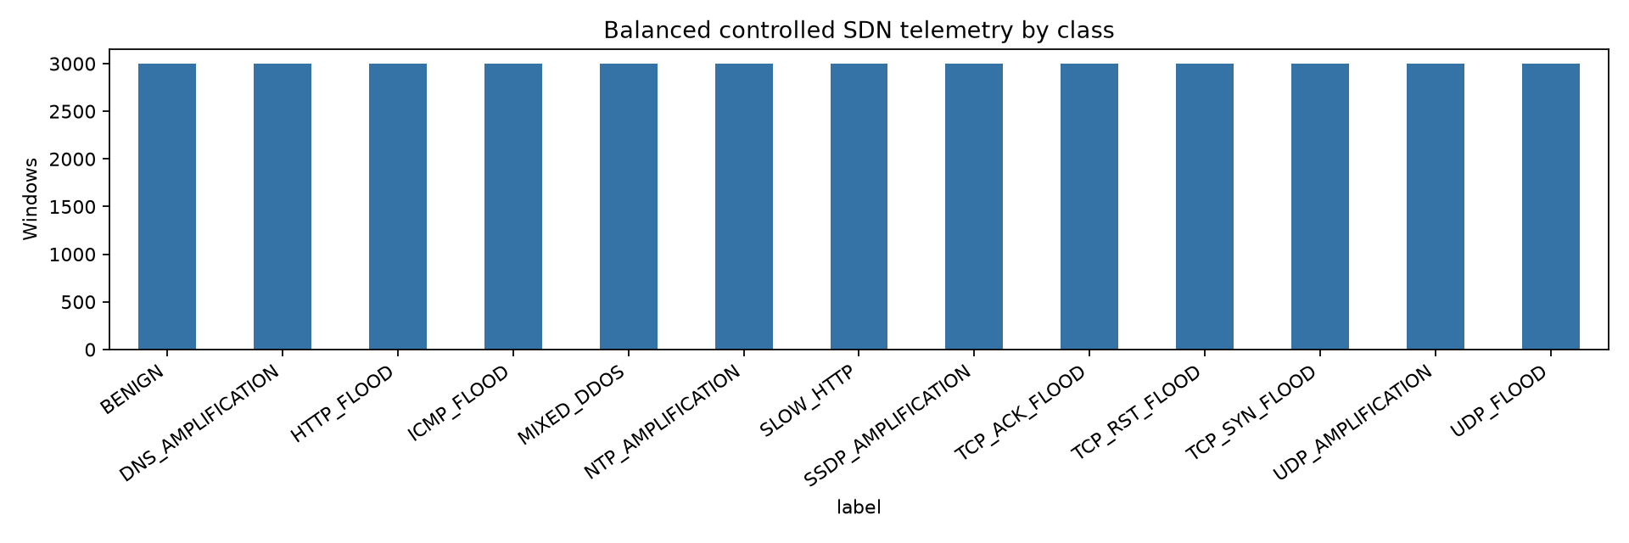
Figure: Balanced Distribution of the 13 SDN DDoS Traffic Classes (3,000 Samples per Class)
The 13 classes span five distinct threat categories: (1) Baseline Normal (BENIGN); (2) Volumetric Transport Floods (UDP_FLOOD, ICMP_FLOOD); (3) Protocol State Floods (TCP_SYN_FLOOD, TCP_ACK_FLOOD, TCP_RST_FLOOD); (4) Application Layer Attacks (HTTP_FLOOD, SLOW_HTTP / Slowloris); and (5) Amplification & Reflection Vectors (DNS_AMPLIFICATION, NTP_AMPLIFICATION, SSDP_AMPLIFICATION, UDP_AMPLIFICATION, MIXED_DDOS).

4. Experimental Results & Quantitative Evaluation
The evaluation used a stratified held-out test partition of 5,850 samples (15% of the controlled synthetic dataset). Model settings are fixed in the notebook; no hyperparameter search was performed.
Machine Learning Model | Held-Out Accuracy | Macro Precision | Macro Recall | Macro F1-Score | Fit Time (s) | Latency (ms/rec)
Random Forest | 0.8159 (81.59%) | 0.8123 | 0.8159 | 0.8085 | 13.275 s | 0.0255 ms
Decision Tree | 0.7918 (79.18%) | 0.7885 | 0.7918 | 0.7891 | 2.822 s | 0.0075 ms
K-Nearest Neighbors | 0.7516 (75.16%) | 0.7464 | 0.7516 | 0.7482 | 0.341 s | 0.1211 ms
Logistic Regression | 0.8026 (80.26%) | 0.7965 | 0.8026 | 0.7978 | 9.151 s | 0.0098 ms

4.1 Comparative Model Performance
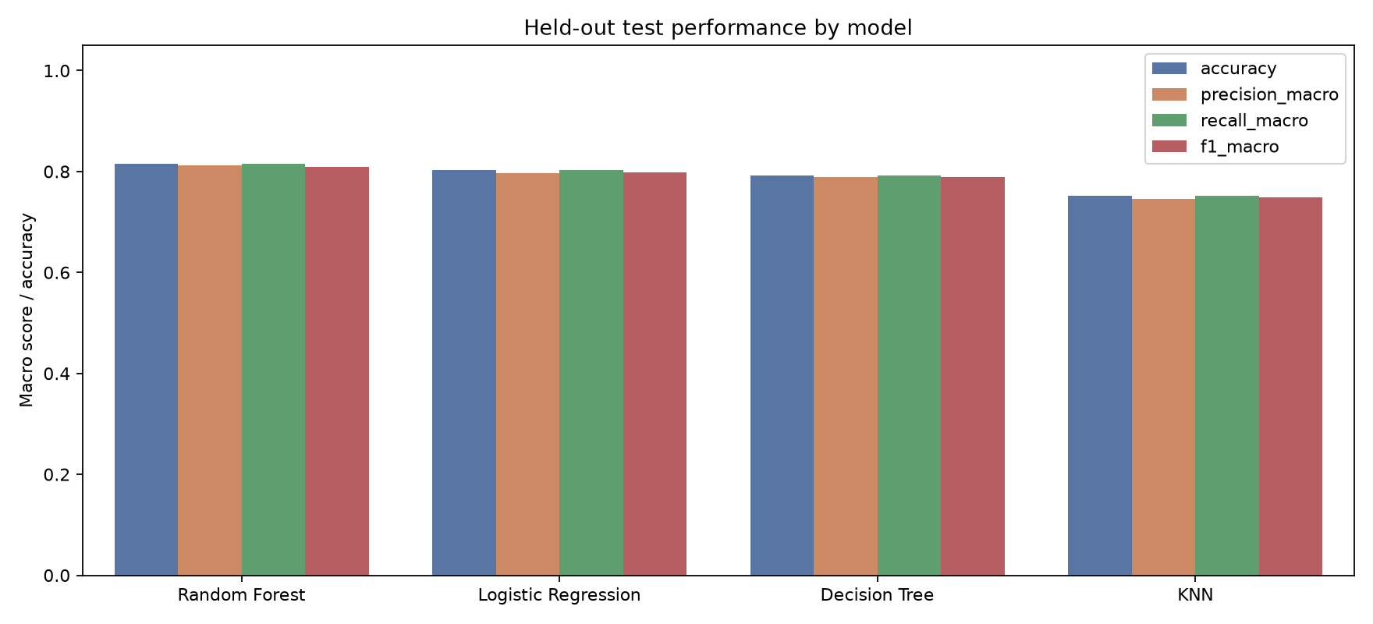
Figure: Held-Out Test Performance Comparison Across Accuracy, Precision, Recall, and F1-Score
On this controlled synthetic split, Random Forest achieved the top overall performance with 81.59% accuracy and 0.8085 macro F1. Logistic Regression achieved 80.26% accuracy and 0.7978 macro F1, Decision Tree achieved 79.18% accuracy and 0.7891 macro F1, and KNN achieved 75.16% accuracy and 0.7482 macro F1. These results measure within-generator separation only and must not be interpreted as live-network or cross-dataset performance.

4.2 Inference Latency & Line-Rate Feasibility
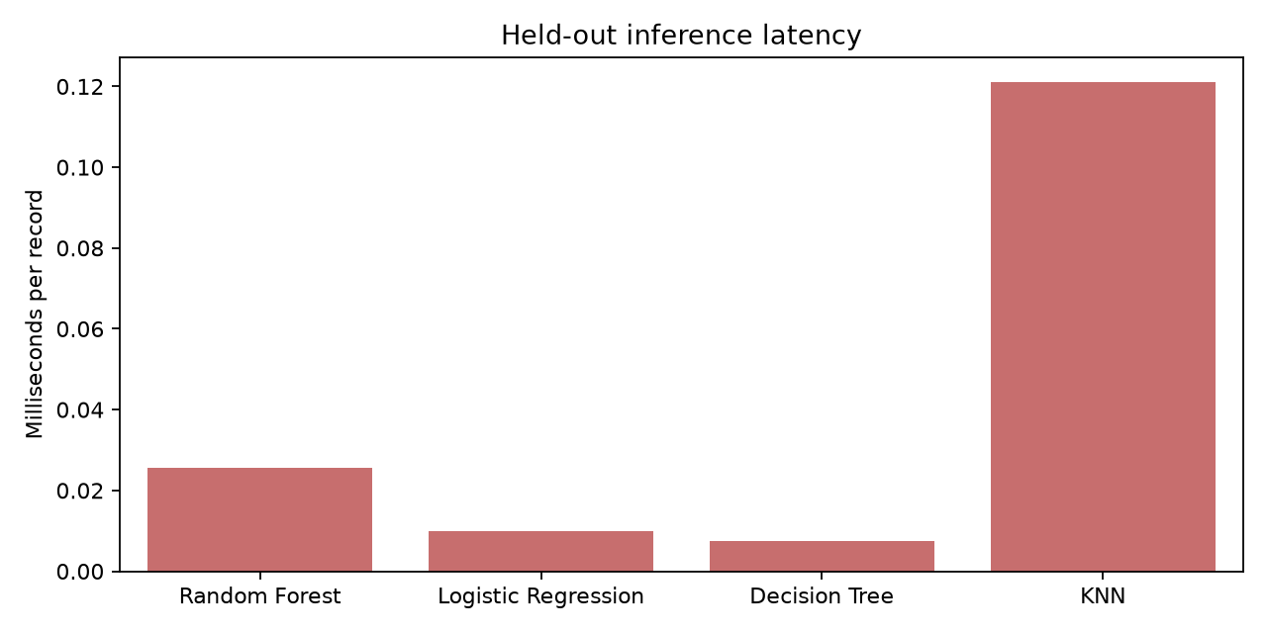
Figure: Held-Out Per-Record Prediction Latency (Milliseconds per Telemetry Window)
The following timings are one local offline Python benchmark of `pipeline.predict` on the held-out batch; they are not end-to-end SDN deployment latency. They exclude telemetry polling, serialization, Kafka/Spark processing, controller decisioning, and FlowMod installation. Logistic Regression was the fastest measured model at 0.0098 ms per record, followed by Decision Tree at 0.0075 ms, Random Forest at 0.0255 ms, and KNN at 0.1211 ms. These values should not be used to claim line-rate or microsecond mitigation capability.

4.3 Normalized Confusion Matrix Analysis
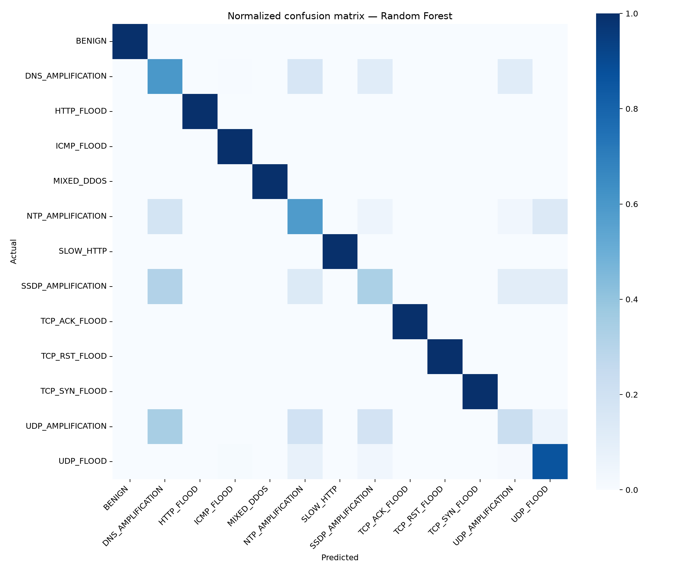
Figure: Normalized 13x13 Confusion Matrix for the Top-Performing Random Forest Model
The normalized confusion matrix summarizes errors for the best controlled-split model. It should be interpreted as a synthetic-data diagnostic; it does not establish zero false positives or performance on live OpenFlow telemetry.

4.4 Global Feature Importance Ranking
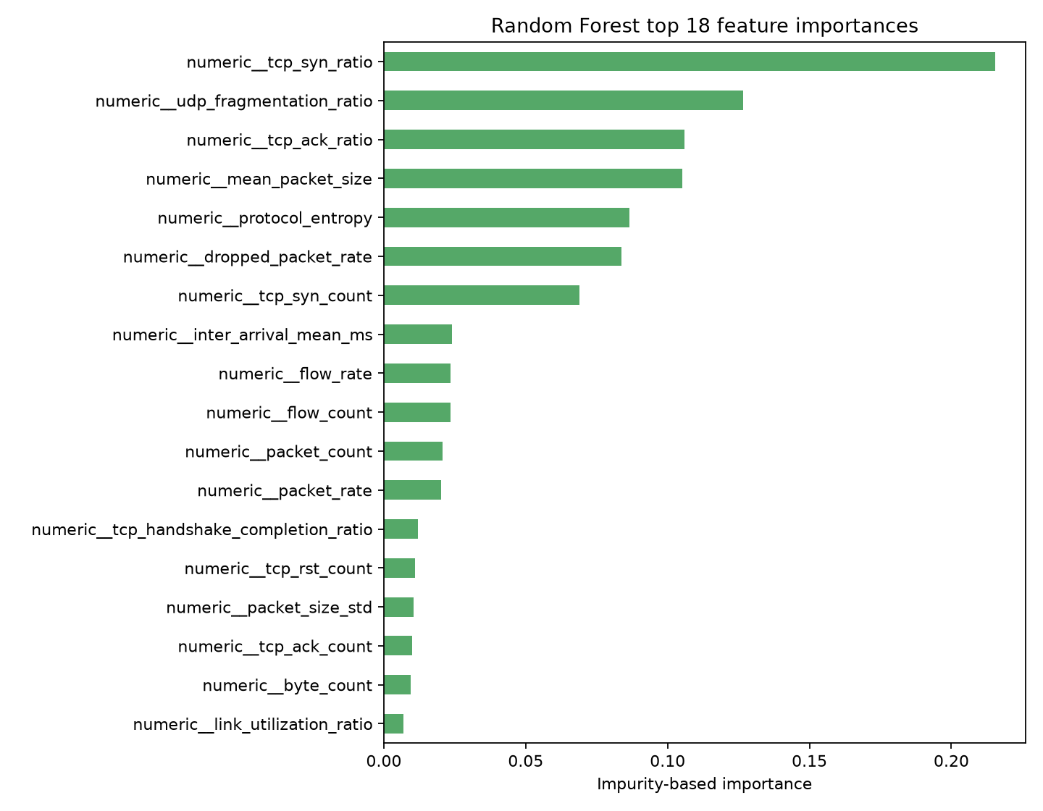
Figure: Top 18 Most Influential Telemetry Features Ranked by Random Forest Impurity Reduction
For the current controlled-split Random Forest, impurity-based importance ranks TCP SYN ratio first, followed by UDP fragmentation ratio, TCP ACK ratio, mean packet size, and protocol entropy. Feature importance is descriptive, not causal, and does not establish operational detection value.
- packet_in_rate & packet_in_count: candidate SDN telemetry signal; it was not a top-ranked feature in the current controlled-split run and requires validation with real controller data.
- flow_table_occupancy & flow_table_size: synthetic flow-table proxies, not measurements of hardware TCAM saturation.
- tcp_syn_ratio & tcp_handshake_completion_ratio: Delineates TCP SYN floods, where SYN ratios approach 1.0 while completion ratios collapse to 0.0.
- packet_rate & byte_rate: Traditional volumetric metrics that distinguish high-bandwidth transport floods from benign web activity.
- src_ip_entropy & dst_ip_entropy: Entropy spikes reveal distributed IP spoofing, whereas entropy drops identify targeted host exhaustion.

4.5 Deployment Recommendations: Two-Tier Hybrid Architecture
Proposed future architecture: a two-tier design may use a low-latency model for candidate alerts and a second model for offline review. It must not be described as deployed until model loading, controller integration, policy enforcement, and end-to-end latency tests are implemented.

5. Conclusion & Reproducibility Guide
This project currently provides an emulated SDN topology and telemetry collector, a controlled synthetic 63-column dataset, analytics notebooks, and an offline four-model evaluation. Kafka/Spark streaming ingestion, raw-telemetry feature extraction, live model inference, and automated mitigation remain planned work.

