Grazioso Salvare Animal Rescue Dashboard README
Description: This project was made for class CS-340 at Southern New Hampshire University. Which is a dashboard that uses MongoDB as well as Python to analyze Austin Animal Center data and is helping Grazioso Salvare be able to identify potential rescue dogs.
Technologies Used:
- Python and MongoDB
- Plotly Dash and Pandas
- Plotly Express and Dash Leaflet
- JupyterLab and Codio
Features:
- Interactive Data Table: Displays the animal records with sorting, filtering and selection.
- Rescue Filters: Includes Water Rescue, Mountain or Wilderness Rescue, Disaster or Individual Tracking, and Rest.
- Pie Chart: Shows the top 10 animal breeds that are based on the selected filters.
- Geolocation Map: Shows where the selected animal’s location using latitude and longitude.
Installation and Usage:
- Open ProjectTwoDashboard.ipynb in Codio JupyterLab.
- Ensure MongoDB is running and the AAC dataset is available.
- Run the notebook cells to launch the dashboard.
- Use the rescue filters data table, pie chart, and map to explore animal records.
Screenshots
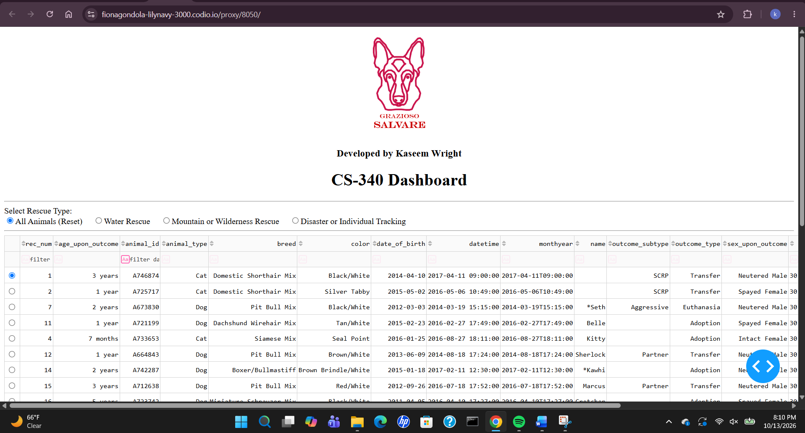
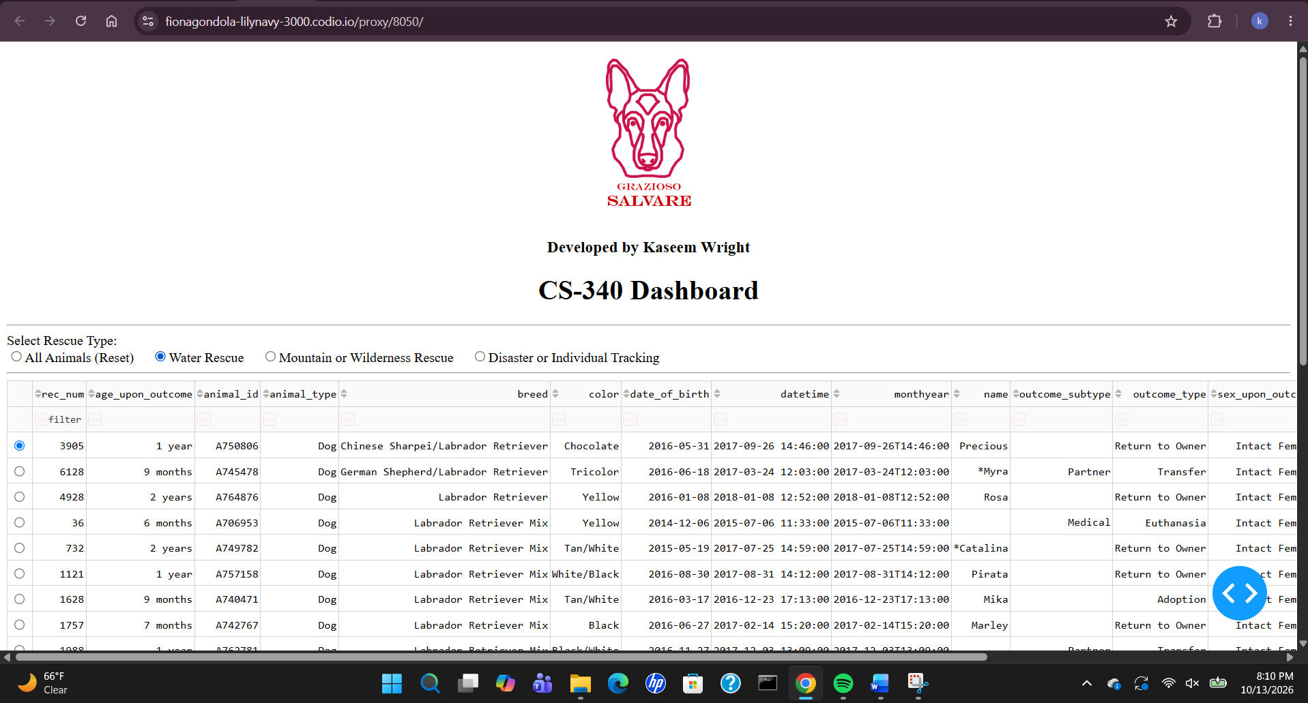
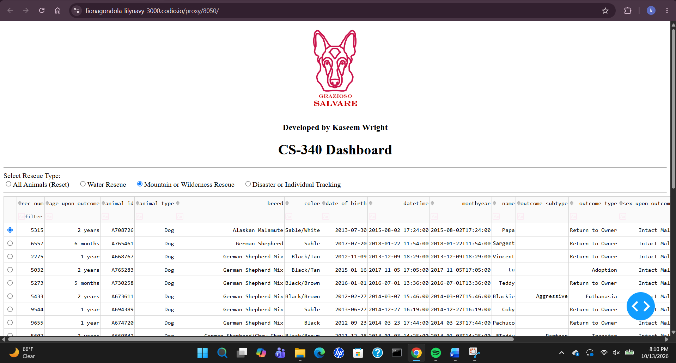
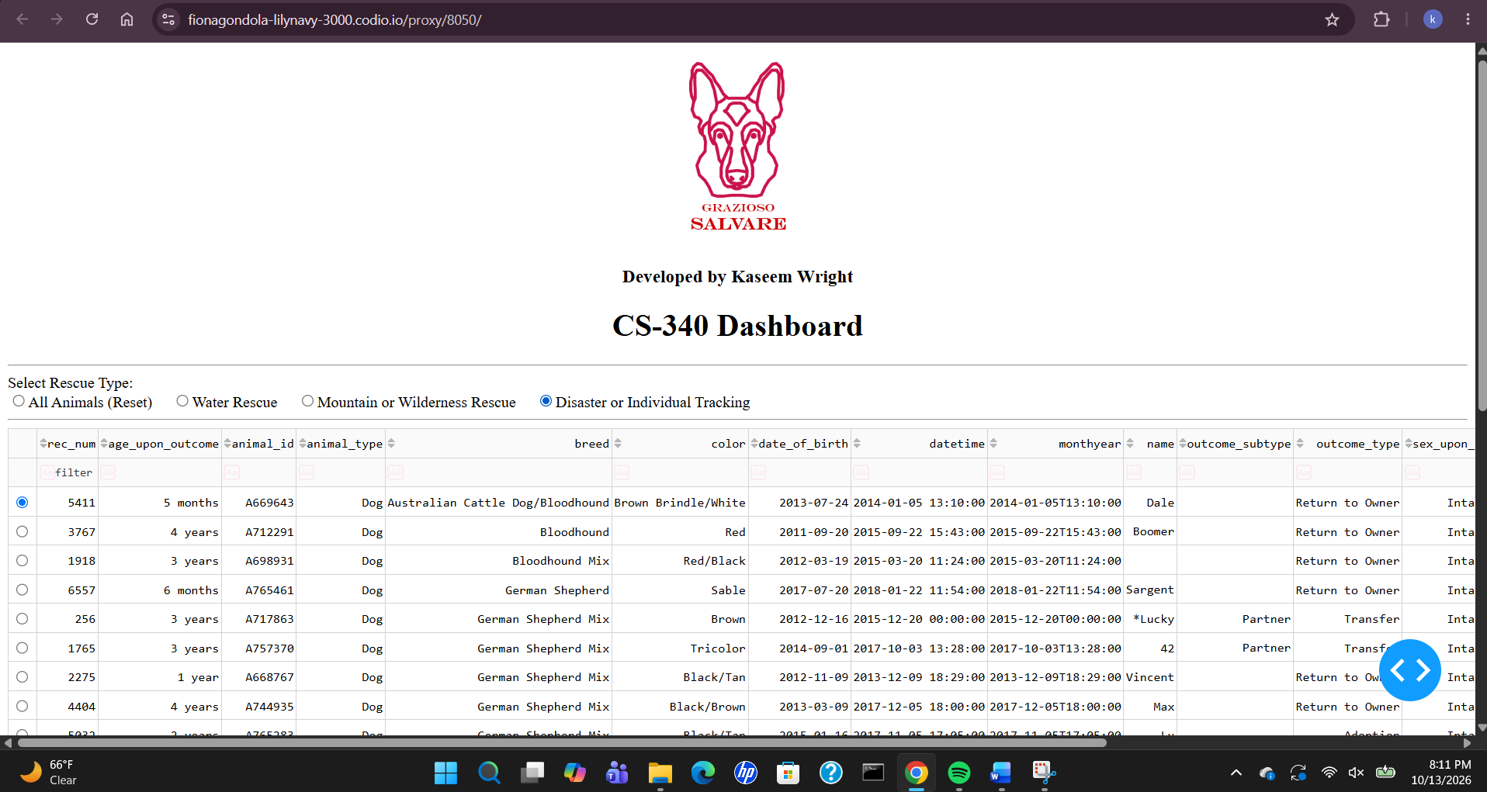
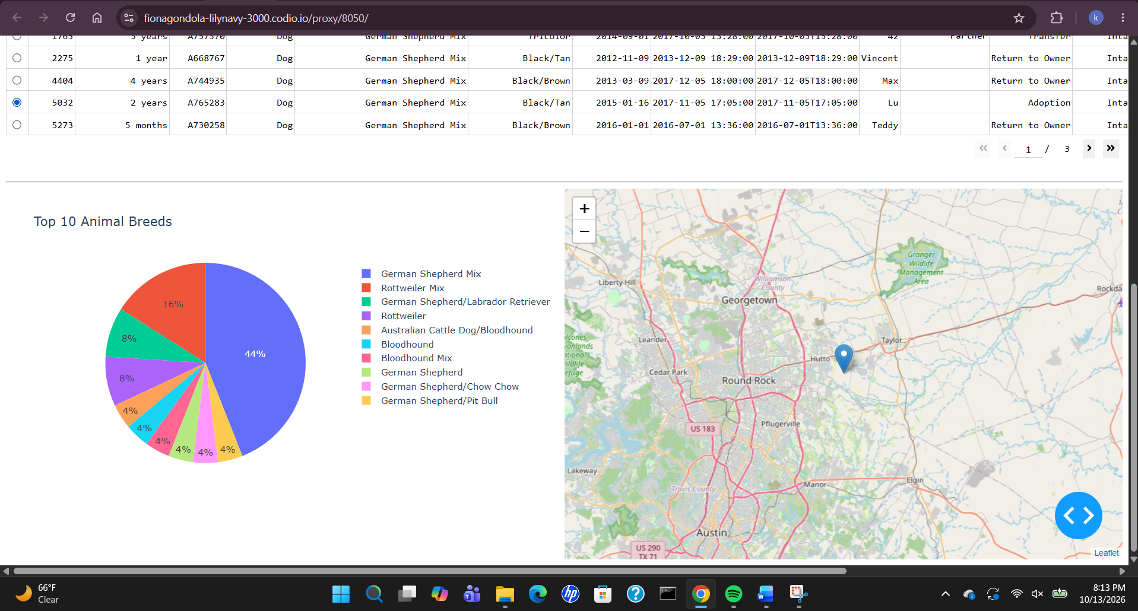
Challenges and Reflection:
One of the main challenges faced while working on this project was implementing callbacks that will update the data table, pie chart as well as the map correctly. But testing and debugging were helpful in resolving these issues.
After working on this project, it has improved my understanding of integrating MongoDB, Python programming, interactive dashboard and Model-View-Controller (MVC) design pattern. And as a result, Ive learned how to be able to transform database records into useful visualization which can be used to aid in decision-making.
Author
Kaseem Wright
Southern New Hampshire University
CS-340: Client/Server Development

