**What is CSS**

CSS stands for Cascading Style Sheets . CSS describes how HTML elements are to be displayed on screen, paper, or in other media

CSS Syntax :- A CSS rule consists of a selector and a declaration block

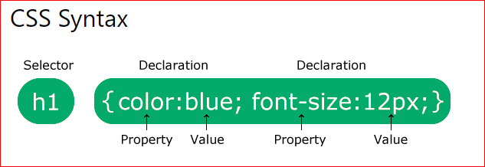

The selector points to the HTML element you want to style. The declaration block contains one or more declarations separated by semicolons. Each declaration includes a CSS property name and a value, separated by a colon. Multiple CSS declarations are separated with semicolons, and declaration blocks are surrounded by curly braces.

**Three Ways to Insert CSS**

* **External CSS**
* **Internal CSS**
* **Inline CSS**

## External CSS :- With an external style sheet, you can change the look of an entire website by changing just one file!

## Internal CSS :- An internal style sheet may be used if one single HTML page has a unique style.

## Inline CSS :- An inline style may be used to apply a unique style for a single element

Note

If you are mention the same style in same tag with inline and external CSS then that case more preference of inline CSS. If you want to increase the preferences of eternal CSS you want to add !important in internal CSS.

In internal and external CSS order is important which is mentioned in first in html document

*<!*DOCTYPE html*>*

*<*html lang="en"*>*

*<*head*>*

*<*meta charset="UTF-8"*>*

*<*meta name="viewport" content="width=device-width, initial-scale=1.0"*>*

*<*title*>*Document*</*title*>*

*<!-- Use Internal css -->*

*<*style*>*

        p{

        background-color: black !important;

        }

*</*style*>*

*</*head*>*

*<*body*>*

*<*h1*>*Type of CSS*</*h1*>*

*<!-- Use inline CSS -->*

*<*p style="background-color: blue;"*>*Lorem ipsum dolor sit amet consectetur adipisicing Reprehenderit ipsa nihil laboriosam dolorem

       accusamus alias? Eius error quidem qui non voluptatum, dolorum ut iure sequi blanditiis delectus, expedita

       animi sed minus obcaecati porro, asperiores doloribus sit officia rem. Nam, voluptate!*</*p*>*

*<*p style="color: brown;"*>*Lorem ipsum dolor sit amet, consectetur adipisicing elit. Repudiandae animi voluptas aut autem vel itaque non

         sit sequi aperiam ab facilis omnis alias maxime quia, dolorem consequatur quibusdam tempore nostrum? *</*p*>*

*<*p style="color: aqua;"*>*Lorem ipsum dolor sit amet consectetur adipisicing elit. Corrupti doloremque repellendus dolor cupiditate excepturi perferendis

         consequuntur officia deserunt facilis iure. Vel molestiae modi animi, non voluptas labore quibusdam repellat eius!*</*p*>*

*</*body*>*

*</*html*>*