**What is window object ?**

The window object represents an open window in a browser . it is browser’s object( not JavaScript object) and it is automatically created by browser. It is a global object with lots of properties and method. like alert(),prompt()….

**HTML DOM (Document Object Model)**

When a web page is loaded , the browser creates a Document Object Model of the page.

The HTML DOM model is constructed as a tree of Objects:

DOM

When we write a HTML code attached with JavaScript we can access all the code of HTML inside the JavaScript.

How we will access the HTML code

Automatically all the HTML code convert in object inside the JavaScript and objects are known as document(document is model or Representation of HTML code and this representation of code look like tree) of HTML code ) and this document available inside the window object as a sub document of window object because in window object already exist a document. And we can access all the HTML code through the sub document.

With the HTML DOM, JavaScript can access and change all the elements of an HTML document.

In other words  The HTML DOM is a standard for how to get, change, add, or delete HTML elements.

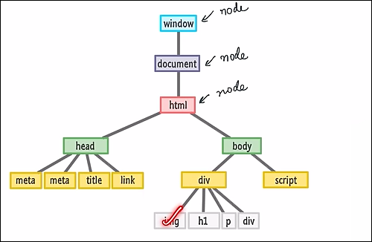

How we will access html in JavaScript

In get.js file

Console.dir(Window); //Access the window object.

Console.dir(window.document); // Access the document

Console.dir(document.body) // print all body object

Console.log(document.body) //print the all body elements of html

Console.dir(document.head) // print all head object

Console.log(document.head) //print the all head elements of html

We use DOM for dynamic manipulation in our web page.

**DOM Manipulations (Accessing are element)**

**Selecting with id**

**document.getElementById**

**After Accessing the html element we use some properties for checking(get) the value and changing(set) the value**

**Read about first child, last child and Children’s( these are used for navigate the element) and also read about Text node, Comment node and element node**

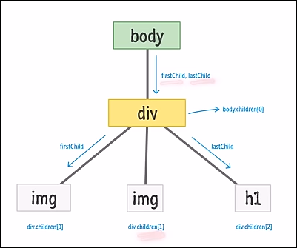

With the object model, JavaScript gets all the power it needs to create dynamic HTML:

* JavaScript can change all the HTML elements in the page
* JavaScript can change all the HTML attributes in the page
* JavaScript can change all the CSS styles in the page
* JavaScript can remove existing HTML elements and attributes
* JavaScript can add new HTML elements and attributes
* JavaScript can react to all existing HTML events in the page
* JavaScript can create new HTML events in the page

Notes

Consol.log() print only the object

Console.dir() is used to print properties and method of special object , special object like document object

Benefit of creating individual file of HTML, CSS and JavaScript

Improve the readability of code.

Promote the modularity

Browser caching means decrease the re-load time. When we load the js file browser automatically save these file . next time when we re-load the web page browser use save js file .

When we load script tag before the body tag in that case DOM is not accessible .so that is the meager reason why we write a script tag just before the ending of body tag