**Git :-** Git is a version control system and it very popular version control system. Version control system is a tools that helps to track changes in code.

(means when we delete, add something in your project Version control system tracks all the history )

**Advantage of git**

* Track history of project
* Collaboration (multiple employees work in same project .)

git is tool

**GitHub :-** It is a website that allows developers to store and manage their code using git.

When we install git we have to configure(means which account is used to changes through git to github)

**Two way to configure Git**

* Global (we can change all the rapo with same account. )
* Local (we can change the rapo with different account. )

**Get setup**

* Git config --global user.name “My Name”
* git config --global user.email “ email id”
* git config --list(if you want to check the satep status).
* git --verson (Check git verson)

**Clone**

It is used to cloning a repository on our local machine.

* git clone <link of repo>
* cd folder_ name (if you want to visit folder inside the folder )
* cd .. (if you want to go back on previous folder)
* ls (it is used to see exist normal file inside the folder. ls not show hidden file )
* ls -a (it is used to see exist normal and hidden file inside the folder )

**Status**

* git status (it is used to check project sattus )

if we change something in the project and then check git status

it shows like this type of status

* untracked file (if you add new file in your existing project. git dose not track your new file . you have to commit your new file then git tracked your new file )

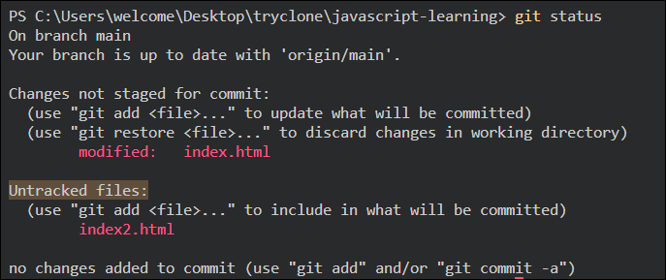

* modified file(if you change something in you exist file )

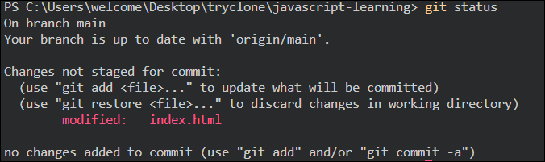

* unmodified (if you not change in you exist file)
* staged(When we change something we have to add. after add show stage (means your file is redy to be committed))

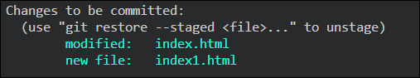

**After changes we have to do two process.**

Add your changes

* git add < file name> (it is use to add changes file individually )
* git add . (it is use to add all changes file at once )

commit – it is the record of changes

* git commit –m “Some massage”



push command

* git push origin main

(origin means it is a name of repo so basically we try to push origin in main branch)

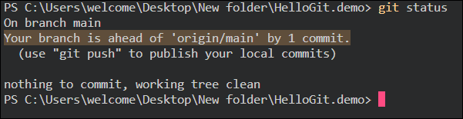

push- upload local repo content to remote repo means now we have to upload our all file local to remote(github)

**How create new git rapo through command.**

**(Upload existing project on github)**

init – is used to create a new git repo .

* git init

first create folder on desktop or any where

then open with vs code and then first check this folder is git repo or not using

* ls –a

. or .. means this folder is not git repo now make git repo we use

* git init



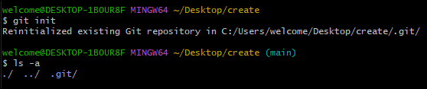

Add some file into git repo

* Git staus
* Git add .
* Git staus
* Git commit –m “Massage”
* Git remote add origin <link of github repo where we add new remote>
* Git remote means github repo add new remote



* Git remote –v (to verify remote) means what is the remote repo

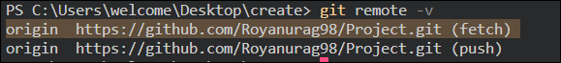

* Git branch (it is used to check the branch Means now we are working on which branch)

Branch

* Suppose 5 person work on a project and each person work on different part of project like someone working on front-end part and someone working on back-end part of that project in that case all person make a copy of that project and then work on that. These copy of project is called branch.
* Git branch –m main (to rename the branch)
* Git push origin main(main is branch name)

**Host Static Web-site on GitHub**

**Open rapo which you want to host**

**Go to seting**

**Then goto page option**

**Then save**

****Verify Existing Remotes****: First, double-check if the remote you're trying to add already exists. You can do this by listing the existing remotes:

git remote -v This command will show you the existing remotes and their URLs.

****Remove Existing Remote****: If the remote exists and you want to replace it with a new one, you can remove the existing remote and then add the new one:

git remote rm origin

Replace **origin** with the name of the remote you want to remove. Then, add the new remote:

git remote add origin <remote_url>