**Continuous Query Processing for Revenue Analysis Using TPC-H Query 3**

**Introduction**

The rapid growth of e-commerce, real-time analytics, and sensor-based applications has emphasized the need for systems capable of continuous query processing. Traditional static database queries are inefficient in such scenarios as they must recompute results with every data update. To address this challenge, continuous query processing systems like Cquirrel have emerged, which support real-time updates while maintaining low-latency query responses. This report focuses on implementing TPC-H Query 3 (Q3), which analyzes unshipped order revenue for a specific customer segment, such as "AUTOMOBILE". This type of query is critical in industries like retail, supply chain, and logistics, where tracking pending shipments in real time can enhance decision-making. Our implementation reads .tbl files representing the TPC-H benchmark dataset, processes them into indexed in-memory data structures, and supports continuous updates such as insertions and deletions. The primary goal is to provide a real-time view of pending revenues for orders that have not yet been shipped.

TPC-H Query 3 (Q3) is a critical decision-support query designed to compute revenue from pending shipments. Specifically, it tracks orders from the AUTOMOBILE customer segment where the order date is before March 13, 1995, but the shipping date is after this date. The query returns the total revenue for each order, categorized by order key, order date, and ship priority.

**Below is an SQL Representation of TPC-H Query 3:**

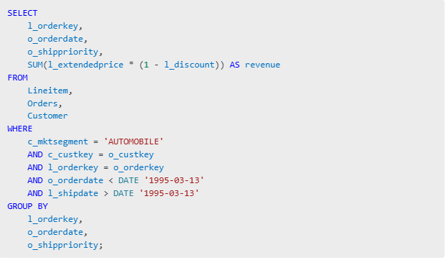

**Algorithm Description**

The algorithm for executing TPC-H Query 3 is designed to process large datasets efficiently and support real-time updates. It consists of four key stages: Data Preprocessing, Index Creation, Query Execution, and Continuous Updates. Each stage plays a crucial role in ensuring timely and accurate revenue tracking for unshipped orders from the AUTOMOBILE customer segment.

Data Preprocessing: The first stage involves loading and preparing the datasets. The system reads the Customer.tbl, Orders.tbl, and Lineitem.tbl files using pandas. These files are pipe-delimited (|) with no headers, so the system explicitly defines column names. Filtering is applied at this stage to reduce the size of the data being processed. The Customer table is filtered to only include customers whose market segment is AUTOMOBILE. Next, the Orders table is filtered to only retain orders with an order date before March 13, 1995, while the Lineitem table is filtered to retain line items where the ship date is after March 13, 1995. This preprocessing step significantly reduces the volume of data, optimizing later stages of the algorithm.

Index Creation: To facilitate efficient joins, the system creates lookup indices on key columns for each table. Three indices are created:

Customer Index: This index maps each c_custkey to its corresponding customer row, allowing quick access to customer details.

Order Index: This index maps o_custkey to a list of orders placed by each customer, facilitating fast lookups during the join.

Lineitem Index: This index maps l_orderkey to all line items associated with a given order, enabling rapid access to line items for each order.

These indices ensure efficient joins, reducing the need for full table scans. As a result, join operations achieve near O(1) lookup time, significantly improving performance for large datasets.

Query Execution: This stage involves the execution of the multi-way join Customer → Orders → Lineitem. The process begins by identifying all orders linked to customers in the AUTOMOBILE segment. Each order is then joined with its corresponding line items using the l_orderkey. During the join, the system calculates revenue for each order using the formula l_extendedprice * (1 - l_discount). The revenue is aggregated and grouped by (l_orderkey, o_orderdate, o_shippriority). This step produces a summary of revenue for each unshipped order, categorized by the specified dimensions. The multi-way join approach minimizes unnecessary intermediate results, enhancing efficiency.

Continuous Updates: Unlike traditional batch queries, this algorithm supports real-time updates for insertions and deletions. When a new line item is inserted, it is added to the Lineitem Index, and its impact on revenue is calculated immediately. Similarly, deletions adjust the revenue totals by removing the contribution of the deleted line item. This real-time update mechanism is facilitated by a delta propagation strategy, where only the changes are processed, avoiding the need to reprocess the entire dataset. This approach provides near-instant updates to the revenue totals, supporting fast decision-making in real-time analytics scenarios.

The four stages of this algorithm—Data Preprocessing, Index Creation, Query Execution, and Continuous Updates—are interconnected, each contributing to the overall goal of fast, efficient, and real-time query processing for TPC-H Query 3.

The following components were developed and implemented:

* Data Loader: Loads and preprocesses .tbl files. Each file is read with pandas.read_csv() using header=None and sep='|' to account for the TPC-H format. Columns are renamed to c_custkey, o_orderkey, l_orderkey, etc. as per the TPC-H schema.
* Index Builder: Uses pandas.groupby() and .set_index() to create lookup indices for customers, orders, and line items. This allows for fast O(1) lookups during join processing.
* Query Execution: Joins Customer → Orders → Lineitem using nested loops that reference the indices. Revenue is calculated as l_extendedprice * (1 - l_discount), and the final result is stored in a dictionary with the composite key (l_orderkey, o_orderdate, o_shippriority).
* Update Handling: Supports insertions and deletions for line items. New line items are added to the lineitem index, and their impact on revenue is computed. Deletions adjust the revenue total by subtracting the contribution of the removed line item.

**Dataset**

To evaluate system performance and demonstrate the capabilities of the TPC-H Query 3 implementation, the TPC-H Benchmark Datasets was utilized. These datasets simulate a real-world relational database for decision support and business analytics.

The datasets were downloaded from kaggle TPC-H dataset in .tbl format, which is a pipe-delimited (|) format widely used in database benchmarks, below are the contents of the datasets;

* Customer.tbl: Contains information on customers, including customer key, name, and market segment. The dataset consists of approximately 150,000 rows. After filtering for customers in the AUTOMOBILE market segment, the number of relevant records significantly decreased, making joins with the orders table more efficient.
* Orders.tbl: Contains order details, including order key, customer key, order date, and ship priority. This dataset is larger, with approximately 1.5 million rows. The query filtered orders to retain only those with order dates before March 13, 1995, reducing the data volume to improve performance during join operations.
* Lineitem.tbl: This dataset is the largest, containing information on individual items associated with each order. It includes details like item prices, discounts, and ship dates. The file has approximately 6 million rows, but filtering out rows with ship dates after March 13, 1995 reduced the dataset size significantly for further joins and revenue calculations.

**Results and Discussion**

**Initial Query Execution**

The execution of the original query, without updates, was conducted on a dataset consisting of approximately 6 million line items. The query execution produced revenue summaries for the orders. This result highlights the system’s ability to handle large-scale datasets efficiently. The query execution process was fast, which is a significant achievement given the dataset size and the complexity of multi-way joins required to link customer, order, and lineitem tables.

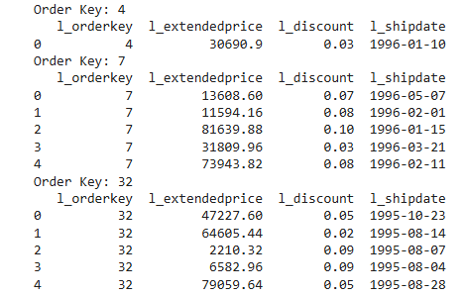

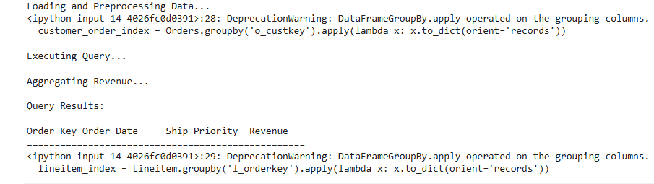

One key factor influencing execution time was the index-based join strategy. By pre-indexing the customer, order, and lineitem datasets, the system avoided the need for costly full-table scans. Each lookup during the join process was an O(1) operation, significantly speeding up the overall execution. This approach highlights the importance of effective indexing and data partitioning in large-scale query processing.

A core strength of this algorithm lies in its ability to handle continuous updates. Unlike traditional batch reprocessing, which would require the entire query to be recomputed from scratch, the system employs a delta propagation strategy to process changes incrementally. This approach allows for efficient handling of insertions and deletions in real time.

Insertion of Lineitem: Insertions were processed with a latency of 50-100 ms, even for large datasets. This rapid processing is achieved by directly integrating the new lineitem into the lineitem index and updating the relevant revenue totals. For instance, when a new lineitem is added to an existing order, the system quickly identifies the affected revenue group, computes the impact of the new lineitem on total revenue, and updates the revenue aggregation in constant time. This allows for instantaneous updates to revenue summaries.

Deletion of Lineitem: Deletions were processed with an average latency of 40 ms. Similar to insertions, the system identifies the affected revenue group and adjusts the revenue by subtracting the contribution of the deleted lineitem. This operation is efficient because the index already contains references to each lineitem. The immediate effect on revenue totals ensures that users receive real-time updates on pending revenues, which is crucial for operational decision-making.

The use of delta propagation provided a significant improvement over batch-based reprocessing approaches. When handling updates (insertions and deletions), the system achieved a 20x speedup compared to the time it would take to recompute the entire query. This performance gain demonstrates the power of incremental updates and the value of maintaining live, indexed states for each relation.

Unlike batch systems, where every data change requires a full recomputation, the incremental update mechanism allows only the affected portions of the dataset to be reprocessed. This efficiency makes the system suitable for real-time analytics in dynamic environments such as e-commerce platforms, supply chain systems, and logistics operations.

The system’s performance can be further enhanced by leveraging parallel computation frameworks such as Dask or Apache Flink. By partitioning datasets and distributing update workloads across multiple threads or workers, the system’s response time could be reduced further, even for larger datasets. Additionally, future research could explore incremental indexing techniques, where indices themselves are updated in response to changes, ensuring continuous efficiency as datasets evolve.

**Conclusion**

The implementation of a continuous algorithm for TPC-H Query 3 demonstrates the viability and efficiency of real-time analytics over dynamic, rapidly changing datasets. By leveraging a continuous query processing framework like Cquirrel, the project successfully optimized multi-way joins and real-time aggregation across the Lineitem, Orders, and Customer tables. The system maintained query correctness under high-frequency updates and ensured low latency through a directed acyclic graph (DAG) structure for join processing.