**pypl discounted cash flow valuation**

**4.6.24**

**Current price: 65.15$**



To calculate a present value of a stock, one can use the discounted cash flow formula.

By doing so, there is a lot of ingredients we would need.

As a head start, we would need the discount rate, we are valuing pypl, thus, we are valuing an equity, so our discount rate should be the cost of equity.

**Cost of equity**

**Risk free rate** – the risk free rate we would use is the us 10 years bond rate, by doing so we assume that the us is a risk free rate investment, we can deduce that because the us moodys rating is aaa. The highest rating there is.

The current us10y yield is 4.40%

**Risk free rate = 4.40%**

**Equity risk premium** – the equity risk premium is the yeild in which equity investors "demand" to invest in the equity market, the riskier the equity marker is, the higher the ERP is.

The value iof equity risk premium is the **market yeild – risk free rate**

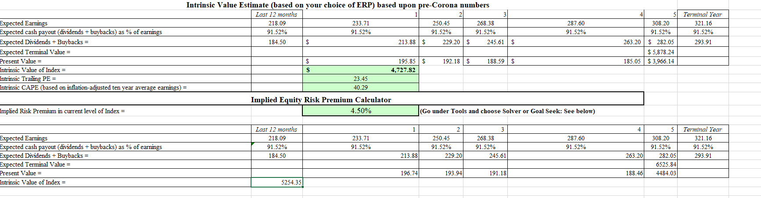To calculate the market yeild, we would use a mini dcf module, were the discount rate is the market yeild, the present value is the market value – s&p500, and the cashflows are growing by dividend base module.

**Equity risk premium = 4.13%**

**Beta –** the beta is the relative measure of the riskniness and the volatility of a firm the the market, to calculate our firm's beta, we would uses an unlevered bottom up beta.

To calculate the bottom up beta, we will diffrer pypl's buisness and calculate each beta:

Transaction revenues is from the credit services, and other services are just over all financial services.

Credit services unlevered beta:

**financial services unlevered beta:**



**Weighted average:**

90.212% * 0.25 + 9.788% * 0.32 = 0.256

now we need to leverd the beta back to our firm:

levered beta = unlevered beta(1+(1-t)(de ratio))

Pypl effective tax rate: 21.5%

Pypl de ratio: 0.4596

**Pypl levered beta = 0.35**

**Pypl cost of EQUITY = rf+(beta*erp) = 4.40%+(0.35*4.13%) = 5.8455%**

**Debt and it's value**

To compute the cost of capital, aka wacc, we need to calculate the debt and it's value.

To do that, first we need to compute the **cost of debt**, and then the **present of value of debt.**

**Cost of debt:**

Cost of debt = rf + x*country default spread + company default spread

We made the judgment that the us is free from default risk, thus;

Country default risk = 0

Cost of debt = rf +x*0 + company default risk = rf + company default risk

Rf = 4.40%  
to calculate company default risk we will calculate a synthetic rating for the company by interest expenses to EBIT.

Cost of debt = 4.40% + 0.7% = 5.1%

**Present value of Debt:**

To calculate the present value of debt, we need to determinate the average years for pypl's debt to mature.

We treat the firm's debt like a coupon, where the yield rate is interest expenses, discount rate as cost of debt, and the fv as book value of total debt.

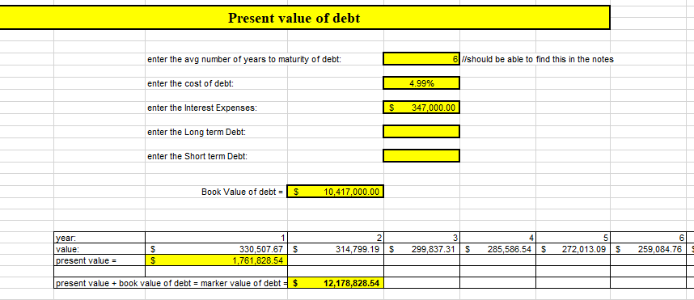

Finally we can compute the cost of capital;

**Cost of capital (wacc) = 5.845183%**

**Cash flow:** the cash is the king…

**R&D:**

To calculate the true cash flow we need to convert the R&D to capital expenses, because R&D is a long term investment.

Because pypl is a tech company, we would roughly deduce it takes about 3 years to pypl's R&D to yield and lose it's value, thus, every year pypl's r&d asset looses a third of it's value to depreciation.

The r&d investments become an asset, and the depreciation is a liability.

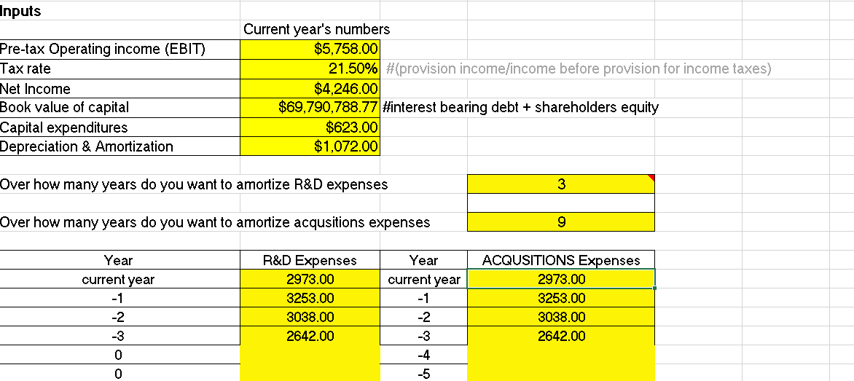Same goes to acquisitions.

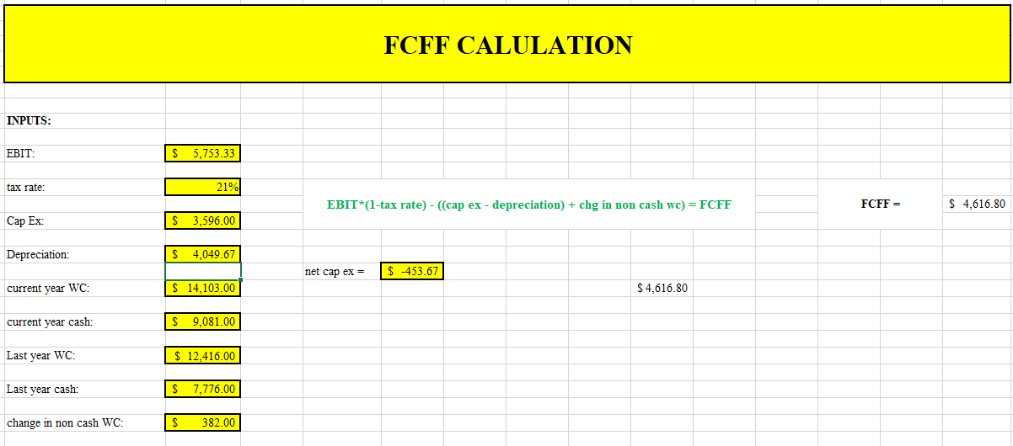After correcting the values we can compute an FCFF;

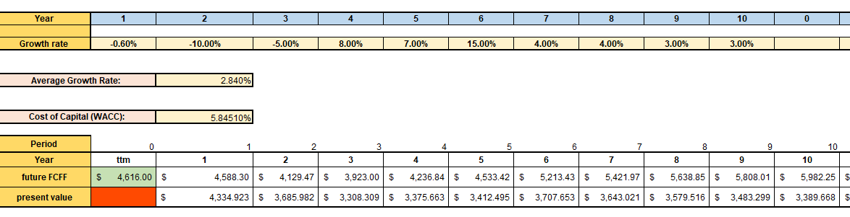If we compute the present value of pypl's stock by analysts expectations we get:

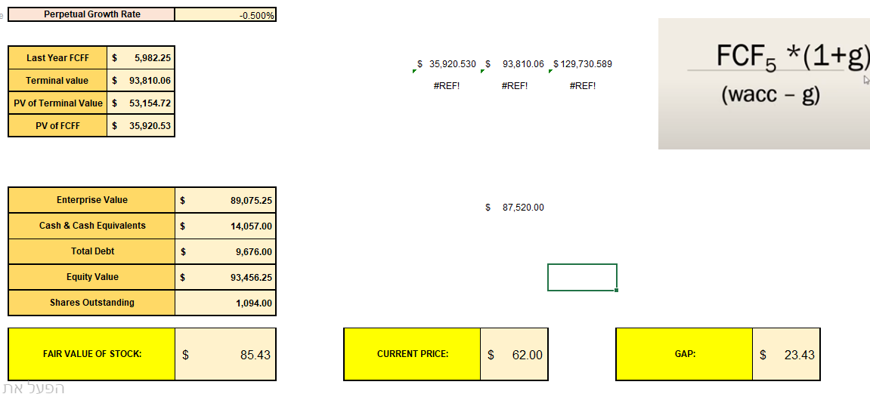

We get that pypls is undervalue, where it's fair value is 85.43$, a gap of about 24%

**UNDER VALUED**