A Project Proposal

Presented to

the Faculty of STI

In Partial Fulfilment

of the Requirements for the Degree of

Bachelor of Science in Information Technology

by:

Camahalan, Royette M.

Chua, Patrick Simon L.

Cordero, Ereberto Jr. E.

Susbrado, Jan Earvin T.

Soriano, Jennyfer G.

Project Adviser

July 20, 2015

**Introduction**

The Tim Tebow Foundation has partnered with CURE International to open the Tebow CURE Hospital in Davao City, Philippines. The hospital specializes in pediatric orthopedic care and features the first Timmy’s Playroom outside of the United States. The Tebow CURE Hospital is a non-stock, non-profit specialty Hospital located in Davao City, Philippines with a primary focus on paediatric orthopaedic care and features the first Timmy’s playroom outside of the United States. Many donors have contributed to the Hospital, including the Sacred Harvest Foundation and the Tim Tebow Foundation. Nowadays many clinics are now using clinical systems to improve and develop productivity.

**Background of the Study**

Technology nowadays is the basic need for businesses or companies. It helps a lot in such a way that it makes work more progressive and productive. People in our society are not satisfied on what they have. They made discoveries, development and experiments for the progress and solution for this chaos situation of our society. Having computers and computer programs may help a business grow bigger and it helps to abridge the prolonged manual operation of a business, institution or a company usually did. It helps a lot because almost all the companies nowadays uses computers and very competitive in many aspects. Whatever kind of business you manage, you are required by law to keep records relating to it.

The Tebow CURE Hospital is a non-stock, non-profit specialty Hospital located in Davao City, Philippines with a primary focus on pediatric orthopaedic care and features the first Timmy’s Playroom outside of the United States.. Many donors have contributed to the Hospital, including the Sacred Harvest Foundation and the Tim Tebow Foundation.

This research was prompted by the impacts of the information on the clinical world. The modern generation of mobile application has been one of the revolutions. So its adoption to our modern era is one of the biggest factors to facilitate doctors to have an easy access to their patients. The use of android application as a platform helps the doctors manage their transactions in their clinic. Clinic management is introduced to optimize clinic’s operation, because of huge changes in management nowadays, management for clinic is important due to the widely spread of technology.

**Current State of Technology**

**Mediwise Clinic Management System**

The Mediwise Clinic Management System is designed to address the practice needs of a range of specialities. This system is fully integrated line of financial, administrative, clinical and decision support systems improve productivity and management control, maximize quality assurance, provide regulatory compliance and risk management. This system cater patients documentation, patients accounting, patients care management, investigation, referrals management, scheduling, medical imaging and documents.

**Clinic Management System(CMS)**

The Clinic Management System(CMS) is developed by Mobigator Technology Group. The system has Waiting Queue, Appointment, Consultation, Dispensary, Inventory, Report, Admin function. The system also provides patients record, set and view appointments and upload laboratory results.

**FreeMED**

FreeMED is developed by FreeMED Software Foundation, a systematized collection of electronically-stored health information, in a digital format, about an individual patient or a population. The unique feature of these software is that it uses.

FreeMED uses an external billing program called REMITT (REMITT Electronic Medical Record Information Translation and Transmission). The name “REMITT” is a Recursive acronym. It communicates with REMITT via an authenticated XML-RPC connection. This connection, once established, allows the transmission of medical billing data as a monolithic chuck of XML. This is then processed into a meta-format via XSLT (Extensive Stylesheet Language Transformations) and finally processed into its final format and transmitted to its ultimate destination.

**Statement of the Problem**

**Major Problem**

How to develop a system manipulating and retrieving patient records, as well as setting and managing appointment schedules per patient?

**Minor Problem**

* How will the proponents convert the manual implementation of patient record?
* How to create a module that will make the doctor aware of the clinic information’s conveniently?
* How to create a module that will accept appointments?
* How will the desktop application communicate with mobile application?

**Objective of the Study**

**General Objective**

Creating a system that will manipulate all the patient records and also managing appointments schedules through mobile application.

**Specific Objective**

* Create a computerize system to input all the information of the patient`s.
* Create a mobile application that will make the doctor aware of his/her appointments every time.
* Create a module that will accept appointments
* Create a web server that will serve as main server of the desktop application and mobile application.

**Scope and Limitation**

The Orthopaedic Management Software with Android Application can help the doctor to track down the doctor appointments. The system is convenient for the doctor for his/her patient record filing and it is convenient for doctors because most of the doctors record for his/her patient can be accessed through android phones. The android application is capable of notifying the doctor appointment two days ahead of time and at the specific day of the appointment the android application will notify exactly seven thirty in the morning. The system can upload the image test results in patient record. The doctor can check or review the history of the patient.

**Scope**

* The system is intended only for Tebow Cure Hospital Orthopaedic Clinic.
* The system to be developed is not only for viewing purposes but it can also input data and make a report.
* The system will block the conflict time of the appointments.
* The system can set appointment.
* The system can postpone appointment and reschedule them.
* The system can upload test result images.
* The system will automatically notify current appointments.
* The system will generate prescription.
* The system can record consultation findings.
* The system can cater payments.

**Limitation**

* The android application cannot access the test result images when the doctor is offline.
* The secretary cannot access mobile application.

**Data Flow Diagram**

**(Context Diagram)**

**Data Flow Diagram**

**(Level 0)**

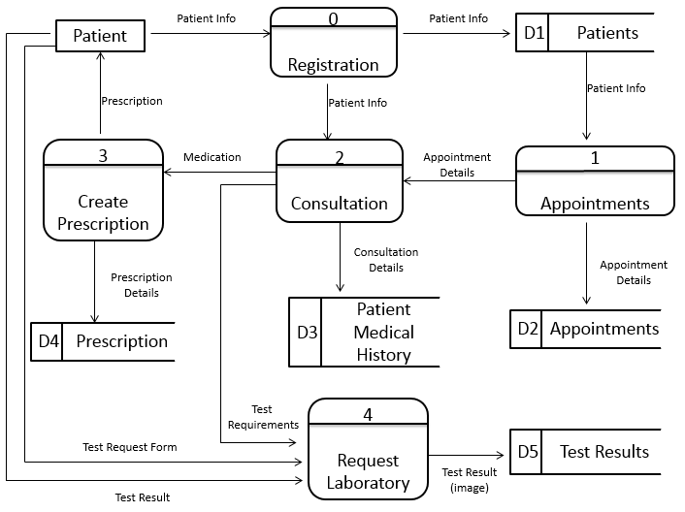

**Architectural Design**