**ECE EXPENSE DISBURSEMENT SYSTEM WITH ANDROID APPLICATION**

A Project Proposal

Presented to

the Faculty of STI

In Partial Fulfilment

of the Requirements for the Degree of

Bachelor of Science in Information Technology

by:

Camahalan, Royette M.

Chua, Patrick Simon L.

Cordero, Ereberto Jr. E.

Susbrado, Jan Earvin T.

Soriano, Jennyfer G.

Project Adviser

July 20, 2015

**Introduction**

ECE marketing is a business in Davao City by Mrs. Aleli Bisnar. ECE marketing runs nationwide. Has branches located in General Santos, Quezon City, Tacloban, Cebu City and others. The primary business is drug distribution. ECE marketing is located at 150 5ThA Street, Ecoland Subdivision, Matina Davao City. ECE marketing provides medical products.

**Background of the Study**

The research was done by the impacts of slow reporting of expenses within the business. The modern generation of the internet, mobile application and the web has been one of the revolutions. So its adoption to our modern era is one of the biggest factors to help companies generates reports that will aid them in decision making and one of that is the expenditures. Aside from that want wrong disbursement of expenses and also in not avoidance of dishonesty of its employees. The use of the web as platform to conduct business transaction gave birth to practice of online reports for transactions, basic things that we are doing today is using computer too make technology so as business industry to make other task easier and accessible.

**Current State**

**ECE Finance**

ECE Marketing is currently using their software called “ECE Finance”. The systems deployed by a business to process, pay, and audit employee-initiated expenses. The system is in a desktop and can access only in office. All expenses of employee are encoded in this computer.

**JD Edwards Enterprise One Expense Management system**

This system is designed to help companies effectively manage reimbursement requests. The system facilitates entering expense reports and provides immediate error notification if information is missing or inaccurate. It also provides control mechanisms to monitor and audit expense reports, and the flexibility to customize the system for evolving expense and travel policies.

**Expense Management Software**

**Expense Management** refers to software designed to submit, process, reimburse, and track employee expenses. The software includes abilities for employees to input expenses for approval through a browser or mobile application. Administrators can track expense reports, enforce company policies for expenses and travel, set up approval routings, and generate reports for specific projects or company departments. In addition, some software’s provide tools to help book and manage travel itineraries.

**Statement of the Problem**

**Major Problem**

How to develop a system that cannot be accessed only in office during input their expense in every employee as they arrive in the office in the system, and also no need to take note their everyday expenses?

**Minor Problem**

* How to create a module to prevent cases of double entry of expense disbursement?
* How to make it fast and accessible?

**Objective of the Study**

**General Objective**

Creating a system that will input their expense through Mobile Application during field, also can view the retaining balance to expend.

**Specific Objective**

* Proponents develop a system auto generated inputting disbursement.
* Proponents develop a system that will lessen time consumption.

**Scope and Limitation**

The ECE Marketing application will help to all employees specially the marketing because it easily track the expense in every agent. Also it capable for agent encode their daily expense in android application or in web.

**Scope**

* This program can encode in android application of their daily expenses or in web.
* Admin can view all the expenses of every agent assign on that particular area.
* The system will automatically calculate the expense.
* Update employee about current balance of their allowance

**Limitation**

* Agent can only encode their daily expense in mobile or in web.

**Data Flow Diagram**

**(Context Diagram)**

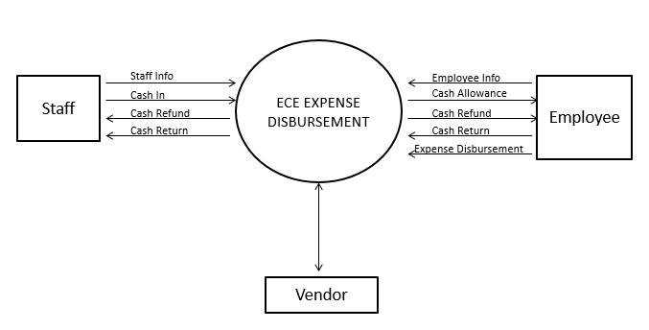

**Data Flow Diagram**

**(Level 0)**

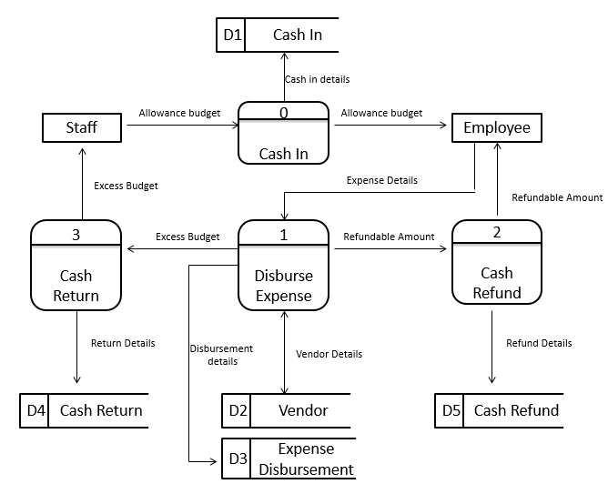

**Architectural Design**

