Clicking the "Update Items" button will bring you to this screen where you can delete things from your list that you do not buy and add things that are not on your list

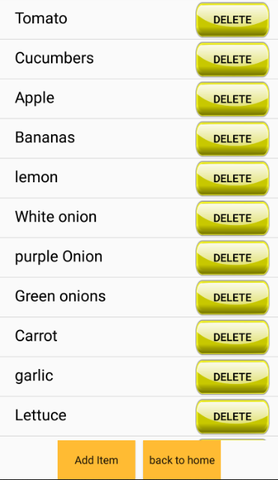

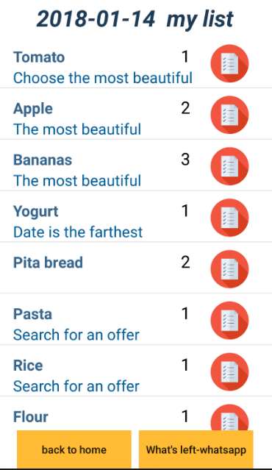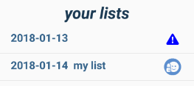

In your list, if you click a product you put him in a shopping cart, it will change its color. This way you can easily see what is in your cart. Repeated clicking will remove the product from the cart

Once you've finished buying all the products in the list will appear a smiley mark. Otherwise, you will see a reading sign

Clicking this button will send the products that were not purchased to your contact in the WhatsApp application

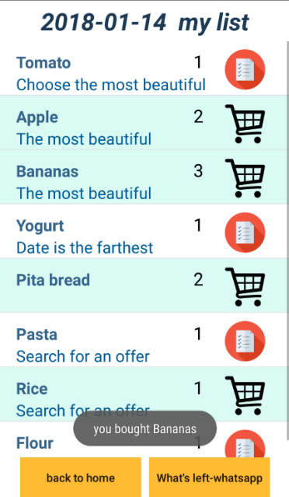

Welcome to

My Shopping List

The best app to create a shopping list. We've prepared a brief guide for you to understand how to use this app.

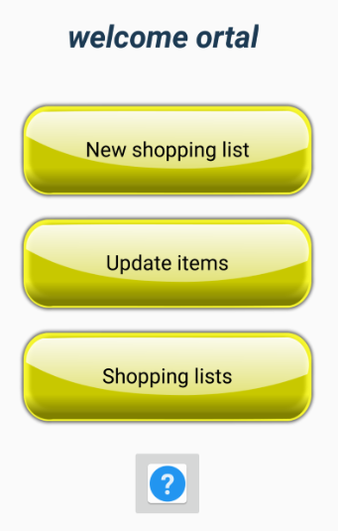

Click here to create a new shopping list

Click here to edit your product list. You can add or delete products.

Click here to view your previous lists

You can always click here to return to these instructions

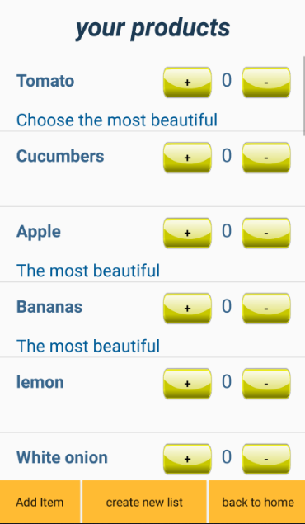

Once you select "new shopping list" you come to this screen, where you can prepare your shopping list.

Once you finish selecting products, you can create a new list here

Here you can add new product to your list

Add a product to the list.