**Problems**

**1. Fing highest number**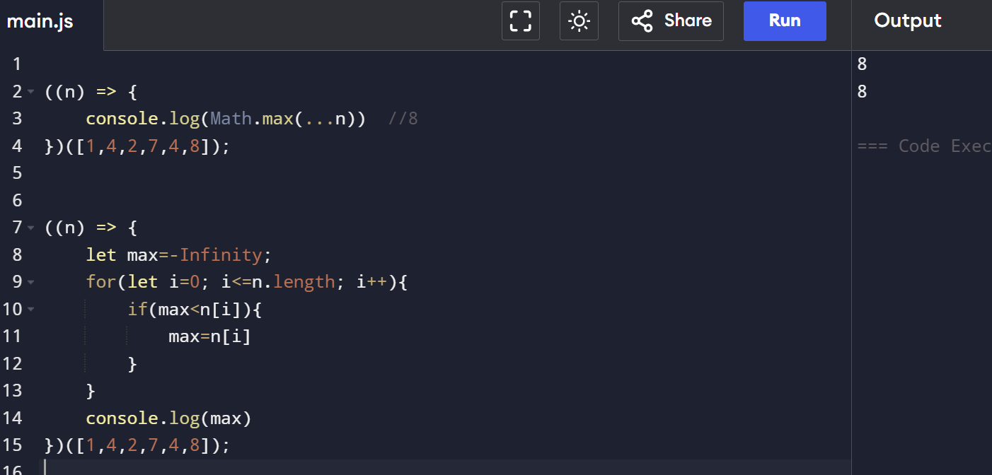

**2. Second largest**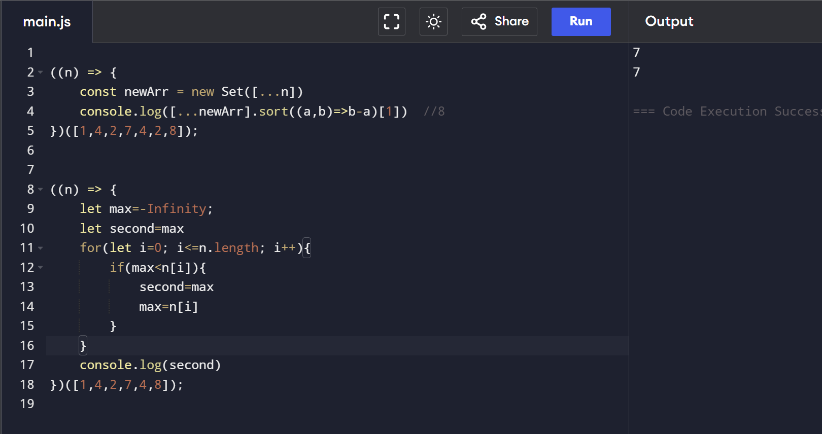

**3. check array is sorted  
**

**4. Remove duplicates  
**