AZ-104

Notes

Cloud adoption Framework

Basically, it’s a framework that allows you to plan how you’re going to use the cloud services. Think of it as a way to help you succeed in creating and implementing cloud properly in stages.

1. Define your strategy.
2. Plan.
3. Ready your organization.
4. Adopt the cloud.
5. Govern and manage your cloud environments.

Azure resource levels

1. Management groups
2. Resource groups
3. Subscriptions
4. Resources

At subscription level

1. Billing
2. Access control
3. Subscription limits

Role based access control

Azure has built in roles to describe common access rules for cloud resources.

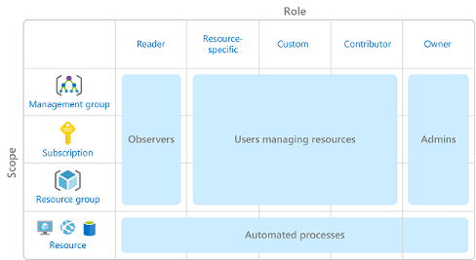

When to use role-based access control?

* Allow one user to manage VMs in a subscription and another user to manage virtual networks.
* Allow a database administrator group to manage SQL databases in a subscription.
* Allow a user to manage all resources in a resource group, such as virtual machines, websites, and subnets.
* Allow an application to access all resources in a resource group.

*RBAC uses an*allow model*. When you're assigned a role, RBAC*allows*you to perform certain actions, such as read, write, or delete. If one role assignment grants you read permissions to a resource group and a different role assignment grants you write permissions to the same resource group, you have both read and write permissions on that resource group.*

You manage access permissions on the **Access control (IAM)** pane in the Azure portal

**Resource Lock**

Prevents resources from being accidentally deleted or changed. It is a policy that acts like a warning system that notifies you that some resources are important and should not be deleted or changed.

1. CanNotDelete, authorized users can view but cannot delete without removing lock
2. ReadOnly, can only view resource but nothing else.

To add resource locks, you can do so on the ‘settings’ then ‘locks’

To make it more robust you can combine resource locks with Azure blueprints. Blueprints allow you to define a set of Azure resources that your organization requires. For example, you can define a blueprint that specifies that a certain resource lock must exist. Azure Blueprints can automatically replace the resource lock if that lock is removed.

**Organize Azure resources using Tags**

Resource tags are another way to organize resources. Tags provide extra information, or metadata, about your resources.

1. **Resource management**
2. **Cost management and optimization**
3. **Operations management**
4. **Security**
5. **Governance and regulatory compliance**
6. **Workload optimization and automation**

**Azure Policy**

**Azure Policy is a service in Azure that enables you to create, assign, and manage policies that control or audit your resources. These policies enforce different rules and effects over your resource configurations so that those configurations stay compliant with corporate standards.**

Azure Policy comes with several built-in policy and initiative definitions that you can use, under categories such as

* **Storage**
* **Networking**
* **Compute**
* **Security centre**
* **Monitoring**

A policy definition expresses what to evaluate and what action to take. For example, you could prevent VMs from being deployed in certain Azure regions. You also could audit your storage accounts to verify that they only accept connections from allowed networks.

**Govern multiple subscriptions by using Azure Blueprints**

**When cloud environment starts to grow, Azure blueprints can define a repeatable set of governance tools for Azure.**

**Blueprints uses a variety of different resource templates such as:**

* + **Role assignments**
  + **Policy assignments**
  + **Azure resource manager templates**
  + **Resource groups**