

Assignment 1 - Xen

IN720 Virtualisation

Roynuka Nukanuka | Virtualization | 02/09/20

Table of Contents

Introduction 2

QEMU Installation 3

Advantages & Disadvantages 4

References 5

# Introduction

The purpose of the assignment basically covers the labs we’ve previously done using Xen. By creating and running a virtual machine using LVM volumes on our Xen servers. In this case we will be doing essentially the same thing using a QEMU image file to launch a VM instance. This document will cover the process I found step by step with some discussion on how and why I did things the way I did. Errors encountered will also be documented as well.

# QEMU Installation

I mainly used resources found online and the past lab material we have done in class. First, I had to update then install QEMU on my host machine

1. Update & Install QEMU

**sudo apt update**

**sudo apt install qemu**

1. Create QEMU image

**qemu-img create -f qcow2 <image name> 20G**

1. Download iso image from Ubuntu, use sudo priveleges

**Sudo wget** [**https://releases.ubuntu.com/14.04/ubuntu-14.04.6-server-amd64.iso**](https://releases.ubuntu.com/14.04/ubuntu-14.04.6-server-amd64.iso)

I stored the downloaded iso image in the root directory as well as the created image.

1. Boot virtual machine run:

**sudo qemu-system-x86_64 -hda <image name> -boot d -cdrom ubuntu-14.04.6-server-amd64.iso -m 640**

If you just run the full command using ‘qemu’ instead of ‘qemu-system-x86_64’ you will run into this error.

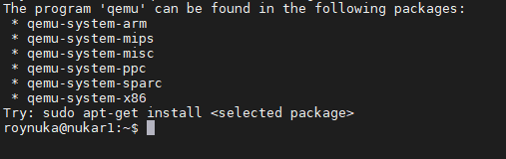

Another error I ran into was the ‘Could not initialize SDL (No available video device) – exiting’

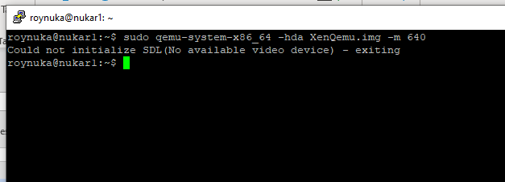

Apparently, this error occurred because I was using putty while trying to install an ISO image. Putty does not have a GUI. To solve this, I moved the installation process over to ‘MobaXterm’. In short its pretty much putty but with a GUI interface. From there I proceeded to the next step.

1. Install & boot virtual machine on MobaXterm

**sudo qemu-system-x86_64 -hda <image name> -boot d -cdrom ubuntu-14.04.6-server-amd64.iso -m 640**

Follow the usual steps to install OS while keeping in mind some considerations such as.

* Select guided partitioning using the entire disk and LVM
* Install on the SCSI1 disk
* Use only 15% for the installation volume group
* Do not enable auto updates
* Install SSH server, but no other packages

After you finish the installation process, reboot the system.

1. Boot VM using image

Once the installation is complete it will prompt to reboot the machine. In this case close the VM and try booting from the installed image using the command

**qemu-system-x86_64 -hda <image name> -m 640**

1. Create Xen guest on QEMU image

While configurating the xen guest to boot from the image. I ran into some errors. So, I found a tutorial on how to run QEMU using gnome so I tweaked some configurations.

**Cd /etc/init**

**Edit the file “tty1.conf” and change this line #exec /sbin/getty -8 38400 tty1 to:**

**Exec /sbin/getty –L hvc0 38400 linux.**

I made sure to make a copy of the file in case I might need to go back to it. After rebooting the machine, I was now booting to GNOME.

From there I proceeded to continue configuring my Xen guest. To do this

Like labs done in the past.

**Cd /etc/xen**

**Sudo cp clone1.cfg qemu.cfg**

Make configuration file changes to

**Guest name**

**name = ‘qemuvm’**

**bootloader = “/usr/lib/xen-4.4/bin pygrub’**

**extra = “root=/dev/xvda1”**

**memory = 1024**

**vcpus = 1**

**vif = [‘’]**

**disk = [‘/home/roynuka/XenQemu.img,raw,xvda,rw’]**



Then launch guest VM using

**sudo xl create -c /etc/xen/qemu.cfg**

Check if guest VM is up and running using

**sudo xl list**

To boot to the created Xen guest use:

**sudo xl console <name of guest vm>**

# Advantages & Disadvantages

Advantages

* Qemu works on most systems, able to manage everything, with less dependence
* Open source
* Pretty straight forward to download an OS iso file onto the created image.

Disadvantages

* Not user friendly and only those with ubuntu, linux experience can use it efficiently

# References

Using QEMU disk images for Xen DomainU systems. (n.d.). Virtuatopia. <https://www.virtuatopia.com/index.php?title=Using_QEMU_Disk_Images_for_Xen_DomainU_Systems&fbclid=IwAR2lRta_nOtxq0XGmevm5QvH-hYiR9NoyX6ciyvpqhkJBKS7-ii727vArz0>

QEMU/Images. (n.d.). Wikibooks. Retrieved September 3, 2020, from <https://en.wikibooks.org/wiki/QEMU/Images>

Canonical. (n.d.). Ubuntu 14.04.6 LTS (Trusty tahr). Ubuntu Releases. <https://releases.ubuntu.com/14.04/>