Create DockerHub Credentials:

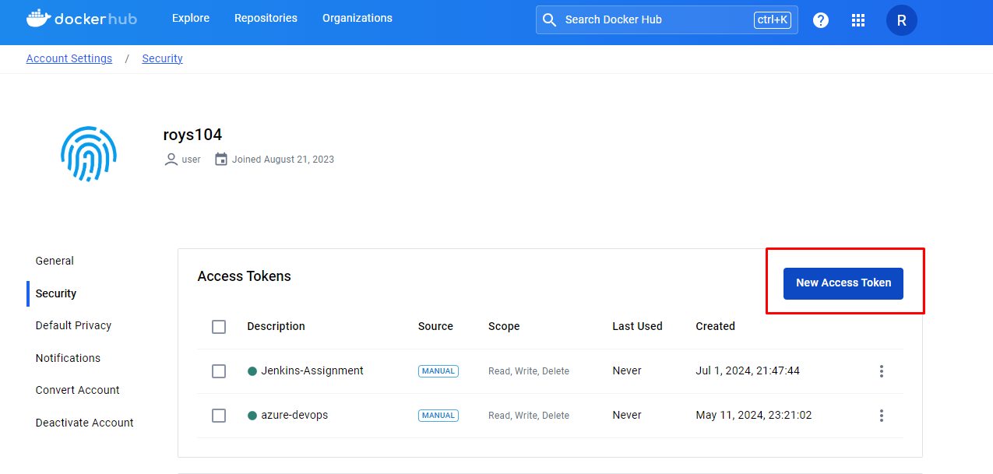

Create GitHub Credentials:

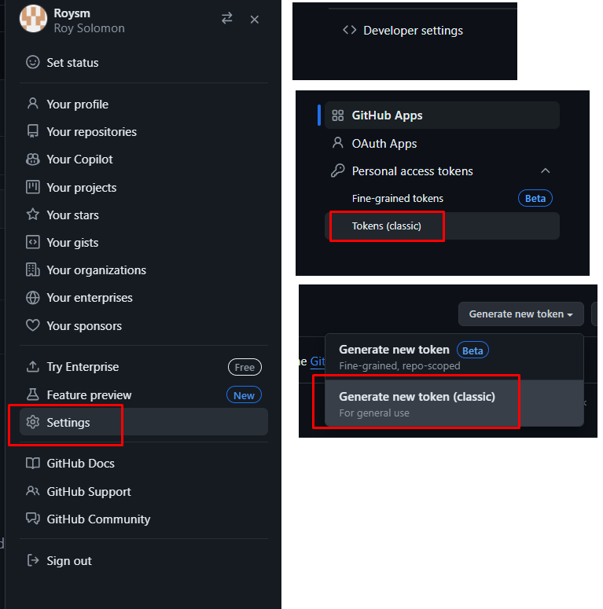

Add Credentials to Jenkins:

* Define ID of the credential



