***Enums***

*According to the Java naming conventions, we should have all constants in capital letters. So, we have enum constants in capital letters.*

*Java enums can be thought of as classes that have a fixed set of constants*

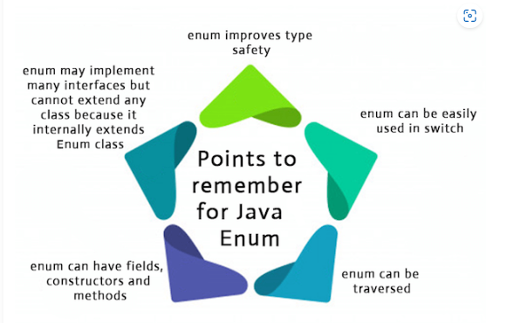

*Instead of creating class with variables decalred as public static final we can create enum class with constant*