*Generics in Java*

*The****Java Generics****programming is introduced in J2SE 5 to deal with type-safe objects. It makes the code stable by detecting the bugs at compile time.*

*Before introducing generics, we used to store any type of objects in the collection, i.e., non-generic. Now generics force the Java programmer to store a specific type of objects.*

[*What is Generics?*](https://www.bing.com/ck/a?!&&p=588c21bcb8ddf5d086ea6a6f03caec4f3f64b75b4da2ebbaa947662ad7566fa3JmltdHM9MTczNTYwMzIwMA&ptn=3&ver=2&hsh=4&fclid=1ded4639-1d75-6af4-0c72-53661cd86bb8&psq=what+is+generics&u=a1aHR0cHM6Ly93d3cuZ2Vla3Nmb3JnZWVrcy5vcmcvZ2VuZXJpY3MtaW4tamF2YS8&ntb=1)

[*1*](https://www.bing.com/ck/a?!&&p=588c21bcb8ddf5d086ea6a6f03caec4f3f64b75b4da2ebbaa947662ad7566fa3JmltdHM9MTczNTYwMzIwMA&ptn=3&ver=2&hsh=4&fclid=1ded4639-1d75-6af4-0c72-53661cd86bb8&psq=what+is+generics&u=a1aHR0cHM6Ly93d3cuZ2Vla3Nmb3JnZWVrcy5vcmcvZ2VuZXJpY3MtaW4tamF2YS8&ntb=1)*Generics in programming refer to the concept of parameterized types, allowing a type (such as Integer, String, or user-defined types) to be a parameter to methods, classes, and interfaces. This enables the creation of classes and methods that can operate on different data types while ensuring type safety and code reusability*

*Advantage of Java Generics*

*There are mainly three advantages of generics. They are as follows:*

***1) Type-safety:****We can hold only a single type of objects in generics. It does not allow to store other objects.*

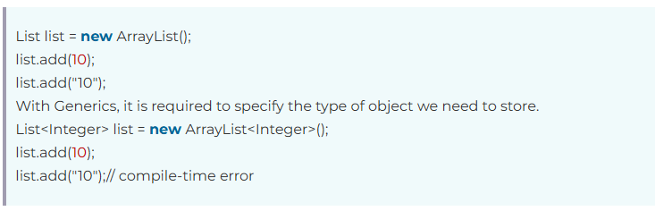

***2) Type casting is not required:****There is no need to typecast the object.*

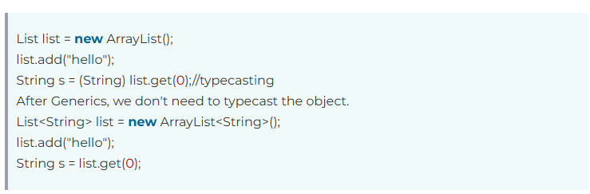

***3) Compile-Time Checking:****It is checked at compile time so problem will not occur at runtime. The good programming strategy says it is far better to handle the problem at compile time than runtime.*



***Syntax****to use generic collection*



***T: TYPE***

***E: ELEMENT(USED IN COLLECTIONS)***

***K: KEY (IN MAPS)***

***V:VALUE (IN MAPS)***

***N:NUMBER***

***Example***

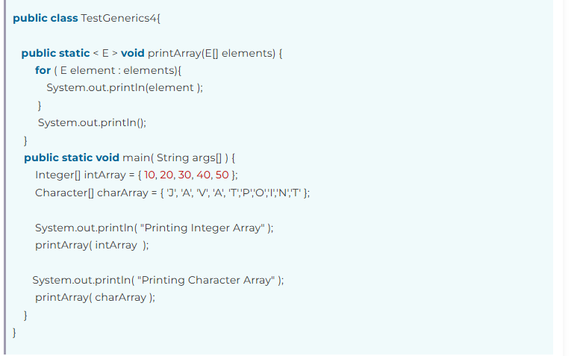

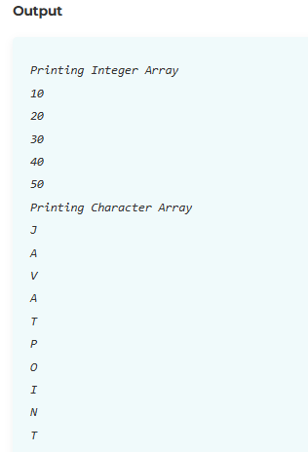

***Example***

