**EXAMPLE1**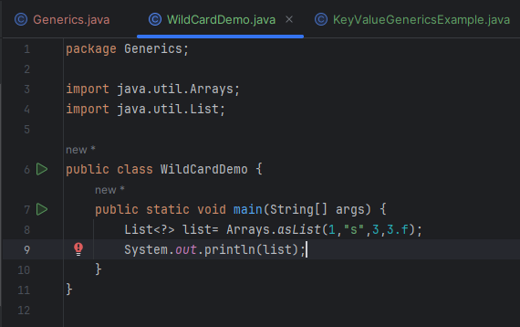

**Output**

**C:\Users\Roystan\.jdks\openjdk-21.0.2\bin\java.exe "-javaagent:C:\Program Files\JetBrains\IntelliJ IDEA Community Edition 2023.3.3\lib\idea_rt.jar=60447:C:\Program Files\JetBrains\IntelliJ IDEA Community Edition 2023.3.3\bin" -Dfile.encoding=UTF-8 -Dsun.stdout.encoding=UTF-8 -Dsun.stderr.encoding=UTF-8 -classpath C:\Users\Roystan\IdeaProjects\JavaWorkspace\out\production\JavaWorkspace Generics.WildCardDemo**

**[1, s, 3, 3.0]**

**Process finished with exit code 0**

**Error : Cannot add values in list as list type is not specified**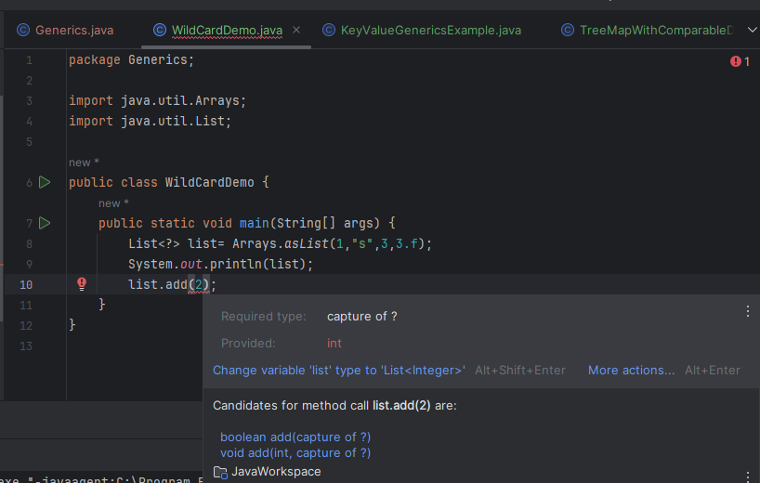

**Upper Bound**

**Working Example**

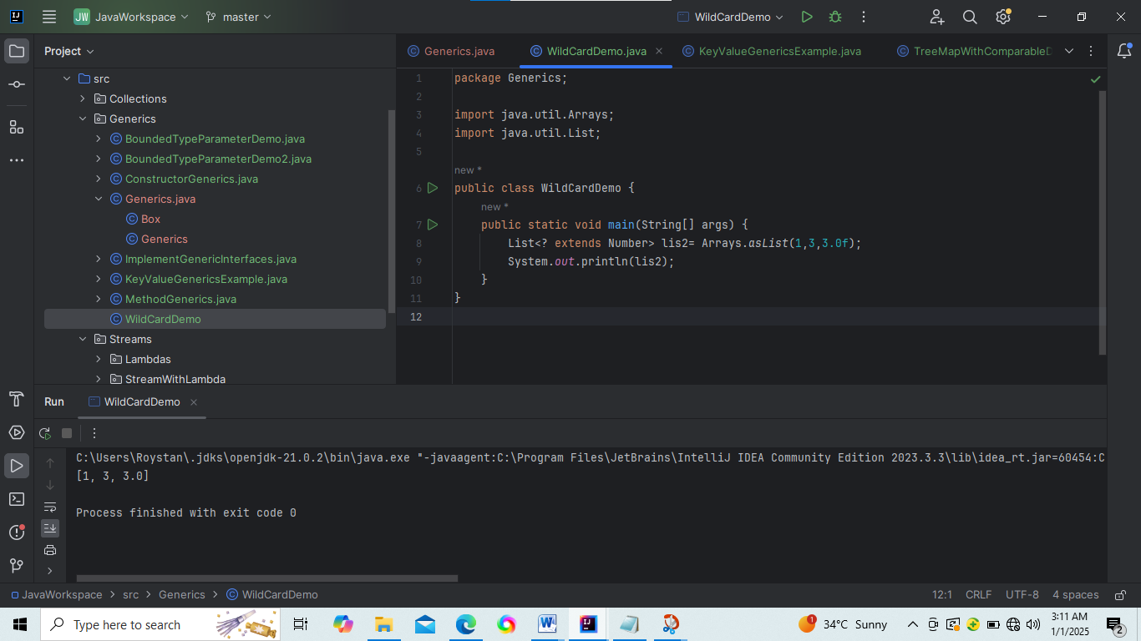

**Compile time Error when string is provided in array.aslist because string doesn’t satisfies upper bound condition**

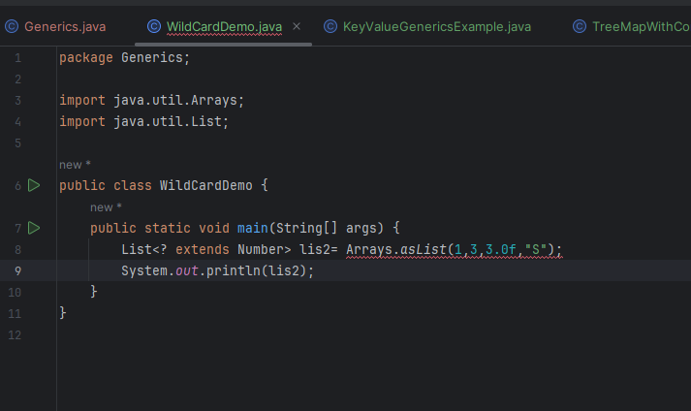

**Error : Cannot add values in list as list type is not specified**

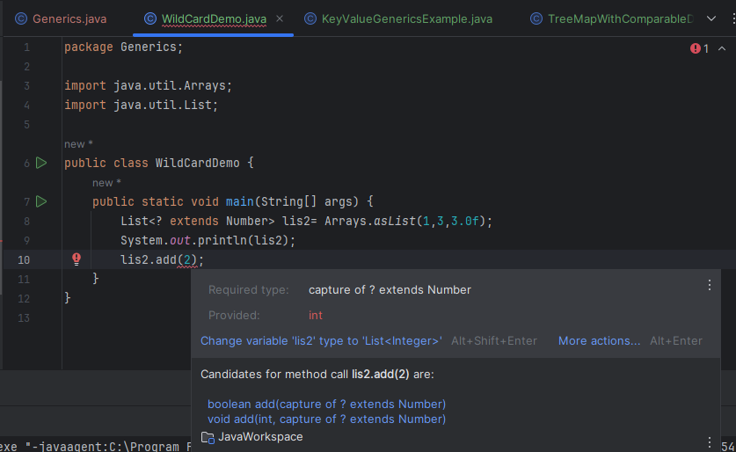

**Lower bound**

**Working Example**

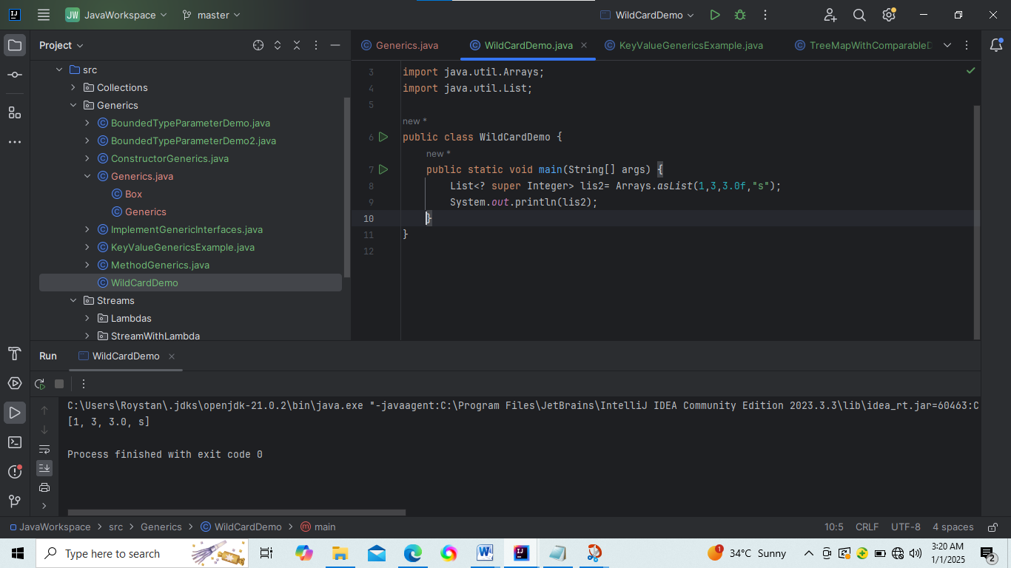

**Error: Cannot add float values in list as list type is lower bounded to Integer**

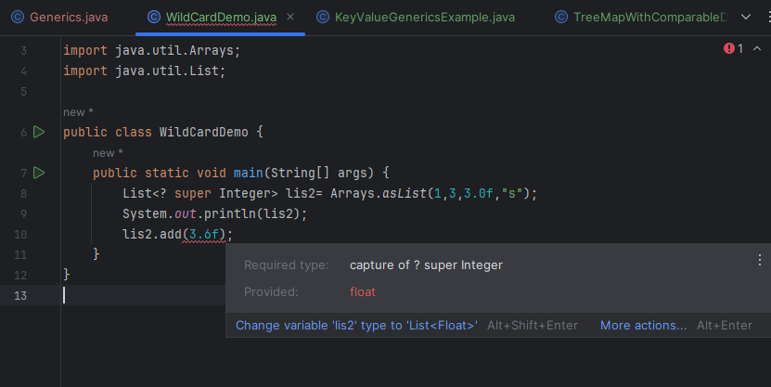

**No compile time error ( adding 3 – because it holds the condition) but it gets run time error**

