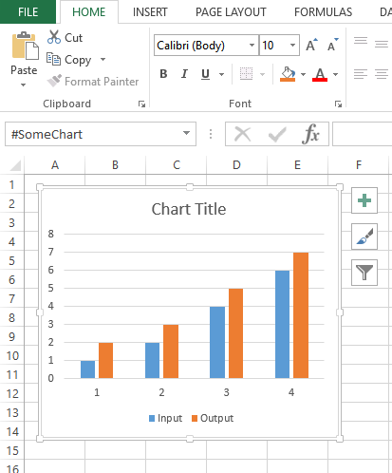

1. Select the Chart 🡪 2. Click Format Tab 🡪 3. Click Selection Pane 🡪 4. Rename chart name (begin with #)

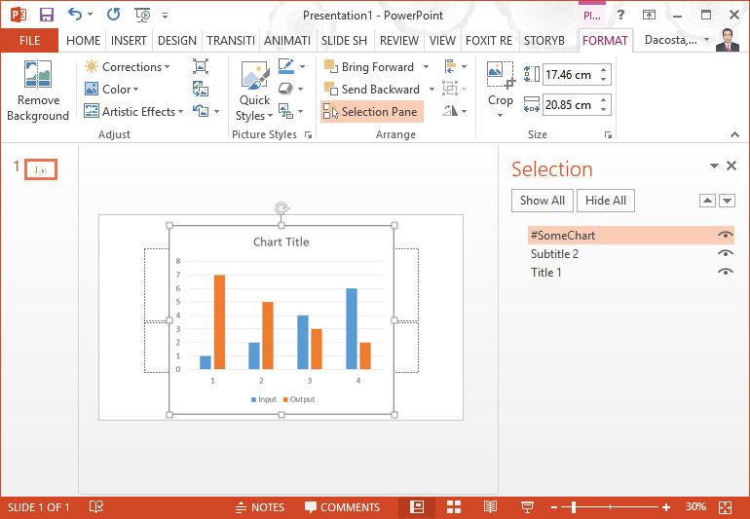

## Steps to rename a chart in PowerPoint

1. Select the Chart 2. Click Format Tab. 3. Click Selection Pane

4. Rename chart name (begin with #) and press enter

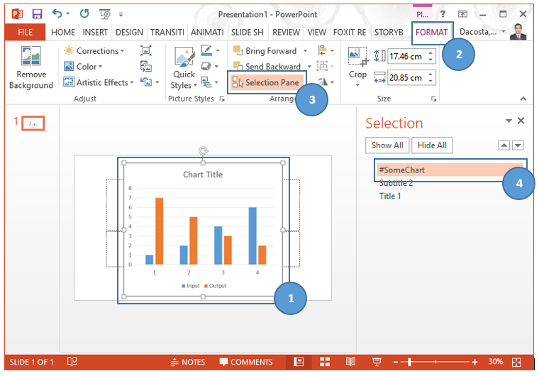

## Steps to rename a chart in Excel

1. Select the Chart 2. Rename chart name (begin with #) and press enter

