DATA&AI project showcase
"Can I AMS this?" is a specialized web application designed for the World of Warcraft community. While I leveraged AI to assist in the development of both the frontend and backend, I personally managed the data scraping process to ensure the accuracy and integrity of the game data—an area where automated AI tools still face limitations.
Although the project is not currently live, this documentation serves as a visual showcase of the application's interface and functionality. The development process provided significant insights into architectural complexity; specifically, I chose a decoupled stack with different languages for the frontend and backend to maximize my learning, even though a unified framework like React would have been more efficient. Additionally, I implemented a dedicated database rather than simple JSON storage to gain deeper experience in data management.

Landing page:
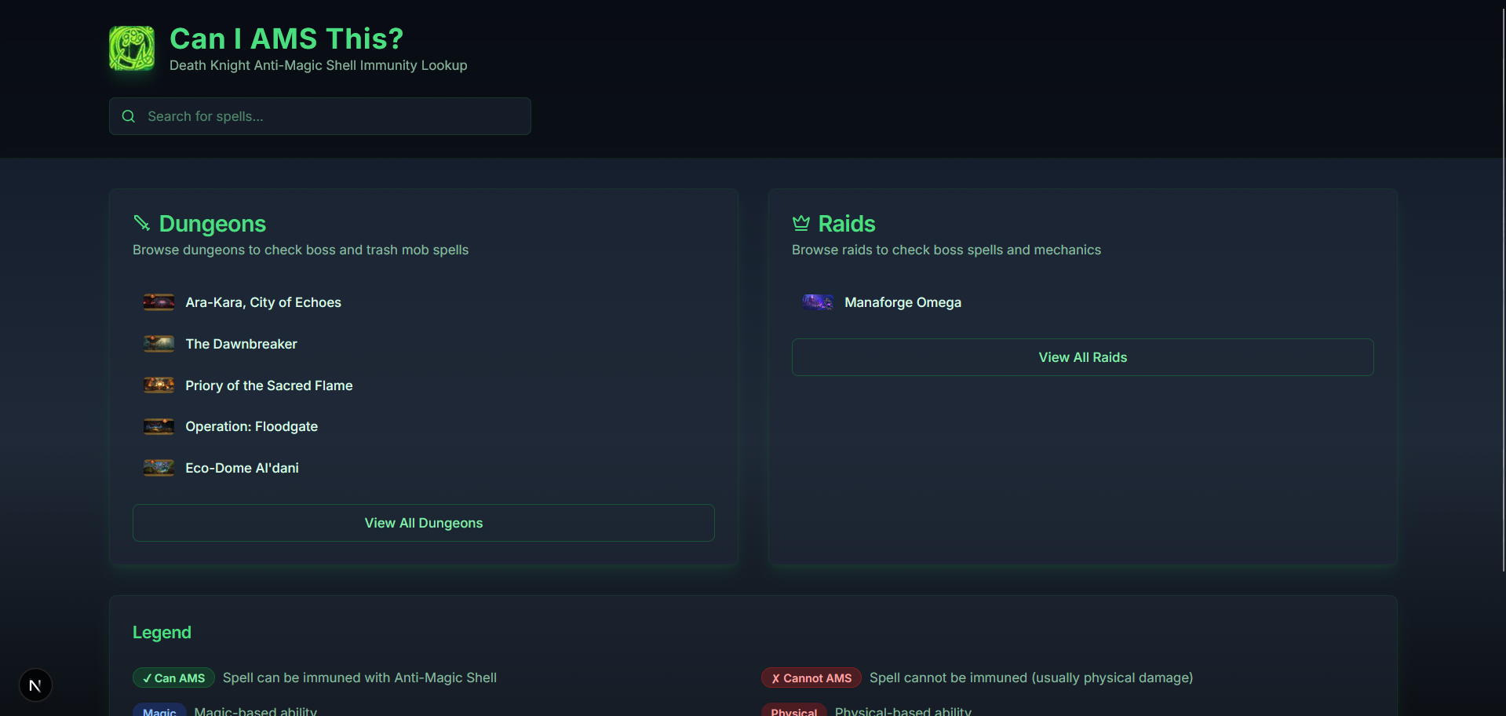
Dungeon list:
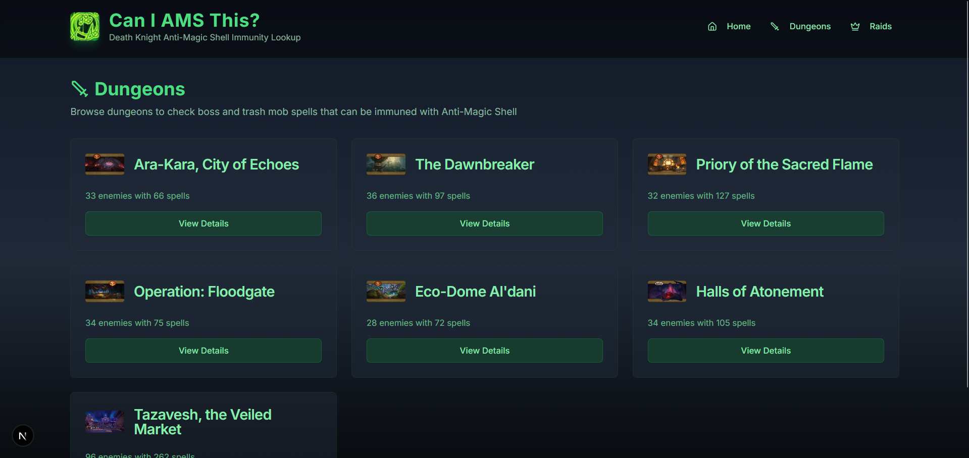
Spell immunity information page with mouse over links to the source:
