**Supporting information**

Fig S1 Pangolins seized in amount (pangolin individual equivalents) and seizure incident numbers over the study period. Note that data only go through March 2016. Note that the increase in seizure incident numbers and individual equivalents could be a consequence of an increase in media coverage, in increase in law enforcement and/or in an increase in pangolin trade volumes.

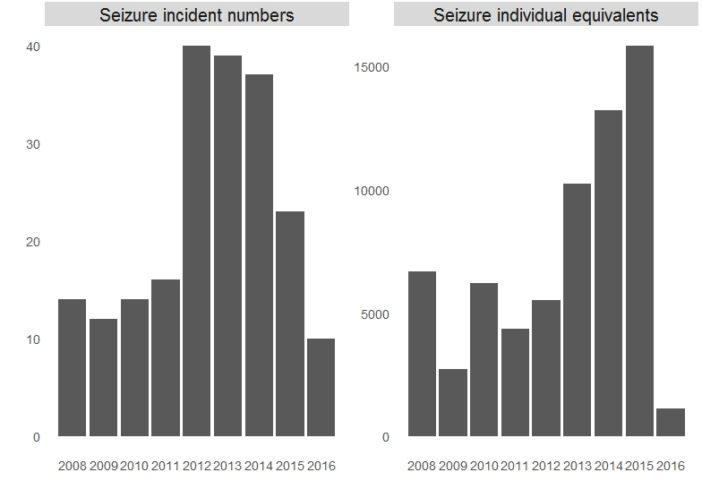

Table S2 Bootstrapping results for betweenness and degree centrality for seizure amount by percentage. 1st and 2nd indicate rank, bw_src is Borgatti's source betweenness, and bw tar is Borgatti's target betweenness.

|  |  |  |  |  |  |  |  |  |  |  |  |  |  |  |  |  |  |  |  |
| --- | --- | --- | --- | --- | --- | --- | --- | --- | --- | --- | --- | --- | --- | --- | --- | --- | --- | --- | --- |
| city | direct_1st | city | direct_2nd | city | bw_src_1st | city | bw_src_2nd | city | bw_tar_1st | city | bw_tar_2nd | city | indegree_1st | city | indegree_2nd | city | outdegree_1st | city | outdegree_2nd |
| Kunming | 89.4 | Qingdao | 51.9 | Kumming | 93.3 | Qingdao | 46.2 | Kunming | 84.9 | Qingdao | 48.9 | Kunming | 34.5 | Kunming | 25.3 | Sanming | 29.2 | Quzhou | 20.7 |
| Yunfu | 9.2 | Nanning | 12.2 | Qingyuan | 3.3 | Nanning | 23.1 | Yunfu | 14.7 | Kunming | 13.3 | Nanning | 33.6 | Indonesia | 15.7 | Dehong | 26.2 | Dehong | 20.3 |
| Qingyuan | 1.3 | Kunming | 6.7 | Yunfu | 2.9 | Jinan | 9.6 | Nanning | 0.2 | Chuxiong | 10.9 | Macau | 11.2 | Guangzhou | 14.1 | Quanzhou | 11.7 | Quanzhou | 9.9 |
|  |  | Jinan | 6.7 |  |  | Beihai | 4.8 |  |  | Wenzhou | 8.8 | Longyan | 11.2 | Wenzhou | 12.7 | Jieyang | 11.2 | Chongzuo | 9.3 |

Table S3 Bootstrapping results for betweenness and degree centrality for seizure times in percentage. 1st and 2nd indicate rank, bw_src is Borgatti's source betweenness, and bw tar is Borgatti's target betweenness.

|  |  |  |  |  |  |  |  |  |  |  |  |  |  |  |  |  |  |  |  |
| --- | --- | --- | --- | --- | --- | --- | --- | --- | --- | --- | --- | --- | --- | --- | --- | --- | --- | --- | --- |
| city | direct_1st | city | direct_2nd | city | bw_src_1st | city | bw_src_2nd | city | bw_tar_1st | city | bw_tar_2nd | city | indegree_1st | city | indegree_2nd | city | outdegree_1st | city | outdegree_2nd |
| Kunming | 89.6 | Qingdao | 53.1 | Kunming | 92.3 | Qingdao | 44.6 | Kunming | 84.8 | Qingdao | 51.5 | Kunming | 68.7 | Wuxi | 33.5 | Sanming | 83.2 | Fangchenggang | 65.8 |
| Yunfu | 8.5 | Nanning | 10.9 | Yunfu | 3.8 | Nanning | 22.2 | Yunfu | 14.7 | Kunming | 13.1 | Longyan | 21.1 | Kunming | 20.5 | Fangchenggang | 15.9 | Longyan | 16.8 |
| Qingyuan | 1.7 | Zhengzhou | 7.1 | Qingyuan | 3.0 | Jinan | 12.9 | Qingyuan | 0.2 | Chuxiong | 8.8 | Wenchang | 7.0 | Shantou | 19.9 | Longyan | 0.9 | Quzhou | 12.7 |
|  |  | Kunming | 7.0 |  |  | Kunming | 6.1 |  |  | Wenzhou | 7.4 | Hangzhou | 2.7 | Chuxiong | 12.2 |  |  | Hangzhou | 2.6 |

Table S4 Bootstrapping results for keyplayers based on fragmentation index for seizure amount (pangolin individual equivalents).

|  |  |
| --- | --- |
| Cities/Countries | Possibilities chosen as key players |
| Guangzhou | 95.7% |
| Vietnam | 62.9% |
| Fangchenggang | 36.2% |
| Kunming | 29.3% |
| Shenzhen | 24.1% |
| Changsha | 19.8% |
| Myanmar | 14.6% |
| Hongkong | 6.0% |
| Nanning | 3.4% |
| Dehong | 2.6% |
| Shanghai | 2.6% |
| Zhangzhou | 1.7% |