English:

There are four questions in the midterm exam. Please package the code and execution results of each question into a folder, compress them into a zip file, and name the file with your student ID (411121201.zip).

中文:

題目總共有4題，請將每題的程式碼以及執行結果打包成一個資料夾，壓縮成zip檔，檔名為學號(411121201.zip)。

Question 1

English:

Please write a program using loop statements that allows the user to enter a positive integer N (<100), and then outputs the multiplication table of 1 to N in a triangular shape.

input:

A positive integer (<100)

output:

Output the result of this number in a triangular shape.

Column width is 4, and it should be right-aligned.

Fill the extra spaces with '.'.

sample input 1:

5

sample output 1:

...1

...2...4

...3...6...9

...4...8..12..16

...5..10..15..20..25

sample input 2:

8

sample output 2:

...1

...2...4

...3...6...9

...4...8..12..16

...5..10..15..20..25

...6..12..18..24..30..36

...7..14..21..28..35..42..49

...8..16..24..32..40..48..56..64

中文:

請使用迴圈敘述撰寫一程式，讓使用者輸入一個正整數（<100），然後以三角形的方式依序輸出1到N的乘法表。

輸入：

一個正整數（<100）

輸出：

以三角形的方式依序輸出此數的乘法結果。

欄寬為4，並應靠右對齊。

多餘的空間請以'.'填滿。

Question 2

English:

Please upload the results as a Zip archive using the "link" function in the answer area.

　　Please using the attached template and resource pack, design a multi-page website that introduces the three domains (Python, Numpy, and Pandas). The requirements for the pages are as follows:

　　1. 　The NDHU logo must be in the top left corner of the page, click on the logo to link to the NDHU website.

　　2. 　The navigation bar in the upper right corner of the page must be linked to each page (Python is the default home page).

　　3. 　An h6 heading for "Data Science" and an h2 heading for the domain's name.

　　4. 　Please include the text of the field description and a picture of the field logo, line breaks for the field description should follow the pattern in the txt file.

　　5. 　The footer should have a CSIE logo in the center of the footer, click on the logo to link to the CSIE website.

　　6. 　Student number, department, and name should be added on the right side of the footer.

Note: The required images and text are already in the res folder in the zip file, please use them yourself.

Example screenshot：

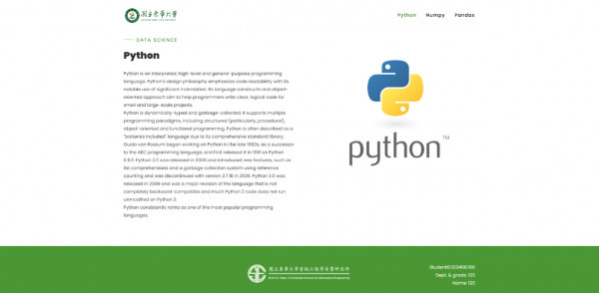

中文：

請將成果含各項資源打包成Zip壓縮檔以回答區「連結」功能上傳

模板及資源包

　　請利用附件模板以及資源包，設計一個多頁式網站，介紹Python、Numpy、Pandas三個領域，每個領域一頁。頁面中需具備的條件如下：

　　1.　頁面左上角須為學校Logo，點擊Logo可以連至學校網站

　　2.　頁面右上角導航列須可以連結到各頁面(Python為預設首頁)

　　3.　須具有一h6標題寫Data Science，另有一h2標題寫領域名稱

　　4.　須附有領域介紹文字以及領域Logo圖片，文字請依照txt檔案中的樣式換行

　　5.　footer中央需有東華資工Logo，點擊Logo可以連至東華資工的網站

　　6.　footer右側需加上學號、系級、姓名

注意：所需的圖片及文字都已經在壓縮檔中的res資料夾，請自行利用

Question 3

English:

Please scrape the article titles, points, and links from the following website and convert them into a dataframe or a 2D list. If an article does not have a point number, display "None".

https://news.ycombinator.com/

中文:

請爬取下列網站中的文章標題，points，還有其連結，並轉為dataframe 型別或二維list，如果該文章目前沒有pointy number，則顯示None

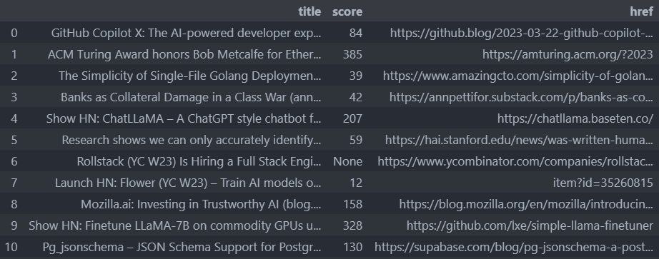

Question 4

Lottery

Write a program that allows users to enter a lottery drawing date number and their lottery numbers, and automatically determines whether they have won a prize. If they have won, output the name of the prize; otherwise, output "NO."

The URL of a lottery website is: "https://www.taiwanlottery.com.tw/lotto/lotto649/history.aspx"

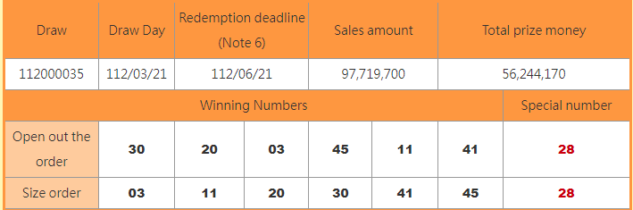

Input:

The drawing date number consists of nine digits, and the lottery numbers consist of six digits ranging from 1 to 49, with no repeats.

Output:

Winning method: Prize name

1. Matching all six winning numbers: Jackpot
2. Matching any five of the winning numbers plus the special number: Second prize
3. Matching any five of the winning numbers: Third prize
4. Matching any four of the winning numbers plus the special number: Fourth prize
5. Matching any four of the winning numbers: Fifth prize
6. Matching any three of the winning numbers plus the special number: Sixth prize
7. Matching any two of the winning numbers plus the special number: Seventh prize
8. Matching any three of the winning numbers: Eighth prize

If the user wins a prize, output the name of the prize. Otherwise, output "NO"

sample input:

112000035

3, 11, 20, 30, 45, 28

sample output:

Second prize

中文

大樂透

請寫一個程式來讓使用者可以藉由輸入一個期別號以及投注號碼，來自動判斷是否有中獎，如果有請輸出獎項名，沒有則輸出NO。

下列為一樂透網站之網址 :

"https://www.taiwanlottery.com.tw/lotto/lotto649/history.aspx"

Input:

期別部分含有九個數字，投注號碼共有六碼，範圍從1~49，不重複

Output:

中獎方式 : 獎項

與當期六個獎號完全相同者 : 頭獎

對中當期獎號之任五碼＋特別號 : 貳獎

對中當期獎號之任五碼 : 參獎

對中當期獎號之任四碼＋特別號 : 肆獎

對中當期獎號之任四碼 : 伍獎

對中當期獎號之任三碼＋特別號 : 陸獎

對中當期獎號之任兩碼＋特別號 : 柒獎

對中當期獎號之任三碼 : 普獎

如果有中獎，就輸出獎項名稱，反之則輸出 NO