Machine Learning HW2

Question 1:

a) We created the 2*300 normally distributed samples using gen_rand.py. The program gets as in input the mean and standard deviation for a normal distribution and creates a file containing 300 samples of that distribution.

b) As we have seen in class, the mean parameter of a normal distribution can be found by averaging all of the samples, and similarly the standard deviation can be found by averaging the squared distance from the mean:
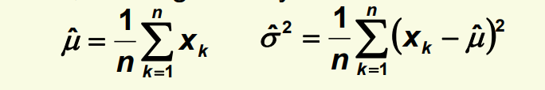

Therefore, we wrote est_parms.py, which found both of these parameters. The outputted results are
as follows:

Class 1: mean = -1.938 standard_deviation = 0.996
Class 2: mean = 1.088 standard_deviation = 1.642

