**Menu layout and basic navigation flow**

**1. Login:**

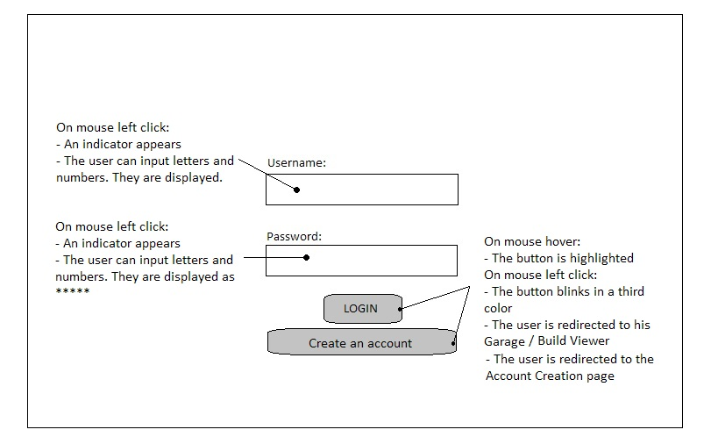

**Figure 1 – Login screen**

When the user types the OAC’s URL and loads it, he will be redirected to the Login screen. This screen can also be considered as the Landing screen.

Available options to the user:

* Login with an already created account by inserting valid credentials in the respective fields
* Create a new account

Basic functionalities of the page’s elements:

The Username and Password fields are loaded blank. The user can type inside them after clicking in the with the left mouse button.  
Credentials input in the Password field will be displayed as “*” for security reasons.

The LOGIN button will redirect the user to his Garage or Build Viewer, depending on the type of account created.  
The Create an account button will redirect the user to the Account Creation page.

When the LOGIN and Create an account buttons are hovered on, they will be highlighted by having their color change to a slightly lighter one than their default color.  
When the LOGIN and Create an account buttons are clicked on with the left mouse button, they will flash in a third color and then redirect the user to the corresponding page.

**2. Account creation**

**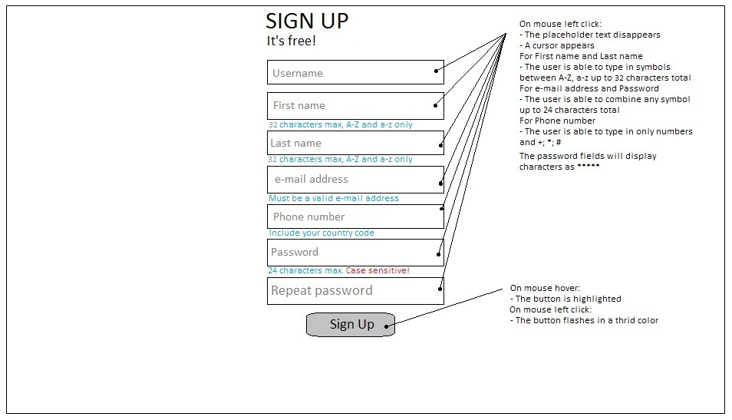  
Figure 2 – Account Creation**

The user can reach this page by clicking on the Create an account button in the Login screen.

Available options to the user:

* Create an Username
* Insert his First and Last names
* Insert his e-mail address
* Insert his phone number
* Create a Password
* Sign Up

Basic functionalities of the page’s elements:

All fields will have a temporary hint text inside them. Once the user begins typing inside the field, the hint should disappear. Only the user inputted text should remain.  
All fields allow the user to type in his credentials after being clicked with the left mouse button.  
The Username, First name and Last name fields allow a maximum of 32 characters.  
The Username field can consist of A-Z, a-z, 0-9, and common special characters such as “@”, “#”, “$”, “%”, “^”, “&”, “*”, “_”, “-“, “.”. The maximum characters that can be used are 32.  
The First name and Last name can consist only of A-Z and a-z characters, up to a maximum of 32 character total.

The e-mail address field can consist of A-Z, a-z, 0-9, and common special characters such as “@”, “#”, “$”, “%”, “^”, “&”, “*”, “_”, “-“, “.”. The maximum characters that can be used are 32.  
The Phone number field can consist only of 0-9 numbers and the “*”, “+”, “#”.

After the user has inputted his credentials in one field and moves to another one, the system will check if those credentials are real, or if they are unavailable for use if another user has already used them.  
If a credential is unavailable or incorrect an appropriate warning message will be displayed on the right of that field. If the credential for Username is taken, the message should be “This Username is already in use by another user. Please select a new Username”. If the credential for e-mail is invalid, the message should be “The entered e-mail is invalid. Please use a valid e-mail address”. All warning messages should be in red.

When the Sign Up button is hovered on, it will be highlighted by having its color change to a slightly lighter one than the default color.

When the Sign Up button is clicked on with the left mouse button, it will flash in a third color and then redirect the user to the Account Successfully Created screen, as well as log him in the OAC simultaneously.

**3. Account Created Successfully**

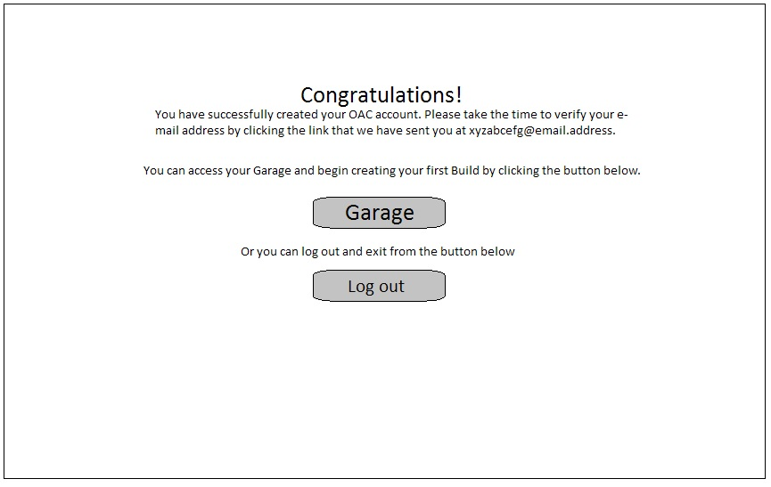

**Figure 3 – Account Created Successfully**

The user can reach this page by clicking on the Sign Up button in the Account Creation screen.

Available options to the user:

* Go to his Garage
* Log out and exit the OAC

Basic functionalities of the page’s elements:

The Garage and Log out buttons will be highlighted if hovered on with the mouse. If they are clicked on with the left mouse button, they will flash in a third color and redirect the user to the respective page.

**3.1. Log out screen**

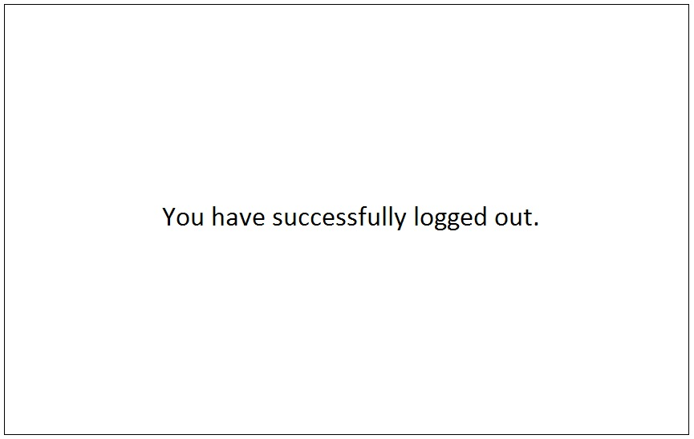

**Figure 3.1 – Successfully Logged Out**

This screen will be displayed every time the user logs out by clicking the Log out button.

**4. Garage**

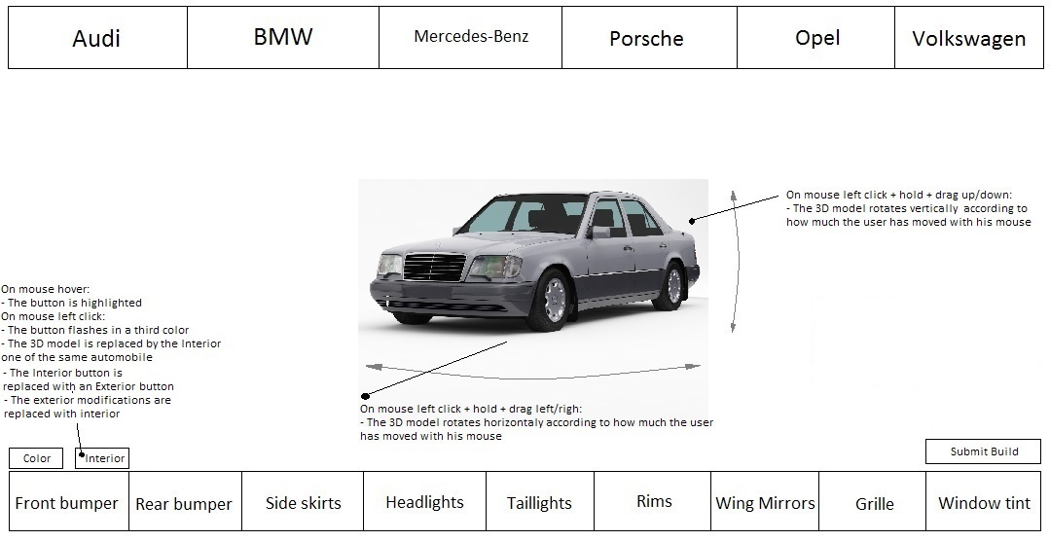

**Figure 4 – Client’s Garage Main - Exterior**

This is the main page of the Client’s Garage. It will be accessed after the user has logged in with his account.

Available options to the user:

* Select a make
  + Select a model
* Select a body part to modify
  + Select any of the available body parts for that category, e.g. any of the available front bumpers for that automobile
* Select a color for the automobile, or select a color for individual body parts
* Rotate the 3D model of the selected automobile
  + Horizontally
  + Vertically
* Enter the Interior 3D model of the selected automobile
* Submit the Build for Review, once it is ready

Basic functionalities of the page’s elements:

*<<  
“Make Menu” refers to the group of buttons located on the top of the page  
“Body Mods Menu” refers to the group of buttons located on the bottom of the page, including the Color, Interior and Submit Build buttons  
>>*

If the user clicks on the 3D model with the left mouse button and holds, then drags from left to right or vice versa, the 3D model will rotate horizontally.  
If the user clicks on the 3D model with the left mouse button and holds, the drags up or down, the 3D model will rotate vertically.

If any of the buttons on the page are hover on with the mouse, they will be highlighted.

**4.1. Selecting a Model and Make**

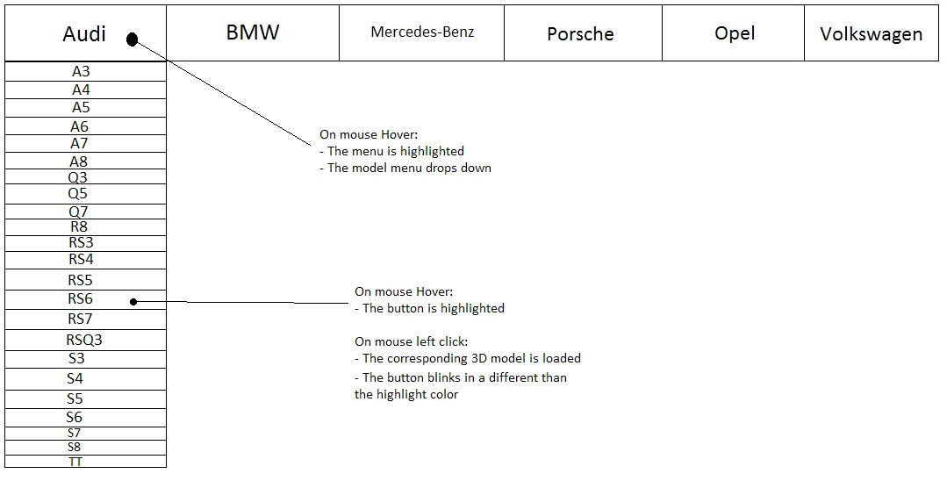

**Figure 4.1 – Select Make and Model**

If any of the buttons from the Make Menu is hovered on, a dropdown menu will be triggered. The dropdown menu will display all available models for that make. If the user hovers on any of the model buttons, they will be highlighted. If the user clicks on them with the left mouse button, they will flash briefly and that model’s 3D model will be loaded.

**4.2. Selecting a Body modification**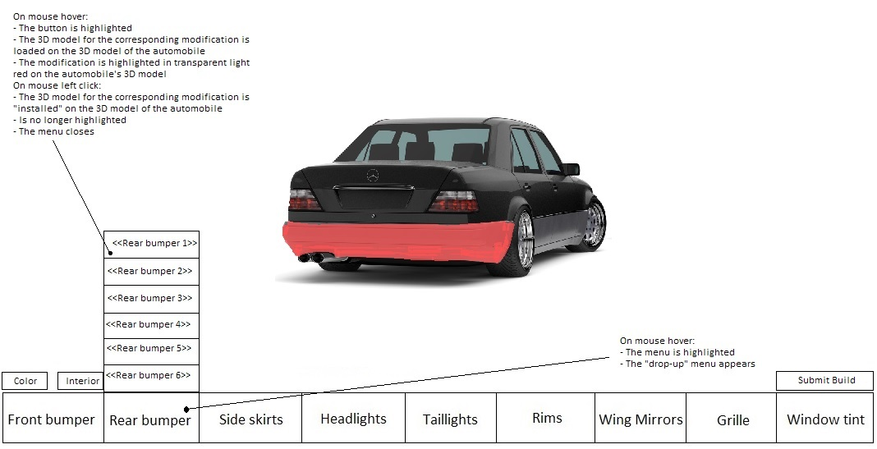

**Figure 4.2 – Select body modification**

The Body Mods Menu will greyed out and be inactive until the user selects a make and a model.  
If a make and model is selected the menu will no longer be greyed out and the user will be able to access it freely.  
If any of the buttons from the Body Mods Menu is hovered on, a drop-up menu will be triggered. The drop-up menu will display all available modifications for that body part. Only body mods that are compatible with the selected make and model will be displayed. If the any of the available body mods is hovered on, it will be displayed on the 3D model of the automobile, but will not be applied. It will also be highlighted by being colored in light red. If the user clicks on any of them with the left mouse button, the button will flash briefly and that body mod’s 3D model will be loaded and applied to the automobiles 3D model. It will no longer be highlighted and will remain as a part of the 3D model.

**4.2.1. Interior modifications**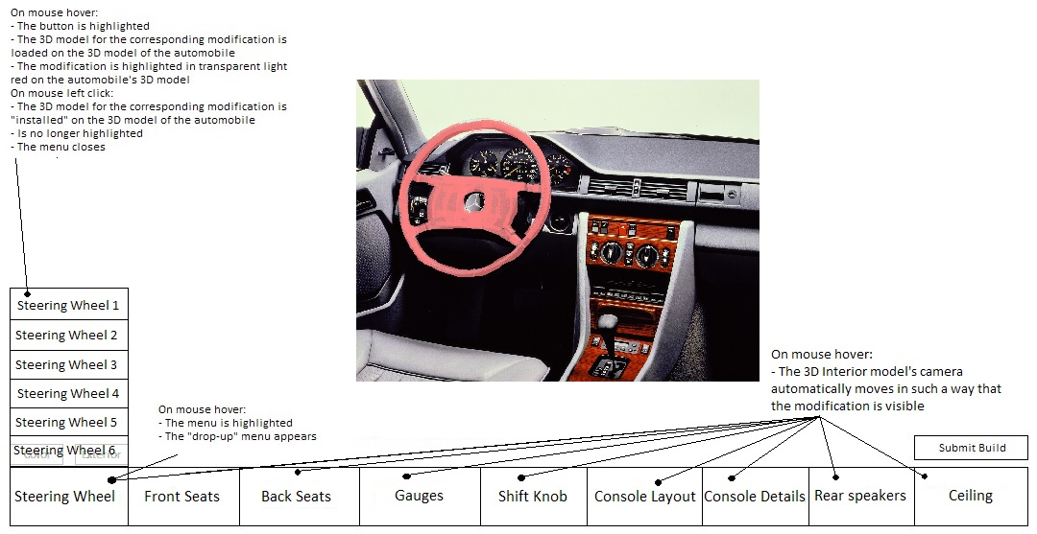

**Figure 4.2.1 – Interior**

If the user clicks on the Interior button with the left mouse button, the 3D model will change to the interior one of the selected automobile.

The same functionalities for the buttons and the 3D model apply from Chapter 4.

**4.3. Selecting Color**

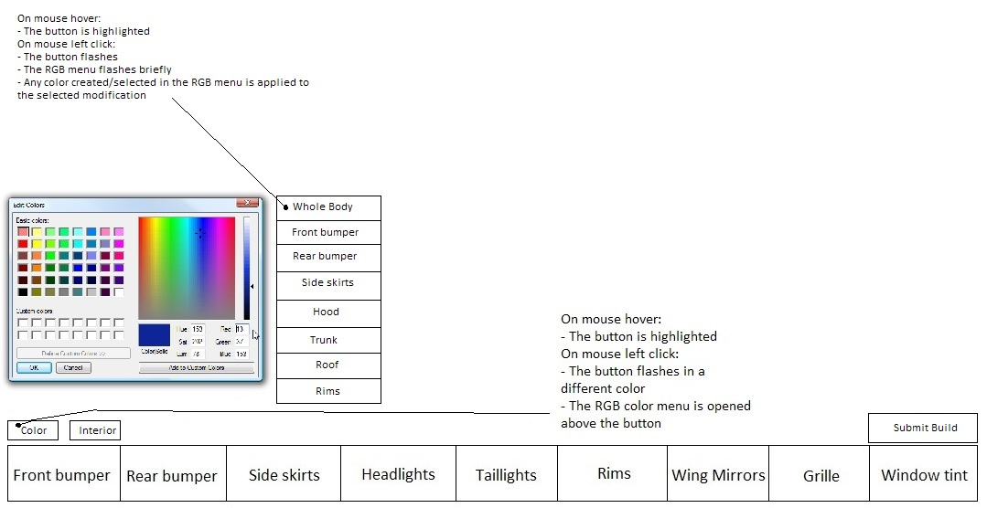

**Figure 4.3 – Select Color**

If the Color button is clicked on with the left mouse button, a RGB color menu will open above it. Next to the RGB color menu a menu consisting of all available modifications that can be painted will appear. Any selected or created color will be applied to the selected body modification and will be displayed on the 3D model.

**4.4. Submit a Build**

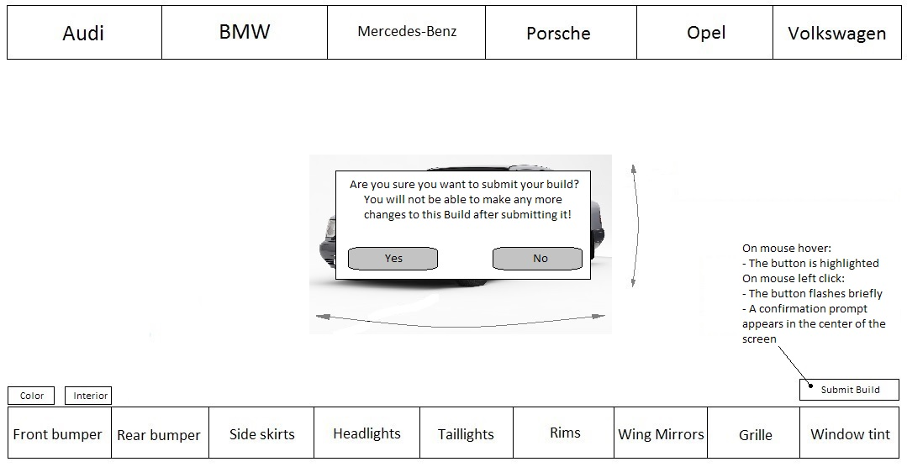

**Figure 4.4 – Submitting a Build**

If the user clicks with the left mouse button on the Submit Build button, he will trigger a confirmation prompt.

Available options to the user:

* Confirm that all changes are final
* Cancel the submission
  + Return back to the Build

Basic functionalities of the page’s elements:

If the user clicks on No, he will close the prompt and be able to modify his build.  
If the user clicks on Yes, he will submit his build and the content of the message will change.

**4.4.1. Submit Successful**

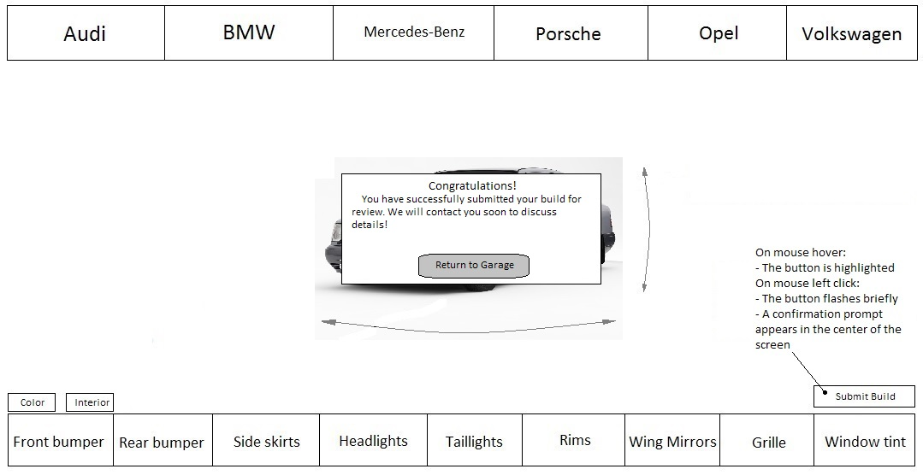

**Figure 4.4.1 – Submit Successful**

If the user reaches this screen by confirming the submission of his build, the prompt’s content will change.

Available options to the user:

* Return to the Garage

Basic functionalities of the page’s elements:

If the user clicks on the Return to Garage button with the left mouse button, the prompt will close and the user will return to the Garage.