**Chapter 4 Uncovering Biological Trajectories**

**4.1 Dimension reduction DR101**

Relevance between DR and trajectories

**4.1.1 Local vs. global structure in DR**

Flowly vs clumpy projections, former good for trajectories, latter good for atlasing

**4.1.2 Recap on PCA, t-SNE and UMAP**

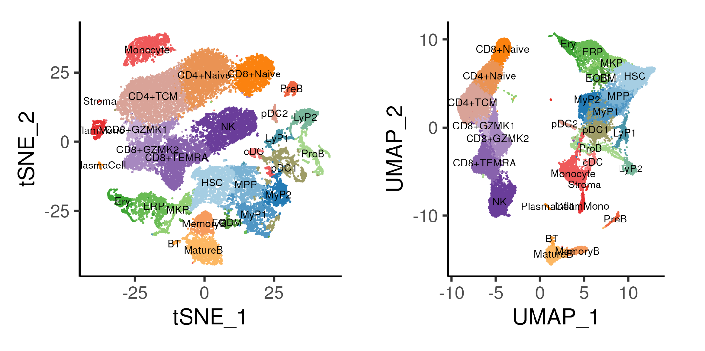

Figure 4.1: t-SNE and UMAP projections of the bone marrow data coloured by cell annotation derived from previous section.

**4.1.3 Force-directed layout**

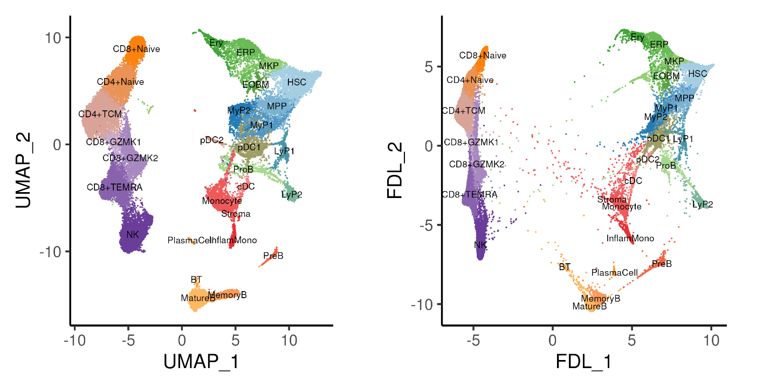

Figure 4.2: UMAP and force-directed layout of the bone marrow data coloured by annotated cell types.

**4.1.4 Diffusion maps**

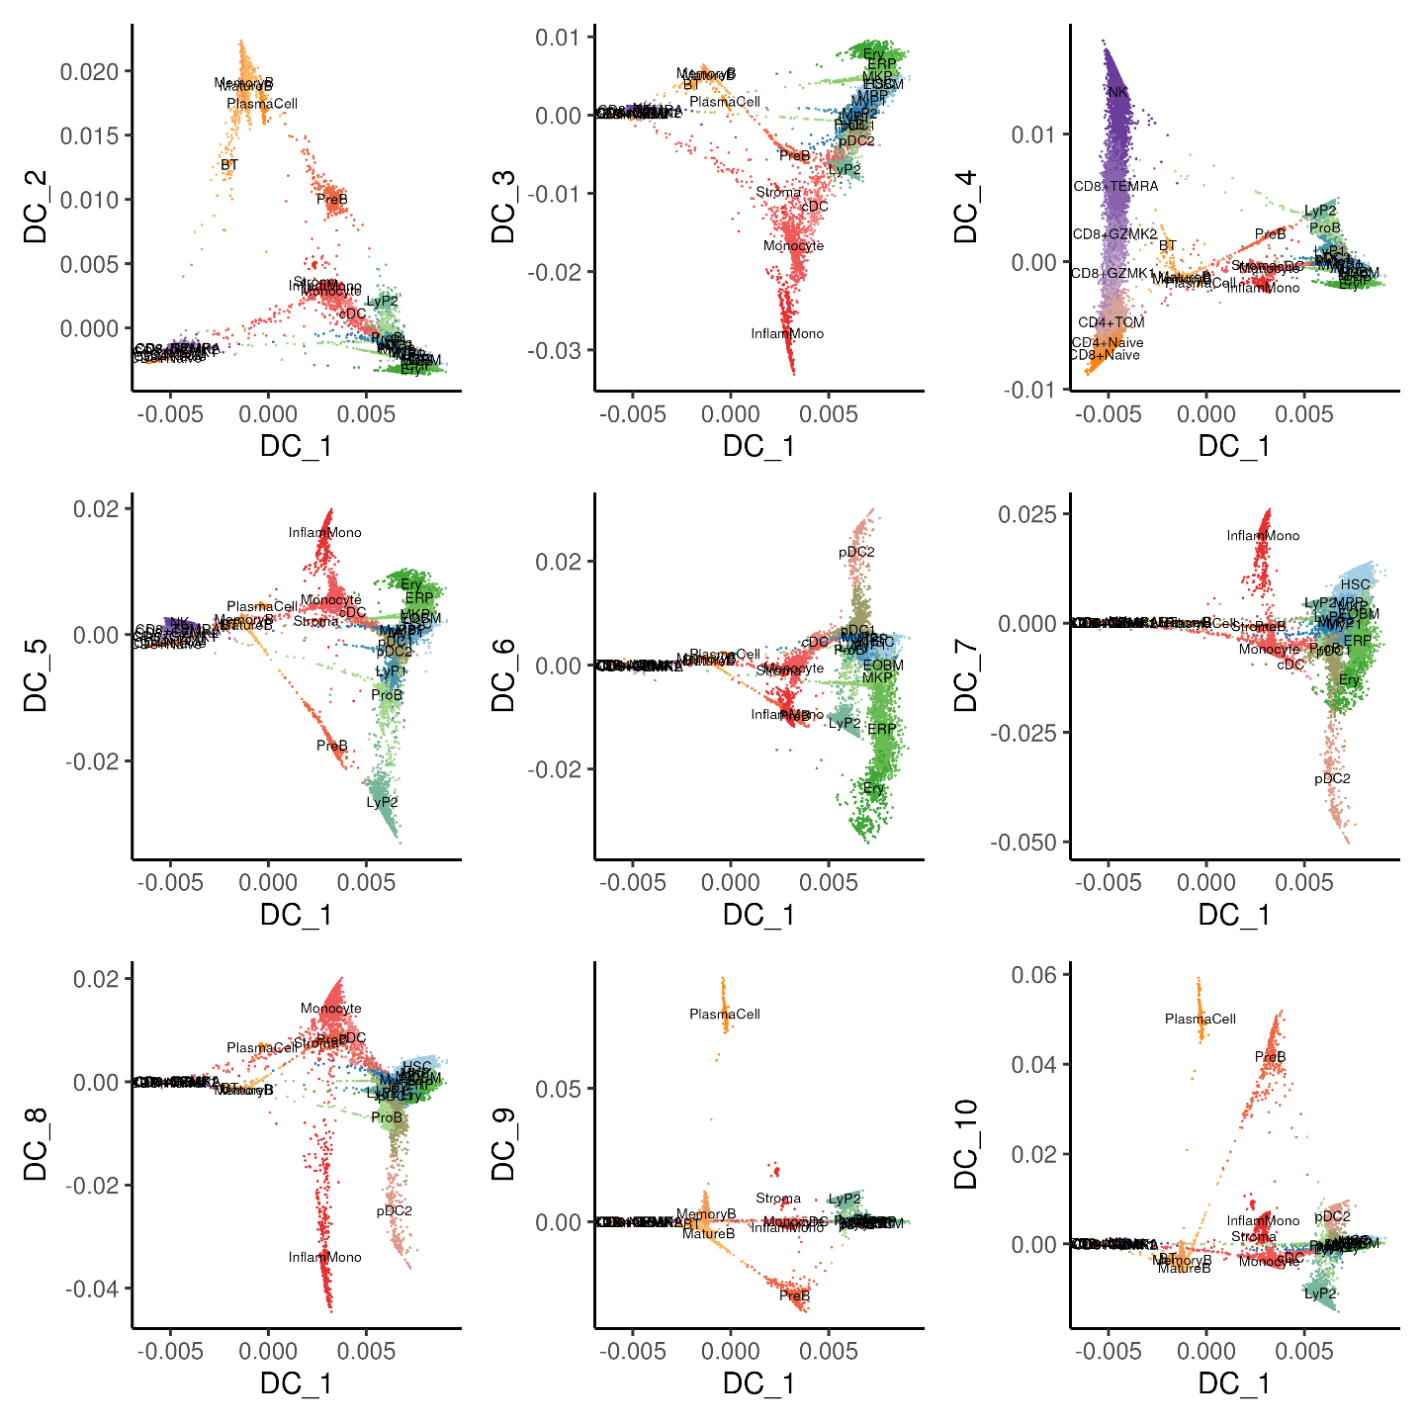

Figure 4.3: Diffusion maps showing the first diffusion component (DC1) plotted with DC2 to DC10 separately, coloured by annotated cell types.

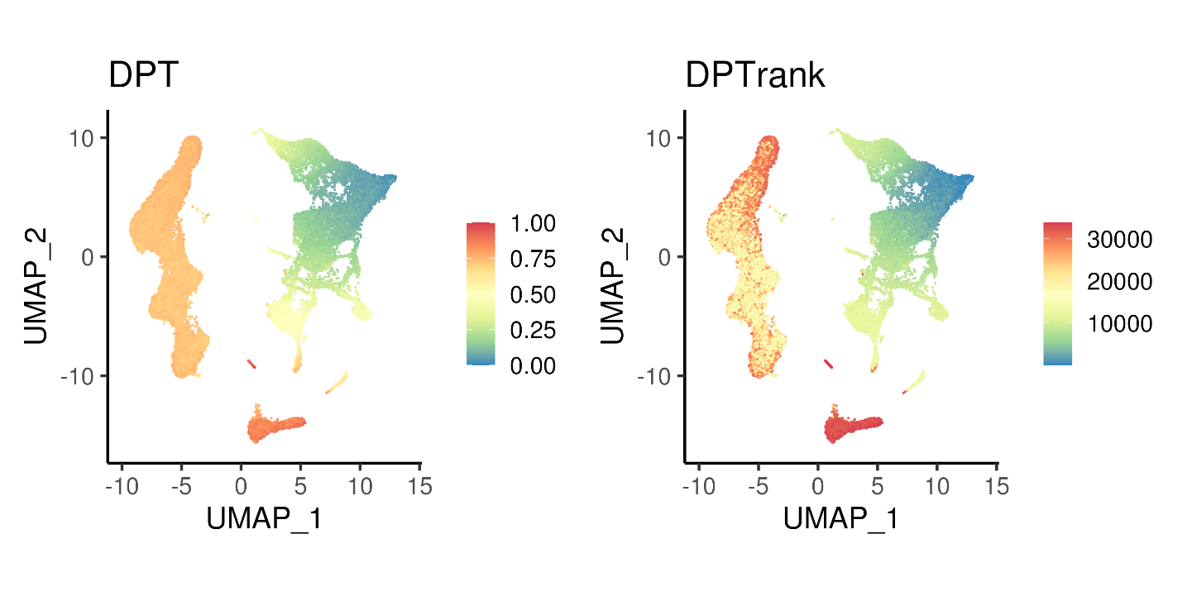

Figure 4.4: Diffusion pseudotime calculated using top 10 DCs and the corresponding rank.

**4.1.5 PHATE**

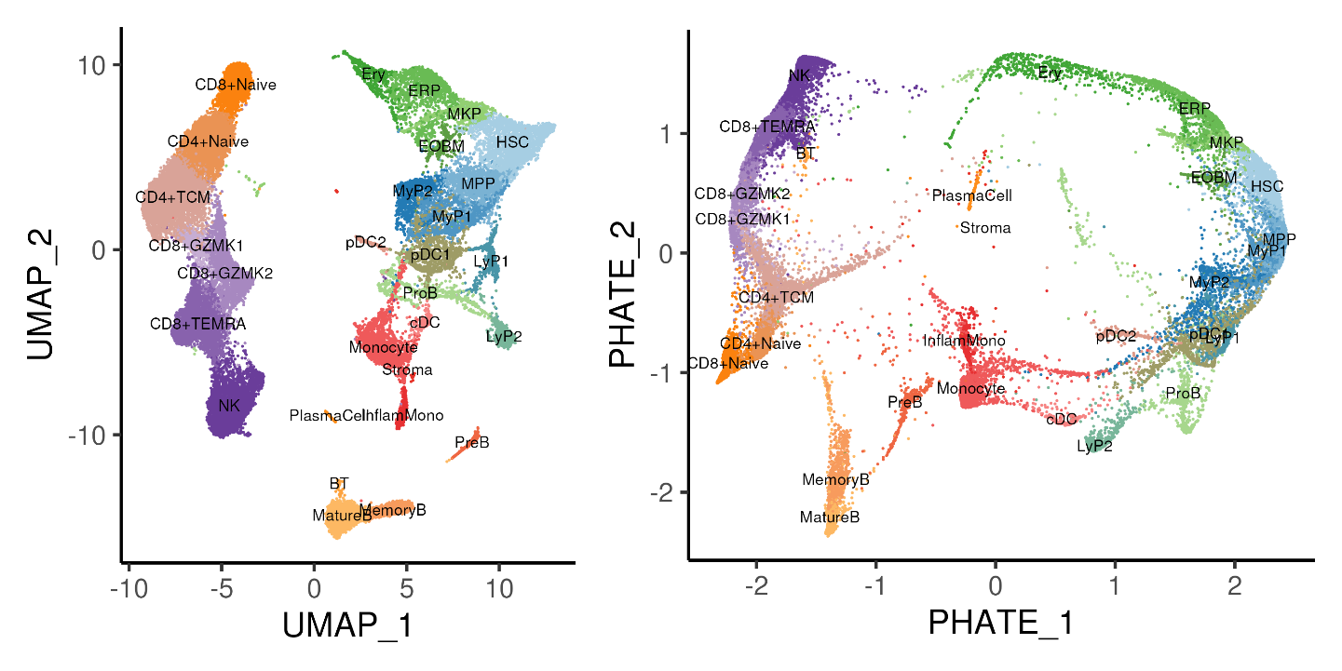

Figure 4.5: UMAP and PHATE projection of the bone marrow data coloured by annotated cell types.

**4.1.6 3D Projections**

HSCMPPMyP1MyP2LyP1LyP2ProBMKPERPEryEOBMpDC1pDC2cDCInflamMonoStromaPreBMemoryBMatureBBTPlasmaCellCD8+NaiveCD4+NaiveCD4+TCMCD8+GZMK1CD8+GZMK2CD8+TEMRANK

Figure 4.6: 3D UMAP of the bone marrow data coloured by annotated cell types.

**4.1.7 Code**

*##### Load required packages*

rm(list = ls())

library(data.table)

library(Matrix)

library(ggplot2)

library(plotly)

library(patchwork)

library(RColorBrewer)

library(Seurat)

library(reticulate)

library(pdist)

library(phateR)

library(SeuratWrappers)

library(monocle3)

library(slingshot)

library(tradeSeq)

library(pheatmap)

library(clusterProfiler)

library(msigdbr)

library(BiocParallel)

**if**(!dir.exists("images/")){dir.create("images/")} *# Folder to store outputs*

*### Define color palettes and plot themes*

colLib = brewer.pal(7, "Paired")

names(colLib) = c("BM0pos", "BM0neg", "BM7pos", "BM7neg",

"BM9pos", "BM9neg", "BM2pos")

colDnr = colLib[c(1,3,5,7)]

names(colDnr) = c("BM0", "BM7", "BM9", "BM2")

colGEX = c("grey85", brewer.pal(7, "Reds"))

colCcy = c("black", "blue", "darkorange")

plotTheme <- theme_classic(base_size = 18)

os <- import("os")

py_run_string("r.os.environ['OMP_NUM_THREADS'] = '4'")

nC <- 4 *# Number of threads / cores on computer*

*### Load stuff from previous script*

seu <- readRDS("bmSeu.rds")

nPC <- 23 *# determined from elbow plot*

nClust <- uniqueN(Idents(seu)) *# Setup color palette*

colCls <- colorRampPalette(brewer.pal(n = 10, name = "Paired"))(nClust)

*##### Sec4: Trajectory Analysis*

*### A. Alternate dimension reduction*

*# Setup python anndata for downstream DFL/DiffMap/PAGA*

sc <- import("scanpy", convert = FALSE)

ad <- import("anndata", convert = FALSE)

adata <- sc$AnnData(

X = np_array(t(GetAssayData(seu)[VariableFeatures(seu),]), dtype="float32"),

obs = seu@meta.data[, c("library", "celltype")],

var = data.frame(geneName = VariableFeatures(seu)))

adata$obsm$update(X_pca = Embeddings(seu, "pca"))

adata$obsm$update(X_umap = Embeddings(seu, "umap"))

adata$var_names <- VariableFeatures(seu)

adata$obs_names <- colnames(seu)

sc$pp$neighbors(adata, n_neighbors = as.integer(30), n_pcs = as.integer(nPC))

*# FDL*

sc$tl$draw_graph(adata, layout = "fa", init_pos = "X_umap")

oupDR <- py_to_r(adata$obsm['X_draw_graph_fa'])

rownames(oupDR) <- colnames(seu)

colnames(oupDR) <- c("FDL_1","FDL_2")

oupDR = oupDR / 10^(floor(log10(diff(range(oupDR))))-1)

seu[["fdl"]] <- CreateDimReducObject(embeddings = oupDR, key = "FDL_",

assay = DefaultAssay(seu))

p1 <- DimPlot(seu, reduction = "umap", pt.size = 0.1, label = TRUE,

label.size = 3, cols = colCls) + plotTheme + coord_fixed()

p2 <- DimPlot(seu, reduction = "fdl", pt.size = 0.1, label = TRUE,

label.size = 3, cols = colCls) + plotTheme + coord_fixed()

ggsave(p1 + p2 & theme(legend.position = "none"),

width = 10, height = 5, filename = "images/dimrdFDL.png")

*# DiffMaps + DPT pseudotime*

sc$tl$diffmap(adata)

oupDR <- py_to_r(adata$obsm['X_diffmap'])

rownames(oupDR) <- colnames(seu)

colnames(oupDR) <- paste0("DC_", 0:(15-1))

oupDR <- oupDR[, paste0("DC_", seq(10))]

seu[["diffmap"]] = CreateDimReducObject(embeddings = oupDR, key = "DC_",

assay = DefaultAssay(seu))

p3 <- list()

**for**(i **in** 2:10){

p3[[paste0("DC1",i)]] <-

DimPlot(seu, reduction = "diffmap", pt.size = 0.1, label = TRUE,

label.size = 3, cols = colCls, dims = c(1,i)) + plotTheme

}

ggsave(wrap_plots(p3) & theme(legend.position = "none"),

width = 12, height = 12, filename = "images/dimrdDiffmap.png")

*# DPT pseudotime*

rootCelltype <- "HSC"

oupDR <- py_to_r(adata$obsm['X_diffmap'])

rownames(oupDR) <- colnames(seu)

colnames(oupDR) <- paste0("DC_", 0:(15-1))

oupDR <- oupDR[, paste0("DC_", seq(10))]

oupDR <- data.table(celltype = seu$celltype, oupDR)

tmp <- oupDR[, lapply(.SD, mean), by = "celltype"] *# celltype centroid*

tmp <- tmp[celltype != rootCelltype]

tmp <- data.frame(tmp[, -1], row.names = tmp$celltype)

oupDR$sampleID <- colnames(seu)

oupDR <- oupDR[celltype == rootCelltype]

oupDR <- data.frame(oupDR, row.names = oupDR$sampleID)

oupDR <- oupDR[, colnames(tmp)]

tmp <- as.matrix(pdist(oupDR, tmp))

rownames(tmp) <- rownames(oupDR)

iTip <- grep(names(which.max(rowSums(tmp))), colnames(seu)) *# tip cell*

py_run_string(paste0("r.adata.uns['iroot'] = ", as.integer(iTip-1))) *# 0-base*

sc$tl$dpt(adata)

seu$DPT <- py_to_r(adata$obs$dpt_pseudotime)

seu$DPTrank <- rank(seu$DPT)

*# seu$tmp = seu$celltype; seu$tmp[iTip] = NA; seu$tmp2=0.1; seu$tmp2[iTip]=3*

*# DimPlot(seu, reduction = "umap", pt.size = seu$tmp2, group.by = "tmp")*

p1 <- FeaturePlot(seu, reduction = "umap", pt.size = 0.1, feature = "DPT") +

scale_color_distiller(palette = "Spectral") + plotTheme + coord_fixed()

p2 <- FeaturePlot(seu, reduction = "umap", pt.size = 0.1, feature = "DPTrank") +

scale_color_distiller(palette = "Spectral") + plotTheme + coord_fixed()

ggsave(p1 + p2 + plot_layout(ncol = 2),

width = 10, height = 5, filename = "images/dimrdDPT.png")

*# PHATE*

oupPhate = phate(t(GetAssayData(seu)[VariableFeatures(seu), ]),

knn = 30, npca = nPC, seed = 0)

oupDR = oupPhate$embedding

oupDR = oupDR / 10^(floor(log10(diff(range(oupDR)))))

rownames(oupDR) = colnames(seu)

colnames(oupDR) = c("PHATE_1","PHATE_2")

seu[["phate"]] <- CreateDimReducObject(embeddings = oupDR, key = "PHATE_",

assay = DefaultAssay(seu))

p1 <- DimPlot(seu, reduction = "umap", pt.size = 0.1, label = TRUE,

label.size = 3, cols = colCls) + plotTheme + coord_fixed()

p2 <- DimPlot(seu, reduction = "phate", pt.size = 0.1, label = TRUE,

label.size = 3, cols = colCls) + plotTheme + coord_fixed()

ggsave(p1 + p2 & theme(legend.position = "none"),

width = 10, height = 5, filename = "images/dimrdPHATE.png")

*# 3D UMAP*

seu <- RunUMAP(seu, dims = 1:nPC, n.components = 3,

reduction.name = "umap3d", reduction.key = "UMAP3D_")

ggData <- data.table(seu@reductions$umap3d@cell.embeddings)

ggData$celltype <- seu$celltype

fwrite(ggData, sep = "\t", file = "images/dimrd3dumap.txt.gz")

p1 <- plot_ly(ggData, x = ~UMAP3D_1, y = ~UMAP3D_2, z = ~UMAP3D_3,

color = ~celltype, type = "scatter3d", size = 1, colors = colCls)

htmlwidgets::saveWidget(partial_bundle(p1), file = "images/dimrd3dumap.html",

selfcontained = TRUE)

**4.2 Trajectory inference and pseudotime**

**4.2.1 Difference between trajectory and pseudotime**

Insert schematic

**4.2.2 Considerations in trajectory inference**

Insert review

**4.2.3 Different trajectory inference methods**

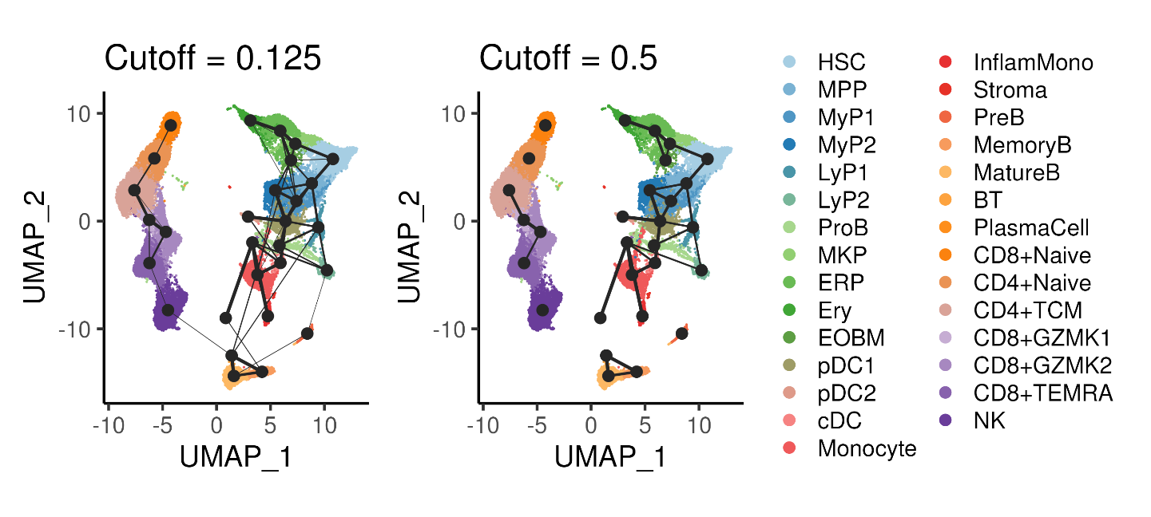

Figure 4.7: PAGA inference of cluster-cluster relationships in the bone marrow data with different cutoffs applied to the cluster connectivity.

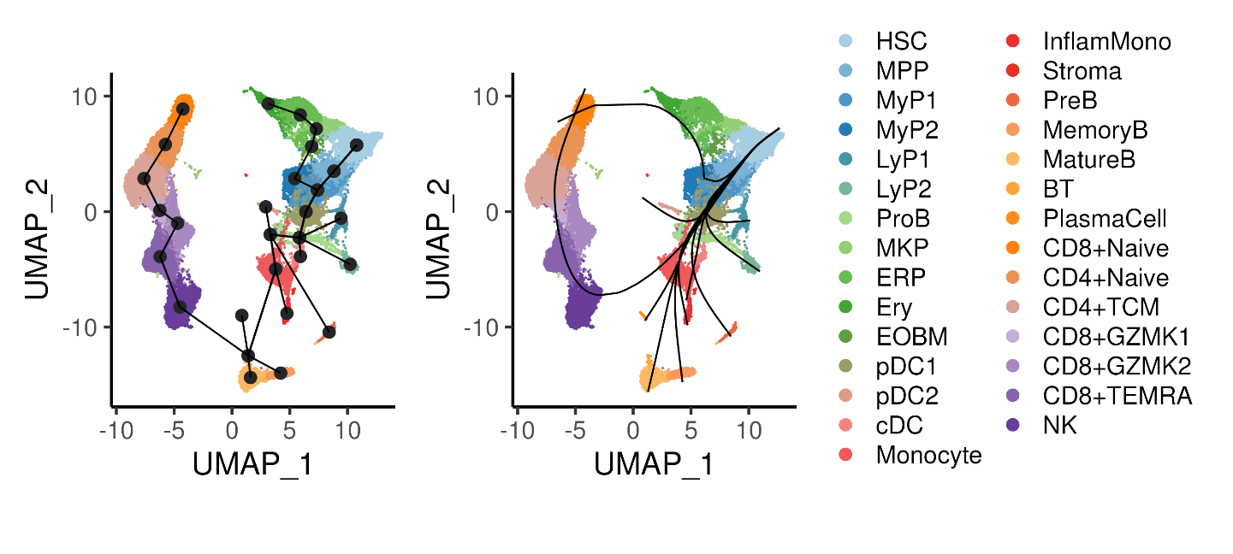

Figure 4.8: Trajectory inference using the Slingshot algorithm, showing the cluster connectivity and smoothed trajectories. Cells are coloured by annotated cell types.

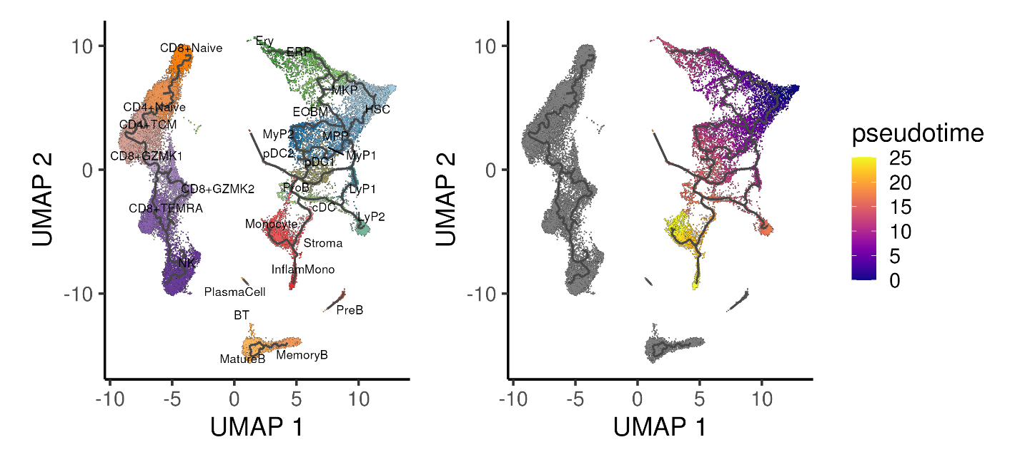

Figure 4.9: Trajectory inference using the Monocle algorithm applied onto the UMAP space, showing the different trajectories and inferred pseudotime for the CD34 progenitor “island”. Cells are coloured by annotated cell types.

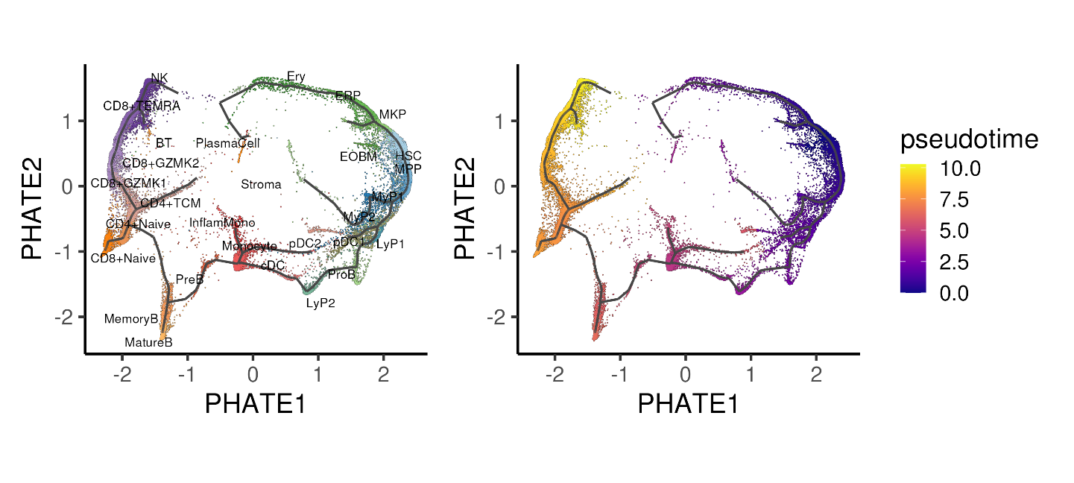

Figure 4.10: Trajectory inference using the Monocle algorithm applied onto the PHATE space, showing the different trajectories and inferred pseudotime for the CD34 progenitor “island”. Cells are coloured by annotated cell types.

**4.2.4 Code**

*### B. Trajectory inference*

*# PAGA*

sc$tl$paga(adata, groups = "celltype")

oupPAGA <- py_to_r(adata$uns[["paga"]]$connectivities$todense())

oupPAGA[upper.tri(oupPAGA)] <- 0

oupPAGA <- data.table(source = levels(seu$celltype), oupPAGA)

colnames(oupPAGA) <- c("source", levels(seu$celltype))

oupPAGA <- melt.data.table(oupPAGA, id.vars = "source",

variable.name = "target", value.name = "weight")

seu@misc$PAGA <- oupPAGA *# Store PAGA results into Seurat object*

ggData = data.table(celltype = seu$celltype, seu@reductions$umap@cell.embeddings)

ggData = ggData[,.(UMAP_1 = mean(UMAP_1), UMAP_2 = mean(UMAP_2)), by = "celltype"]

oupPAGA = ggData[oupPAGA, on = c("celltype" = "source")]

oupPAGA = ggData[oupPAGA, on = c("celltype" = "target")]

colnames(oupPAGA) = c("celltypeA","UMAP1A","UMAP2A","celltypeB",

"UMAP1B","UMAP2B","weight")

oupPAGA$plotWeight = oupPAGA$weight * 1

p3 <- DimPlot(seu, reduction = "umap", pt.size = 0.1, label = FALSE,

label.size = 3, cols = colCls) + plotTheme + coord_fixed()

p1 <- p3 +

geom_point(data = ggData, aes(UMAP_1, UMAP_2), size = 3, color = "grey15") +

geom_segment(data = oupPAGA[weight > 0.125], color = "grey15",

linewidth = oupPAGA[weight > 0.125]$plotWeight,

aes(x = UMAP1A, y = UMAP2A, xend = UMAP1B, yend = UMAP2B)) +

ggtitle("Cutoff = 0.125")

p2 <- p3 +

geom_point(data = ggData, aes(UMAP_1, UMAP_2), size = 3, color = "grey15") +

geom_segment(data = oupPAGA[weight > 0.5], color = "grey15",

linewidth = oupPAGA[weight > 0.5]$plotWeight,

aes(x = UMAP1A, y = UMAP2A, xend = UMAP1B, yend = UMAP2B)) +

ggtitle("Cutoff = 0.5")

ggsave(p1 + p2 + plot_layout(guides = "collect"),

width = 10, height = 4.5, filename = "images/dimrdTrajPAGA.png")

*# Slingshot*

sce <- as.SingleCellExperiment(seu)

sce <- slingshot(sce, reducedDim = 'UMAP', clusterLabels = sce$celltype,

start.clus = 'HSC', approx_points = 200)

slsMST <- slingMST(sce, as.df = TRUE)

slsCrv <- slingCurves(sce, as.df = TRUE)

p3 <- DimPlot(seu, reduction = "umap", pt.size = 0.1, label = FALSE,

label.size = 3, cols = colCls) + plotTheme + coord_fixed()

p1 <- p3 +

geom_point(data = slsMST, aes(UMAP_1, UMAP_2), size = 3, color = "grey15") +

geom_path(data = slsMST %>% arrange(Order),

aes(UMAP_1, UMAP_2, group = Lineage))

p2 <- p3 +

geom_path(data = slsCrv %>% arrange(Order),

aes(UMAP_1, UMAP_2, group = Lineage))

ggsave(p1 + p2 + plot_layout(guides = "collect"),

width = 10, height = 4.5, filename = "images/dimrdTrajSlingshot.png")

*# Monocle on UMAP*

cds <- as.cell_data_set(seu)

cds <- cluster_cells(cds, reduction_method = "UMAP")

cds <- learn_graph(cds)

cds <- order_cells(cds, root_cells = colnames(cds)[iTip])

p1 <- plot_cells(

cds, color_cells_by = "celltype",

label_groups_by_cluster = F, label_branch_points = F, label_roots = F,

label_leaves = F, cell_size = 0.2, group_label_size = 3) +

scale_color_manual(values = colCls) + plotTheme + coord_fixed() +

theme(legend.position = "none")

p2 <- plot_cells(

cds, color_cells_by = "pseudotime",

label_groups_by_cluster = F, label_branch_points = F, label_roots = F,

label_leaves = F, cell_size = 0.2) + plotTheme + coord_fixed()

ggsave(p1 + p2,

width = 10, height = 4.5, filename = "images/dimrdTrajMono.png")

*# Monocle on PHATE*

cds2 <- as.cell_data_set(seu)

cds2@int_colData@listData[["reducedDims"]]@listData[["UMAP"]] <-

cds2@int_colData@listData[["reducedDims"]]@listData[["PHATE"]]

cds2 <- cluster_cells(cds2, reduction_method = "UMAP")

cds2 <- learn_graph(cds2)

cds2 <- order_cells(cds2, root_cells = colnames(cds2)[iTip])

p1 <- plot_cells(

cds2, color_cells_by = "celltype",

label_groups_by_cluster = F, label_branch_points = F, label_roots = F,

label_leaves = F, cell_size = 0.2, group_label_size = 3) +

scale_color_manual(values = colCls) + plotTheme + coord_fixed() +

theme(legend.position = "none")

p2 <- plot_cells(

cds2, color_cells_by = "pseudotime",

label_groups_by_cluster = F, label_branch_points = F, label_roots = F,

label_leaves = F, cell_size = 0.2) + plotTheme + coord_fixed()

ggsave(p1 + p2 & xlab("PHATE1") & ylab("PHATE2"),

width = 10, height = 4.5, filename = "images/dimrdTrajMonoPH.png")

**4.3 Differential expression in trajectories**

**4.3.1 DE within and between trajectories**

Insert tradeseq image

**4.3.2 Different trajectory DE methods**

Trade-seq, pseudotimeDE, geneSwitches

**4.3.3 Followup Analysis**

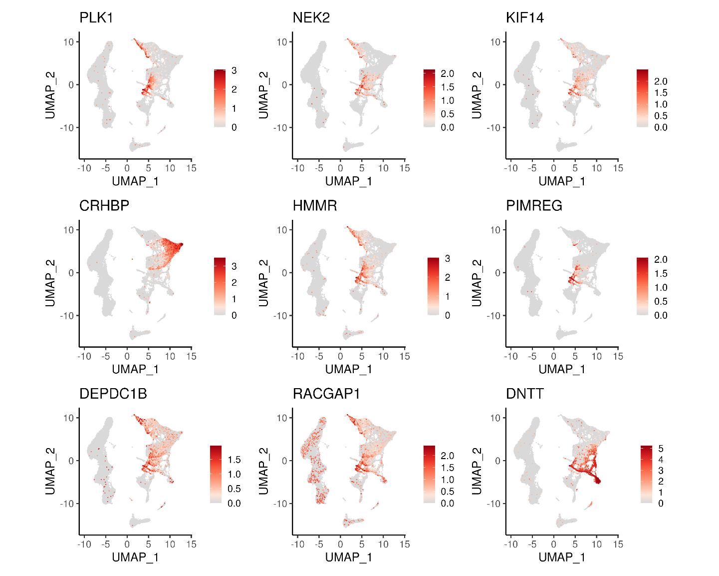

Figure 4.11: UMAP of top 9 DEGs along the HSC->MyP and HSC->LyP trajectories.

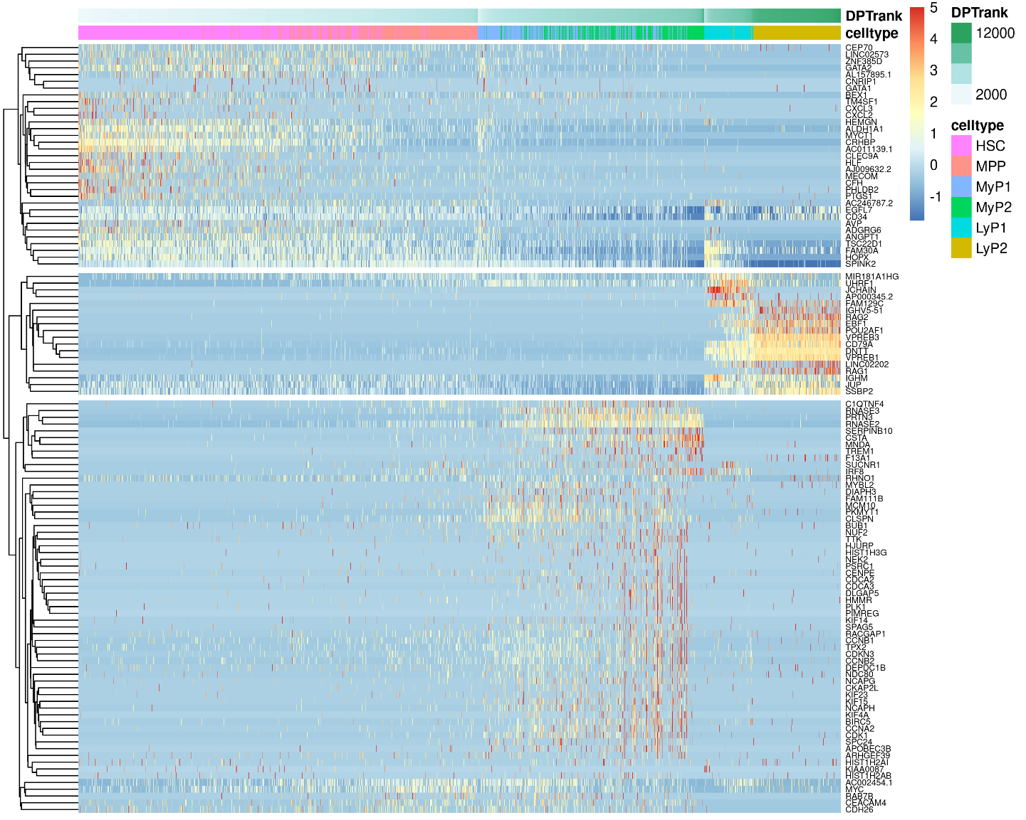

Figure 4.12: Heatmap showing gene expression changes across pseudotime for the top genes changing along the HSC->MyP and HSC->LyP trajectories.

**4.3.4 Code**

*### C. DE on trajectories*

*# Focus on two lineage:*

*### HSC -> MPP -> MyP1 -> MyP2*

*### HSC -> MPP -> LyP1 -> LyP2*

*# Trade-seq setup*

set.seed(42)

inpCells <- c("HSC","MPP","MyP1","MyP2","LyP1","LyP2")

inpCells <- seu@meta.data[seu$celltype %in% inpCells, ]

inpCells <- data.table(cell = rownames(inpCells), inpCells)

inpCells$segment <- "Common"

inpCells[celltype %in% c("MyP1","MyP2")]$segment <- "Myeloid"

inpCells[celltype %in% c("LyP1","LyP2")]$segment <- "Lymphoid"

inpCells$segment <- factor(inpCells$segment,

levels = c("Common", "Myeloid", "Lymphoid"))

inpCts <- GetAssayData(object = seu, slot = "counts")[, inpCells$cell]

inpCts <- inpCts[rowSums(inpCts >= 3) >= 20, ] *# Relax this if you want more genes*

inpDPT <- cbind(inpCells$DPT, inpCells$DPT)

rownames(inpDPT) <- inpCells$cell

colnames(inpDPT) <- c("Myeloid", "Lymphoid")

inpWgt <- matrix(data = 0, nrow = nrow(inpCells), ncol = 2)

rownames(inpWgt) <- inpCells$cell

colnames(inpWgt) <- c("Myeloid", "Lymphoid")

inpWgt[inpCells$celltype %in% c("HSC","MPP"), 1:2] <- 1/2

inpWgt[inpCells$celltype %in% c("MyP1","MyP2"), 1] <- 1

inpWgt[inpCells$celltype %in% c("LyP1","LyP2"), 2] <- 1

*# Actual trade-seq run*

register(MulticoreParam(30))

oupTrSK <- evaluateK(counts = inpCts, pseudotime = inpDPT, cellWeights = inpWgt,

nGenes = 250)

dev.copy(png, width = 8, height = 6, units = "in", res = 300,

filename = "images/dimrdTrajDEk.png"); dev.off()

oupTrS <- fitGAM(counts = inpCts, pseudotime = inpDPT, cellWeights = inpWgt,

nknots = 7)

*# Association test*

oupTrSres1 <- associationTest(oupTrS, lineages = TRUE)

oupTrSres1 <- data.table(gene = rownames(oupTrSres1), oupTrSres1)

oupTrSres1$padj_all <- p.adjust(oupTrSres1$pvalue, method = "fdr")

oupTrSres1$padj_1 <- p.adjust(oupTrSres1$pvalue_1, method = "fdr")

oupTrSres1$padj_2 <- p.adjust(oupTrSres1$pvalue_2, method = "fdr")

oupTrSres1 <- oupTrSres1[order(-meanLogFC)]

p1 <- FeaturePlot(seu, reduction = "umap", pt.size = 0.1, order = TRUE,

feature = oupTrSres1[order(-meanLogFC)]$gene[1:9]) &

scale_color_gradientn(colors = colGEX) & plotTheme & coord_fixed()

ggsave(p1, width = 15, height = 12, filename = "images/dimrdTrajDEassoc.png")

ggData <- GetAssayData(object = seu, slot = "data")

ggData <- ggData[oupTrSres1[meanLogFC > 5]$gene,

inpCells[order(segment, DPT)]$cell]

ggData <- t(scale(t(ggData)))

ggData[ggData > 5] <- 5; ggData[ggData < -5] <- -5

tmp <- data.frame(celltype = inpCells$celltype,

DPTrank = inpCells$DPTrank,

row.names = inpCells$cell)

pheatmap(as.matrix(ggData), cluster_cols = FALSE, show_colnames = FALSE,

cutree_rows = 3, gaps_col = cumsum(table(tmp$segment)),

annotation_col = tmp, fontsize_row = 6,

width = 10, height = 8,

filename = "images/dimrdTrajDEassocH.png")