


CAMARINES SUR POLYTECHNIC COLLEGES
COLLEGE OF COMPUTER STUDIES

Descriptive Statistics Calculator
A website tool designed to calculate statistical values quickly and easily and accurately including the mean, median, mode,range,variance,standard deviation. quartiles, and interquartile range.

This tool helps you compute the mean, mian, mode, range, variance, standard deviation, quartiles, and of a list of numbers quickly and easily.
Submitted to:
Elena Clarexe Gulane
Instructor

By
Princess P. Arnante
Kathlyn Cris P. Ibo
Crizza Ann R. Villar
Fiona S. Hilutin

May 2025

DOCUMENTATIONS

CALCULATOR OVERVIEW
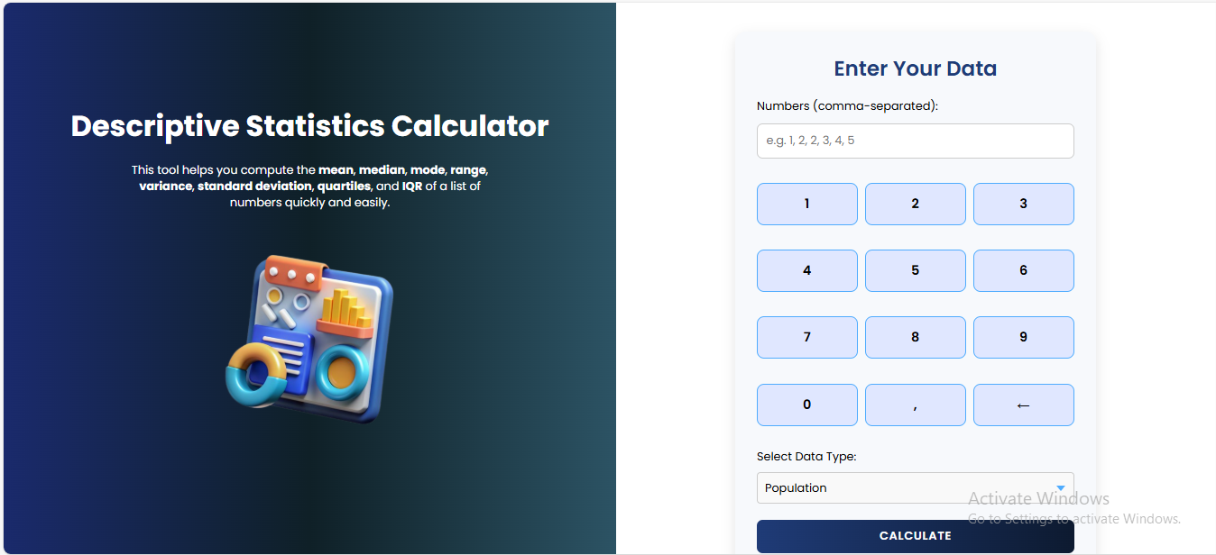
Figure 1: Calculator Overview
The Descriptive Statistics Calculator was split into two main sections:
- Information Section (Left Side): Provides a brief description of what the calculator does and lists the statistics it computes.
- Calculator Section (Right Side): This is where the user will interact with the calculator to input data and view the results.
- Numbers (Comma-separated) Input Field: where the user enters the list of numbers. Numbers should be separated by commas (e.g. 1,2,3,4,5).
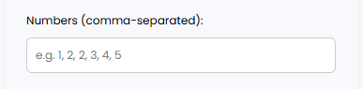
Figure 2: Numbers Input Field

- Keypad: A set of buttons to help user to input numbers (0-9)and (,) and use of backspace ( ← )for corrections.
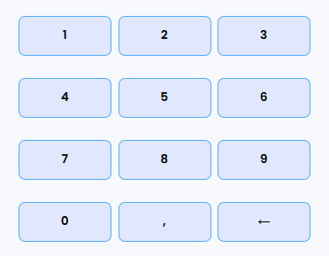
Figure 3: Keypad
- Select Data Type Dropdown: This dropdown allows users to choose whether the data represents a “Population” or “Sample”. This selection affects the calculation of Variance and Standard Deviation.
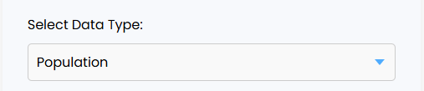
Figure 4: Data Type Selection
- Calculate Button: Click this button after entering your numbers and selecting the data type to compute the statistics.

Figure 5: Calculate Button
- Results Area: This section displays all the calculated descriptive statistics. Each statistic will have its own label and a corresponding value.
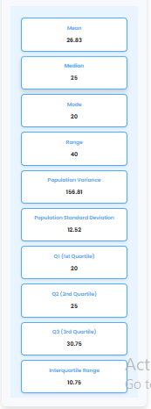
Figure 6: Results Area

HOW TO USE THE CALCULATOR
Follow these simple steps to calculate the descriptive statistics for your data:
Step 1: Enter your Data
- Locate the “Numbers (comma-separated):” input field.
- Type your number into this field
- Separate each number with a comma.
- Enter the whole numbers (e.g. 40,10,5,70)
- Tip: You can use the Keypad buttons to easily input numbers.
- Example: For the numbers 40,10,5,70,70. you would type 40,10,5,70,70
Step 2: Select Data Type
- Find the “Select Data Type:” dropdown menu.
- Click on the dropdown and choose one of the following options:
- Population: Select this if your data includes every member of the group you are studying.
- Sample: Select this if your data is a subset of a larger group.
- Note: Your choice here will influence the calculation of variance and standard deviation.
Step 3: Calculate Statistics
- Once you've entered your numbers and selected the data type, click the "Calculate" button.
Step 4: View the Result
- The Result Area will update to display the calculated statistics. Each statistic will be clearly labeled.

UNDERSTANDING THE RESULT
- Mean: The average of all numbers in your dataset. It's calculated by summing all numbers and dividing by the count of numbers.
- Median: The middle value of a dataset when the numbers are arranged in order. If there's an even number of data points, it's the average of the two middle numbers.
- Mode: The number that appears most frequently in your dataset. If all numbers appear with the same frequency, the calculator will indicate "No unique mode." If there are multiple modes, they will all be listed.
- Range: The difference between the highest and lowest values in your dataset.
- Variance: A measure of how spread out the numbers are from the mean.
- Population Variance: Calculated when your data represents the entire population.
- Sample Variance: Calculated when your data is a sample from a larger population (Formula: n-1/n).
- Standard Deviation: The square root of the variance. It indicates the typical distance between the data points and the mean.
- Population Standard Deviation: Corresponding to population variance.
- Sample Standard Deviation: Corresponding to sample variance.
- Q1 (1st Quartile): Represents the 25th percentile of your data. 25% of the data falls below this value.
- Q2 (2nd Quartile): This is the same as the Median, representing the 50th percentile. 50% of the data falls below this value.
- Q3 (3rd Quartile): Represents the 75th percentile of your data. 75% of the data falls below this value.
- Interquartile Range: The range of the middle 50% of your data. It's calculated as Q3 - Q1.

TROUBLESHOOTING
- “Please enter valid numbers.”
- This message appears if the input field is empty or if the numbers entered are not in a valid format (e.g., text instead of numbers, incorrect comma separation).
- Solution: Ensure you only enter numbers and separate them with commas. Use the keypad if you're having trouble.

- Result showing “ _ “ or no change after clicking Calculate.
- This might happen if there’s an issue with the input for any non-numeric characters or extra spaces. Ensure you click the Calculate button after making changes.

