Repeated Measures ANOVA - bin 1
Within Subjects Effects
Cases |  | Sum of Squares |  | df |  | Mean Square |  | F |  | p
gaze |  | 12062.214 |  | 1 |  | 12062.214 |  | 12.778 |  | < .001
Residuals |  | 41536.410 |  | 44 |  | 944.009
action |  | 501.274 | ᵃ | 2 | ᵃ | 250.637 | ᵃ | 0.150 | ᵃ | 0.861 | ᵃ
Residuals |  | 146865.533 |  | 88 |  | 1668.927
gaze ✻ action |  | 3139.734 |  | 2 |  | 1569.867 |  | 1.936 |  | 0.150
Residuals |  | 71361.686 |  | 88 |  | 810.928
Note. Type III Sum of Squares
ᵃ Mauchly's test of sphericity indicates that the assumption of sphericity is violated (p < .05).

Between Subjects Effects
Cases |  | Sum of Squares |  | df |  | Mean Square |  | F |  | p
Residuals |  | 902117.636 |  | 44 |  | 20502.674
Note. Type III Sum of Squares

Descriptives
Descriptives
gaze |  | action |  | N |  | Mean |  | SD |  | SE |  | Coefficient of variation
congruent |  | consistent |  | 45 |  | 374.707 |  | 64.573 |  | 9.626 |  | 0.172
 |  | inconsistent |  | 45 |  | 384.130 |  | 73.506 |  | 10.958 |  | 0.191
 |  | control |  | 45 |  | 376.713 |  | 66.707 |  | 9.944 |  | 0.177
incongruent |  | consistent |  | 45 |  | 391.853 |  | 66.628 |  | 9.932 |  | 0.170
 |  | inconsistent |  | 45 |  | 387.923 |  | 65.792 |  | 9.808 |  | 0.170
 |  | control |  | 45 |  | 395.877 |  | 60.132 |  | 8.964 |  | 0.152

Descriptives plots
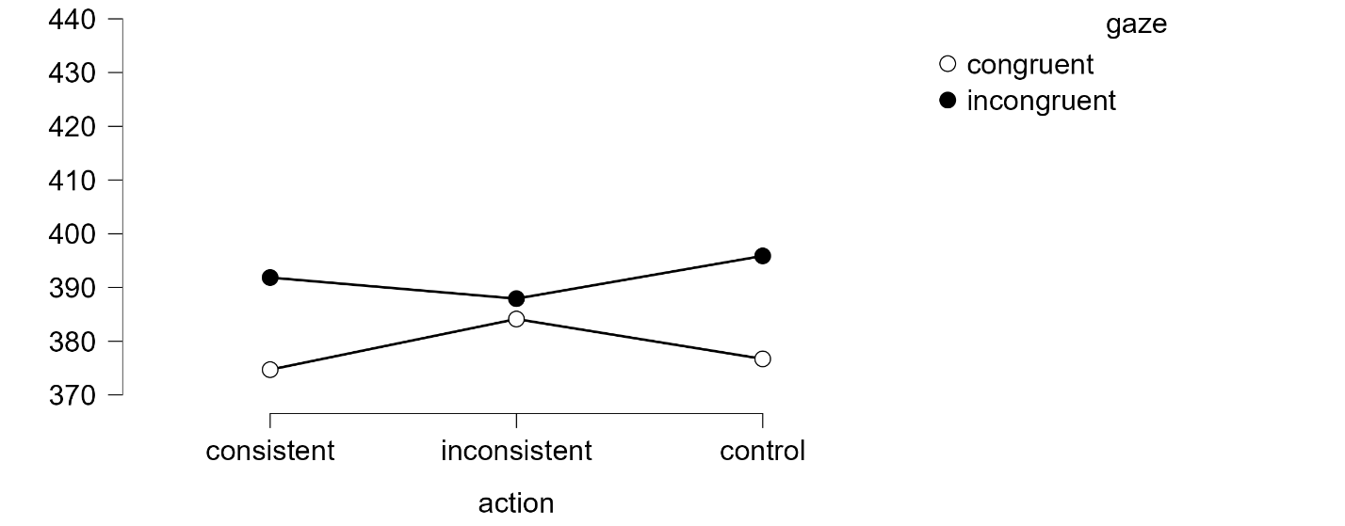
Repeated Measures ANOVA – bin 2
Within Subjects Effects
Cases |  | Sum of Squares |  | df |  | Mean Square |  | F |  | p
gaze |  | 7223.939 |  | 1 |  | 7223.939 |  | 6.658 |  | 0.013
Residuals |  | 47738.522 |  | 44 |  | 1084.966
action |  | 1980.843 | ᵃ | 2 | ᵃ | 990.421 | ᵃ | 0.479 | ᵃ | 0.621 | ᵃ
Residuals |  | 181927.169 |  | 88 |  | 2067.354
gaze ✻ action |  | 2456.513 |  | 2 |  | 1228.257 |  | 2.086 |  | 0.130
Residuals |  | 51813.401 |  | 88 |  | 588.789
Note. Type III Sum of Squares
ᵃ Mauchly's test of sphericity indicates that the assumption of sphericity is violated (p < .05).

Between Subjects Effects
Cases |  | Sum of Squares |  | df |  | Mean Square |  | F |  | p
Residuals |  | 1.405×10⁺⁶ |  | 44 |  | 31935.547
Note. Type III Sum of Squares

Descriptives
Descriptives
gaze |  | action |  | N |  | Mean |  | SD |  | SE |  | Coefficient of variation
congruent |  | consistent |  | 45 |  | 447.626 |  | 81.582 |  | 12.162 |  | 0.182
 |  | inconsistent |  | 45 |  | 456.734 |  | 83.525 |  | 12.451 |  | 0.183
 |  | control |  | 45 |  | 454.884 |  | 85.403 |  | 12.731 |  | 0.188
incongruent |  | consistent |  | 45 |  | 462.921 |  | 82.177 |  | 12.250 |  | 0.178
 |  | inconsistent |  | 45 |  | 458.586 |  | 74.186 |  | 11.059 |  | 0.162
 |  | control |  | 45 |  | 468.772 |  | 71.765 |  | 10.698 |  | 0.153

Descriptives plots
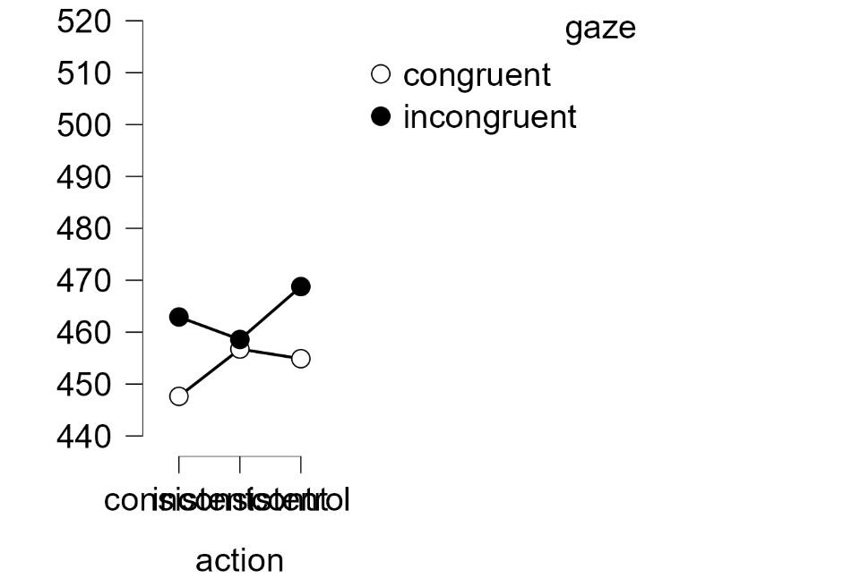

Results
Repeated Measures ANOVA – bin 3
Within Subjects Effects
Cases |  | Sum of Squares |  | df |  | Mean Square |  | F |  | p
gaze |  | 4111.381 |  | 1 |  | 4111.381 |  | 5.289 |  | 0.026
Residuals |  | 34203.913 |  | 44 |  | 777.362
action |  | 12261.282 | ᵃ | 2 | ᵃ | 6130.641 | ᵃ | 2.501 | ᵃ | 0.088 | ᵃ
Residuals |  | 215708.400 |  | 88 |  | 2451.232
gaze ✻ action |  | 2379.742 |  | 2 |  | 1189.871 |  | 1.679 |  | 0.193
Residuals |  | 62371.579 |  | 88 |  | 708.768
Note. Type III Sum of Squares
ᵃ Mauchly's test of sphericity indicates that the assumption of sphericity is violated (p < .05).

Between Subjects Effects
Cases |  | Sum of Squares |  | df |  | Mean Square |  | F |  | p
Residuals |  | 1.860×10⁺⁶ |  | 44 |  | 42265.443
Note. Type III Sum of Squares

Descriptives
Descriptives
gaze |  | action |  | N |  | Mean |  | SD |  | SE |  | Coefficient of variation
congruent |  | consistent |  | 45 |  | 500.681 |  | 92.662 |  | 13.813 |  | 0.185
 |  | inconsistent |  | 45 |  | 513.384 |  | 94.401 |  | 14.072 |  | 0.184
 |  | control |  | 45 |  | 517.892 |  | 96.344 |  | 14.362 |  | 0.186
incongruent |  | consistent |  | 45 |  | 513.545 |  | 90.098 |  | 13.431 |  | 0.175
 |  | inconsistent |  | 45 |  | 512.855 |  | 88.255 |  | 13.156 |  | 0.172
 |  | control |  | 45 |  | 528.971 |  | 81.708 |  | 12.180 |  | 0.154

Descriptives plots
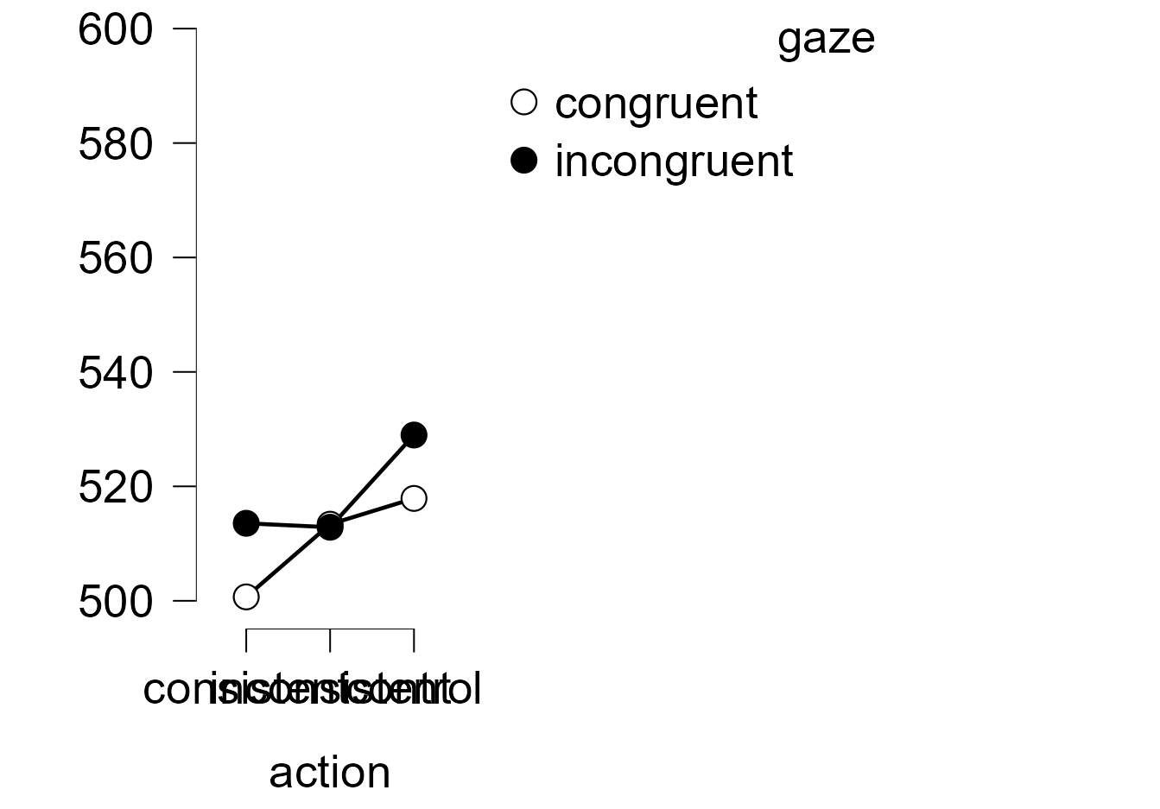

Repeated Measures ANOVA – bin 4
Within Subjects Effects
Cases |  | Sum of Squares |  | df |  | Mean Square |  | F |  | p
gaze |  | 12272.463 |  | 1 |  | 12272.463 |  | 11.757 |  | 0.001
Residuals |  | 45930.042 |  | 44 |  | 1043.865
action |  | 31898.772 | ᵃ | 2 | ᵃ | 15949.386 | ᵃ | 6.162 | ᵃ | 0.003 | ᵃ
Residuals |  | 227775.957 |  | 88 |  | 2588.363
gaze ✻ action |  | 294.179 |  | 2 |  | 147.090 |  | 0.135 |  | 0.874
Residuals |  | 95616.912 |  | 88 |  | 1086.556
Note. Type III Sum of Squares
ᵃ Mauchly's test of sphericity indicates that the assumption of sphericity is violated (p < .05).

Between Subjects Effects
Cases |  | Sum of Squares |  | df |  | Mean Square |  | F |  | p
Residuals |  | 2.663×10⁺⁶ |  | 44 |  | 60515.468
Note. Type III Sum of Squares

Descriptives
Descriptives
gaze |  | action |  | N |  | Mean |  | SD |  | SE |  | Coefficient of variation
congruent |  | consistent |  | 45 |  | 560.008 |  | 103.228 |  | 15.388 |  | 0.184
 |  | inconsistent |  | 45 |  | 571.984 |  | 103.781 |  | 15.471 |  | 0.181
 |  | control |  | 45 |  | 589.011 |  | 118.585 |  | 17.678 |  | 0.201
incongruent |  | consistent |  | 45 |  | 576.121 |  | 104.648 |  | 15.600 |  | 0.182
 |  | inconsistent |  | 45 |  | 585.316 |  | 107.065 |  | 15.960 |  | 0.183
 |  | control |  | 45 |  | 600.017 |  | 104.911 |  | 15.639 |  | 0.175

Descriptives plots
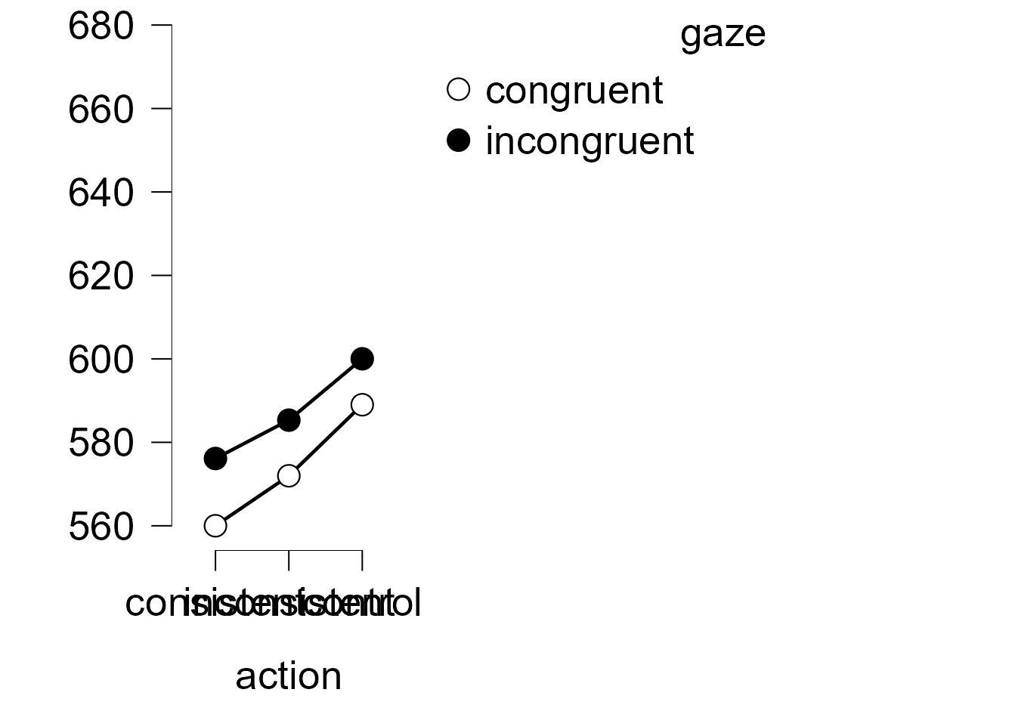

Repeated Measures ANOVA – bin 5
Within Subjects Effects
Cases |  | Sum of Squares |  | df |  | Mean Square |  | F |  | p
gaze |  | 17146.977 |  | 1 |  | 17146.977 |  | 9.996 |  | 0.003
Residuals |  | 75477.400 |  | 44 |  | 1715.395
action |  | 70072.874 | ᵃ | 2 | ᵃ | 35036.437 | ᵃ | 8.413 | ᵃ | < .001 | ᵃ
Residuals |  | 366501.020 |  | 88 |  | 4164.784
gaze ✻ action |  | 926.987 |  | 2 |  | 463.494 |  | 0.183 |  | 0.833
Residuals |  | 223265.998 |  | 88 |  | 2537.114
Note. Type III Sum of Squares
ᵃ Mauchly's test of sphericity indicates that the assumption of sphericity is violated (p < .05).

Between Subjects Effects
Cases |  | Sum of Squares |  | df |  | Mean Square |  | F |  | p
Residuals |  | 4.579×10⁺⁶ |  | 44 |  | 104061.654
Note. Type III Sum of Squares

Descriptives
Descriptives
gaze |  | action |  | N |  | Mean |  | SD |  | SE |  | Coefficient of variation
congruent |  | consistent |  | 45 |  | 661.979 |  | 130.867 |  | 19.509 |  | 0.198
 |  | inconsistent |  | 45 |  | 670.014 |  | 137.118 |  | 20.440 |  | 0.205
 |  | control |  | 45 |  | 703.371 |  | 155.686 |  | 23.208 |  | 0.221
incongruent |  | consistent |  | 45 |  | 680.461 |  | 133.935 |  | 19.966 |  | 0.197
 |  | inconsistent |  | 45 |  | 688.649 |  | 137.810 |  | 20.544 |  | 0.200
 |  | control |  | 45 |  | 714.069 |  | 148.610 |  | 22.153 |  | 0.208

Descriptives plots
