Cross-Experiment RT Analysis — Results
Because the three experiments differed in the modality of the direction-selection response (keypress, mouse click, touchscreen tap), the data from all three experiments were combined into a single cross-experiment analysis, with Experiment entered as a between-subjects factor (N = 41, 48, 49 for Experiments 1–3; N = 138 total). This made it possible to test whether response modality moderates how gaze congruency and action consistency interact.
A post-hoc power analysis, with experiment entered as a between-subjects factor (G*Power 3.1.9.6), confirmed high power (power = 0.935) for the current sample (N = 138) to detect a medium effect (f = 0.25); as in the individual experiments, Greenhouse–Geisser correction and Bonferroni-corrected post hoc comparisons were applied wherever needed.

Mixed ANOVA (raw RT)
To determine whether response modality influenced the relationship between action-outcome consistency and gaze cueing, we first performed a mixed 2 (Gaze Congruency) × 3 (Action Consistency) × 3 (Experiment as between factor) ANOVA on raw reaction times, Greenhouse–Geisser corrected throughout. As expected, the main effects of Gaze, F(1, 135) = 44.74, p < .001, η²ₚ = .249, and Action, F(1.41, 190.79) = 20.20, p < .001, η²ₚ = .130, were both significant, confirming what each individual experiment already established: both factors independently modulate RT. The Gaze × Action interaction was also significant, F(1.88, 253.95) = 22.00, p < .001, η²ₚ = .140. The three-way interaction — the direct test of whether response modality changes the relationship between gaze congruency and action consistency — approaches but does not reach conventional significance, F(3.76, 253.95) = 2.33, p = .061.
Term | Result
Experiment (between) | F(2, 135) = 0.04, p = .965 (n.s.)
Gaze | F(1, 135) = 44.74, p < .001, η²ₚ = .249
Gaze × Experiment | F(2, 135) = 0.06, p = .939 (n.s.)
Action | F(1.41, 190.79) = 20.20, p < .001, η²ₚ = .130
Action × Experiment | F(2.83, 190.79) = 1.24, p = .298 (n.s.)
Gaze × Action | F(1.88, 253.95) = 22.00, p < .001, η²ₚ = .140
Gaze × Action × Experiment | F(3.76, 253.95) = 2.33, p = .061 (marginal)
Post hoc tests decomposing the marginal three-way interaction (conditional on gaze and on action) showed the same pattern as before: the congruency effect was present in consistent and control trials but not in inconsistent trials, in all three experiments. However, no comparison between experiments reached significance, possibly because comparing raw RT across independent samples involves much larger error (SE ≈ 18–20 ms). We therefore used a standardized effect-size measure (Cohen’s d), which is less sensitive to this noise, to test more directly for modality differences.

Standardized GC-effect analysis (Cohen’s d)
To maximally rule out noise in individual RT data, we calculated Cohen’s d per subject as a direct, standardized measure of the gaze-cueing (congruency) effect within each action condition (each subject’s own congruent- and incongruent-trial RTs pooled into one SD, then the mean difference divided by it) and submitted this to a 3 (GC effect in action condition) × 3 (Experiment) ANOVA.
Term | Result
d (main effect) | F(1.84, 247.74) = 31.15, p < .001, η²ₚ = .187
d × Experiment | F(3.67, 247.74) = 3.28, p = .015, η² = .029, η²ₚ = .046
Experiment (collapsed across condition) | 0/3 pairwise comparisons significant (all p ≥ .925)
The main effect of d — i.e., whether the standardized GC effect itself differs by action condition, collapsed across experiment — was significant, F(1.84, 247.74) = 31.15, p < .001, η²ₚ = .187. The follow-up post hoc showed all three action conditions differed significantly from one another: consistent produced the largest GC effect, followed by control, with inconsistent the smallest (consistent vs. inconsistent: MD = 0.34, t(135) = 6.91, Cohen’s d = 0.95, p < .001; consistent vs. control: MD = 0.10, t(135) = 2.67, d = 0.28, p = .026; inconsistent vs. control: MD = −0.24, t(135) = −5.31, d = −0.67, p < .001). The between-subjects effect of Experiment (movement modality) alone was not significant, F(2, 135) = 0.64, p = .530, η²ₚ = .009 — modality does not shift the overall level of the GC effect on its own. More importantly, the interaction between the standardized, action-conditioned GC effect and Experiment reached significance, F(3.67, 247.74) = 3.28, p = .015, though with a small effect size (η²ₚ = .046).
Post hoc comparisons on this interaction, conditional on action condition, showed that consistent and control never differed significantly between any pair of experiments (all p ≥ .354), while inconsistent trials showed a significant Experiment 1 vs. Experiment 3 difference (d = 0.703, p = .016): even though Experiment 1’s own GC effect within the inconsistent condition did not reach significance on its own, it was still significantly stronger than Experiment 3’s — where the effect was not just weaker but numerically reversed, meaning no real GC effect was present there at all. Experiment 2’s inconsistent-condition GC effect sat numerically between Experiments 1 and 3, but did not differ significantly from either.
In summary, the standardized GC effect differed reliably by action condition, and its dependence on response modality was concentrated specifically in the inconsistent condition — the simple main effect of Experiment reached significance only there, not in the consistent or control conditions. This is exactly what the d × Experiment interaction is testing: whether modality changes the GC effect, and the answer is yes, but only when the action’s outcome contradicts the participant’s own choice (see General Discussion for interpretation).
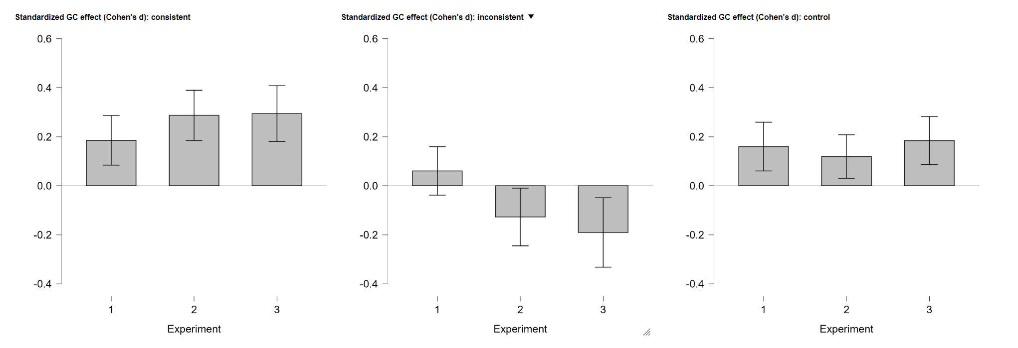
Effect size per experiment

