2×3 rANOVA and main effects
(Gaze × Action) - tarting with the anovas on RT - they are done to test if GC effect is present, if AOC (action-outcome consisteny) effect is pressent if they somehow influence eachother trough interaction. we found out that
- exp 1. Faster when gaze points to the target, and faster in the active conditions than control — but which active condition you're in doesn't change the size of the GC effect. (report post hoc on action
- exp 2. same thing but also interaction -> GC effect interacts/depends on AOC effect and vice versa
- exp 3. the same.

-> to check where GC effect is present per action condition we did simle main effect tests ->
- in exp 1 - GCE is there on congruent trials when your action matched the outcome, or when there was no action at all; no reliable difference (not enof strong gce to reach significance) when your action didn't match - incnsistent conditions;
- for exp 2 and 3: Same consistent/control pattern, but in the inconsistent condition not just missing gce - a numaricaly reverced pattern (participants were slower when gaze looked at the direction different of the chosen one.) however not significat, but visible in both experiments 2 and 3 that include different movement modality.
-> to chech where action effect is present per gaze condition we did action main effect ->
- exp 1 - Action consistency changes RT about equally whether gaze was congruent or incongruent — no asymmetry.
- exp 2 - Action consistency changes RT on both sides, but the effect is clearly stronger on incongruent trials - making GCE dissapearing;
- exp 3 - even stonger asumethry than exp 2 - in inconsistent making GCE dissapearing even more
- overall a pattern that action metters and tendensy that this movement modalyty also has influence (leads to gratrer asymetry between the two conditions; (the action is more infuential in incngruent conditions whenever there is more movement

what we know so far: there is GCE, there is SOA in all experiments. in exp 1 thy dont influecne eachother. in exp 2 and 3 however, with the different modality of the movement and interaction between gaze and action starts to persists. the man effects are saing that the gce is present in consistent in consistent and inconsitent conditions. no gce in inconsistent condition. even more (though not sigificant) a reverced numbers of gc eggect if there in the inconsistent condition in the experiments with greater movement modality (2 and 3). regardint the soa, the effect is present in all gaze conditions in all experiments, however its becomming stronger for incongruent conditions (and weaker for congruent) with the greater movement modality. in other words the bigger the movement, the stronger is the acton effect (does this meand the RT is slower) when the gaze is pointing into the opposite direction (when the external cue is contraversial).

---------------------------
Effect size ANOVAs
(per experiment)
To check the interaction deeper, we did ANOVA on effect size. where effect size in the difference between congruent and incongruent condition. it was expectec to replicate the anova results, but at the same time to let us easily didderentiate which levels differ from which
- exp 1 - confirms the same conclusion as the interaction above: no reliable difference in effect size. Post hoc: none of the three conditions differ from each other (all Holm p≥.63).
- exp 2 and 3 has the same pattern of results - significant difference in effect sizes, confirming the already established interacton; in both exp. inconsistent condition differs from consistent and control one. whereas no difference between control and consistent was established.

- this gave us evidence that GCE is not following the same pattern across action conditions and more spcifically, it differes between consistent and comtrolled from one side and inconsistent on the other. the descripive statistics showing the slower RTs (weaker GCE) in inconsistent codition

---------------------------
ANCOVA - the action start time (the actual time of direction selection) is used as covariate in ANCOVA; it represents the temporal prediction effect; they press a button/ click with the mouse and expet that after given time period target will appear; so they predict when to expext the target; temporal prediction; by maximaly reducing the predictability we are left with only maximum the intentionality; is this volition part of SoA - yes; by doing ANCOVA, we are testing intentionalyty and volition, excluding temporal prdiction;
ANCOVA statistically controls for variability associated with action initiation time, allowing us to examine whether the gaze-action interaction remains after accounting for this source of variance
- exp 1 - Gaze×Action x initiation time was significant - indicates that the relationship between gaze congruency and action consistency depended on participants' initiation time. Thus, in Experiment 1, temporal factors were not merely a source of nuisance variance but moderated the experimental effects themselves. therefor logicaly Gaze×Action wasnt significant... wtf ?! ( i may not include this ancova ... n the report)
- Experiments 2 and 3 - Initiation time does not change the pattern of results. After accounting for temporal prediction, the gaze-action interaction is still present.This supports the idea that the effect is not explained solely by temporal prediction, related with active trials, but also involves some other cognitive mechanism.
Gaze × Action × Initiation Time → not significant
Gaze × Action → significant

------------------------------
because of the modality difference that we established earlier, we decide to test if modality of the movement is also influencing the GCE. - >

3-way Mixed ANOVA (raw RT)
--------------------------------
Mixed Effect size ANOVA that used experiment number as between factor and .... the others. To determine whether response action modality influenced the relationship between action-outcome consistency and gaze cueing, we first performed a mixed ANOVA on raw reaction times. The three-way interaction between Experiment, Gaze Congruency, and Action Consistency approached significance, p = .061. (gg corrected )

-> simple main effect of gaze in all experiments
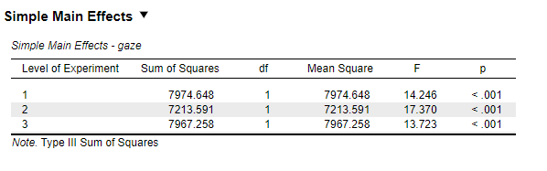

-> and simple main effect on of gaze not in inconsistent trials;
the simple GC effect is confirmed significant within consistent (p<.001) and control (p<.001) — but there's no significant congruent-vs-incongruent pair within the inconsistent condition specifically, even pooling all 138 subjects. Confirms what the per-experiment decomposition already suggested: inconsistent's GC effect isn't just weaker, it doesn't survive at all once pooled.
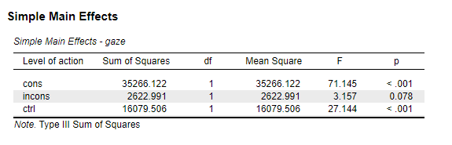

- To check which conditions was differences were coming from -> post hocs
- Collapsed on action

A post hoc on action confirmed that active conditions (cons and incons) are different than the passive (ctrl) one, both being faster than it (16.86 and 17.24 ms each). But did not differ between themselves (0.37 ms diff) .
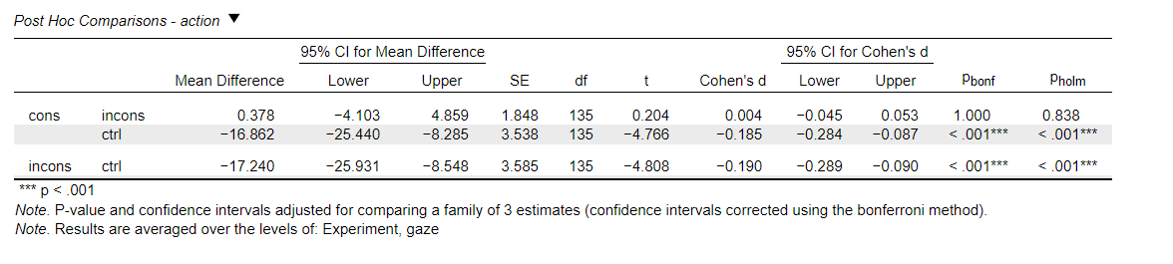

--------------- not sure -------------------

- To check Does the effect of Action on gaze cueing change across experiments?" - Experiment × Gaze × Action interaction post hoc

People behave similarly across the three experiments in the consistent and control Action conditions. The main cross-experiment change occurs in the inconsistent Action condition, particularly when the gaze points away from the target (incongruent gaze).
This is exactly what a significant (or marginal) Experiment × Gaze × Action interaction means: the relationship between gaze cueing and action consistency is not the same in all three experiments. The difference is driven primarily by the inconsistent Action condition.

- Post hoc on gaze x action
This table says which of the six condition means differ from each other, averaged across the three experiments.
The important findings are:
- Consistent condition: Congruent RT is significantly faster than incongruent RT (gaze cueing present).
- Control condition: Congruent RT is significantly faster than incongruent RT (gaze cueing present).
- Inconsistent condition: Congruent RT is not significantly different from incongruent RT (no reliable gaze cueing overall).
It also shows some action differences within each gaze level:
- For congruent trials, both consistent and inconsistent are faster than control.
- For incongruent trials, inconsistent is slower than consistent and control.
Overall interpretation:
The interaction is driven by the inconsistent condition, where the normal gaze cueing pattern disappears (or reverses), while the consistent and control conditions show the expected gaze cueing effect.

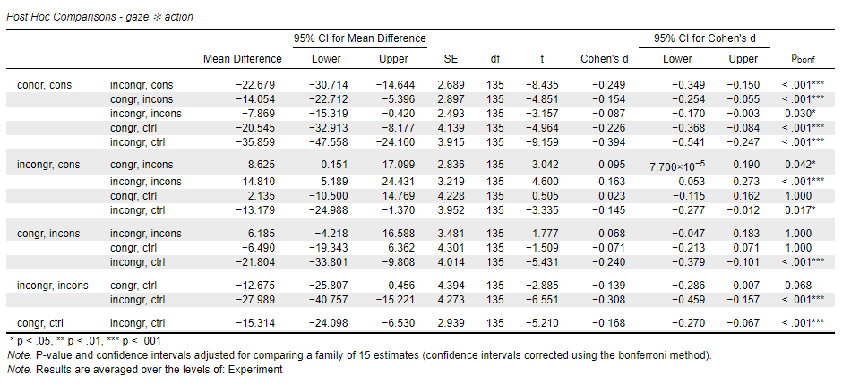

--------------not sure------------------

3-way Mixed ANOVA (log RT)
--------------------------------

> why we did this? --- answer here
> results: Nearly identical picture to raw RT, however exp x gaze x action interaction is strongly significant (p=0.18)
- action collapsed – control is slower and different than the other 2 (explain in details)
- gaze x action x exp - Exp2 and Exp3 each pick up one extra significant pair not present in raw RT — consistent vs. inconsistent within congruent trials specifically (p=.030, p=.020) — a slightly more granular effect the log transform surfaces that raw ms didn't reach significance on individually (13 significant pairs vs. raw RT's 12, same underlying story).

Standardized GC-effect analysis (Cohen's d)
--------------------------------
Finally, to ensure that this effect was not driven by differences in absolute reaction-time scale across experiments, we repeated the analysis using standardized gaze-cueing effect sizes (Cohen's d).
  - Significant interaction of cohens d x experiment
  - To check if modality of movement did differ -> simple may effect of experiment – shows significant difference only in inconsistent condition – the movement matters inly when internal and external cues are leading to different directions.
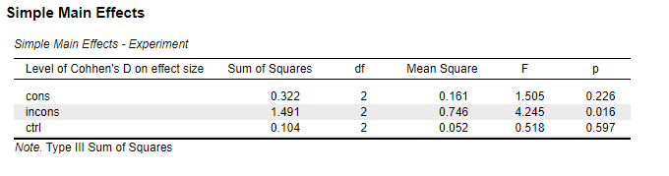

-unlike with raw RT the post hoc on cohens d on effect size per action condition show significant difference between all conditions

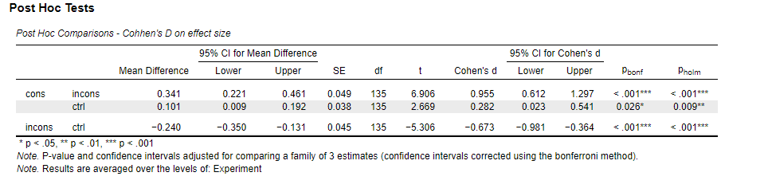

-the one on the cohens d x experiment showed significant differences only in comparison involving inconsistent conditions -> The effect of movement modality is not general—it is almost entirely driven by changes in the inconsistent action condition, while the consistent and control conditions remain comparatively stable. (36 pairs, 12 significant): every single significant pair involves the inconsistent condition vs. either consistent or control — in some cases within the same experiment, in some cases across experiments. Consistent and control cells never differ significantly from each other, and same-condition comparisons across experiments (e.g., Exp1 cons vs Exp2 cons) never reach significance either. Inconsistent is doing 100% of the work here.

- Experiment, collapsed: 0/3 significant — no experiment differs from another in overall standardized effect size, confirming the difference is triggered from the inconsistent action;

4. GC-effect ANOVA (raw ms, no covariate)

  - Marginal p value for interaction – p=0.06
  - Simple main effect on GC-effect - not significant;
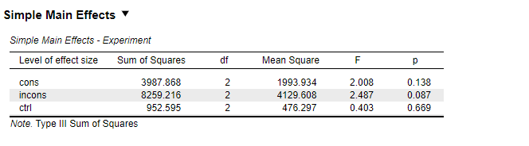
  - Post hoc on CG effect – shows inconsistent as different that the other 2 (this is different that the other analysis, isn’t it, but it makes sense since the CGE is missing in inconsistent trials)
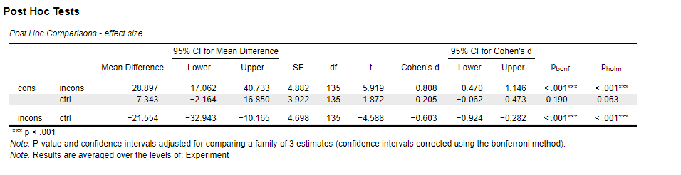

  - Same exact pattern as Cohen's d —Experiment collapsed 0/3 significant,
  - Experiment×condition 10/36 significant, all involving inconsistent — just two fewer significant pairs than the Cohen's d version (10 vs. 12), consistent with the raw-ms scale being the least sensitive of the four methods, as established throughout.

Bottom line across all four:
  - GC is present – congruent is gaster than incongruent
  - Action effect is there – active trials are faster than control trials
  - AOC – inconsistent is different – its slower that consistent and control
  - Modality of the movement matters only in inconsistent trials - > ANOVA in inconsistent trials ->

One way ANOVA of cohens d in inconsistent trials
  - Results showing significant effect of experiment (movement modality) p=0.016;
  - Post hoc showing significant difference only between exp 1 and exp 3
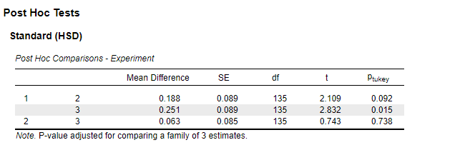
  - However, the effect for exp 2 and exp 3 is not only weaken, its in re reversed direction (participants are faster to trials that they were pointing at, even though incongruent with the gaze at the screen)

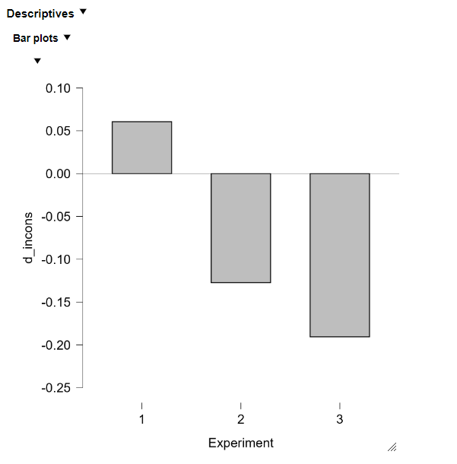
  - with larger movement -> greater reduction on GCE;

