Interface Of Ms Word
1. Title Bar
2. Quick Access Toolbar
3. Ribbon
4. Tabs
5. Document Area
6. Status Bar
7. View Buttons And Zoom Slides
8. File Tab (Back Stage View)
Tittle bar:
It is found at very top of the window and it shows document name.
Quick access toolbar:
It is found at top left corner of the window and It has shortcuts for save,undo and redo.
Ribbon:
It is the big horizontal area below the tittle bar and contains tabs,home,insert, design,page layout,referances,mailing,reviews,view .
Tabs:
Tabs are the main menus across the ribbon when you click a tab you see a group of commands(button and icon).
Document area:
It is large wide space which looks like page and paper called document area.
Status bar:
It is found at the bottom left corner which shows page number,word count and language and zoom level of your document.
View buttons and zoom:
It is found at the right side of status.It contains button to switch print layout and web layout.Zoom slider is used to make page larger and smaller.
File tab: When you click file,it opens a new menu called back stage view. It has options for creating new document,open and existing docuent,save and save as,print and save documents.
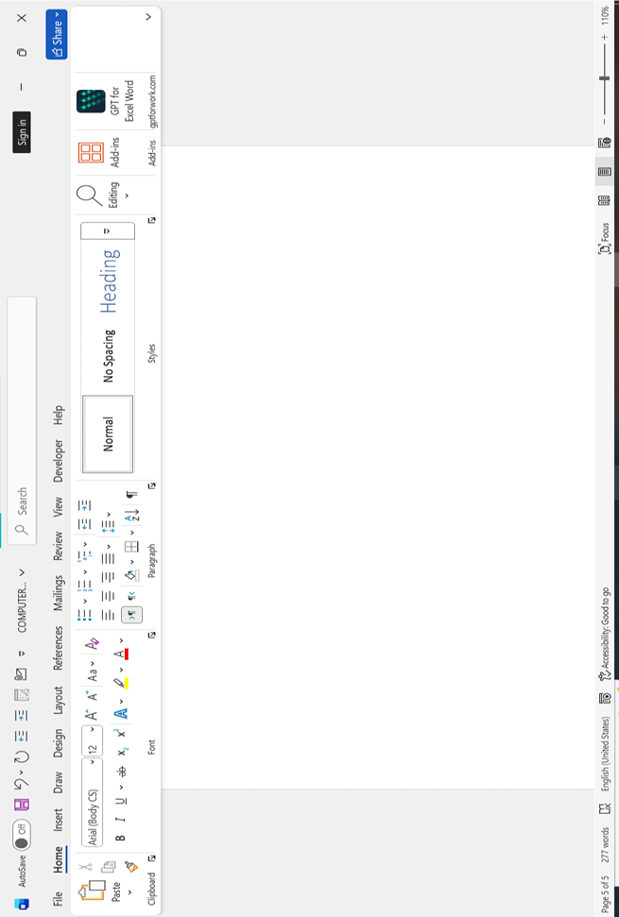 Formatting:
Page formatting mean to changing the appearance of text, paragraph and pages to make a document neat,reasonable and attractive.
Types of formatting:
- Character formatting
- Paragraph formatting
- Page formatting

- Character formatting:
- Bold
- Italic
- Underline
- Font face
- Font size
- Font color
- Highlight
- Case change(upper,lower,sentence)
- Subscript/superscript
- Paragraph formatting
- Affects entire paragraph
- Alignment(left,right,centre,justify)
- Line spacing
- Indent(space between margin and text)
- Bullets and numbering (insert tab)
- Border and shading
- Page formatting
- Affect whole page or entire document
- Margin
- Orientation(portrait,landscape)
- Page size (all,letter,legal)
- Columns
- Page border
- Page color (background color)
- Header and footer
- Page number

Short cut key:
- Ctrl + C = copy
- Ctrl + V = paste
- Ctrl + X = cut
- Ctrl +L = left align
- Ctrl + E = centre align
- Ctrl + J = justify
- Ctrl + Z = undo
- Ctrl + Y = redo
- Ctrl + P = paste
- Ctrl + S = save
- Ctrl + P = print
- Ctrl + B = bold
- Ctrl + I = italic
- Ctrl + U = underline
Text Selection Keys:

- Shift +
^{Select one character at a time}
- Shift +

- Shift+
^{Select one line}
- Shift+

- Shift+clt+
^{Select one word}
- Shift+clt+

- Shift+clt+
^{Select one paragraph}
- Shift+clt+

- Shift +home = Select from inserting point to begining of line

- Shift +end = Select from inserting point to end of line

- Ctrl + A = Select all/entire text in a document

Short cut keys:
- Ctrl + C = copy
- Ctrl + V = paste
- Ctrl + X = cut
- Ctrl +L = left align
- Ctrl + E = centre align
- Ctrl + J = justify
- Ctrl + Z = undo
- Ctrl + Y = redo
- Ctrl + P = paste
- Ctrl + S = save
- Ctrl + P = print
- Ctrl + B = bold
- Ctrl + I = italic
- Ctrl + U = underline
Text Selection Keys:

- Shift +
- Shift +

- Shift+
- Shift+

- Shift+clt+
- Shift+clt+

- Shift+clt+
- Shift+clt+

- Shift +home = Select from inserting point to begining of line

- Shift +end = Select from inserting point to end of line

- Ctrl + A = Select all/entire text in a document

