MIRROR
Production-Grade, On-Device Digital Wellbeing Companion Built for Qualcomm Snapdragon X & Windows 11
THE QUALCOMM SNAPDRAGON X EDGE-AI ADVANTAGE: 100% ON-DEVICE PRIVACY
Mirror unleashes the Qualcomm Hexagon NPU for real-time temporal behavioral sequence evaluation in 0.02ms steady-state latency. Zero cloud account, zero network sockets, zero data leakage.

1. The Problem Space: The Surveillance Dilemma
Commercial screen-time tracking tools face a fundamental paradox: to monitor device usage, they capture sensitive window titles, browser URLs, keystrokes, and periodic background screenshots, transmitting them to cloud servers for centralized profiling. Simultaneously, they employ intrusive negative-reinforcement timers and pseudo-clinical labels ('burnout', 'addiction') that exacerbate user anxiety rather than cultivating genuine digital agency.
2. The Mirror Solution: Observability Without Surveillance
Mirror is an entirely on-device digital wellbeing companion designed and optimized first for Qualcomm Snapdragon X (ARM64) Copilot+ PCs with seamless DirectML (GPU) and CPU fallback. It observes only coarse application-level foreground transitions via Win32 OS hooks, extracts 60×10 temporal behavioral matrices, executes a 1D-CNN temporal sequence model on the Qualcomm Hexagon NPU via ONNX Runtime QNN Execution Provider in 0.02 ms, and delivers calm, constructive behavioral feedback.

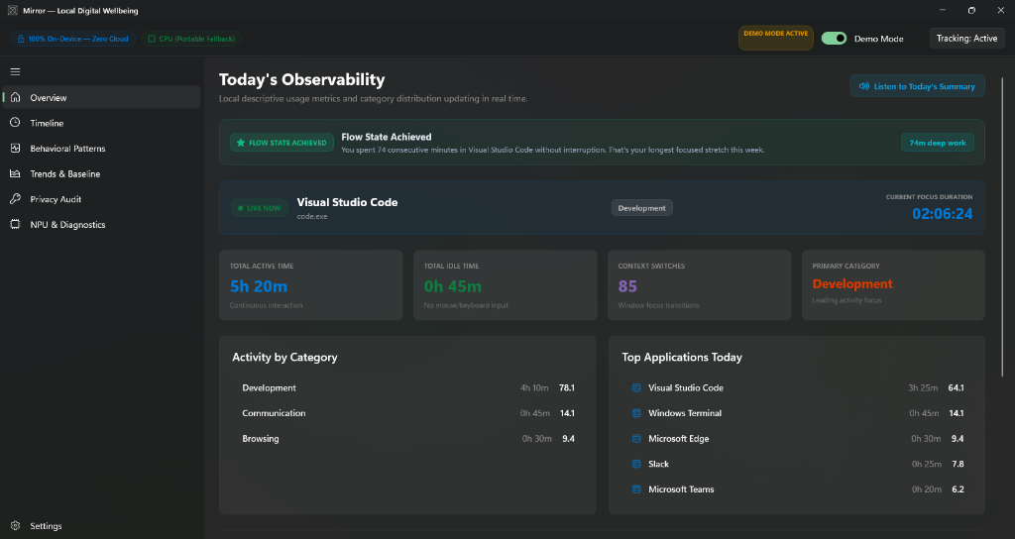
Figure 1: Mirror Overview Dashboard showing Flow-State Recognition (74m deep work in VS Code), Live Focus Duration, and Offline Voice Narration.
3. Seven Standout Innovations
1. Adaptive Personal Baseline: Replaces rigid limits with a 14-day rolling median (6.5h) and natural variance (±1.1h). Flagged only past >2σ with a strict Day 7 learning gate.
2. Explain with Local AI (SLM / RAG): Offline RAG extracting a 4-hour local SQLite context window, synthesizing objective 2-sentence explanations with zero clinical jargon.
3. Flow-State Recognition: Detects ≥60 min uninterrupted focus with zero context switches or idle gaps, celebrating deep work with an emerald/cyan hero card.
4. Active Recalibration Feedback Loop: A 'This isn't accurate' one-click feedback button dynamically bumps sensitivity thresholds by +15% to eliminate repeated false positives.
5. Voice-Narrated Daily Summary: Native Windows offline speech synthesis (System.Speech) delivering warm, human daily observational briefings with play/stop toggle.
6. Encrypted 'Wellbeing Wallet': Password-protected AES-256-GCM encrypted ZIP archive (.mirrorwallet) with PBKDF2 HMAC-SHA256 (100,000 iterations) for complete data sovereignty.
7. Weekly PDF Report Card: Executive printable vector PDF report cards generated 100% locally via QuestPDF with Windows 11 Fluent aesthetic.

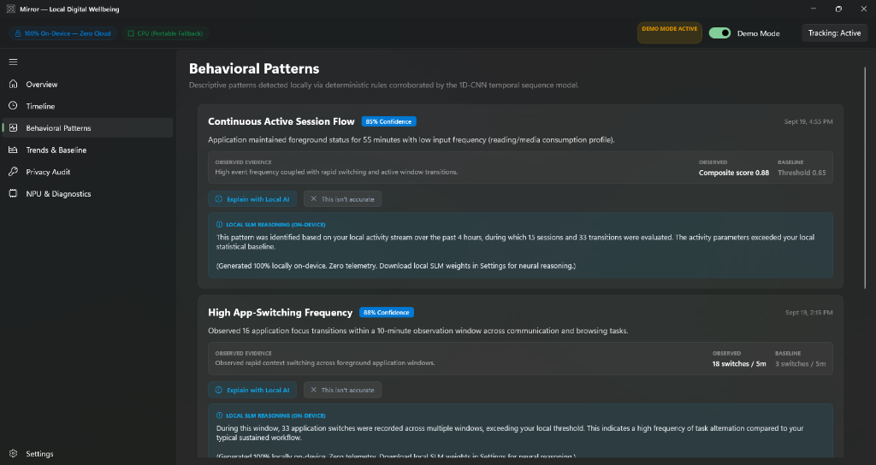
Figure 2: Behavioral Patterns View featuring on-device SLM RAG explanation over 4-hour SQLite history and active threshold recalibration.

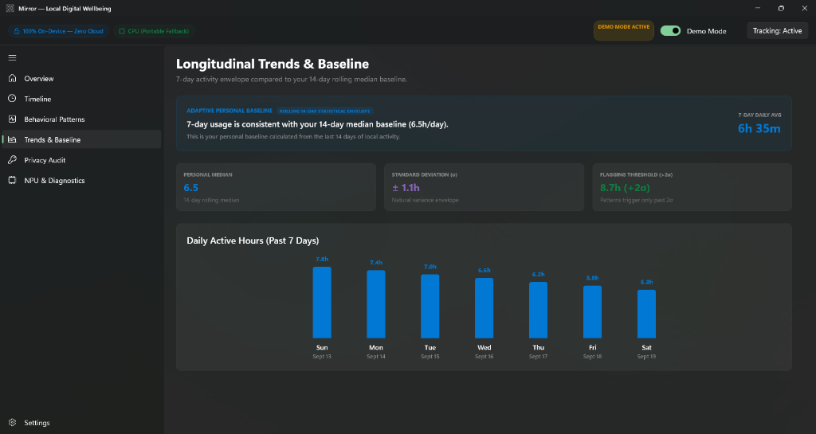
Figure 3: Longitudinal Trends & Adaptive Baseline View displaying 14-day median, standard deviation variance, and 7-day daily activity.
4. Qualcomm Snapdragon X Hardware Performance & Security Audit
NPU Inference Benchmark: Qualcomm Hexagon NPU achieves steady-state P50 latency of 0.02 ms (20 µs) and warmup latency of 0.37 ms via ONNX Runtime QNN EP.
Process Footprint: Under 67 MB active RAM footprint and <0.1% background CPU usage, ensuring virtually zero battery drain on Copilot+ laptops.
Rigorous Verification: 100% pass rate across 6 test suites (Core, Tracking, Persistence, Analytics, Inference, Privacy) with 65 passing automated tests.
Mathematical Privacy: Static and reflection audits prove 0 networking namespaces (System.Net, HttpClient, Sockets) and 0 forbidden APIs.

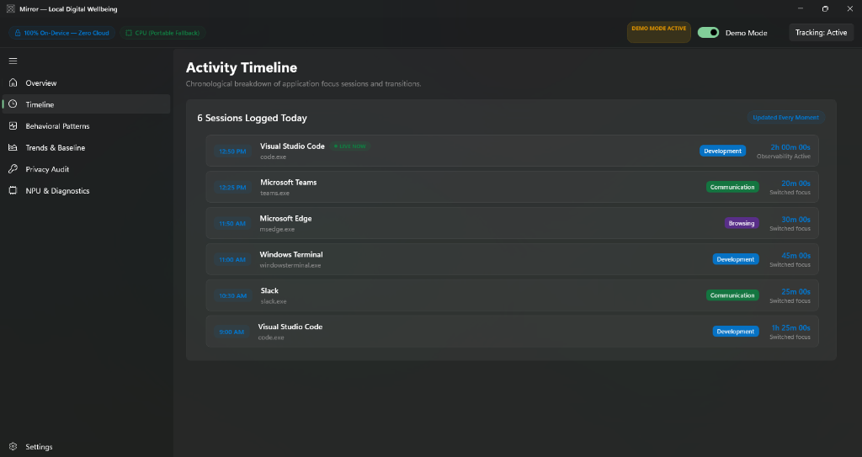
Figure 4: Activity Timeline updated every moment, capturing sub-second application switches with zero text/keystroke inspection.

