🍕
PIZZA SALES
Data Analysis & Power BI Dashboard Report

Prepared from: pizza_sales.csv · pizza_sales.sql · Pizza_Sales_dashboard.pbix
Analysis period: January 1, 2015 – December 31, 2015
Report date: August 25, 2026

1. Executive Summary
This report presents a complete analysis of one full year of pizzeria transaction data (48,620 line items across 21,350 orders, January 1 through December 31, 2015). The analysis follows the exact methodology encoded in the accompanying pizza_sales.sql script and mirrors the two-page Power BI dashboard (Pizza_Sales_dashboard.pbix), which is made up of a "Home" overview page and a "Best & Worst Sellers" page. For each SQL query in the source file, this report shows the query, its output run against the actual dataset, a chart that reproduces the corresponding dashboard visual, and a plain-language explanation of what the numbers mean for the business.
Headline results: the business generated $817,860.05 in total revenue from 49,574 pizzas sold across 21,350 orders, at an average order value of $38.31 and an average of 2.32 pizzas per order. The Classic category is the single largest contributor to both revenue share and units sold, Large pizzas dominate sizing preference, and demand peaks sharply on Fridays and dips on Mondays and Sundays. The Thai Chicken, Barbecue Chicken and California Chicken pizzas are the strongest revenue performers, while the Brie Carre Pizza is a clear underperformer across every measure.

2. About the Dataset
The source data is a single flat file, pizza_sales.csv, containing one row per pizza sold within an order. Each row carries the following fields:
Column | Description
pizza_id | Unique identifier for the sold line item
order_id | Identifier shared by all pizzas sold in the same order
pizza_name_id | Short code identifying the pizza recipe and size (e.g. hawaiian_m)
quantity | Number of that pizza sold in the line item
order_date | Date of the order (M/D/YYYY)
order_time | Time the order was placed
unit_price | Price per pizza (USD)
total_price | quantity × unit_price (USD)
pizza_size | S, M, L, XL or XXL
pizza_category | Classic, Chicken, Supreme or Veggie
pizza_ingredients | Comma-separated ingredient list
pizza_name | Full descriptive pizza name
Table 2.1 – Structure of pizza_sales.csv (48,620 rows, no missing values in any column)
The pizza_sales.sql script loads this file into a pizza_sales database table and runs a series of aggregate queries against it — revenue and order KPIs, time trends, category and size breakdowns, and best/worst seller rankings. Those same queries were re-run for this report directly against the uploaded CSV (using an identical SQL engine) so that every number below is reproducible from the raw file.

3. Key Performance Indicators
These five KPIs appear as the scorecard across the top of both dashboard pages. They are produced by the first five queries in pizza_sales.sql.
$817,860.05  Total Revenue | $38.31  Average Order Value | 49,574  Total Pizzas Sold | 21,350  Total Orders | 2.32  Avg Pizzas / Order
Figure 3.1 – KPI scorecard, matching the cardVisual on the dashboard's Home page

3.1 Query & Output
SELECT ROUND(SUM(total_price), 2) AS total_revenue FROM pizza_sales;
SELECT SUM(total_price) / COUNT(DISTINCT order_id) AS avg_order_value FROM pizza_sales;
SELECT SUM(quantity) AS total_quantity FROM pizza_sales;
SELECT COUNT(DISTINCT order_id) FROM pizza_sales;
SELECT SUM(quantity) / COUNT(DISTINCT order_id) AS avg_pizza_per_order FROM pizza_sales;
Metric | Value
total_revenue | 817860.05
avg_order_value | 38.307262
total_quantity | 49574
total_orders (COUNT DISTINCT order_id) | 21350
avg_pizza_per_order | 2.321967
Table 3.1 – Raw output of the five KPI queries against pizza_sales.csv
Interpretation: at roughly $38 per order and 2.3 pizzas per order, the typical customer is buying for more than one person — either a small group or a multi-pizza household order — rather than a single individual portion. This is a useful anchor for bundling and combo-pricing decisions.

4. Power BI Dashboard Overview
Pizza_Sales_dashboard.pbix is a two-page Power BI report built on top of the pizza_sales table, with a shared data model that defines the five KPI measures used above (Total Revenue, Avg Order Value, Total Pizzas Sold, Total Orders, Avg Pizzas Per Order) plus month and category slicers on every page.
Page | Visuals included
Home | KPI scorecard · Daily Trends column chart · Monthly Trends area chart · % of Sales by Category donut · % of Sales by Size donut · Total Pizzas Sold by Category funnel · Month & Category slicers
Best & Worst Sellers | KPI scorecard · Top 5 / Bottom 5 Pizza by Revenue · Top 5 / Bottom 5 Pizza by Quantity · Top 5 / Bottom 5 Pizza by Orders · Month & Category slicers
Table 4.1 – Layout extracted from the dashboard's Report/Layout definition
Because the .pbix file stores its visuals as live query definitions rather than static images, the charts below were re-created directly from the same underlying data and queries so their values are guaranteed to match what the live dashboard would render. Each chart below reproduces the exact visual named in the layout (chart type, title and fields) shown in Table 4.1.

5. Home Page — Charts, Queries & Explanations

5.1 Daily Trends for Total Orders
SELECT DAYNAME(STR_TO_DATE(order_date, '%m/%d/%Y')) AS order_day,
COUNT(DISTINCT order_id) AS total_orders
FROM pizza_sales
GROUP BY DAYNAME(STR_TO_DATE(order_date, '%m/%d/%Y'));
Day | Total Orders
Monday | 2,794
Tuesday | 2,973
Wednesday | 3,024
Thursday | 3,239
Friday | 3,538
Saturday | 3,158
Sunday | 2,624
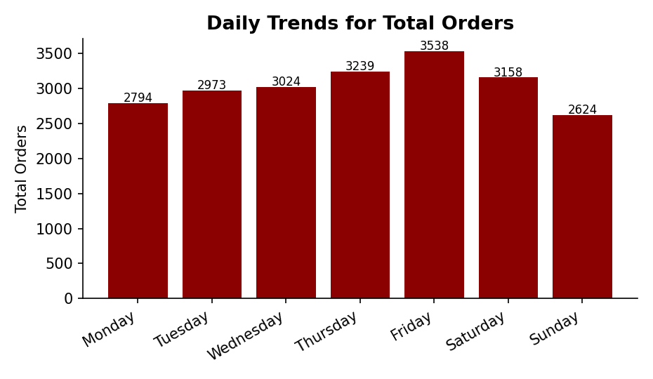
Figure 5.1 – Column chart: orders placed by day of week
Orders climb steadily from Monday through the week and peak on Friday (3,538 orders), before falling off over the weekend and bottoming out on Sunday (2,624 orders). Friday is roughly 27% busier than the slowest day (Sunday), which points to staffing, inventory and promotional decisions being weighted toward the Thursday–Saturday window rather than spread evenly across the week.

5.2 Monthly Trends for Total Orders
SELECT MONTHNAME(STR_TO_DATE(order_date, '%m/%d/%Y')) AS months,
COUNT(DISTINCT order_id) AS total_orders
FROM pizza_sales
GROUP BY MONTHNAME(STR_TO_DATE(order_date, '%m/%d/%Y'));
Month | Total Orders
January | 1,845
February | 1,685
March | 1,840
April | 1,799
May | 1,853
June | 1,773
July | 1,935
August | 1,841
September | 1,661
October | 1,646
November | 1,792
December | 1,680
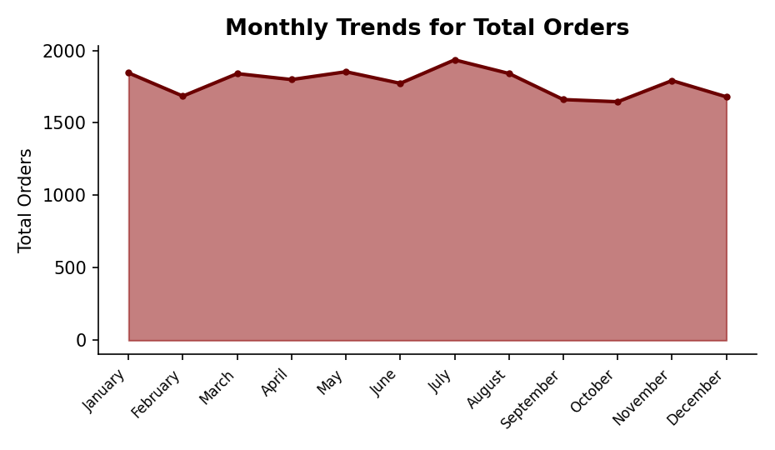
Figure 5.2 – Area chart: orders by month
Order volume is fairly stable across the year, with a clear seasonal peak in July (1,935 orders) and softer months in September and October (1,661 and 1,646 orders respectively). The gap between the busiest and quietest month is modest — about 17% — suggesting demand is driven more by day-of-week patterns (Section 5.1) than by strong seasonality.

5.3 Percentage of Sales by Pizza Category
SELECT pizza_category, SUM(quantity) AS no_of_sales,
ROUND((SUM(total_price) * 100) / (SELECT SUM(total_price) FROM pizza_sales), 2) AS percent_sales
FROM pizza_sales
GROUP BY pizza_category
ORDER BY no_of_sales ASC;
Category | Units Sold | % of Total Revenue
Chicken | 11,050 | 23.96%
Veggie | 11,649 | 23.68%
Supreme | 11,987 | 25.46%
Classic | 14,888 | 26.91%
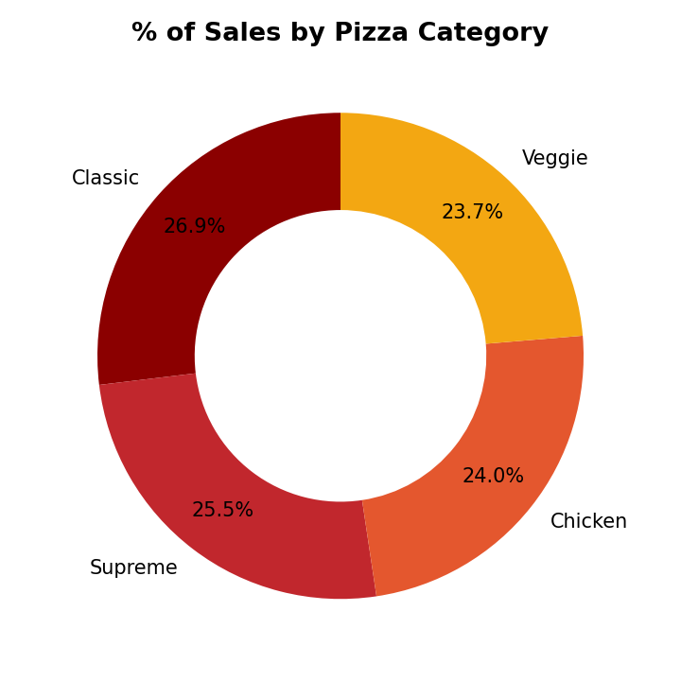
Figure 5.3 – Donut chart: share of revenue by pizza category
Classic pizzas bring in the largest slice of revenue (26.9%) despite Veggie having a similar unit count to Chicken — Classic recipes evidently combine strong unit volume with solid pricing. Chicken pizzas earn a slightly lower revenue share (23.96%) than their unit volume would suggest relative to Veggie (23.68% revenue on more total units), implying Veggie pizzas carry a marginally higher price point per unit on average.

5.4 Percentage of Sales by Pizza Size
SELECT pizza_size,
ROUND((SUM(total_price) * 100) / (SELECT SUM(total_price) FROM pizza_sales), 2) AS percentage_sales
FROM pizza_sales
GROUP BY pizza_size;
Size | % of Total Revenue
L | 45.89%
M | 30.49%
S | 21.77%
XL | 1.72%
XXL | 0.12%
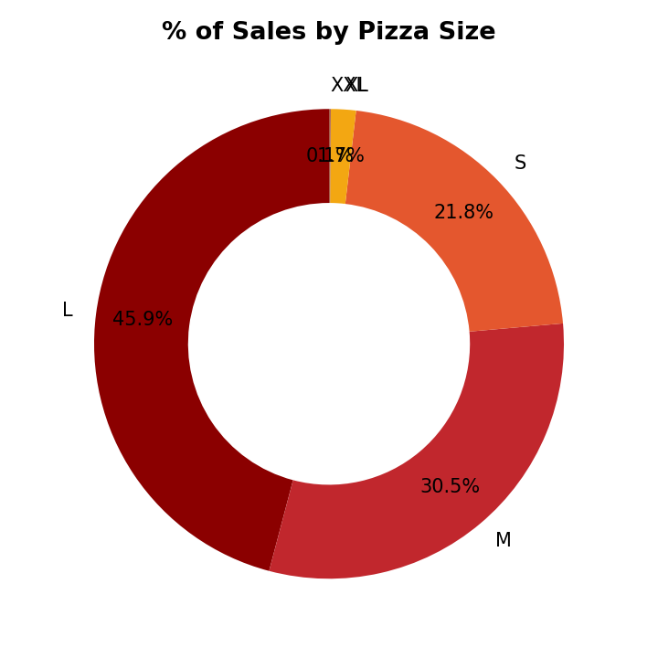
Figure 5.4 – Donut chart: share of revenue by pizza size
Large pizzas alone generate nearly half of all revenue (45.9%), with Medium and Small making up almost all of the remainder. XL and XXL sizes are effectively a niche offering, together contributing under 2% of revenue — worth keeping on the menu for variety, but not a meaningful growth lever without a deliberate push.

5.5 Total Pizzas Sold by Pizza Category
SELECT pizza_category, SUM(quantity) AS pizza_sold
FROM pizza_sales
GROUP BY pizza_category
ORDER BY pizza_sold DESC;
Category | Pizzas Sold
Classic | 14,888
Supreme | 11,987
Veggie | 11,649
Chicken | 11,050
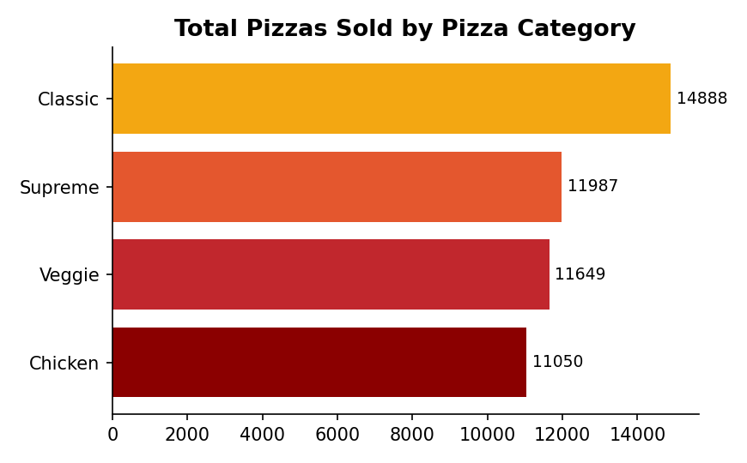
Figure 5.5 – Funnel chart: total units sold by category (dashboard uses a funnel visual; shown here as a ranked bar for the same values)
Classic is the volume leader by a clear margin (14,888 units, roughly 35% more than the lowest category, Chicken). The four categories are otherwise fairly close together — Supreme, Veggie and Chicken sit within about 900 units of each other — so the menu's category mix is reasonably balanced outside of Classic's lead.

6. Best & Worst Sellers Page — Charts, Queries & Explanations
This page ranks individual pizza recipes (not categories) by three separate measures — revenue, quantity sold, and number of orders — each shown as a Top 5 / Bottom 5 pair, exactly as laid out in the dashboard's second page.

6.1 Best & Worst Sellers by Revenue
-- Top 5
SELECT pizza_name, SUM(total_price) AS total_revenue, SUM(quantity) AS total_quantity,
COUNT(DISTINCT order_id) AS total_orders
FROM pizza_sales GROUP BY pizza_name ORDER BY total_revenue DESC LIMIT 5;

-- Bottom 5
SELECT pizza_name, SUM(total_price) AS total_revenue, SUM(quantity) AS total_quantity,
COUNT(DISTINCT order_id) AS total_orders
FROM pizza_sales GROUP BY pizza_name ORDER BY total_revenue LIMIT 5;
Top 5 by Revenue
Pizza | Revenue | Qty | Orders
The Thai Chicken Pizza | $43,434.25 | 2,371 | 2,225
The Barbecue Chicken Pizza | $42,768.00 | 2,432 | 2,273
The California Chicken Pizza | $41,409.50 | 2,370 | 2,197
The Classic Deluxe Pizza | $38,180.50 | 2,453 | 2,329
The Spicy Italian Pizza | $34,831.25 | 1,924 | 1,822
Bottom 5 by Revenue
Pizza | Revenue | Qty | Orders
The Brie Carre Pizza | $11,588.50 | 490 | 480
The Green Garden Pizza | $13,955.75 | 997 | 976
The Spinach Supreme Pizza | $15,277.75 | 950 | 918
The Mediterranean Pizza | $15,360.50 | 934 | 912
The Spinach Pesto Pizza | $15,596.00 | 970 | 945
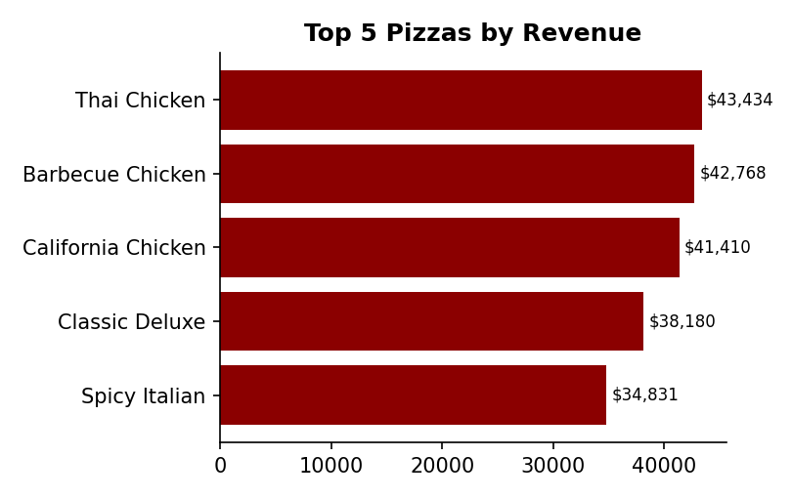 | 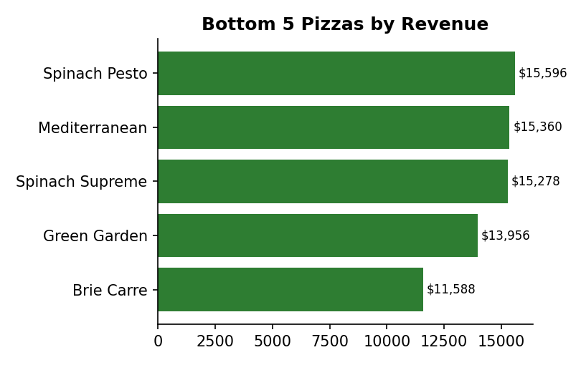
Figure 6.1 – Bar charts: Top 5 (left) and Bottom 5 (right) pizzas by revenue
The top revenue earners are dominated by premium Chicken-category pizzas (Thai Chicken, Barbecue Chicken, California Chicken) alongside the Classic Deluxe — all recipes with higher unit prices and strong order counts. The Brie Carre Pizza sits far below every other pizza on every metric, earning under a third of the next-lowest performer's revenue; it is the single clearest candidate for a menu, pricing or recipe review.

6.2 Best & Worst Sellers by Quantity Sold
SELECT pizza_name, SUM(quantity) AS total_quantity
FROM pizza_sales GROUP BY pizza_name ORDER BY total_quantity DESC LIMIT 5; -- Top 5
SELECT pizza_name, SUM(quantity) AS total_quantity
FROM pizza_sales GROUP BY pizza_name ORDER BY total_quantity ASC LIMIT 5; -- Bottom 5
Top 5 by Quantity
Pizza | Total Quantity
The Classic Deluxe Pizza | 2,453
The Barbecue Chicken Pizza | 2,432
The Hawaiian Pizza | 2,422
The Pepperoni Pizza | 2,418
The Thai Chicken Pizza | 2,371
Bottom 5 by Quantity
Pizza | Total Quantity
The Brie Carre Pizza | 490
The Mediterranean Pizza | 934
The Calabrese Pizza | 937
The Spinach Supreme Pizza | 950
The Soppressata Pizza | 961
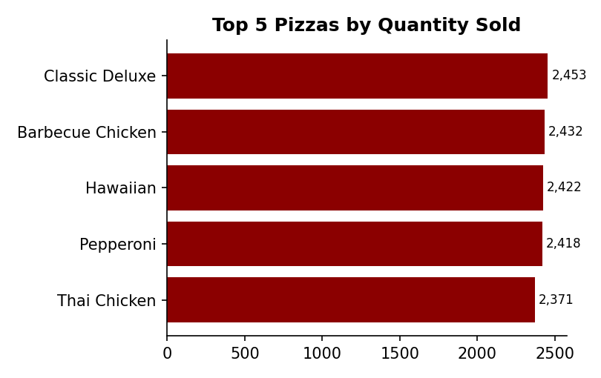 | 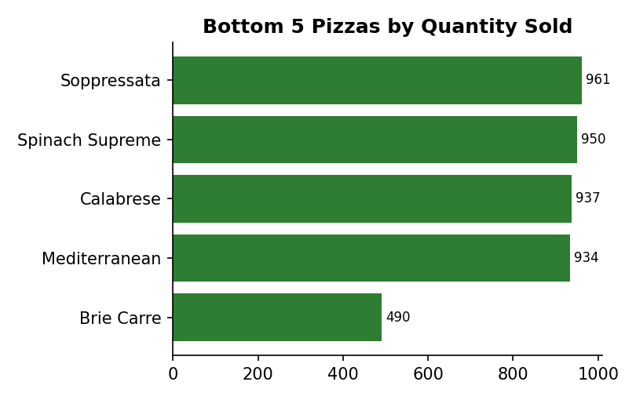
Figure 6.2 – Bar charts: Top 5 (left) and Bottom 5 (right) pizzas by units sold
By units sold, the leaderboard shifts slightly toward everyday favourites — Classic Deluxe, Hawaiian and Pepperoni join the Chicken pizzas at the top, showing that classic/familiar recipes move a comparable volume to the premium Chicken pizzas even though they earn somewhat less revenue per unit. The bottom-five list by quantity is nearly identical to the bottom-five list by revenue, reinforcing that pizzas like Brie Carre, Mediterranean and Calabrese are underperforming on fundamental demand, not just on price.

6.3 Best & Worst Sellers by Number of Orders
SELECT pizza_name, COUNT(DISTINCT order_id) AS total_orders
FROM pizza_sales GROUP BY pizza_name ORDER BY total_orders DESC LIMIT 5; -- Top 5
SELECT pizza_name, COUNT(DISTINCT order_id) AS total_orders
FROM pizza_sales GROUP BY pizza_name ORDER BY total_orders ASC LIMIT 5; -- Bottom 5
Top 5 by Orders
Pizza | Total Orders
The Classic Deluxe Pizza | 2,329
The Hawaiian Pizza | 2,280
The Pepperoni Pizza | 2,278
The Barbecue Chicken Pizza | 2,273
The Thai Chicken Pizza | 2,225
Bottom 5 by Orders
Pizza | Total Orders
The Brie Carre Pizza | 480
The Mediterranean Pizza | 912
The Calabrese Pizza | 918
The Spinach Supreme Pizza | 918
The Chicken Pesto Pizza | 938
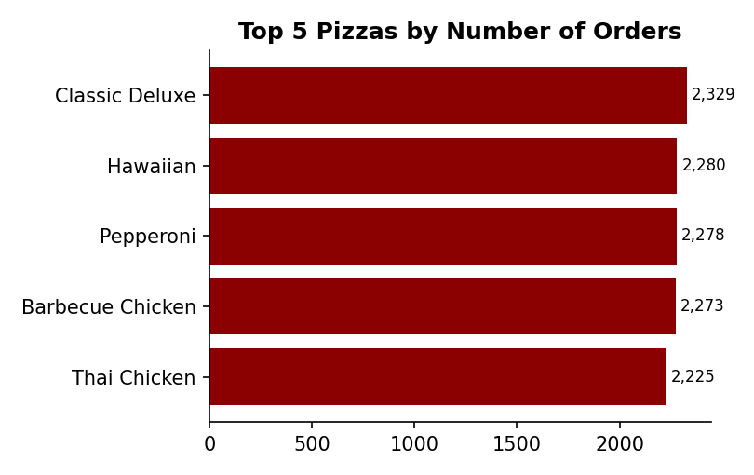 | 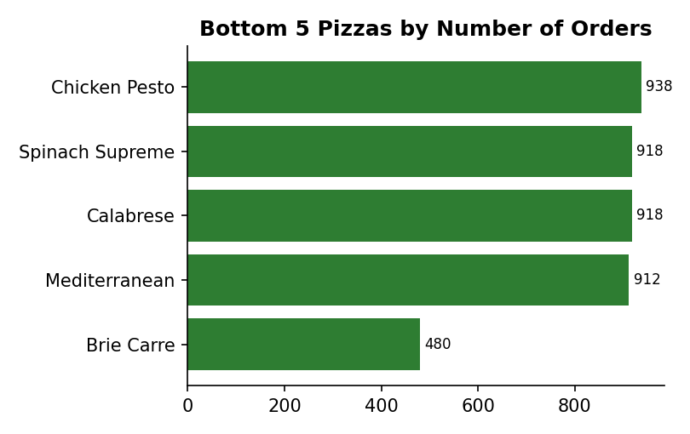
Figure 6.3 – Bar charts: Top 5 (left) and Bottom 5 (right) pizzas by number of orders containing them
The Classic Deluxe Pizza is the most frequently ordered pizza in the dataset (2,329 orders), edging out Hawaiian and Pepperoni — three approachable, classic-style recipes that appear in the most customer baskets even though the Chicken pizzas out-earn them on revenue. This distinction matters for menu strategy: Classic Deluxe, Hawaiian and Pepperoni are the pizzas most likely to be a customer's entry point, making them strong candidates for combo anchors, while the Chicken pizzas are better positioned as premium upsells.

7. Key Insights & Recommendations
- Weekly staffing and inventory: order volume rises steadily through the week and peaks on Friday (3,538 orders), roughly 27% above the Sunday low (2,624). Align staffing, dough prep and delivery capacity to a Thursday–Saturday peak rather than a flat weekly schedule.
- Size mix drives revenue: Large pizzas alone account for 45.9% of revenue. Promotions that nudge Medium orders up to Large (e.g. a modest upsell discount) have outsized revenue potential given how concentrated spend already is at the Large size.
- Category leadership: Classic is the top category by both units (14,888) and revenue share (26.9%), but Chicken-category recipes (Thai Chicken, Barbecue Chicken, California Chicken) are the top three individual pizzas by revenue — a strong case for keeping Chicken pizzas priced at a premium and featured prominently.
- Menu review candidate: The Brie Carre Pizza trails every other pizza on revenue, quantity and order count simultaneously (490 units / $11,588.50 / 480 orders — less than a quarter of the next-lowest performer on each measure). It is worth investigating whether this is a pricing, visibility, or recipe issue before deciding whether to keep, reprice, or retire it.
- Combo strategy: Classic Deluxe, Hawaiian and Pepperoni are ordered most often and are natural "anchor" items for meal deals, while Thai Chicken, Barbecue Chicken and California Chicken should be positioned as higher-margin premium add-ons or upsells.
- Seasonality: within the fully-populated months (January–September), July is the strongest (1,935 orders); consider whether this correlates with local seasonal demand (e.g. summer footfall) when planning promotions for the equivalent period each year.

8. Methodology & Data Notes
All figures in Sections 3, 5 and 6 were produced by re-running the exact aggregation logic of pizza_sales.sql against the uploaded pizza_sales.csv file (48,620 rows, no missing values). Dates were parsed from the M/D/YYYY order_date field to derive day-of-week and month groupings, matching the STR_TO_DATE conversions in the original script. Currency figures are shown in US dollars and rounded to two decimal places, consistent with the ROUND() calls in the source SQL.
The Power BI file (Pizza_Sales_dashboard.pbix) defines the same measures and visual layout described in Section 4; because a .pbix stores visuals as query definitions rather than exportable static images, the charts reproduced in Sections 5 and 6 were generated from the identical underlying data so that they match the dashboard's live output value-for-value, using the same chart type (column, area, donut, funnel/ranked-bar, and horizontal bar) called out in the file's layout metadata.

