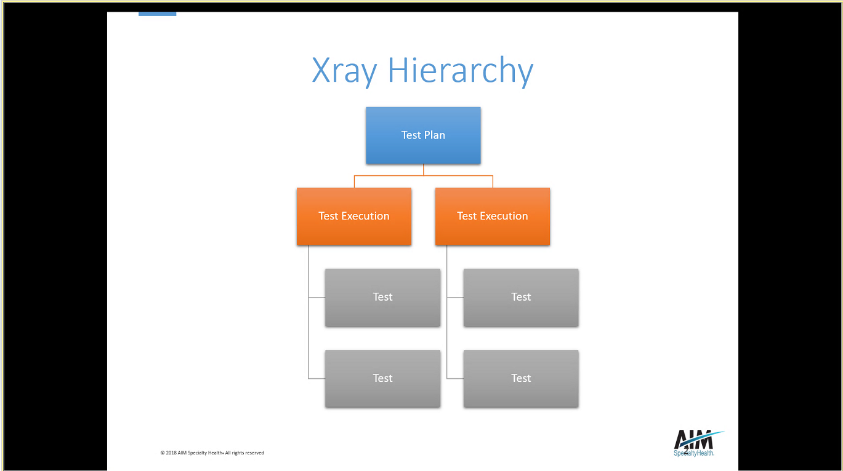

Test plan is linked to story

First link test plan to test

2nd link test to Test Execution

3rd link is test Execution to test Plan

XID-19 is issue ID

Then click create