**Comp5541 Team Project Proposal**

Francisco is an astronomy enthusiast and a restaurant owner. His restaurant, called Friends of the Stars, is located at west island of Montreal nearby Morgan Arboretum. Most of his customers and employees are astronomy lovers as well. His restaurant can provide food, drinks, and locations for those who want to spend their time observing sky during the night. In July of this year, there will be many astronomy events that can be observed in Montreal, including Perseid meteor shower and International Space Station passing over head. In order to provide the best experience on both the dinning and astronomy fronts for his customers, Francisco has decided to consult a software company for the best solution.

Friends of the Stars is a two chiefs, three waiters, and one dish washer restaurant with 18 tables (six people per table). **Waiters** take orders from costumers and deliver the orders to chiefs. They also need to process the payments, serve food and drinks to the tables, clean the tables and bring used dishes to dishwasher. **Chefs** need to prepare the food. Almost all the employees and consumers like to observe the sky, so Francisco wants to adapt a software which can simplify the serving procedures and also provide the staff with important current events occurring in the stratosphere so that they can notify the consumers accordingly. On the other hand, Francisco also wants to promote astronomy events (and of course his restaurant) to new costumers who might want to experience astronomy observing. He would like to have some recommendation function of astronomy events and/or the foods of his restaurant.

**Friend of the Stars restaurant now serves:**

Foods: Hamburger, Hotdog, Fried chicken, roasted chicken, dumpling, salads, potato soup, tomato soup (8)

Drinks: Water, soda, beer, home-made cider (4)

Desert: Ice cream, apple pie (2)

**Friend of the Stars restaurant:**

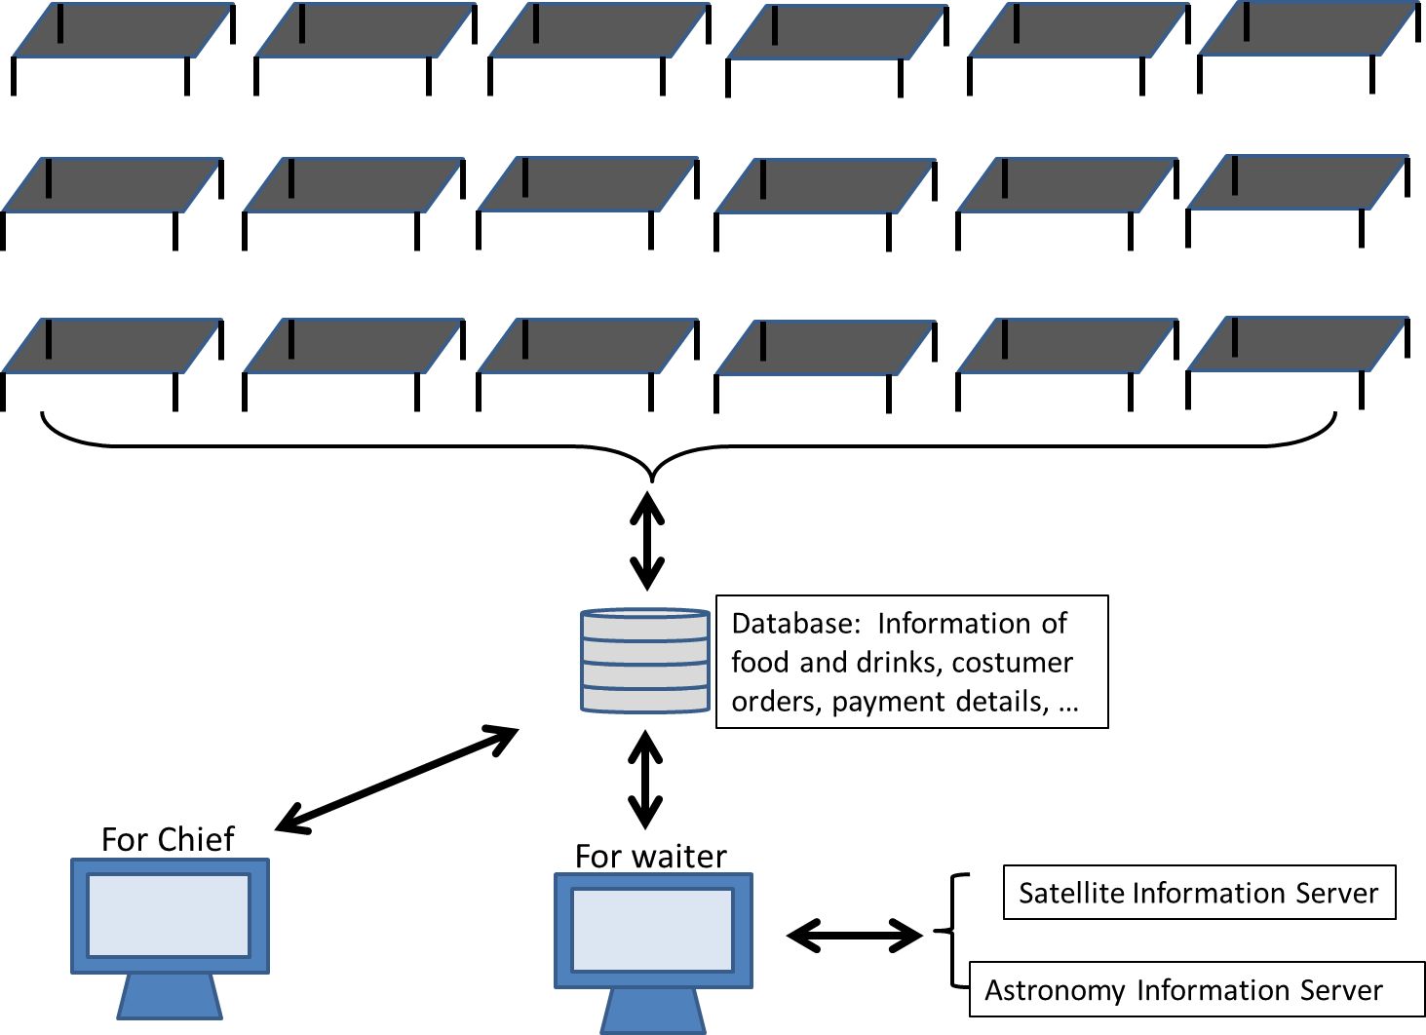

Functions of the user-end interface:

1. Food and drink display (menu)
2. Food and drink recommendations
3. Food and drink order
4. Cancel ordering
5. Total payment
6. Order verification
7. Satellite information display
8. Astronomy event display
9. Feedback

Functions of the waiter-end interface:

1. Table ordering information display
2. Table ordering confirmation
3. Serving information of each ordering
4. Payment check

Functions of the chief-end interface:

1. Ordered food display
2. Prepared food marker
3. Food sold out marker