**GL01**

SPESIFIKASI KEBUTUHAN PERANGKAT LUNAK

Role Playing Game Prince of Thunder

untuk:

Universitas Komputer Indonesia

Dipersiapkan oleh:

Mayga Syamsuhenda 10110233

Giri Gerhan Lantara 10110235

Swayji Giandika Kartia 10110258

Rasyida Nurlailani 10110772

Merriel Lushena 10111268

Jurusan Teknik Informatika - Universitas Komputer Indonesia

Jl. Dipati Ukur Nomor 112-114, 40132

|  |  |  |  |  |
| --- | --- | --- | --- | --- |
| unikom | Jurusan Teknik Informatika  Universitas Komputer Indonesia | Nomor Dokumen | | Halaman |
| *GL01* | | *1/* |
| Revisi | *1* | *Tgl: 19-5-2014* |

DAFTAR PERUBAHAN

|  |  |
| --- | --- |
| Revisi | Deskripsi |
| A |  |
| B |  |
| C |  |
| D |  |
| E |  |
| F |  |
| G |  |

|  |  |  |  |  |  |  |  |  |
| --- | --- | --- | --- | --- | --- | --- | --- | --- |
| INDEX  TGL | - | A | B | C | D | E | F | G |
| Ditulis oleh |  |  |  |  |  |  |  |  |
| Diperiksa oleh |  |  |  |  |  |  |  |  |
| Disetujui oleh |  |  |  |  |  |  |  |  |

Daftar Halaman Perubahan

|  |  |  |  |
| --- | --- | --- | --- |
| Halaman | Revisi | Halaman | Revisi |
|  |  |  |  |

**Daftar Isi**

# BAB I

# Pendahuluan

## Tujuan Penulisan Dokumen

## Lingkup Masalah

## Aturan Penomoran

Penulisan dokumen ini menggunakan berbagai macam aturan penamaan dan penomoran yang berbeda-beda untuk beberapa bagian tertentu. Aturan penamaan dan penomoran yang digunakan berdasarkan hal atau bagian adalah seperti yang tercantum pada table berikut:

|  |  |
| --- | --- |
| Hal atau Bagian | Aturan Penomoran atau Penamaan |
| Kebutuhan Fungsional | SKPL-F-xxx |
| Kebutuhan Non Fungsional | SKPL-NF-xxx |
| Use Case | UC-xxx |

## Referensi

## Deskripsi Umum Dokumen

## Spesifikasi Kebutuhan Perangkat Lunak ini terdiri dari dua bab sebagai berikut: BAB I Pendahuluan

Pada pendahuluan diberikan gambaran umum tentang dokumen yang berisikan:

* Tujuan Penulisan Dokumen
* Lingkup Masalah
* Aturan Penomoran
* Referensi
* Deksripsi Umum Dokumen

**BAB II Kebutuhan Perangkat Lunak**

Pada bab ini dijelaskan kebutuhan perangkat lunak yang diperlukan di dalam pengembangan RPG Game

# Bab II

# Kebutuhan Perangkat Lunak

## Deskripsi Umum Sistem

## Fitur Utama Perangkat Lunak

### Kebutuhan Fungsional

Kebutuhan fungsional terdiri dari:

|  |  |
| --- | --- |
| SKPL-ID | Keterangan |
| **SKPL-F-001** | Sistem menyediakan menu new game |
| **SKPL-F-002** | Sistem menyediakan menu continue game |
| **SKPL-F-003** | Sistem menyediakan menu Exit game |
| **SKPL-F-004** | Sistem menyediakan menu Fight an Enemy |
| **SKPL-F-005** | Sistem menyediakan menu Attack on Enemy |
| **SKPL-F-006** | Sistem menyediakan menu Use Special Attack on Enemy |
| **SKPL-F-007** | Sistem menyediakan menu Guarding From Attack Enemy |
| **SKPL-F-008** | Sistem menyediakan menu Use Magic Attack on Enemy |
| **SKPL-F-009** | Sistem menyediakan menu Use Items on Character/Enemy |
| **SKPL-F-010** | User dapat memilih target sasaran |
| **SKPL-F-011** | Sistem menyediakan menu Escape From Battle |
| **SKPL-F-012** | Sistem menyediakan menu Paused Game |
| **SKPL-F-013** | Sistem menyediakan menu Inventory Players |
| **SKPL-F-014** | Sistem menampilkan daftar barang ( List of Items ) |
| **SKPL-F-015** | Sistem menampilkan daftar senjata ( List of Weapons ) |
| **SKPL-F-016** | Sistem menampilkan daftar armor ( List of Armors ) |
| **SKPL-F-017** | Sistem menampilkan daftar keterangan barang berharga (List Of Valuables Items) |
| **SKPL-F-018** | Sistem menyediakan menu option on game |
| **SKPL-F-019** | Sistem menyediakan menu Skills On Players |
| **SKPL-F-020** | Sistem menyediakan menu Special Skills On Players |
| **SKPL-F-021** | Sistem menyediakan menu Magic Skills On Players |
| **SKPL-F-022** | Sistem menyediakan menu status player |
| **SKPL-F-023** | Sistem menyediakan menu Equipment On Players |
| **SKPL-F-024** | Sistem menyediakan menu Change Equipment Player |
| **SKPL-F-025** | Sistem menyediakan menu Optimize Equipment Player |
| **SKPL-F-026** | Sistem menyediakan menu Clear Equipment Player |
| **SKPL-F-027** | Sistem menyediakan menu formasi player |
| **SKPL-F-028** | User dapat mengubah formasi players |
| **SKPL-F-029** | Sistem menyediakan menu save game |
| **SKPL-F-030** | Sistem menampilkan menu Game End |
| **SKPL-F-031** | Sistem dapat keluar dari permainan |
| **SKPL-F-032** | Sistem menyediakan menu Exit To Title |
| **SKPL-F-033** | Sistem menyediakan menu Shop |
| **SKPL-F-034** | Sistem menyediakan menu Sell |
| **SKPL-F-035** | Sistem menyediakan menu Buy Weapon |
| **SKPL-F-036** | Sistem menyediakan menu Buy Armor |
| **SKPL-F-037** | Sistem menyediakan menu Buy Potion |

### Kebutuhan Non Fungsional

|  |  |
| --- | --- |
| SKPL-Id | Keterangan |
| **SKPL-NF-001** | User dapat memilih slot file untuk load game |

## Model Use Case

### Diagram Use Case

Diagram Use Case merupakan pemodelan untuk menggambarkan kelakuan (behavior) sistem yang akan dibuat. Sistem yang dibuat seperti terlihat dalam use case berikut:

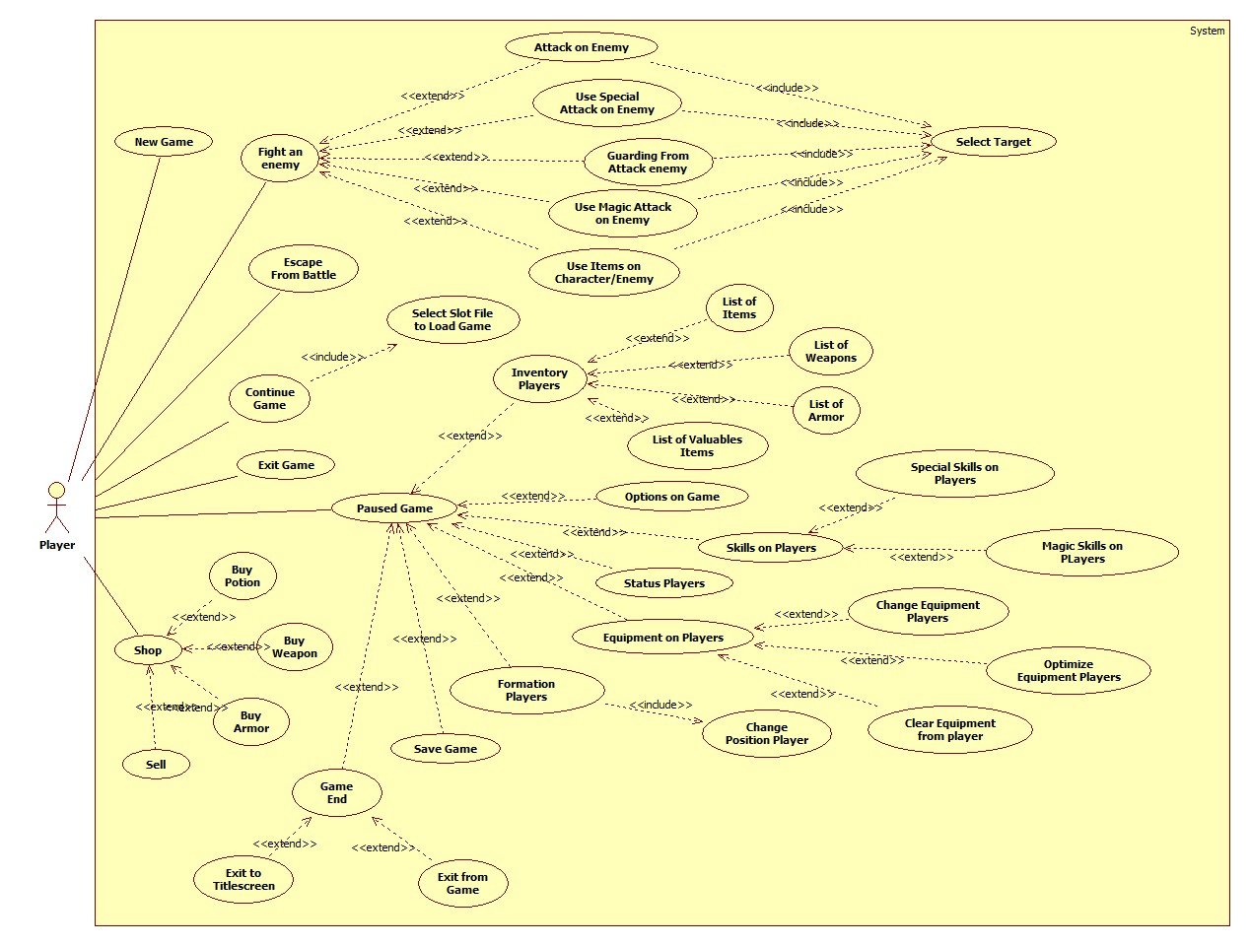

**Gambar 2.2 Diagram Use Case**

### Definisi Aktor

Bagian ini diisi dengan daftar actor dan dekripsi role untuk actor tersebut. Dekripsi role harus menjelaskan wewenang pada role tersebut dalam perangkat lunak. Bisa dibuat dalam bentuk table berikut:

|  |  |  |
| --- | --- | --- |
| No | Actor | Deksripsi |
| 1 | Player | Actor dengan role ini mempunyai tugas untuk memainkan permainan. |

### Definisi Use Case

Bagian ini diisi dengan daftar use case dan deksripsi singkat mengenai use case tersebut. Bisa dibuat dalam bentuk table berikut:

|  |  |  |
| --- | --- | --- |
| ID | Use Case | Deksripsi |
| UC-001 | New Game |  |
| UC-002 | Fight on Enemy |  |
| UC-003 | Attack on Enemy |  |
| UC-004 | Use Special Attack on Enemy |  |
| UC-005 | Guarding from Attack Enemy |  |
| UC-006 | Use Magic Attak on Enemy |  |
| UC-007 | Use Items on Character/Enemy |  |
| UC-008 | Select Target |  |
| UC-009 | Escape From Battle |  |
| UC-010 | Continue Game |  |
| UC-011 | Select Slot File to Load Game |  |
| UC-012 | Exit Game |  |
| UC-013 | Paused Game |  |
| UC-014 | Inventory Player |  |
| UC-015 | List of Items |  |
| UC-016 | List of Weapon |  |
| UC-017 | List of Armor |  |
| UC-018 | List of Valuables Items |  |
| UC-019 | Options on Game |  |
| UC-020 | Skills on Players |  |
| UC-021 | Special Skills on Player |  |
| UC-022 | Magic Skills on Player |  |
| UC-023 | Status Players |  |
| UC-024 | Equipment on Players |  |
| UC-025 | Change Equipment Players |  |
| UC-026 | Optimize Equipment Players |  |
| UC-027 | Clear Equipment Players |  |
| UC-028 | Formation Players |  |
| UC-029 | Change Position Player |  |
| UC-030 | Save Game |  |
| UC-031 | Game End |  |
| UC-032 | Exit from Game |  |
| UC-033 | Exit to Titlescreen |  |
| UC-034 | Shop |  |
| UC-035 | Buy Potion |  |
| UC-036 | Buy Weapon |  |
| UC-037 | Buy Armor |  |
| UC-037 | Sell |  |

### Skenario Use Case

Bagian ini diisi dengan skenario (flow of event) untuk beberapa use case utama,yang menggambarkan urutan interaksi actor dengan use case tersebut dari awal sampai akhir.

1. Skenario Use Case New Game

|  |  |  |
| --- | --- | --- |
| **Use Case Name** | **New Game** | |
| Related Requirements | Requirements A.1 | |
| Goal in Context | Menampilkan permainan dari awal | |
| Preconditions | Player berada di menu utama | |
| Succesful End Condition | Berhasil untuk menampilkan permainan baru | |
| Failed End Condition | Gagal untuk menampilkan permainan baru | |
| Primary Actors | Player | |
| Secondary Actors | **-** | |
| Trigger | Player memilih menu New Game | |
| Main Flow | Step | Action |
|  | 1 | Sistem menampilkan intro permainan |
|  | 2 | Player memilih gender tokoh |
|  | 3 | Sistem merubah tampilan tokoh |
|  | 4 | Player memasukan nama untuk tokoh yang di mainkan |
|  | 5 | Sistem memasukan nama tokoh |
|  | 6 | Sistem menampilkan permainan |
| Extensions | Step | Branching Action |
|  | 1.1 | Gagal menampilkan intro permainan |
|  | 3.1 | Gagal merubah tampilan tokoh |
|  | 5.1 | Gagal memasukan nama tokoh |
|  | 6.1 | Gagal menampilkan permainan |

1. Skenario Use Case Continue Game

|  |  |  |
| --- | --- | --- |
| **Use Case Name** | **Continue Game** | |
| Related Requirements | Requirements A.2 | |
| Goal in Context | Menampilkan daftar file permainan yang di simpan | |
| Preconditions | Player berada di menu utama | |
| Succesful End Condition | Player bisa memilih menu Continue Game | |
| Failed End Condition | Player tidak bisa memilih menu Continue Game | |
| Primary Actors | Player | |
| Secondary Actors | **-** | |
| Trigger | Player berada di menu utama | |
| Included Cases | **Select Slot File to Load Game** | |
| Main Flow | Step | Action |
|  | 1 | Sistem mengecek file permainan |
|  | 2 | Player memilih menu Continue Game |
|  | 3  **Include:: Select Slot File to Load Game** | Sistem menampilkan menu Select Slot File |
| Ekstensions | Step | Branching Action |
|  | 1.1 | Sistem tidak menemukan file permainan |

1. Skenario Use Case Select Slot File to Load Game

|  |  |  |
| --- | --- | --- |
| **Use Case Name** | **Select Slot File to Load Game** | |
| Related Requirements | Requirements A.2 | |
| Goal in Context | Menampilkan permainan yang di simpan | |
| Preconditions | Player memilih menu Continue Game | |
| Succesful End Condition | Berhasil melanjutkan permainan | |
| Failed End Condition | Gagal melanjutkan permainan | |
| Primary Actors | Player | |
| Secondary Actors | **-** | |
| Trigger | Player memilih menu Continue Game | |
| Included Cases | **Select Slot File to Load Game** | |
| Main Flow | Step | Action |
|  | 1 | Sistem menampilkan daftar file permainan |
|  | 2 | Player memilih file permainan yang sudah di simpan |
|  | 3 | Menampilkan permainan yang di simpan |
| Ekstensions | Step | Branching Action |
|  | 2.1 | Player menekan tombol kembali |
|  | 3.1 | Gagal menampilkan permainan yang di simpan |

1. Skenario Use Case Exit Game

|  |  |  |
| --- | --- | --- |
| **Use Case Name** | **Exit Game** | |
| Related Requirements | Requirements A.3 | |
| Goal in Context | Keluar dari permainan | |
| Preconditions | Player berada di menu utama | |
| Succesful End Condition | Berhasil keluar dari permainan | |
| Failed End Condition | Gagal keluar dari permainan | |
| Primary Actors | Player | |
| Secondary Actors | **-** | |
| Trigger | Player berada di menu utama | |
| Main Flow | Step | Action |
|  | 1 | Player memilih menu Exit Game |
|  | 2 | Sistem mengakhiri permainan |
| Ekstensions | Step | Branching Action |
|  | 2.1 | Sistem tidak bisa mengakhiri permainan |

1. Skenario Use Case Fight an Enemy

|  |  |  |
| --- | --- | --- |
| **Use Case Name** | **Fight an Enemy** | |
| Related Requirements | Requirement A.4 | |
| Goal in Context | Menampilkan menu jenis serangan | |
| Preconditions | Player berada dalam permainan | |
| Succesful End Condition | Berhasil menampilkan menu serangan | |
| Failed End Condition | Gagal menampilkan menu serangan | |
| Primary Actors | Player | |
| Secondary Actors | **-** | |
| Trigger | Player memilih menu Fight | |
| Main Flow | Step | Action |
|  | 1 | Sistem menjalankan perintah Battle |
|  | 2 | Sistem menampilkan menu pertarungan |
|  | 3 | Player memilih menu Fight |
|  | 4 | Sistem menampilkan menu jenis serangan |
|  | 5 | Player memilih menu jenis serangan |
| Ekstensions | Step | Branching Action |
|  | 5.1 | Player memilih menu **Attack On Enemy** |
|  | 5.2 | Player memilih menu **Use Special Attack On Enemy** |
|  | 5.3 | Player memilih menu **Guarding From Attack Enemy** |
|  | 5.4 | Player memilih menu **Use Magic Attack On Enemy** |
|  | 5.5 | Player memilih menu **Use Items On Enemy** |
|  | 5.6 | Player menekan tombol kembali |
|  | 5.6.1 | Sistem menampilkan menu pertarungan |

1. Skenario Use Case Attack on Enemy

|  |  |  |
| --- | --- | --- |
| **Use Case Name** | **Attack on Enemy** | |
| Related Requirements | Requirement A.4.1 | |
| Goal in Context | Melakukan serangan biasa kepada musuh | |
| Preconditions | Player memilih menu Fight | |
| Succesful End Condition | Berhasil melakukan serangan | |
| Failed End Condition | Gagal melakukan serangan | |
| Primary Actors | Player | |
| Secondary Actors | **-** | |
| Trigger | Player memilih menu Attack | |
| Include Cases | Select Target | |
| Main Flow | Step | Action |
|  | 1 | Sistem menjalankan kondisi serangan biasa |
|  | 2  **Include::Select Target** | Sistem menampilkan daftar sasaran |
| Ekstensions | Step | Branching Action |
|  | 1.1 | Player menekan tombol kembali |
|  | 1.1.1 | Sistem menampilkan menu jenis serangan |

1. Skenario Use Case Use Special Attack on Enemy

|  |  |  |
| --- | --- | --- |
| **Use Case Name** | **Use Special Attack on Enemy** | |
| Related Requirements | Requirement A.4.2 | |
| Goal in Context | Melakukan serangan special kepada musuh | |
| Preconditions | Player memilih menu Fight | |
| Succesful End Condition | Berhasil melakukan serangan | |
| Failed End Condition | Gagal melakukan serangan | |
| Primary Actors | Player | |
| Secondary Actors | **-** | |
| Trigger | Player memilih menu Special | |
| Include Cases | Select Target | |
| Main Flow | Step | Action |
|  | 1 | Sistem menampilkan daftar special skill |
|  | 2 | Player memilih skill |
|  | 3 | Sistem menjalankan kondisi serangan special |
|  | 4  **Include::Select Target** | Sistem menampilkan daftar sasaran |
| Ekstensions | Step | Branching Action |
|  | 2.1 | Player menekan tombol kembali |
|  | 2.1.1 | Sistem menampilkan menu jenis serangan |
|  | 2.2 | Player tidak bisa memilih skill |

1. Skenario Use Case Guarding From Attack Enemy

|  |  |  |
| --- | --- | --- |
| **Use Case Name** | **Guarding From Attack Enemy** | |
| Related Requirements | Requirement A.4.3 | |
| Goal in Context | Melanjutkan pertarungan dengan tidak melakukan serangan | |
| Preconditions | Player memilih menu Fight | |
| Succesful End Condition | Sistem berhasil menjalankan pertarungan tanpa tokoh menyerang | |
| Failed End Condition | Sistem gagal menjalankan pertarungan tanpa tokoh menyerang | |
| Primary Actors | Player | |
| Secondary Actors | **-** | |
| Trigger | Player memilih menu Guard | |
| Main Flow | Step | Action |
|  | 1 | Sistem menjalankan kondisi guard pada tokoh |
|  | 2 | Sistem menjalankan perintah bertarung |
|  | 3 | Sistem menampilkan pesan |
|  | 4 | Sistem mengecek kondisi pertarungan |
| Ekstensions | Step | Branching Action |
|  | 1.1 | Sistem gagal menjalankan kondisi guard pada tokoh |
|  | 2.1 | Sistem gagal menjalankan perintah bertarung |

1. Skenario Use Case Use Magic Attack on Enemy

|  |  |  |
| --- | --- | --- |
| **Use Case Name** | **Use Magic Attack on enemy** | |
| Related Requirements | Requirement A.4.4 | |
| Goal in Context | Melakukan serangan magic kepada musuh | |
| Preconditions | Player memilih menu Fight | |
| Succesful End Condition | Berhasil melakukan serangan magic | |
| Failed End Condition | Gagal melakukan serangan magic | |
| Primary Actors | Player | |
| Secondary Actors | **-** | |
| Trigger | Player memilih menu Magic | |
| Include Cases | Select Target | |
| Main Flow | Step | Action |
|  | 1 | Sistem menampilkan daftar magic skill |
|  | 2 | Player memilih skill |
|  | 3 | Sistem menjalankan kondisi serangan magic |
|  | 4  **Include::Select Target** | Sistem menampilkan daftar sasaran |
| Ekstensions | Step | Branching Action |
|  | 2.1 | Player menekan tombol kembali |
|  | 2.1.1 | Sistem menampilkan menu jenis serangan |
|  | 2.2 | Player tidak bisa memilih skill |

1. Skenario Use Case Use Items on Character/Enemy

|  |  |  |
| --- | --- | --- |
| **Use Case Name** | **Use Items on Character/Enemy** | |
| Related Requirements | Requirement A.4.5 | |
| Goal in Context | Menggunakan barang kepada tokoh pemain | |
| Preconditions | Player memilih menu Fight | |
| Succesful End Condition | Berhasil menggunakan barang | |
| Failed End Condition | Gagal menggunakan barang | |
| Primary Actors | Player | |
| Secondary Actors | **-** | |
| Trigger | Player memilih menu Items | |
| Include Cases | Select Target | |
| Main Flow | Step | Action |
|  | 1 | Sistem menampilkan daftar items |
|  | 2 | Player memilih items |
|  | 3 | Sistem menjalankan kondisi menggunakan items |
|  | 4  **Include::Select Target** | Sistem menampilkan daftar sasaran |
|  |  |  |
| Ekstensions | Step | Branching Action |
|  | 2.1 | Player menekan tombol kembali |
|  | 2.1.1 | Sistem menampilkan menu jenis serangan |
|  | 2.2 | Player tidak bisa memilih items |

1. Skenario Use Case Select Target

|  |  |  |
| --- | --- | --- |
| **Use Case Name** | **Select Target** | |
| Related Requirements | Requirement A.4.1, A.4.2, A.4.3, A4.4 | |
| Goal in Context | Menyelesaikan pertarungan | |
| Preconditions | Player sudah memilih menu Fight | |
| Succesful End Condition | Berhasil mengakhiri pertarungan | |
| Failed End Condition | Gagal mengakhiri pertarungan | |
| Primary Actors | Player | |
| Secondary Actors | **-** | |
| Trigger | Player memilih nama sasaran | |
| Include Cases | Select Target | |
| Main Flow | Step | Action |
|  | 1 | Sistem menampilkan daftar sasaran |
|  | 2 | Player memilih sasaran |
|  | 3 | Sistem menjalankan perintah bertarung |
|  | 3 | Sistem menampilkan pesan pertarungan |
|  | 4 | Sistem mengecek kondisi pertarungan |
| Ekstensions | Step | Branching Action |
|  | 2.1 | Player tidak bisa memilih sasaran |
|  | 3.1 | Gagal menjalankan perintah bertarung |
|  | 4.1 | Sistem gagal mengecek kondisi pertarungan |

1. Skenario Use Case Escape from Battle

|  |  |  |
| --- | --- | --- |
| **Use Case Name** | **Escape from Battle** | |
| Related Requirements | Requirement A.5 | |
| Goal in Context | Menghindari pertarungan dengan musuh | |
| Preconditions | Player berada dalam permainan | |
| Succesful End Condition | Player melanjutkan permainan | |
| Failed End Condition | Player tidak melanjutkan permainan | |
| Primary Actors | Player | |
| Secondary Actors | **-** | |
| Trigger | Player memilih menu Escape | |
| Main Flow | Step | Action |
|  | 1 | Sistem menjalankan perintah Battle |
|  | 2 | Sistem menampilkan menu pertarungan |
|  | 3 | Sistem mengecek kondisi Escape |
|  | 4 | Player memilih menu Escape |
|  | 5 | Sistem mengahkiri perintah Battle |
|  | 6 | Sistem menampilkan permainan |
| Ekstensions | Step | Branching Action |
|  | 4.1 | Player tidak bisa memilih menu Escape |
|  | 1.1 | Sistem gagal menampilkan pesan |
|  | 2.1 | Sistem gagal menampilkan permainan |

1. Skenario Use Case Paused Game

|  |  |  |
| --- | --- | --- |
| **Use Case Name** | **Paused Game** | |
| Related Requirements | Requirement A.6 | |
| Goal in Context | Menampilkan menu pause | |
| Preconditions | Player berada pada permainan yang sedang berlangsung | |
| Succesful End Condition | Berhasil menghentikan permainan | |
| Failed End Condition | Gagal menghentikan permainan | |
| Primary Actors | Player | |
| Secondary Actors | **-** | |
| Trigger | Player menekan tombol pause dalam permainan | |
| Main Flow | Step | Action |
|  | 1 | Sistem menampilkan menu pause |
|  | 2 | Player memilih menu pause |
| Ekstensions | Step | Branching Action |
|  | 2.1 | Player memilih menu **Inventory** |
|  | 2.2 | Player memilih menu **Option** |
|  | 2.2 | Player memilih menu **Skills** |
|  | 2.3 | Player memilih menu **Status** |
|  | 2.4 | Player memilih menu **Equipment** |
|  | 2.5 | Player memilih menu **Formation** |
|  | 2.6 | Player memilih menu **Save Game** |
|  | 2.7 | Player memilih menu **Game End** |
|  | 2.8 | Player menggunakan tombol kembali |
|  | 2.8.1 | Sistem menampilkan permainan |

1. Skenario Use Case Inventory Players

|  |  |  |
| --- | --- | --- |
| **Use Case Name** | **Inventory Players** | |
| Related Requirements | Requirement A.6.1 | |
| Goal in Context | Menampilkan menu inventory | |
| Preconditions | Player sudah berada di menu paused game | |
| Succesful End Condition | Berhasil menampilkan menu inventory | |
| Failed End Condition | Gagal menampilkan menu inventory | |
| Primary Actors | Player | |
| Secondary Actors | **-** | |
| Trigger | Player memilih menu inventory | |
| Main Flow | Step | Action |
|  | 1 | Sistem menampilkan menu inventory |
|  | 2 | Player memilih menu |
| Ekstensions | Step | Branching Action |
|  | 2.1 | Player memilih menu **Items** |
|  | 2.2 | Player memilih menu **Weapons** |
|  | 2.3 | Player memilih menu **Armor** |
|  | 2.4 | Player memilih menu **Valuables** |
|  | 2.5 | Player menekan tombol kembali |
|  | 2.5.1 | Sistem menampilkan menu paused game |

1. Skenario Use Case List of Items

|  |  |  |
| --- | --- | --- |
| **Use Case Name** | **List Of Items** | |
| Related Requirements | Requirement A.6.1.2 | |
| Goal in Context | Menampilkan daftar barang dan menggunakan barang yang dimiliki player | |
| Preconditions | Player sudah berada di menu inventory | |
| Succesful End Condition | Berhasil menampilkan daftar perlengkapan barang dan menggunakan barang | |
| Failed End Condition | Gagal menampilkan daftar perlengkapan barang dan menggunakan barang | |
| Primary Actors | Player | |
| Secondary Actors | **-** | |
| Trigger | Player memilih menu Items | |
| Main Flow | Step | Action |
|  | 1 | Sistem menampilkan daftar barang |
|  | 2 | Sistem mengecek daftar items yang bisa digunakan |
|  | 3 | Player memilih items dalam daftar |
|  | 4 | Sistem menampilkan keterangan Items |
|  | 5 | Player menggunakan items |
|  | 6 | Player memilih tokoh player yang akan menggunakan items |
|  | 7 | Sistem menjalankan perintah menggunakan items pada tokoh player |
| Ekstensions | Step | Branching Action |
|  | 1.1 | Sistem gagal menampilkan daftar items |
|  | 4.1 | Sistem gagal menampilkan keterangan items |
|  | 5.1 | Player tidak bisa menggunakan items |
|  | 7.1 | Sistem gagal menjalankan perintah menggunakan items pada tokoh player |

1. Skenario Use Case List of Weapons

|  |  |  |
| --- | --- | --- |
| **Use Case Name** | **List Of Weapons** | |
| Related Requirements | Requirement A.6.1.3 | |
| Goal in Context | Menampilkan daftar senjata yang dimiliki player | |
| Preconditions | Player sudah berada di menu inventory players | |
| Succesful End Condition | Berhasil menampilkan daftar dan keterangan senjata | |
| Failed End Condition | Gagal menampilkan daftar dan keterangan senjata | |
| Primary Actors | Player | |
| Secondary Actors | **-** | |
| Trigger | Player memilih menu Weapons | |
| Main Flow | Step | Action |
|  | 1 | Sistem menampilkan daftar weapon |
|  | 2 | Player memilih weapon dalam daftar |
|  | 4 | Sistem menampilkan keterangan pada Weapon yang dipilih |
| Ekstensions | Step | Branching Action |
|  | 2.1 | Sistem gagal menampilkan daftar Weapon |
|  | 4.1 | Sistem gagal menampilkan keterangan pada senjata yang dipilih |

1. Skenario Use Case List of Armor

|  |  |  |
| --- | --- | --- |
| **Use Case Name** | **List Of Armor** | |
| Related Requirements | Requirement A.6.1.4 | |
| Goal in Context | Menampilkan daftar armor yang dimiliki player | |
| Preconditions | Player sudah berada di menu inventory players | |
| Succesful End Condition | Berhasil menampilkan daftar dan keterangan armor | |
| Failed End Condition | Gagal menampilkan daftar dan keterangan armor | |
| Primary Actors | Player | |
| Secondary Actors | **-** | |
| Trigger | Player memilih menu List Of Armor | |
| Main Flow | Step | Action |
|  | 1 | Sistem menampilkan daftar armor |
|  | 2 | Player memilih Armor dalam daftar |
|  | 4 | Sistem menampilkan keterangan armor yang dipilih |
| Ekstensions | Step | Branching Action |
|  | 1.1 | Sistem gagal menampilkan daftar armor |
|  | 4.1 | Sistem gagal menampilkan keterangan pada armor yang dipilih |

1. Skenario Use Case List of Valuables Items

|  |  |  |
| --- | --- | --- |
| **Use Case Name** | **List Of Valuables Items** | |
| Related Requirements | Requirement A.6.1.5 | |
| Goal in Context | Menampilkan daftar dan keterangan barang berharga yang dimiliki player | |
| Preconditions | Player sudah berada di menu inventory players | |
| Succesful End Condition | Berhasil menampilkan daftar dan keterangan barang berharga | |
| Failed End Condition | Gagal menampilkan daftar dan keterangan barang berharga | |
| Primary Actors | Player | |
| Secondary Actors | **-** | |
| Trigger | Player memilih menu Valuables | |
| Main Flow | Step | Action |
|  | 1 | Sistem menampilkan daftar barang berharga |
|  | 2 | Player memilih ValuablesItems dalam daftar |
|  | 4 | Sistem menampilkan keterangan pada barang berharga yang dipilih |
| Ekstensions | Step | Branching Action |
|  | 2.1 | Sistem gagal menampilkan daftar barang berharga |
|  | 4.1 | Sistem gagal menampilkan keterangan barang berharga yang dipilih |

1. Skenario Use Case Options on Game

|  |  |  |
| --- | --- | --- |
| **Use Case Name** | **Option On Game** | |
| Related Requirements | Requirement A.6.2 | |
| Goal in Context | Menampilkan menu pilhan pengaturan dalam permainan | |
| Preconditions | Player sudah berada di menu paused game | |
| Succesful End Condition | Berhasil merubah pengaturan dalam permainan | |
| Failed End Condition | Gagal merubah pengaturan dalam permainan | |
| Primary Actors | Player | |
| Secondary Actors | **-** | |
| Trigger | Player memilih menu option | |
| Main Flow | Step | Action |
|  | 1 | Sistem menampilkan menu option |
|  | 2 | Player memilih pengaturan yang akan diubah |
|  | 3 | Sistem merubah pengaturan permainan |
| Ekstensions | Step | Branching Action |
|  | 1.1 | Sistem gagal menampilkan menu option |
|  | 2.1 | Player menekan tombol kembali |
|  | 2.1.1 | Sistem menampilkan menu pause |
|  | 3.1 | Sistem gagal merubah pengaturan permainan |

1. Skenario Use Case Skills On Players

|  |  |  |
| --- | --- | --- |
| **Use Case Name** | **Skills On Players** | |
| Related Requirements | Requirement A.6.3 | |
| Goal in Context | Menampilkan menu Skill | |
| Preconditions | Player sudah berada di menu paused game | |
| Succesful End Condition | Berhasil menampilkan menu skills | |
| Failed End Condition | Gagal menampilkan menu skills | |
| Primary Actors | Player | |
| Secondary Actors | **-** | |
| Trigger | Player memilih menu skills | |
| Main Flow | Step | Action |
|  | 1 | Player memilih tokoh |
|  | 2 | Sistem menampilkan menu skills |
|  | 3 | Player memilih menu |
| Ekstensions | Step | Branching Action |
|  | 2.1 | Sistem gagal menampilkan menu skills |
|  | 3.1 | Player memilih menu **Special Skills** |
|  | 3.2 | Player memilih menu **Magic Skills** |
|  | 3.3 | Player menekan tombol kembali |

1. Skenario Use Case Special Skills on Players

|  |  |  |
| --- | --- | --- |
| **Use Case Name** | **Special Skills On Players** | |
| Related Requirements | Requirement A.6.3.1 | |
| Goal in Context | Menampilkan daftar dan keterangan skills yang di miliki tokoh player | |
| Preconditions | Player sudah berada di menu skills on Player | |
| Succesful End Condition | Berhasil menampilkan daftar dan keterangan skills tokoh player | |
| Failed End Condition | Gagal menampilkan daftar dan keterangan skills tokoh player | |
| Primary Actors | Player | |
| Secondary Actors | **-** | |
| Trigger | Player memilih menu special skills | |
| Main Flow | Step | Action |
|  | 1 | Sistem menampilkan daftar skills spesial tokoh player |
|  | 2 | Player memilih spesial skill tokoh |
|  | 3 | Sistem menampilkan keterangan pada skills |
| Ekstensions | Step | Branching Action |
|  | 1.1 | Sistem gagal menampilkan daftar skills spesial tokoh player |
|  | 3.1 | Sistem gagal menampilkan keterangan pada skills |

1. Skenario Use Case Magic Skills On Players

|  |  |  |
| --- | --- | --- |
| **Use Case Name** | **Magic Skills On Players** | |
| Related Requirements | Requirement A.6.3.2 | |
| Goal in Context | Menampilkan daftar dan keterangan skills magic yang dimiliki tokoh player | |
| Preconditions | Player sudah berada di menu Skills on Player | |
| Succesful End Condition | Berhasil menampilkan daftar dan keterangan skills tokoh player | |
| Failed End Condition | Gagal menampilkan daftar dan keterangan skills tokoh player | |
| Primary Actors | Player | |
| Secondary Actors | **-** | |
| Trigger | Player memilih menu magic skills | |
| Main Flow | Step | Action |
|  | 1 | Sistem menampilkan daftar skill magic tokoh player |
|  | 2 | Player memilih magic skill tokoh |
|  | 3 | Sistem menampilkan keterangan pada skill |
| Ekstensions | Step | Branching Action |
|  | 1.1 | Sistem gagal menampilkan daftar skill magic tokoh player |
|  | 3.1 | Sistem gagal menampilkan keterangan pada skill |

1. Skenario Use Case Status Players

|  |  |  |
| --- | --- | --- |
| **Use Case Name** | **Status Players** | |
| Related Requirements | Requirement A.6.4 | |
| Goal in Context | Menampilkan informasi tentang tokoh player | |
| Preconditions | Player sudah berada di menu paused game | |
| Succesful End Condition | Berhasil menampilkan informasi tokoh player | |
| Failed End Condition | Gagal menampilkan informasi tokoh player | |
| Primary Actors | Player | |
| Secondary Actors | **-** | |
| Trigger | Player memilih menu status | |
| Main Flow | Step | Action |
|  | 1 | Player memilih tokoh |
|  | 2 | Sistem menampilkan informasi status players |
| Ekstensions | Step | Branching Action |
|  | 2.1 | Sistem gagal menampilkan informasi status players |

1. Skenario Use Case Equipment On Players

|  |  |  |
| --- | --- | --- |
| **Use Case Name** | **Equipment On Players** | |
| Related Requirements | Requirement A.6.5 | |
| Goal in Context | Menampilkan menu mengubah equipment yang dipakai tokoh player | |
| Preconditions | Player sudah berada di menu paused game | |
| Succesful End Condition | Berhasil menampilkan menu mengubah equipment tokoh player | |
| Failed End Condition | Gagal menampilkan menu mengubah equipment tokoh player | |
| Primary Actors | Player | |
| Secondary Actors | **-** | |
| Trigger | Player memilih menu equipment | |
| Main Flow | Step | Action |
|  | 1 | Player memilih tokoh |
|  | 2 | Sistem menampilkan menu mengubah equipment |
|  | 3 | Player memilih menu |
| Ekstensions | Step | Branching Action |
|  | 2.1 | Sistem gagal menampilkan menu mengubah equipment |
|  | 3.1 | Player memilih menu **Change** |
|  | 3.2 | Player memilih menu **Optimize** |
|  | 3.3 | Player memilih menu **Clear** |
|  | 3.4 | Player menekan tombol kembali |
|  | 3.4.1 | Sistem menampilkan menu pause |

1. Skenario Use Case Change Equipment Player

|  |  |  |
| --- | --- | --- |
| **Use Case Name** | **Change Equipment Player** | |
| Related Requirements | Requirement A.6.5.1 | |
| Goal in Context | Merubah peralatan yang digunakan tokoh player | |
| Preconditions | Player sudah berada di menu equipment on players | |
| Succesful End Condition | Berhasil merubah peralatan tokoh player | |
| Failed End Condition | Gagal merubah peralatan tokoh player | |
| Primary Actors | Player | |
| Secondary Actors | **-** | |
| Trigger | Player memilih menu change | |
| Main Flow | Step | Action |
|  | 1 | Sistem menampilkan peralatan yang digunakan tokoh player |
|  | 2 | Player memilih peralatan yang akan dirubah |
|  | 3 | Sistem menampilkan daftar peralatan |
|  | 4 | Player memilih peralatan yang lain |
|  | 5 | Sistem merubah peralatan yang dipilih |
|  | 6 | Sistem menampilkan peralatan tokoh yang telah dirubah |
| Ekstensions | Step | Branching Action |
|  | 2.1 | Player tidak bisa memilih peralatan yang akan diubah |
|  | 2.2 | Player menekan tombol kembali |
|  | 3.1 | Sistem gagal menampilkan daftar peralatan |
|  | 4.1 | Player menekan tombol kembali |
|  | 5.1 | Sistem gagal merubah peralatan yang dipilih |

1. Skenario Use Case Optimize Equipment Player

|  |  |  |
| --- | --- | --- |
| **Use Case Name** | **Optimize Equipment Player** | |
| Related Requirements | Requirement A.6.5.2 | |
| Goal in Context | Merubah peralatan tokoh player secara otomatis | |
| Preconditions | Player sudah berada di menu equipment on players | |
| Succesful End Condition | Berhasil merubah peralatan tokoh player secara otomatis | |
| Failed End Condition | Gagal merubah peralatan tokoh player secara otomatis | |
| Primary Actors | Player | |
| Secondary Actors | **-** | |
| Trigger | Player memilih menu optimize | |
| Main Flow | Step | Action |
|  | 1 | Sistem menampilkan peralatan yang digunakan tokoh player |
|  | 2 | Sistem mengecek peralatan lain yang bisa dipakai oleh tokoh player |
|  | 3 | Sistem merubah peralatan tokoh player |
|  | 4 | Sistem menampilkan peralatan tokoh yang telah diubah |
| Ekstensions | Step | Branching Action |
|  | 2.1 | Sistem tidak menemukan peralatan lain yang bisa dipakai oleh tokoh player |

1. Skenario Use Case Clear Equipment Player

|  |  |  |
| --- | --- | --- |
| **Use Case Name** | **Clear Equipment Player** | |
| Related Requirements | Requirement A.6.5.2 | |
| Goal in Context | Melepaskan peralatan yang digunakan tokoh player secara otomatis | |
| Preconditions | Player sudah berada di menu equipment on players | |
| Succesful End Condition | Berhasil melepaskan peralatan tokoh player secara otomatis oleh sistem | |
| Failed End Condition | Gagal melepaskan peralatan tokoh player secara otomatis oleh sistem | |
| Primary Actors | Player | |
| Secondary Actors | **-** | |
| Trigger | Player memilih menu clear | |
| Main Flow | Step | Action |
|  | 1 | Sistem menampilkan peralatan yang digunakan tokoh player |
|  | 2 | Sistem melepaskan peralatan yang digunakan oleh tokoh player |
|  | 3 | Sistem menampilkan peralatan tokoh yang telah diubah |
| Ekstensions | Step | Branching Action |
|  | 2.1 | Sistem gagal melepaskan peralatan yang digunakan oleh tokoh player |

1. Skenario Use Case Formation Players

|  |  |  |
| --- | --- | --- |
| **Use Case Name** | **Formation Players** | |
| Related Requirements | Requirement A.6.6 | |
| Goal in Context | Menampilkan menu formasi tokoh player | |
| Preconditions | Player sudah berada di menu paused game | |
| Succesful End Condition | Berhasil menampilkan menu formation players | |
| Failed End Condition | Gagal menampilkan menu formation players | |
| Primary Actors | Player | |
| Secondary Actors | **-** | |
| Trigger | Player berada di menu pause | |
| Main Flow | Step | Action |
|  | 1 | Sistem mengecek jumlah tokoh player |
|  | 2 | Player memilih menu formation |
|  | 4  Include :: **Change Position Player** | Sistem menampilkan formasi player yang dapat diubah |
| Ekstensions | Step | Branching Action |
|  | 1.1 | Sistem menemukan jumlah tokoh player hanya 1 |
|  | 2.1 | Player tidak bisa memilih menu formation |
|  | 2.2 | Player menekan tombol kembali |

1. Skenario Use Case Change Position Players

|  |  |  |
| --- | --- | --- |
| **Use Case Name** | **Change Position Players** | |
| Related Requirements | Requirement A.6.6 | |
| Goal in Context | Menampilkan formasi tokoh player yang telah diubah | |
| Preconditions | Player sudah berada di menu position players | |
| Succesful End Condition | Berhasil menampilkan formasi yang telah diubah | |
| Failed End Condition | Gagal menampilkan formasi yang telah diubah | |
| Primary Actors | Player | |
| Secondary Actors | **None** | |
| Trigger | Player memilih menu formation players | |
| Main Flow | Step | Action |
|  | 1 | Sistem menampilkan menu formasi player |
|  | 2 | Player memilih tokoh player yang akan diubah posisinya |
|  | 3 | Player memilih posisi tokoh player dalam formasi |
|  | 4 | Sistem merubah formasi yang telah diubah |
|  | 5 | Sistem menampilkan formasi player yang telah diubah |
| Ekstensions | Step | Branching Action |
|  | 2.1 | Player tidak bisa memilih tokoh player yang akan diubah |
|  | 2.2 | Player menekan tombol kembali |
|  | 2.2.1 | Sistem menampilkan menu pause |
|  | 4.1 | Sistem gagal merubah formasi |

1. Skenario Use Case Save Game

|  |  |  |
| --- | --- | --- |
| **Use Case Name** | **Save Game** | |
| Related Requirements | Requirement A.6.7 | |
| Goal in Context | Menampilkan slot untuk save game | |
| Preconditions | Player sudah berada di menu paused game | |
| Succesful End Condition | Berhasil menyimpan di file slot yang dipilih | |
| Failed End Condition | Gagal menyimpan di file slot yang dipilih | |
| Primary Actors | Player | |
| Secondary Actors | **-** | |
| Trigger | Player memilih menu save game | |
| Main Flow | Step | Action |
|  | 1 | Sistem menampilkan slot file untuk menyimpan permainan |
|  | 2 | Player memilih slot file |
|  | 3 | Sistem menyimpan permainan di slot file yang telah dipilih |
| Ekstensions | Step | Branching Action |
|  | 1.1 | Sistem gagal menampilkan slot file untuk menyimpan permainan |
|  | 2.1 | Player menekan tombol kembali |
|  | 2.1.1 | Sistem menampilkan menu paused game |
|  | 3.1 | Sistem gagal menyimpan permainan di slot file yang telah dipilih |

1. Skenario Use Case Game End

|  |  |  |
| --- | --- | --- |
| **Use Case Name** | **Game End** | |
| Related Requirements | Requirement A.6.8 | |
| Goal in Context | Menampilkan Menu Game End | |
| Preconditions | Player sudah berada di paused game | |
| Succesful End Condition | Berhasil menampilkan menu game end | |
| Failed End Condition | Gagal menampilkan menu game end | |
| Primary Actors | Player | |
| Secondary Actors | **-** | |
| Trigger | Player memilih menu game end | |
| Main Flow | Step | Action |
|  | 1 | Sistem menampilkan menu game end |
|  | 2 | Player memilih menu |
| Ekstensions | Step | Branching Action |
|  | 1.1 | Sistem gagal menampilkan menu game end |
|  | 2.1 | Player memilih **Exit From Game** |
|  | 2.2 | Player memilih **Exit To Title** |
|  | 2.3 | Player menekan tombol kembali |
|  | 2.3.1 | Sistem menampilkan menu paused game |

1. Skenario Use Case Exit From Game

|  |  |  |
| --- | --- | --- |
| **Use Case Name** | **Exit From Game** | |
| Related Requirements | Requirement A.6.8.1 | |
| Goal in Context | Keluar dari permainan | |
| Preconditions | Player memilih menu game end | |
| Succesful End Condition | Berhasil keluar dari permainan | |
| Failed End Condition | Gagal keluar dari permainan | |
| Primary Actors | Player | |
| Secondary Actors | **-** | |
| Trigger | Player berada di menu game end | |
| Main Flow | Step | Action |
|  | 1 | Player memilih exit from game |
|  | 2 | Sistem menjalankan perintah keluar dari aplikasi permainan |
| Ekstensions | Step | Branching Action |
|  | 2.1 | Sistem gagal menjalankan perintah keluar dari aplikasi permainan |

1. Skenario Use Case Exit To Title

|  |  |  |
| --- | --- | --- |
| **Use Case Name** | **Exit To Title** | |
| Related Requirements | Requirement A.6.8.2 | |
| Goal in Context | Keluar dari permainan dan kembali ke menu utama | |
| Preconditions | Player memilih menu game end | |
| Succesful End Condition | Berhasil keluar dari permainan dan kembali ke menu utama | |
| Failed End Condition | Gagal keluar dari permainandan tidak berhasil ke menu utama | |
| Primary Actors | Player | |
| Secondary Actors | **-** | |
| Trigger | Player berada di menu game end | |
| Main Flow | Step | Action |
|  | 1 | Player memilih exit to TitleScreen |
|  | 2 | Sistem menjalankan perintah keluar dari permainan dan kembali ke menu utama |
| Ekstensions | Step | Branching Action |
|  | 2.1 | Sistem gagal menjalankan perintah keluar dari permainan dan tidak berhasil kembali ke menu utama |

1. Skenario Use Case Shop

|  |  |  |
| --- | --- | --- |
| **Use Case Name** | **Shop** | |
| Related Requirements | Requirement A.7 | |
| Goal in Context | Menampilkan menu untuk berbelanja dalam permainan | |
| Preconditions | Player sedang memainkan permainan | |
| Succesful End Condition | Sistem berhasil menampilkan menu | |
| Failed End Condition | Sistem gagal untuk menampilkan menu | |
| Primary Actors | Player | |
| Secondary Actors | **-** | |
| Trigger | Player menekan tombol untuk berinteraksi dengan pedagang | |
| Main Flow | Step | Action |
|  | 1 | Sistem menampilkan menu shop |
|  | 2 | Player memilih menu |
| Ekstensions | Step | Branching Action |
|  | 2.1 | Player memilih menu Buy |
|  | 2.1.1 | Sistem menampilkan menu **Buy Weapon** |
|  | 2.1.2 | Sistem menampilkan menu **Buy Armor** |
|  | 2.1.3 | Sistem menampilkan menu **Buy Potion** |
|  | 2.2 | Player memilih menu **Sell** |
|  | 2.3 | Player menekan tombol kembali |
|  | 2.4.1 | Sistem menampilkan permainan |

1. Skenario Use Case Sell

|  |  |  |
| --- | --- | --- |
| **Use Case Name** | **Sell** | |
| Related Requirements | Requirement A.7.1 | |
| Goal in Context | Menampilkan daftar dan menjual barang yang dimiliki player | |
| Preconditions | Player sudah berada di menu shop | |
| Succesful End Condition | Berhasil menjual barang yang dimiliki player | |
| Failed End Condition | Gagal menjual barang yang dimiliki player | |
| Primary Actors | Player | |
| Secondary Actors | **-** | |
| Trigger | Player memilih menu Sell | |
| Main Flow | Step | Action |
|  | 1 | Sistem melakukan pengecekan barang bisa dijual atau tidak |
|  | 2 | Sistem menampilkan daftar barang |
|  | 3 | Player memilih barang yang akan dijual |
|  | 4 | Sistem menampilkan keterangan pada barang |
|  | 5 | Player menggunakan tombol untuk menjual |
|  | 6 | Sistem menjalankan perintah menjual barang |
|  | 7 | Sistem menambahkan uang player |
| Ekstensions | Step | Branching Action |
|  | 2.1 | Sistem gagal menampilkan daftar barang |
|  | 4.1 | Sistem gagal menampilkan keterangan pada barang |
|  | 5.1 | Barang tidak bisa dijual |
|  | 5.2 | Player menggunakan tombol kembali |
|  | 5.2.1 | Sistem menampilkan menu shop |

1. Skenario Use Case Buy Weapon

|  |  |  |
| --- | --- | --- |
| **Use Case Name** | **Buy Weapon** | |
| Related Requirements | Requirement A.7.2 | |
| Goal in Context | Menampilkan daftar dan membeli weapon yang telah disediakan | |
| Preconditions | Player sudah berada di menu shop | |
| Succesful End Condition | Berhasil membeli weapon yang telah disediakan | |
| Failed End Condition | Gagal membeli weapon yang telah disediakan | |
| Primary Actors | Player | |
| Secondary Actors | **-** | |
| Trigger | Player memilih menu Buy | |
| Main Flow | Step | Action |
|  | 1 | Sistem menampilkan daftar weapon yang bisa dibeli |
|  | 2 | Player memilih weapon yang akan dibeli |
|  | 3 | Sistem menampilkan keterangan pada weapon |
|  | 4 | Player menggunakan tombol untuk membeli |
|  | 5 | Player memasukan jumlah weapon yang akan dibeli |
|  | 6 | Sistem menambahkan weapon pada inventory player |
|  | 7 | Sistem mengurangi uang player |
| Ekstensions | Step | Branching Action |
|  | 1.1 | Sistem gagal menampilkan daftar senjata |
|  | 3.1 | Sistem gagal menampilkan keterangan pada weapon |
|  | 4.1 | Player menggunakan tombol kembali |
|  | 4.1.1 | Sistem menampilkan menu shop |
|  | 4.2 | Weapon tidak bisa dibeli |

1. Skenario Use Case Buy Armor

|  |  |  |
| --- | --- | --- |
| **Use Case Name** | **Buy Armor** | |
| Related Requirements | Requirement A.7.3 | |
| Goal in Context | Menampilkan daftar dan membeli armor yang telah disediakan | |
| Preconditions | Player sudah berada di menu shop | |
| Succesful End Condition | Berhasil membeli armor yang telah disediakan | |
| Failed End Condition | Gagal membeli armor yang telah disediakan | |
| Primary Actors | Player | |
| Secondary Actors | **-** | |
| Trigger | Player memilih menu Buy | |
| Main Flow | Step | Action |
|  | 1 | Sistem menampilkan daftar armor yang bisa dibeli |
|  | 2 | Player memilih armor yang akan dibeli |
|  | 3 | Sistem menampilkan keterangan pada armor |
|  | 4 | Player menggunakan tombol untuk membeli |
|  | 5 | Player memasukan jumlah armor yang akan dibeli |
|  | 6 | Sistem menambahkan armor pada inventory player |
|  | 7 | Sistem mengurangi uang player |
| Ekstensions | Step | Branching Action |
|  | 1.1 | Sistem gagal menampilkan daftar armor |
|  | 3.1 | Sistem gagal menampilkan keterangan pada armor |
|  | 4.1 | Player menggunakan tombol kembali |
|  | 4.1.1 | Sistem menampilkan menu shop |
|  | 4.2 | Armor tidak bisa dibeli |

1. Skenario Use Case Buy Potion

|  |  |  |
| --- | --- | --- |
| **Use Case Name** | **Buy Potion** | |
| Related Requirements | Requirement A.7.4 | |
| Goal in Context | Menampilkan daftar dan membeli potion yang telah disediakan | |
| Preconditions | Player sudah berada di menu shop | |
| Succesful End Condition | Berhasil membeli potion yang telah disediakan | |
| Failed End Condition | Gagal membeli potion yang telah disediakan | |
| Primary Actors | Player | |
| Secondary Actors | **-** | |
| Trigger | Player memilih menu Buy | |
| Main Flow | Step | Action |
|  | 1 | Sistem menampilkan daftar potion yang bisa dibeli |
|  | 2 | Player memilih potion yang akan dibeli |
|  | 3 | Sistem menampilkan keterangan pada potion |
|  | 4 | Player menggunakan tombol untuk membeli |
|  | 5 | Player memasukan jumlah potion yang akan dibeli |
|  | 6 | Sistem menambahkan potion pada inventory player |
|  | 7 | Sistem mengurangi uang player |
| Ekstensions | Step | Branching Action |
|  | 1.1 | Sistem gagal menampilkan daftar potion |
|  | 3.1 | Sistem gagal menampilkan keterangan pada potion |
|  | 4.1 | Player menggunakan tombol kembali |
|  | 4.1.1 | Sistem menampilkan menu shop |
|  | 4.2 | Potion tidak bisa dibeli |

## Activity Diagram

### Activity Diagram New Game

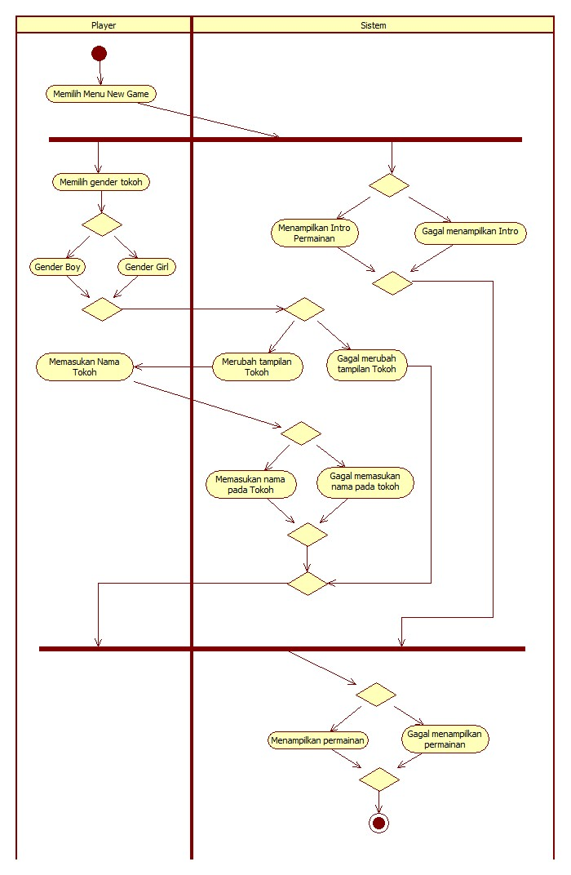

### Activity Diagram Continue Game

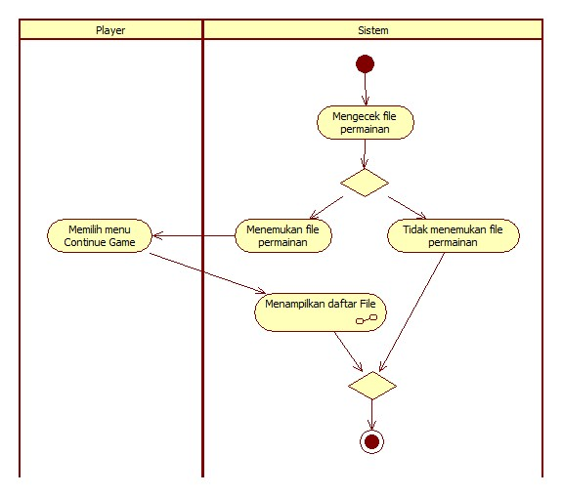

### Activity Diagram Select Slot File to Load Game

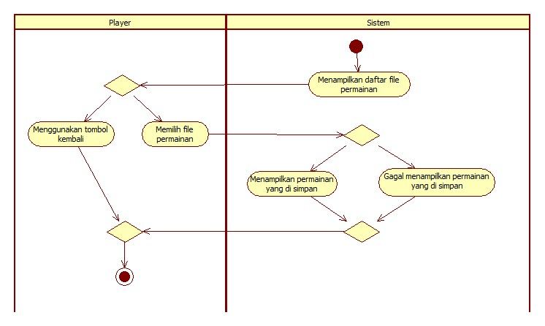

### Activity Diagram Exit Game

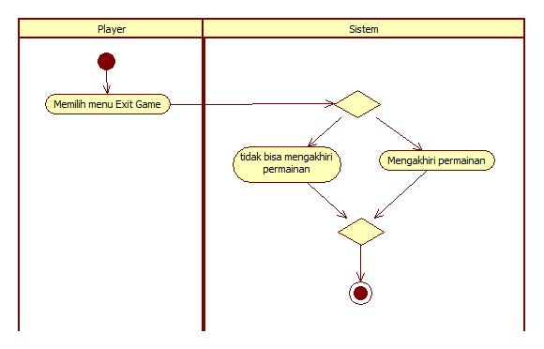

### Activity Diagram Fight an Enemy

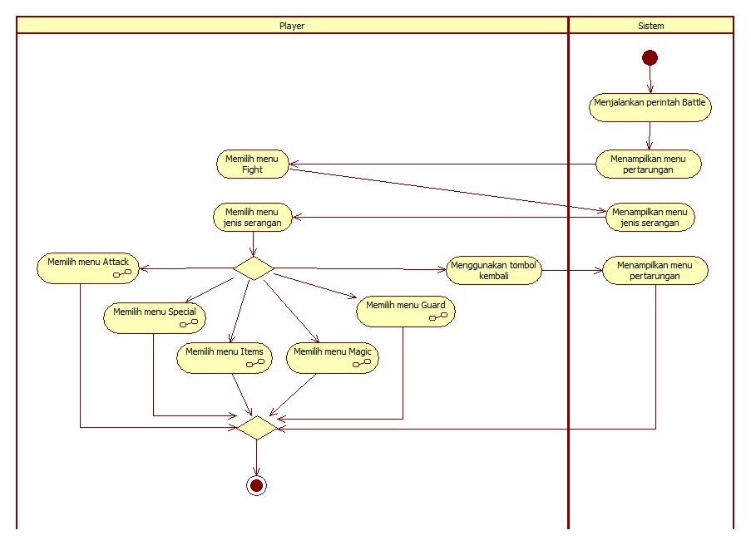

### Activity Diagram Attack on Enemy

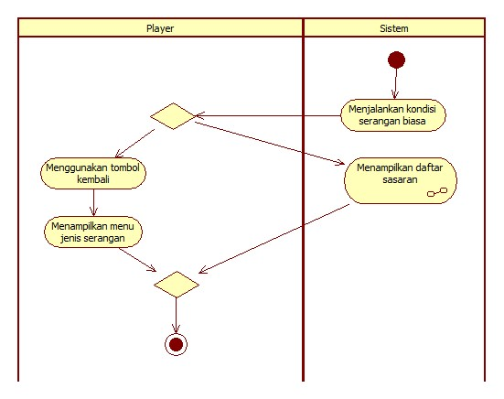

### Activity Diagram Use Special Attack on Enemy

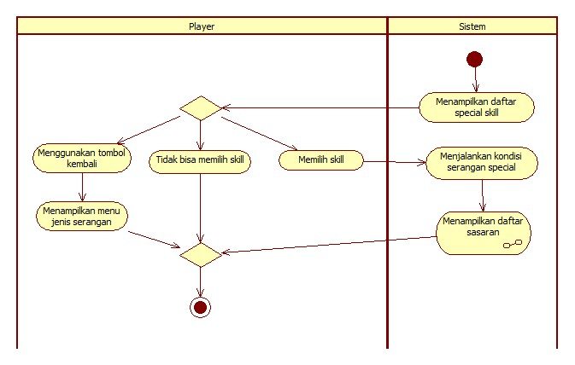

### Activity Diagram Guarding From Attack Enemy

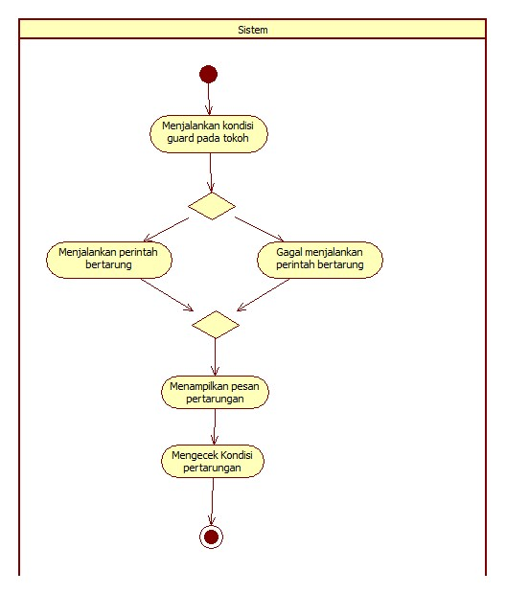

### Activity Diagram Use Magic Attak on Enemy

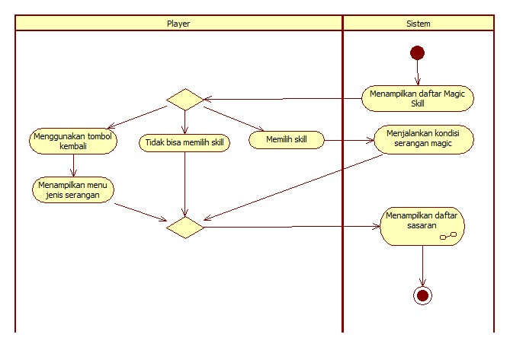

### Activity Diagram Use Items on Character/Enemy

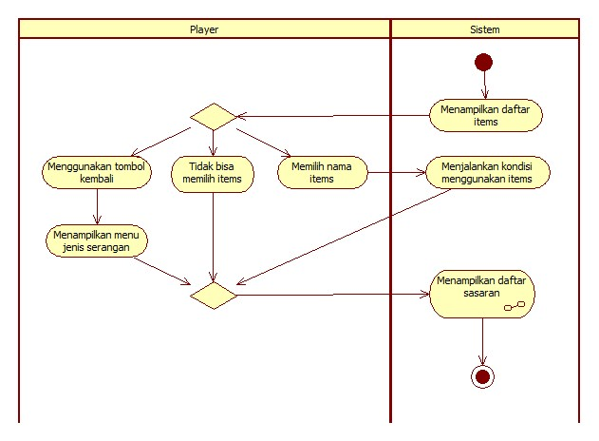

### Activity Diagram Select Target

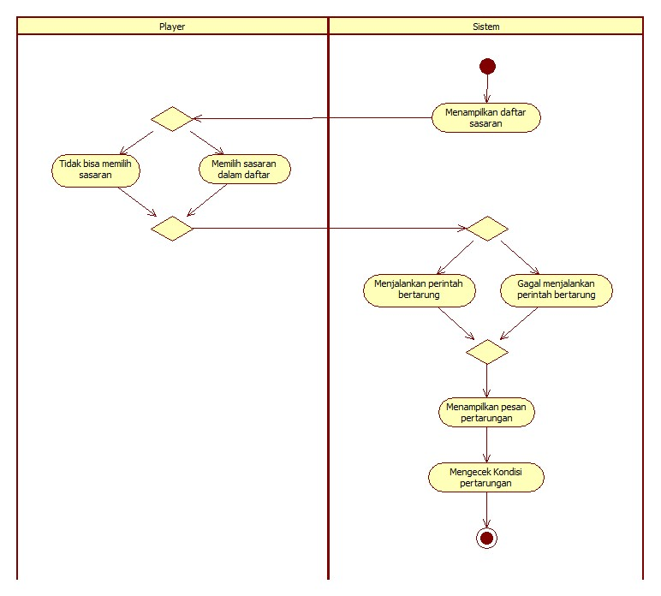

### Activity Diagram Escape from Battle

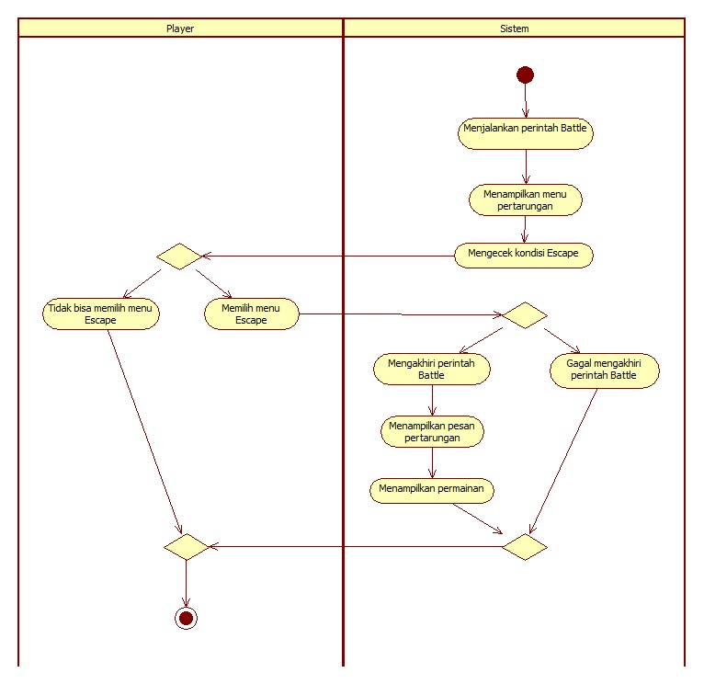

### Activity Diagram Paused Game

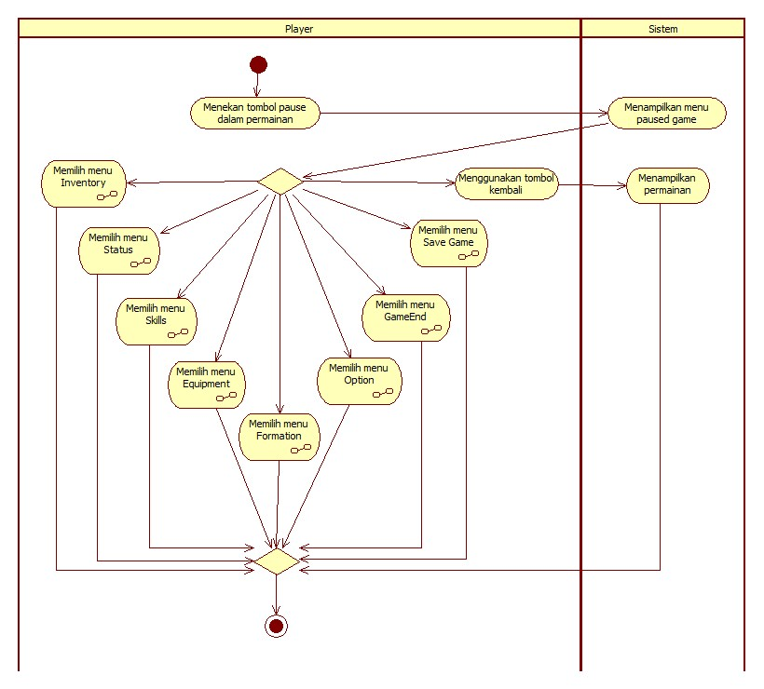

### Activity Diagram Inventory Player

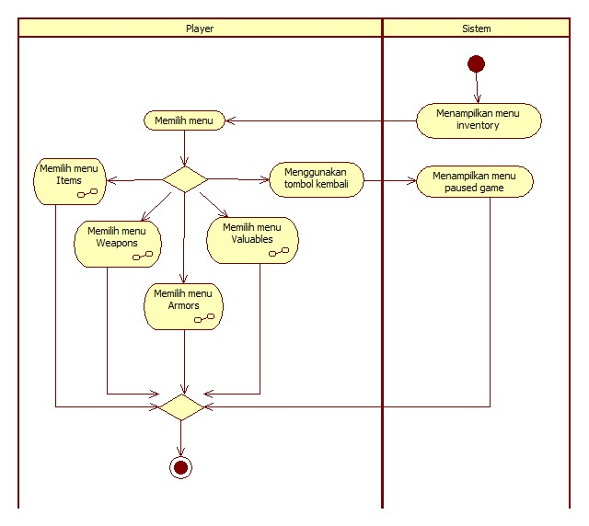

### Activity Diagram List of Items

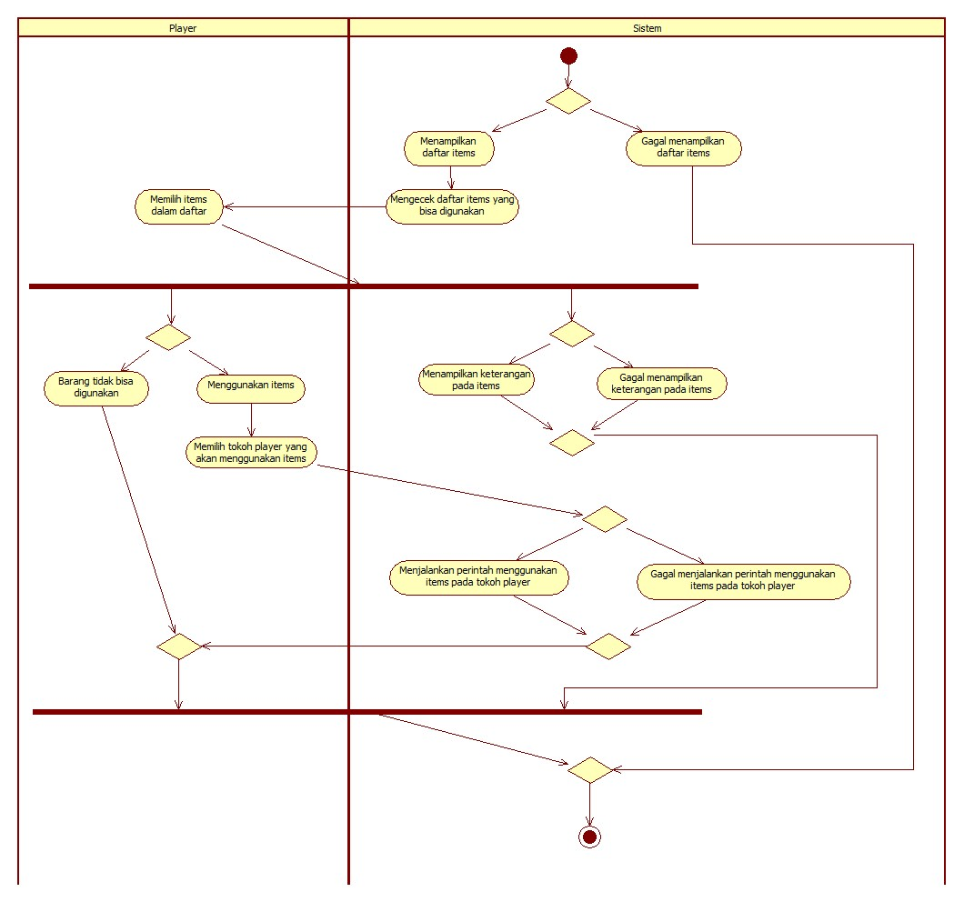

### Activity Diagram List of Weapon

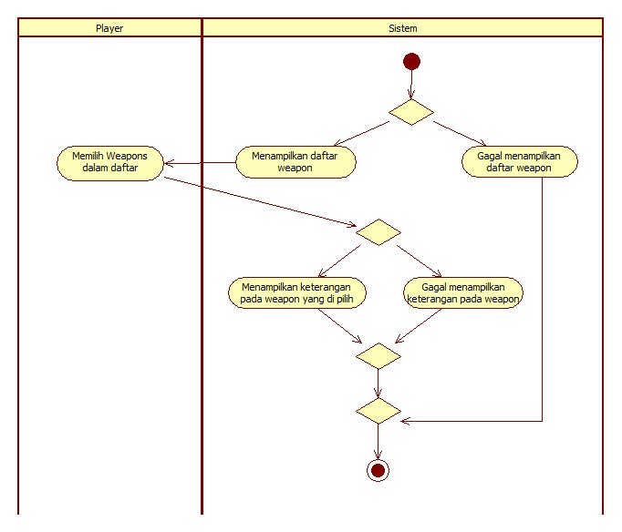

### Activity Diagram List of Armor

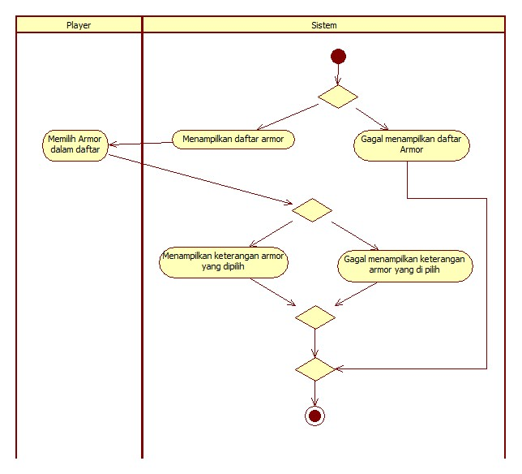

### Activity Diagram List of Valuables Items

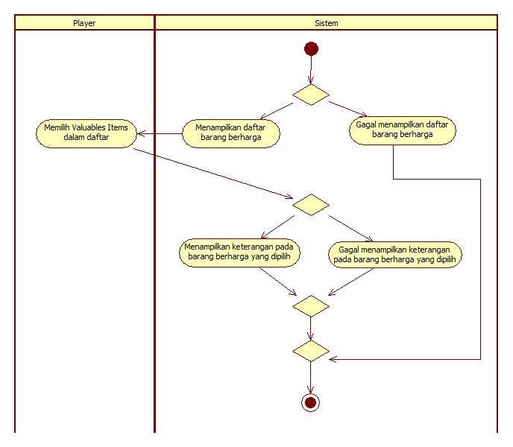

### Activity Diagram Options on Game

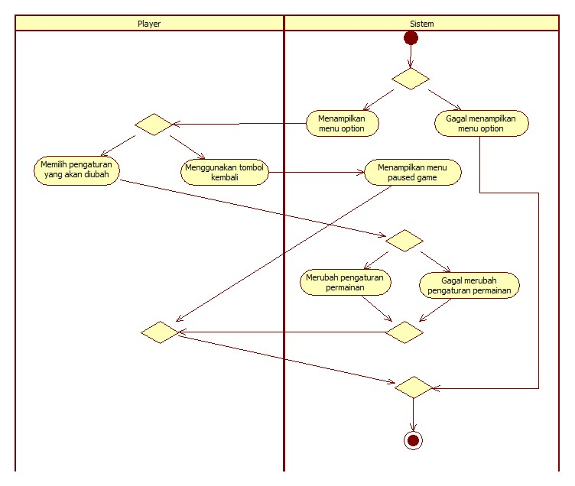

### Activity Diagram Skills On Players

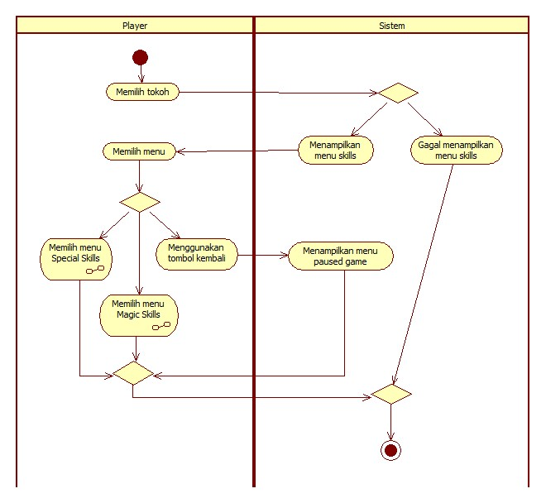

### Activity Diagram Special Skills on Players

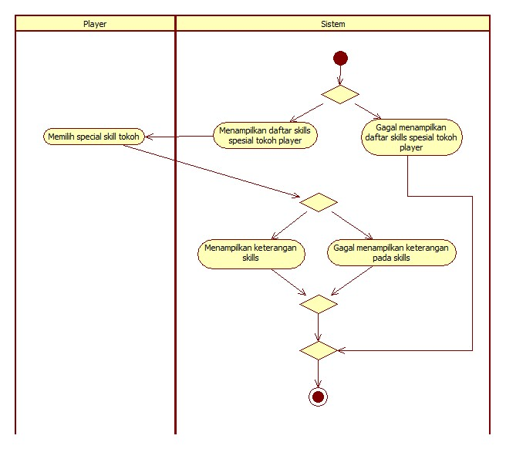

### Activity Diagram Magic Skills on Players

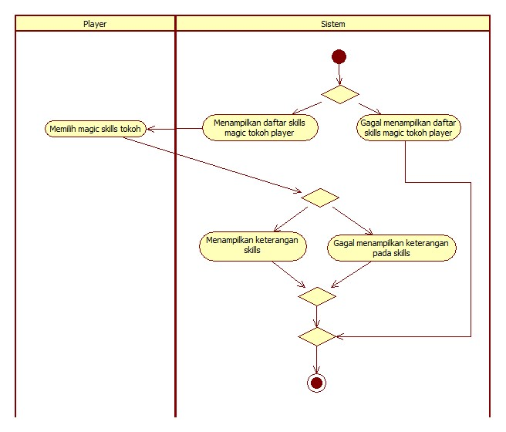

### Activity Diagram Status Players

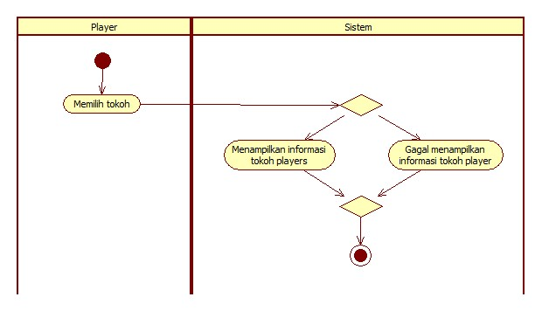

### Activity Diagram Equipment On Players

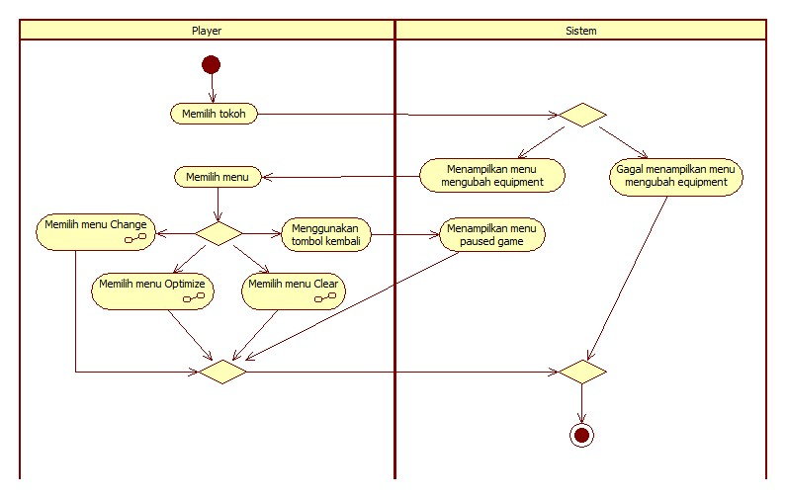

### Activity Diagram Change Equipment Players

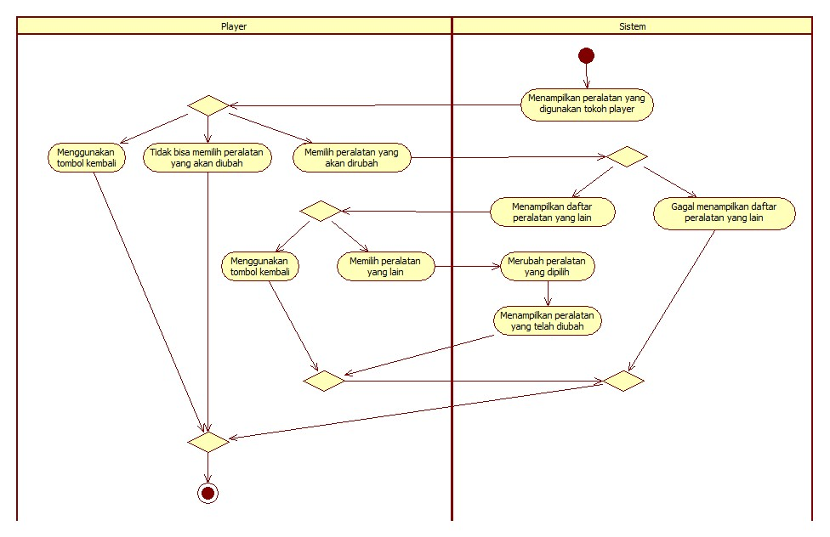

### Activity Diagram Optimize Equipment Players

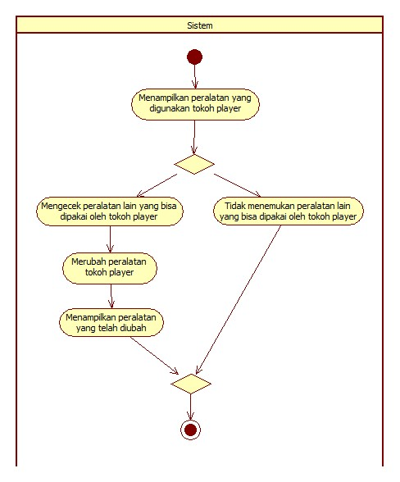

### Activity Diagram Clear Equipment Players

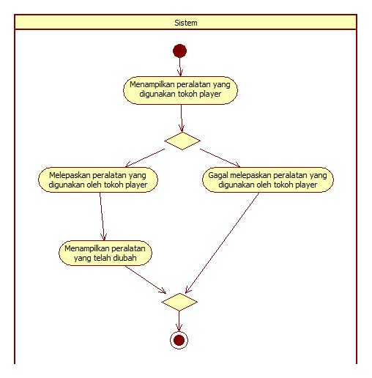

### Activity Diagram Formation Players

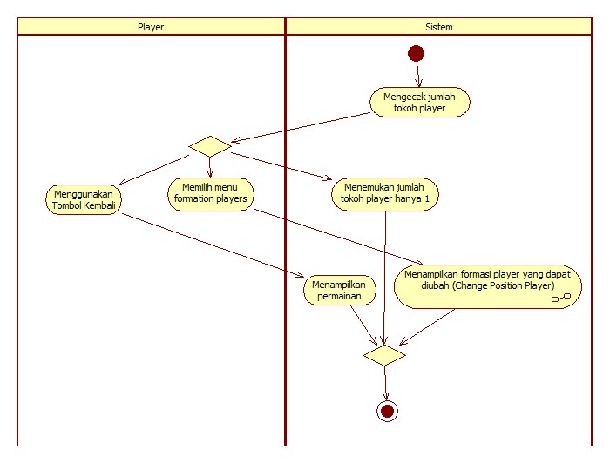

### Activity Diagram Change Position Players

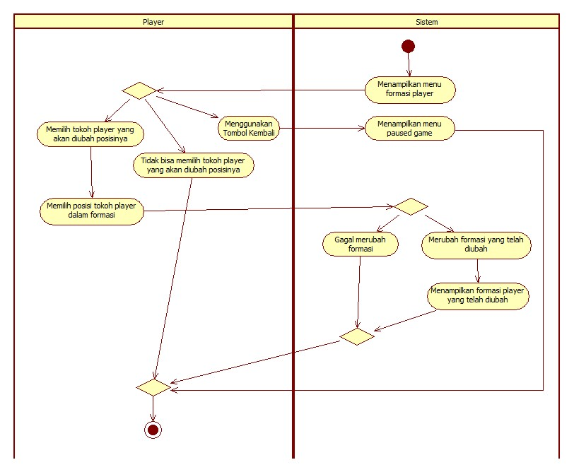

### Activity Diagram Save Game

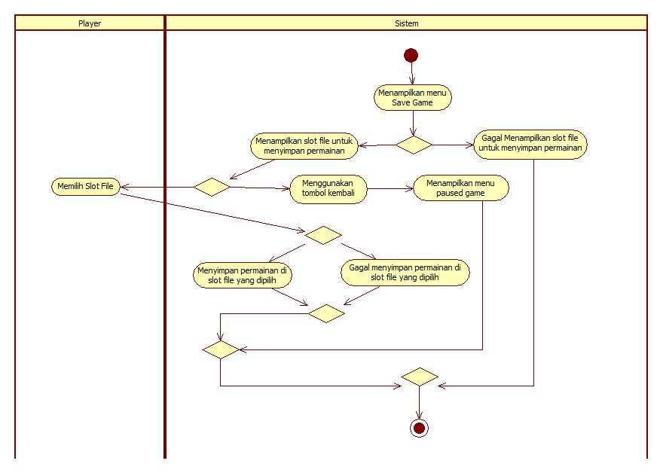

### Activity Diagram Game End

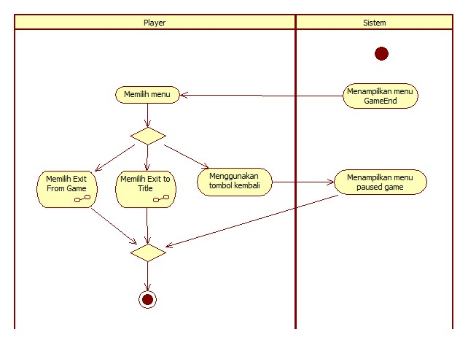

### Activity Diagram Exit from Game

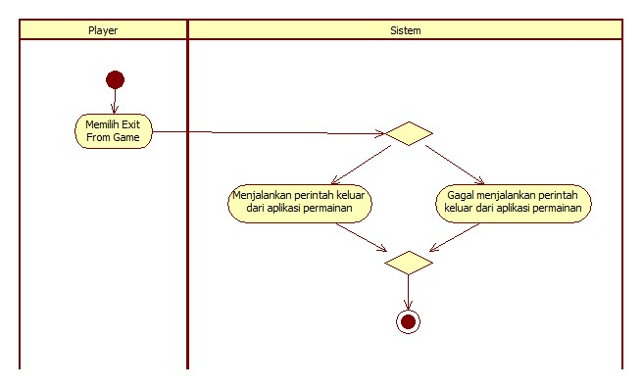

### Activity Diagram Exit to Titlescreen

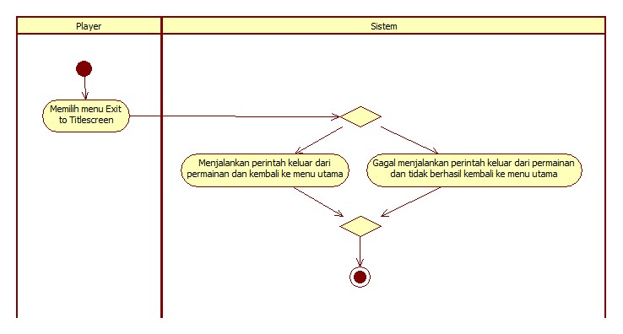

### Activity Diagram Shop

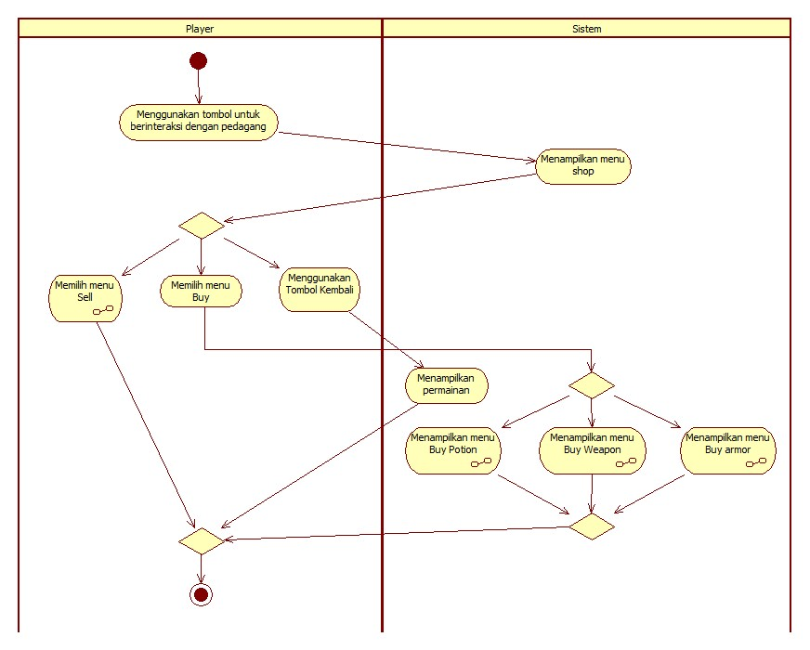

### Activity Diagram Sell

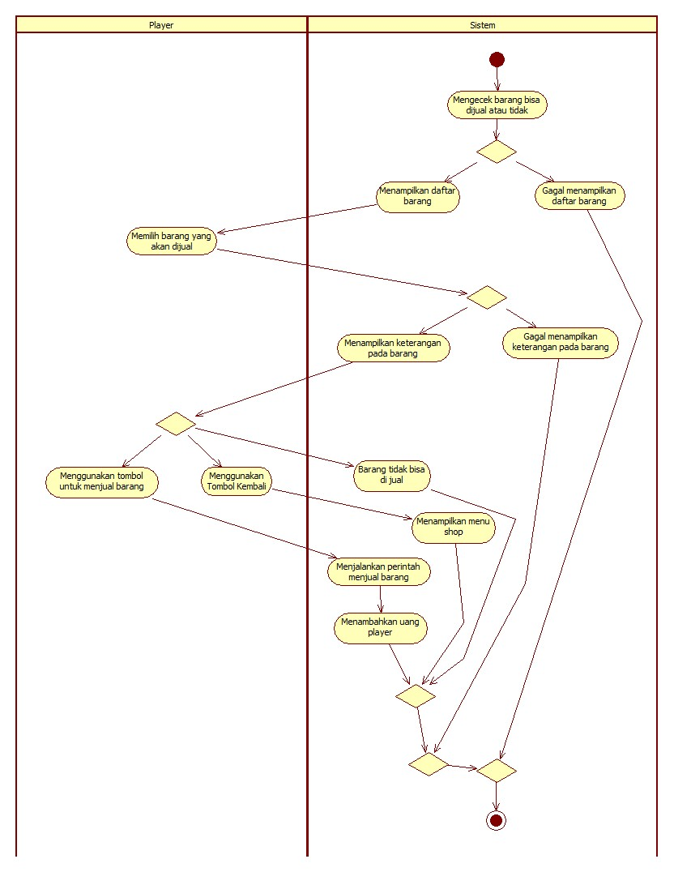

### Activity Diagram Buy Weapon

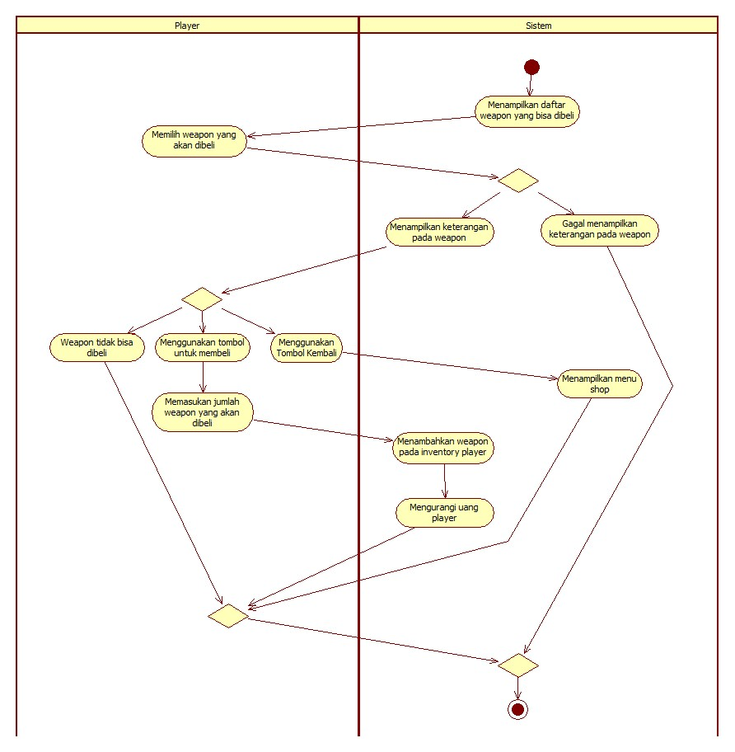

### Activity Diagram Buy Armor

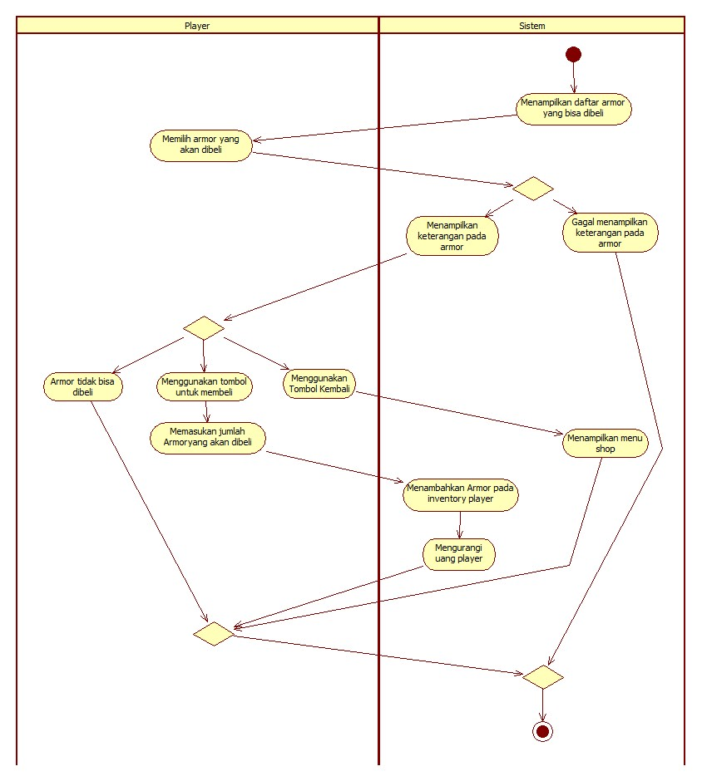

### Activity Diagram Buy Potion

