**Amazon code:**

**HTML**

<!DOCTYPE html>

<html lang="en">

<head>

    <meta charset="UTF-8">

    <meta name="viewport" content="width=device-width, initial-scale=1.0">

    <title>Document</title>\

    <link rel="stylesheet" href="style1.css">

</head>

<body>

    <center><img src="1.jpg" alt="amazon" width="500" height="200">

    </center>

    <div class="example1">

        <form>

        <h1 style="font-weight: 500;">Sign in</h1>

        <p><b>Email or mobile phone number</b></p>

        <input type="text">

        <br>

        <br>

        <center>

        <button>Continue</button>

        </center>

        <p>By continuing,you agree to Amazon's <a href="file:///C:/Team%203/CSS/boxmodel/index2.html?">Conditions of Use</a>

        and <a href="file:///C:/Team%203/CSS/boxmodel/index2.html?">Privacy Notice</a>.</p>

        <a href="">Need help?</a><br><hr>

        <p style="font-weight: 700;">Buying for work?</p>

        <a href="">Shop on Amazon Business</a>

        </form>

        </div>

    </body>

    </html>

**CSS:**

.example1{

background-color:white ;

color:black;

width:350px;

height: fit-content;

padding-top: 10px;

padding-left: 30px;

padding-right: 30px;

padding-bottom: 30px;

border:1px solid rgb(38, 36, 36);

border-radius: 8px;

margin: 10px auto;

font-family: Arial, Helvetica, sans-serif;

}

img{

width: 200px;

height: 100px;

}

.example1 button{

background-color: rgb(222, 215, 31);

border-radius: 3px;

border: 2px;

color: black;

padding: 5px 8px;

width: 100%;

}

.example1 form{

input[type="text"]{

width: 100%;

}

}

.example1 a{

text-decoration: none;

color: blue;

}

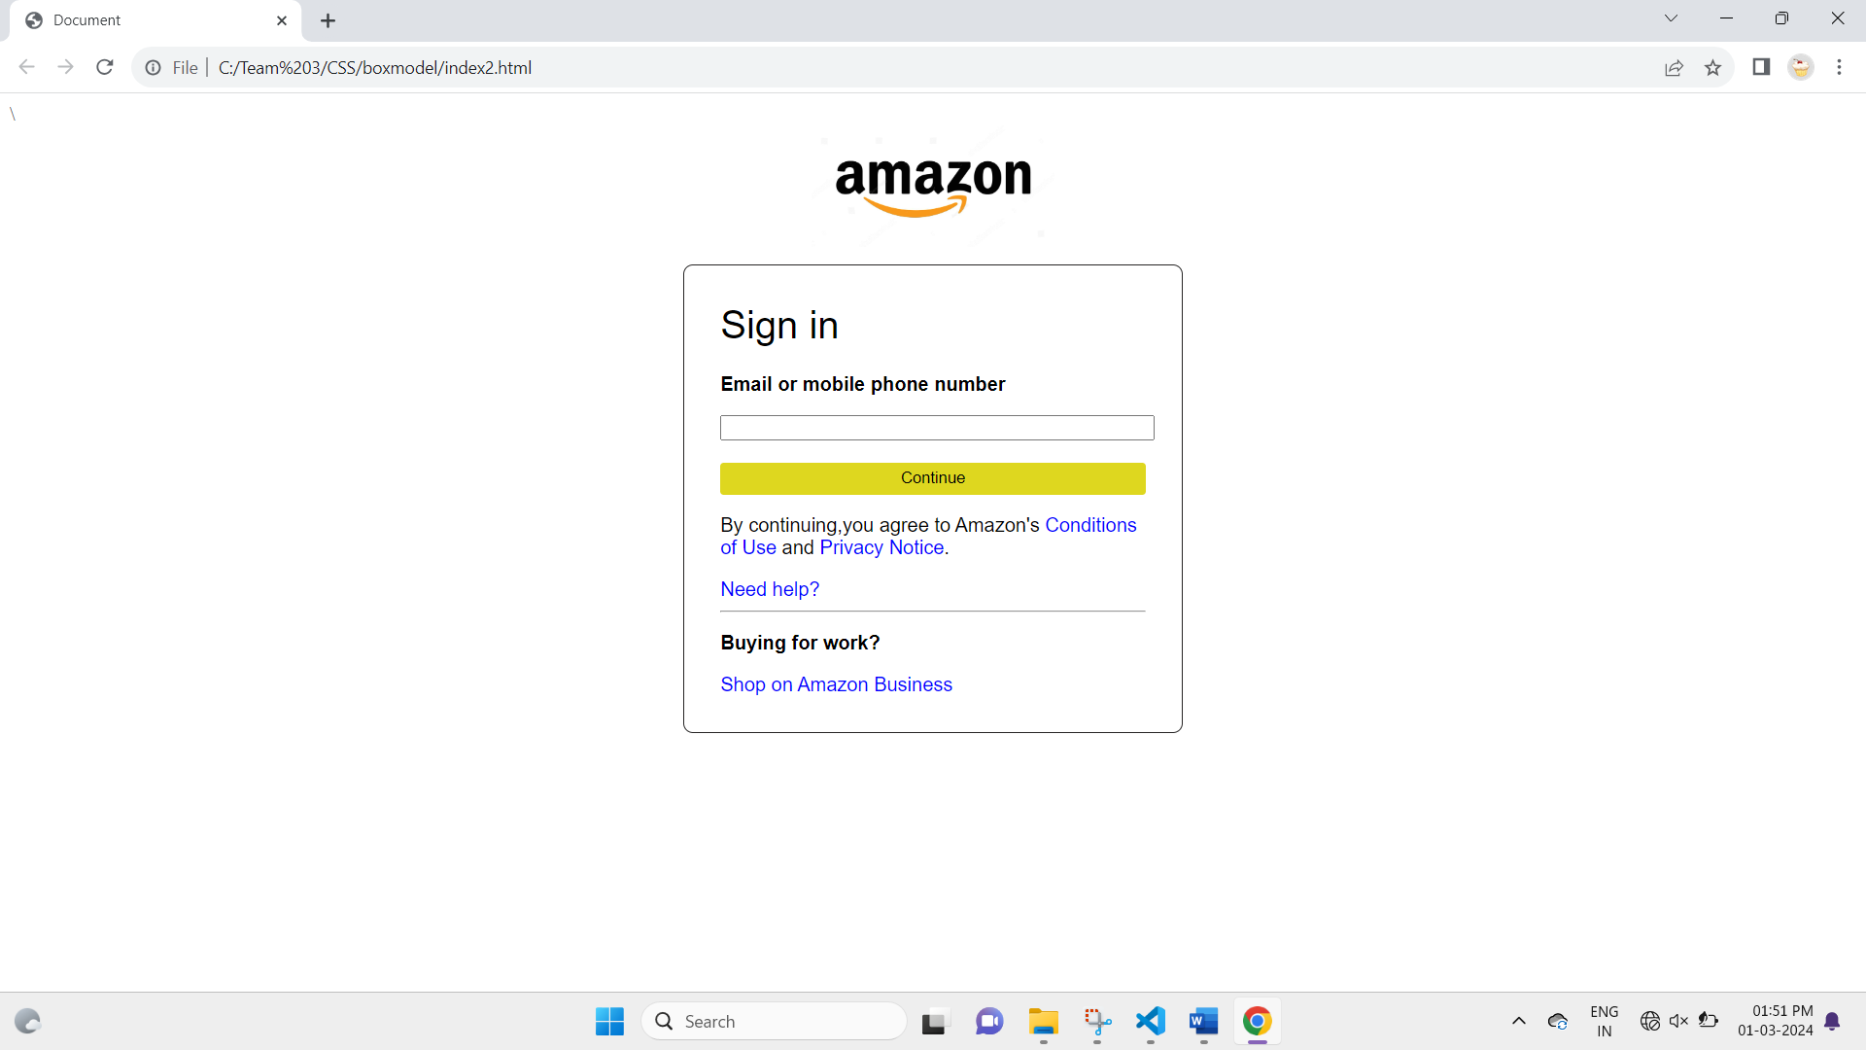

POSITIONS

HTML:

<!DOCTYPE html>

<html lang="en">

<head>

  <meta charset="UTF-8">

  <meta http-equiv="X-UA-Compatible" content="IE=edge">

  <meta name="viewport" content="width=device-width, initial-scale=1.0">

  <title>Photo Arena</title>

  <link rel="stylesheet" href="style2.css">

  <!-- Google Fonts -->

  <link rel="preconnect" href="https://fonts.googleapis.com">

  <link rel="preconnect" href="https://fonts.gstatic.com" crossorigin>

  <link href="https://fonts.googleapis.com/css2?family=Baloo+2:wght@700&display=swap" rel="stylesheet">

</head>

<body>

  <div class="container">

    <!-- Navigation Bar -->

    <nav>

      <div class="logo">

        <h1> Photo Arena </h1>

      </div>

      <div class="menu">

        <a href=""> Home </a>

        <a href="#"> Services </a>

        <a href="#"> Courses </a>

        <a href="#"> Gallery </a>

        <a href="#"> About Us </a>

      </div>

    </nav>

    <main>

      <section>

        <h3> World of Images </h3>

        <h1><span class="nameslideshow"></span> Photography </h1>

        <p> Come &#127939; Capture &#128248; Learn &#127891;</p>

        <a href="#" class="btn1"> Learn More </a>

        <a href="#" class="btn2"> Login </a>

      </section>

    </main>

  </div>

</body>

</html>

**CSS:**

* {

    margin: 0;

    padding: 0;

    box-sizing: border-box;

    font-family: 'Baloo 2', cursive;

  }

  .container {

    width: 100%;

    height: 100vh;

    background-image: linear-gradient(rgba(0, 0, 0, 0.3), rgba(0, 0, 0, 0.2)), url(https://i.pinimg.com/236x/a3/d2/b8/a3d2b85c29439c9fbcd724f1a41bc2ca.jpg);

    background-size: cover;

    background-repeat: no-repeat;

  }

  nav {

    width: 100%;

    height: 12vh;

    background-color: #00000052;

    color: #fff;

    display: flex;

    justify-content: space-between;

    align-items: center;

    text-transform: uppercase;

  }

  nav .logo {

    width: 25%;

    text-align: center;

    font-size: 18px;

    text-shadow: 3px 4px 2px black;

  }

  nav .menu {

    width: 40%;

    display: flex;

    justify-content: space-around;

  }

  nav .menu a {

    text-decoration: none;

    color: #fff;

    font-weight: bold;

    margin-bottom: 2px;

    position: relative;

  }

  nav .menu a:hover {

    color: #00fc13;

  }

  nav .menu a::before {

    content: "";

    position: absolute;

    bottom: 0;

    left: 0;

    width: 0%;

    height: 2px;

    background-color: #b200fc;

    transition: all 0.3s linear;

  }

  nav .menu a:hover::before {

    width: 100%;

  }

  nav .menu a:first-child {

    color: #00fc13;

  }

  main {

    width: 100%;

    height: 85vh;

    display: flex;

    justify-content: center;

    align-items: center;

    text-align: center;

    color: #fff;

  }

  section h3 {

    font-size: 33px;

    font-weight: 400;

    text-transform: uppercase;

    letter-spacing: 2px;

    text-shadow: 1px 1px 1px #000;

  }

  section h1 {

    margin: 14px 0px 18px 0;

    font-size: 45px;

    font-weight: 500;

    text-transform: uppercase;

    text-shadow: 1px 1px 2px #000;

  }

  section p {

    font-size: 20px;

    text-shadow: 1px 1px 1px #000;

    margin-bottom: 45px;

  }

  section a {

    padding: 9px 30px;

    border-radius: 4px;

    outline: none;

    text-decoration: none;

    font-size: 14px;

    font-weight: 600;

    margin-right: 14px;

  }

  section .btn1 {

    background-color: #fff;

    color: black;

  }

  section .btn1:hover {

    background-color: #000;

    color: #fff;

    transition: all 0.3s linear;

  }

  section .btn2 {

    background-color: #00fc13;

    color: black;

  }

  section .btn2:hover {

    background-color: #b200fc;

    color: #fff;

    transition: all 0.3s linear;

  }

  .nameslideshow:after {

    color: #00fc13;

    animation: changename 7s infinite linear;

    content: '';

  }

  @keyframes changename{

    0% { content: "Portrait"}

    25% { content: "Landscape"}

    50% { content: "Editorial"}

    75% { content: "Event"}

    100% { content: "Nature"}

  }

