Distributed Database Design

- Design problem

- Design strategies (top-down, bottom-up)

- Fragmentation

- Allocation and replication of fragments, optimality, heuristics

Design Problem

- Design problem of distributed systems: Making decisions about the placement of data and programs across the sites of a computer network as well as possibly designing the network itself.

- In DDBMS, the distribution of applications involves

– Distribution of the DDBMS software

– Distribution of applications that run on the database

- Distribution of applications will not be considered in the following; instead the distribution

of data is studied.

DDBS Design Strategies

- Top-down approach

– Designing systems from scratch

– Homogeneous systems

- Bottom-up approach

– The databases already exist at a number of sites

– The databases should be connected to solve common tasks

DDBS Design Strategies . . .
- Top-down design strategy

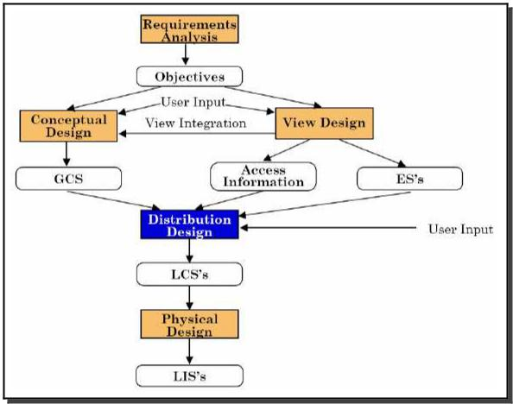

DDBS Design Strategies . . .

- The activity begins with a requirements analysis that defines both the data and processing needs of all potential database users”
- objectives are defined with respect to performance, reliability and availability,
economics, and expandability (flexibility).
- The requirements document is input to two parallel activities: view design and
conceptual design.
  - The view design activity deals with defining the interfaces for end users.
  - The conceptual design, on the other hand, is the process by which the enterprise
is examined to determine entity types and relationships among these entities.
One can possibly divide this process into two related activity groups
entity analysis and functional analysis.
- Entity analysis is concerned with determining the entities, their attributes, and the relationships among them.
- Functional analysis, on the other hand, is concerned with determining the fundamental functions with which the modeled enterprise is involved.
- There is a relationship between the conceptual design and the view design.
The conceptual design can be interpreted as being an integration of user views.
Even though this view integration activity is very important, the conceptual model
should support not only the existing applications, but also future applications.
View integration should be used to ensure that entity and relationship requirements for all
the views are covered in the conceptual schema.

- The global conceptual schema (GCS) and access pattern information collected
as a result of view design are inputs to the distribution design step. The objective
at this stage, is to design the local conceptual schemas (LCSs) by distributing the entities over the sites of the distributed system.
- Rather than distributing relations, it is quite common to divide them into subrelations,
called fragments, which are then distributed. Thus, the distribution design
activity consists of two steps: fragmentation and allocation.
- The last step in the design process is the physical design, which maps the local
conceptual schemas to the physical storage devices available at the corresponding
sites. The inputs to this process are the local conceptual schema and the access pattern
information about the fragments in them.

- Distribution design is the central part of the design in DDBSs (the other tasks are similar to traditional databases)

– Objective : Design the LCSs by distributing the entities (relations) over the sites

– Two main aspects have to be designed carefully ∗ Fragmentation

      - Relation may be divided into a number of sub-relations, which are distributed ∗ Allocation and replication
      - Each fragment is stored at site with ”optimal” distribution

      - Copy of fragment may be maintained at several sites

- Distribution design issues

– Why fragment at all?

– How to fragment?

– How much to fragment?

– How to test correctness?

– How to allocate?

Fragmentation

•

•

What is a reasonable unit of distribution? Relation or fragment of relation?

Relations as unit of distribution:

– If the relation is not replicated, we get a high volume of remote data accesses.

– If the relation is replicated, we get unnecessary replications, which cause problems in executing updates and waste disk space

– Might be an Ok solution, if queries need all the data in the relation and data stays at the only sites that uses the data

- Fragments of relations as unit of distribution:

– Application views are usually subsets of relations

– Thus, locality of accesses of applications is defined on subsets of relations

– Permits a number of transactions to execute concurrently, since they will access different portions of a relation

– Parallel execution of a single query (intra-query concurrency)

– However, semantic data control (especially integrity enforcement) is more difficult

⇒ Fragments of relations are (usually) the appropriate unit of distribution.

Fragmentation . . .

- Fragmentation aims to improve:

– Reliability

– Performance

– Balanced storage capacity and costs

– Communication costs

– Security

- The following information is used to decide fragmentation:
The logical organization of the database, the location of the applications, the
access characteristics of the applications to the database, and the properties of the
computer systems at each site
The information needed for distribution design can be divided into four categories:
database information, application information, communication network information,
and computer system information.
The latter two categories are completely quantitative in nature and are used in allocation models rather than in fragmentation algorithms.

– Quantitative information: frequency of queries, site, where query is run, selectivity of the queries, etc.

– Qualitative information: types of access of data, read/write, etc.

Fragmentation . . .

- Types of Fragmentation

– Horizontal: partitions a relation along its tuples

– Vertical: partitions a relation along its attributes

– Mixed/hybrid: a combination of horizontal and vertical fragmentation


(a) Horizontal Fragmentation
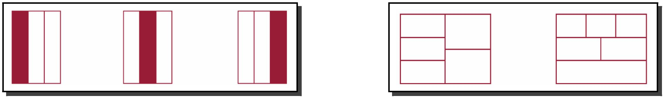

(b) Vertical Fragmentation (c) Mixed Fragmentation

Fragmentation . . .

- Exampe
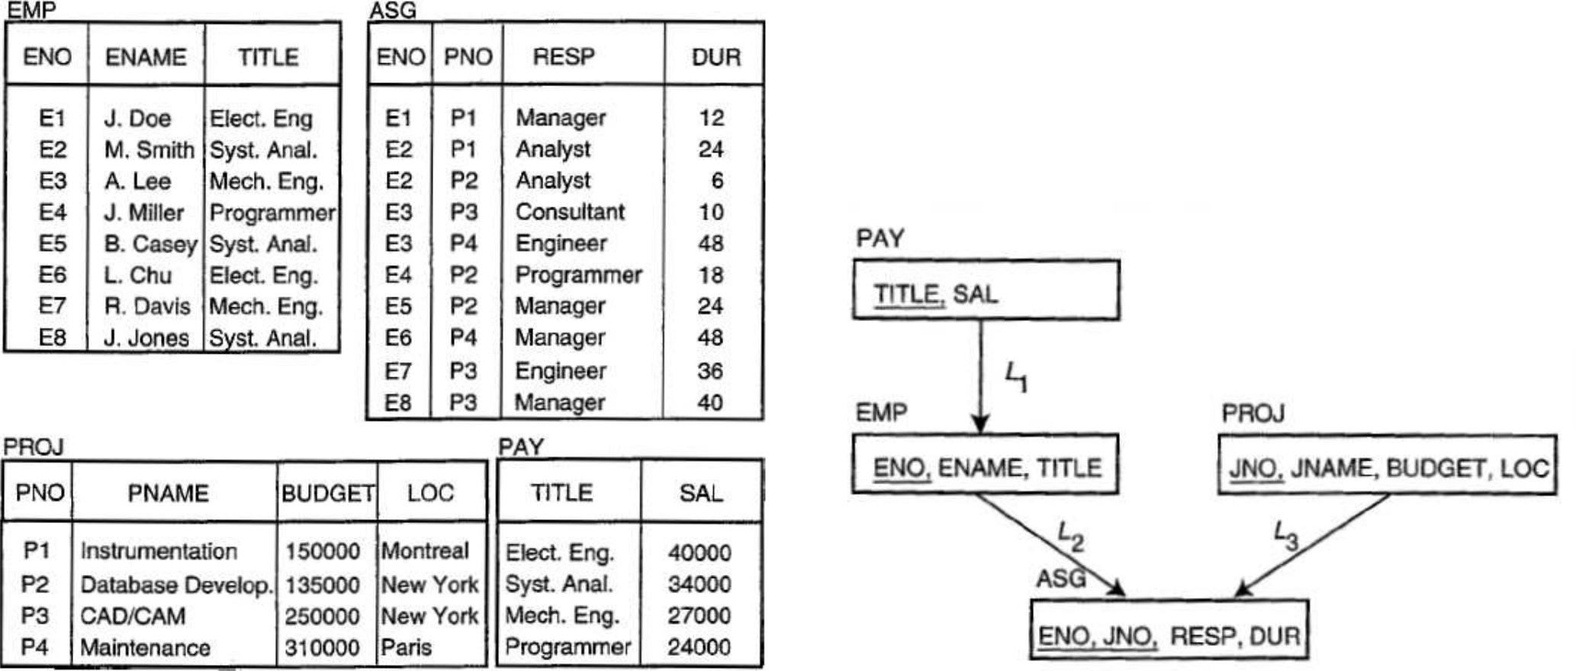

Data E-R Diagram

Fragmentation . . .

- Example (contd.): Horizontal fragmentation of PROJ relation

– PROJ1: projects with budgets less than 200, 000

– PROJ2: projects with budgets greater than or equal to 200, 000
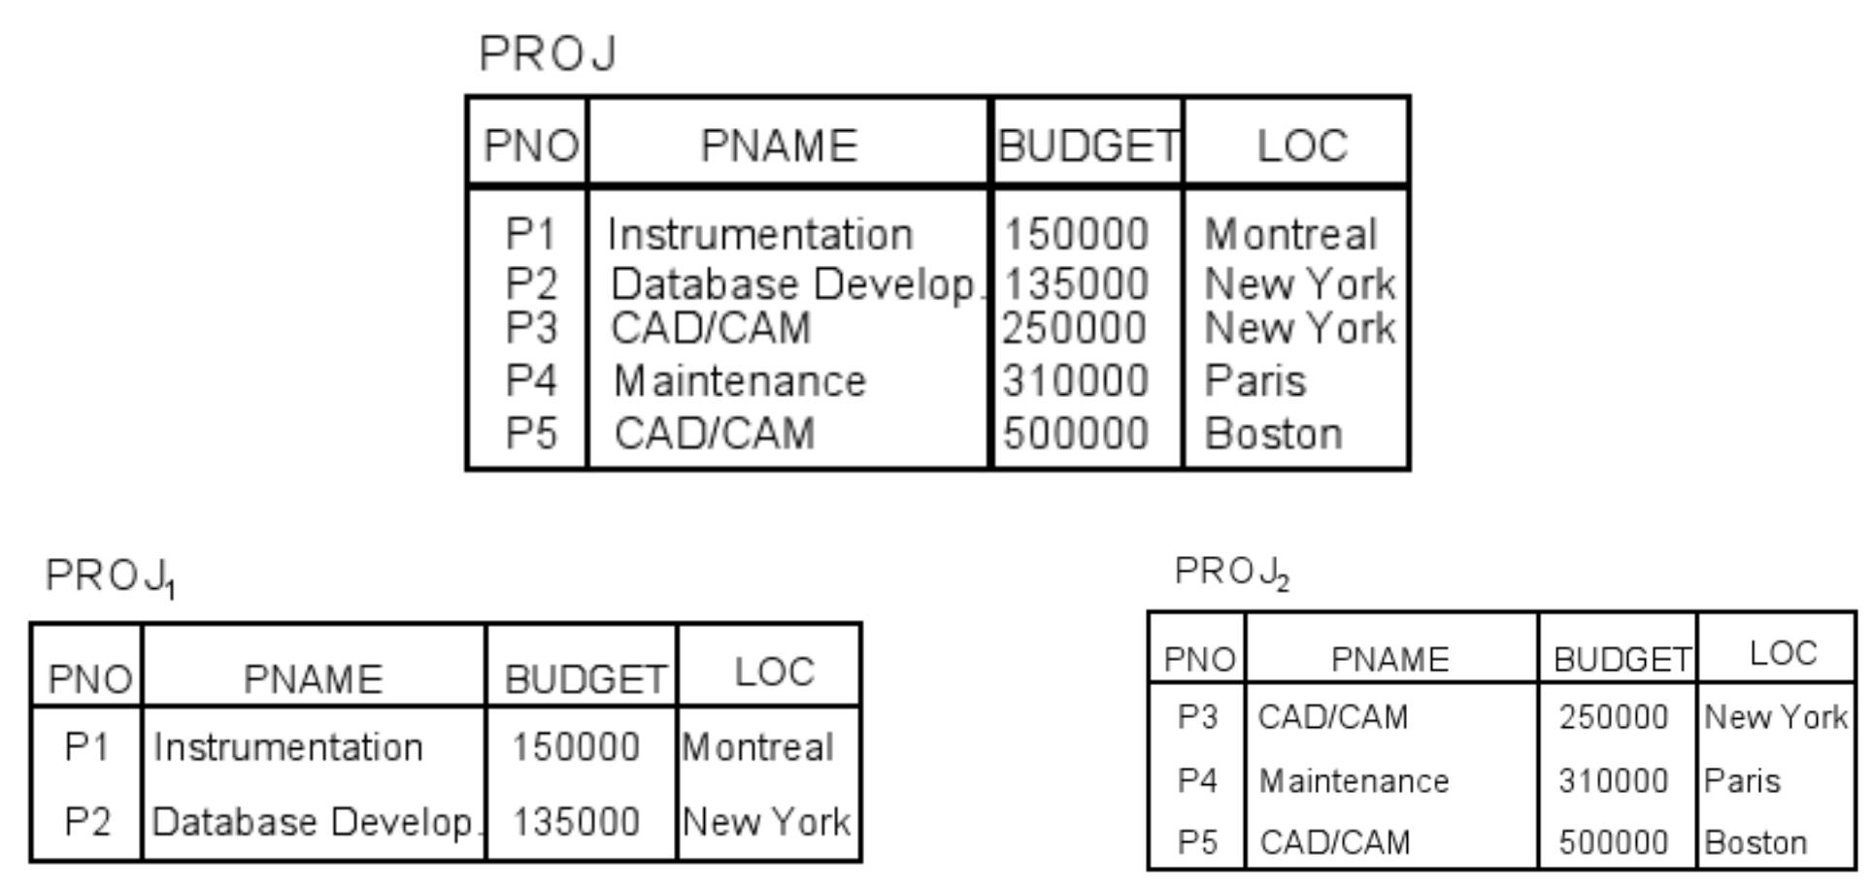

Fragmentation . . .

- Example (contd.): Vertical fragmentation of PROJ relation

– PROJ1: information about project budgets

– PROJ2: information about project names and locations
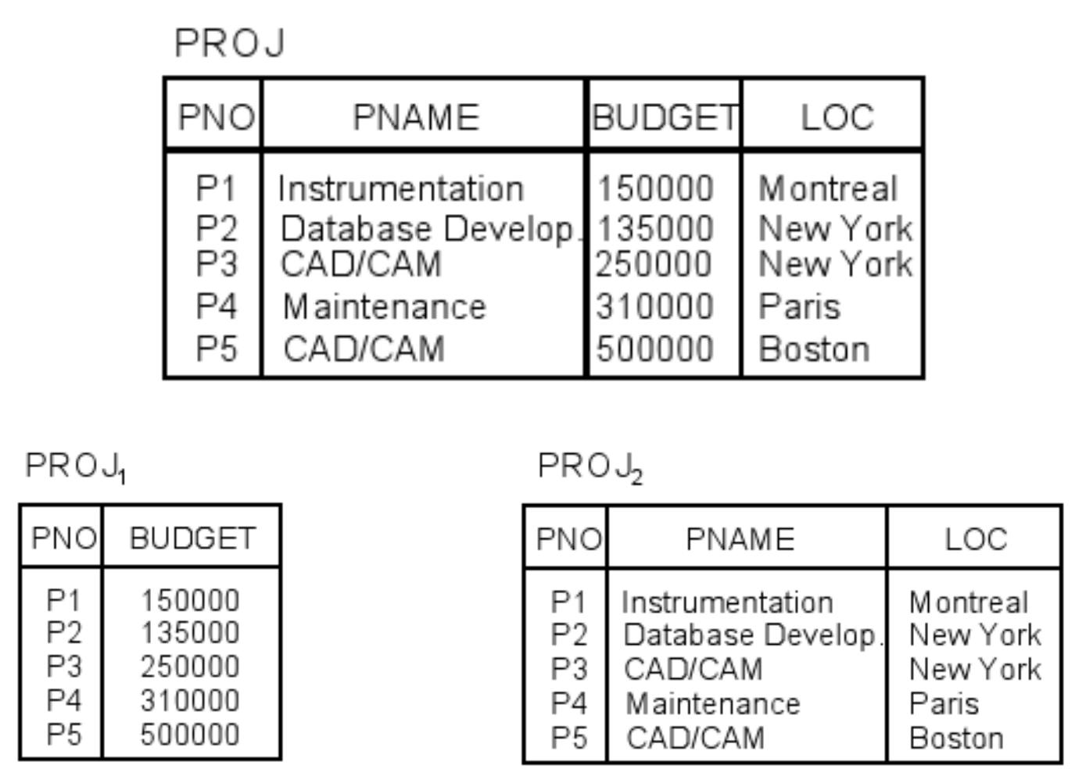

Correctness Rules of Fragmentation

- Completeness

– Decomposition of relation R into fragments R₁, R₂, . . . , R_{n} is complete if each data item in R can also be found in some R_{i}.

- Reconstruction

– If relation R is decomposed into fragments R₁, R₂, . . . , R_{n}, then there should exist some relational operator ∇ that reconstructs R from its fragments, i.e.,
R = R₁∇ . . . ∇R_{n}

∗ Union to combine horizontal fragments ∗ Join to combine vertical fragments

- Disjointness

– If relation R is decomposed into fragments R₁, R₂, . . . , R_{n} and data item d_{i} appears in fragment R_{j} , then d_{i} should not appear in any other fragment R_{k} (exception: primary key attribute for vertical fragmentation)

∗ For horizontal fragmentation, data item is a tuple
∗ For vertical fragmentation, data item is an attribute

Degree of Fragmentation

The extent to which the database should be fragmented is an important decision
that affects the performance of query execution. The degree of fragmentation goes from
one extreme,that is, not to fragment at all, to the other extreme, to fragment to the level of individual tuples (in the case of horizontal fragmentation) or to the level of individual
attributes (in the case of vertical fragmentation).
Such a level can only be defined with respect to the applications that will run on the database.

Allocation Alternatives
decision on the allocation of the fragments to various sites on the network.
When data are allocated, it may either be replicated or maintained as a single copy.
The reasons for replication are reliability and efficiency of read-only queries.
If there are multiple copies of a data item, there is a good chance that some copy of the data will be accessible somewhere even when system failures occur. Furthermore, read-only queries that access the same data items can be executed in parallel since copies exist on multiple sites. On the other
hand, the execution of update queries cause trouble since the system has to ensure
that all the copies of the data are updated properly. Hence the decision regarding

replication is a trade-off that depends on the ratio of the read-only queries to the update queries.
A non-replicated database (commonly called a partitioned database) contains
fragments that are allocated to sites, and there is only one copy of any fragment on
the network. In case of replication, either the database exists in its entirety at each
site (fully replicated database), or fragments are distributed to the sites in such a way
that copies of a fragment may reside in multiple sites (partially replicated database).

Horizontal Fragmentation

- Intuition behind horizontal fragmentation

– Every site should hold all information that is used to query at the site

– The information at the site should be fragmented so the queries of the site run faster
- There are two versions of horizontal partitioning: primary and derived.
- Primary horizontal fragmentation of a relation is performed using predicates that are defined on that relation.
- Derived horizontal fragmentation, on the other hand, is the partitioning of a relation that
results from predicates being defined on another relation.
- Information Requirements of Horizontal Fragmentation
- Database Information:
The database information concerns the global conceptual schema.
In this context it is important to note how the database relations are connected to one another.
- The direction of the link shows a one-to-many relationship.
For example, for each title there are multiple employees with that title;
thus there is a link between the PAY and EMP relations.
- More commonly used terms, within the relational framework, are source relation for owner and target relation for member. Let us define two functions: owner and member, both of which provide mappings from the set of links to the set of relations.
- owner(L1) = PAY
- member(L1) = EMP
- The quantitative information required about the database is the cardinality of each
relation R, denoted card(R).

Application Information:
- Both qualitative and quantitative information is required about applications. The qualitative information guides the fragmentation activity, whereas the quantitative information is incorporated primarily into the allocation models.
- The fundamental qualitative information consists of the predicates used in user
queries. If it is not possible to analyze all of the user applications to determine these
predicates, one should at least investigate the most “important” ones. It has been suggested that as a rule of thumb, the most active 20% of user queries account for 80% of the total data accesses. This “80/20 rule” may be used as
a guideline in carrying out this analysis.

- Horizontal fragmentation is defined as selection operation , σ_{p}(R)

- user queries quite often include more complicated predicates, which are Boolean combinations of
simple predicates. One combination that we are particularly interested in, called a
minterm predicate, is the conjunction of simple predicates.

Horizontal Fragmentation . . .

- Computing horizontal fragmentation (idea)
Interms of quantitative information

– Compute the Access frequency of the individual queries of the site q₁, . . . , q_{Q}
If Q = {q1; q2; ….. ; qq} is a set of user queries, acc(qi) indicates the access
frequency of query qi in a given period.

– Rewrite the queries of the site in the conjunctive normal form (disjunction of conjunctions); the conjunctions are called minterms.

– Compute the selectivity of the minterms
Minterm selectivity: number of tuples of the relation that would be accessed
by a user query specified according to a given minterm predicate. For example,
the selectivity of m1 of Example 3.6 is 0 since there are no tuples in PAY that
satisfy the minterm predicate. The selectivity of m2, on the other hand, is 1 since one of the four tuples in PAY satisfy m2. We denote the selectivity of a
minterm mi as sel(mi).

– Find the minimal and complete set of minterms (predicates)

∗ The set of predicates is complete if and only if any two tuples in the same fragment are referenced with the same probability by any application

∗ The set of predicates is minimal if and only if there is at least one query that accesses the fragment

– There is an algorithm how to find these fragments algorithmic ally (the algorithm

COM_MIN and PHORIZONTAL

Primary Horizontal Fragmentation

- Example:
^{PROJ 1= σ}BUDGET<200000^{(PROJ} ⁾
^{PROJ 2= σ}BUDGET≥200000^{(PROJ} ⁾

Horizontal Fragmentation . . .

- Example: Fragmentation of the PROJ relation

– Consider the following query: Find the name and budget of projects given their PNO.

– The query is issued at all three sites

– Fragmentation based on LOC, using the set of predicates/minterms
{LOC =′ Montreal′, LOC =′ NewYork′, LOC =′ Paris′}

PROJ1 = σLOC=′ Montreal′ (PROJ )

PNO PNAME BUDGET LOC

P1 Instrumentation 150000 Montreal

P ROJ3 = σLOC=′ P aris′ (P ROJ )

PROJ2 = σLOC=′ NewYork′ (PROJ )
PNO | PNAME | BUDGET | LOC
P2 | Database Develop. | 135000 | New York
P3 | CAD/CAM | 250000 | New York

PNO PNAME BUDGET LOC

P4 Maintenance 310000 Paris

- If access is only according to the location, the above set of predicates is complete

– i.e., each tuple of each fragment PROJ_{i} has the same probability of being accessed

- If there is a second query/application to access only those project tuples where the budget is less than $200000, the set of predicates is not complete.

– P2 in PROJ₂ has higher probability to be accessed

Horizontal Fragmentation . . .

- Example (contd.):

– Add BUDGET ≤ 200000 and BUDGET > 200000 to the set of predicates to make it complete.

⇒ {LOC =′ Montreal′, LOC =′ N ewYork′, LOC =′ Paris′,
BUDGET ≥ 200000, BUDGET < 200000} is a complete set

– Minterms to fragment the relation are given as follows:

(LOC =′Montreal′) ∧ (BUDGET ≤ 200000)
(LOC =′Montreal′) ∧ (BUDGET > 200000)
(LOC =′ NewYork′) ∧ (BUDGET ≤ 200000)
(LOC =′ NewYork′) ∧ (BUDGET > 200000)
(LOC =′ Paris′) ∧ (BUDGET ≤ 200000)

(LOC =′ Paris′) ∧ (BUDGET > 200000)

Horizontal Fragmentation . . .

- Example (contd.): Now, PROJ₂ will be split in two fragments

PROJ1 = σLOC=′ Montreal′ (PROJ ) |  |  |  |  |  | PROJ2 = σLOC=′ N Y′∧BUDGET <200000(PROJ )
PNO | PNAME | BUDGET | LOC |  |  | PNO | PNAME |  | BUDGET |  | LOC
P1 | Instrumentation 150000 |  | Montreal |  |  | P2 | Database Develop. |  | 135000 | New York
PROJ3 = σLOC=′ Paris′ (PROJ ) |  |  |  |  |  | PROJ₂′ = σ_{LOC=}′ _{N Y}′_{∧BUDGET} _{≥200000}(PROJ )
PNO | PNAME | BUDGET LOC |  |  |  | PNO | PNAME | BUDGET LOC
P4 | Maintenance | 310000 Paris |  |  |  | P3 | CAD/CAM | 250000 | New York

– PROJ₁ and PROJ₂ would have been split in a similar way if tuples with budgets smaller and greater than 200.000 would be stored

Horizontal Fragmentation . . .

- In most cases intuition can be used to build horizontal partitions. Let {t₁, t₂, t₃},
{t₄, t₅}, and {t₂, t₃, t₄, t₅} be query results. Then tuples would be fragmented in the following way:

t₁ t₂ t₃ t₄ t₅

Vertical Fragmentation

- Objective of vertical fragmentation is to partition a relation into a set of smaller relations so that many of the applications will run on only one fragment.

- Vertical fragmentation of a relation R produces fragments R₁, R₂, . . . , each of which contains a subset of R's attributes.

- Vertical fragmentation is defined using the projection operation of the relational algebra:
^{Π}A₁,A₂,...,A_{n} ^{(R)}
- Example:

P ROJ₁ = Π_{P N O,BU DGET} (P ROJ )

^{P ROJ}2 = ΠP N O,P N AM E,LOC (^{P ROJ} )
- Vertical fragmentation has also been studied for (centralized) DBMS

– Smaller relations, and hence less page accesses

– e.g., MONET system

Vertical Fragmentation . . .

- Vertical fragmentation is inherently more complicated than horizontal fragmentation

– In horizontal partitioning: for n simple predicates, the number of possible minterms is 2^{n}; some of them can be ruled out by existing implications/constraints.

– In vertical partitioning: for m non-primary key attributes, the number of possible fragments is equal to B(m) (= the mth Bell number), i.e., the number of partitions of a set with m members.

∗ For large numbers, B(m) ≈ m^{m} (e.g., B(15) = 10⁹)

- Optimal solutions are not feasible, and heuristics need to be applied.

Vertical Fragmentation . . .

- Two types of heuristics for vertical fragmentation exist:

– Grouping : assign each attribute to one fragment, and at each step, join some of the fragments until some criteria is satisfied.
∗ Bottom-up approach

– Splitting : starts with a relation and decides on beneficial partitioni ngs based on the access behaviour of applications to the attributes.
∗ Top-down approach

∗ Results in non-overlapping fragments

∗ “Optimal” solution is probably closer to the full relation than to a set of small relations with only one attribute

∗ Only vertical fragmentation is considered here

Vertical Fragmentation . . .

- Application information: The major information required as input for vertical fragmentation is related to applications

– Since vertical fragmentation places in one fragment those attributes usually accessed together, there is a need for some measure that would define mo re precisely the notion of “togetherness”, i.e., how closely related the attributes are.

– This information is obtained from queries and collected in the Attribute Usage Matrix and Attribute Affinity Matrix .

Vertical Fragmentation . . .

- Given are the user queries/applications Q = (q₁, . . . , q_{q} ) that will run on relation
R(A₁, . . . , A_{n})

- Attribute Usage Matrix: Denotes which query uses which attribute:

(
1 iff q_{i} uses A_{j}
use (q_{i}, A_{j} ) =
0 otherwise

– The use (q_{i}, •) vectors for each application are easy to define if the designe r knows the applications that willl run on the DB (consider also the 80-20 rule)

Vertical Fragmentation . . .

- Example: Consider the following relation:

P ROJ (P N O, P N AM E, BU DGET , LOC)

and the following queries:

q₁ = SELECT BUDGET FROM PROJ WHERE PNO=Value q₂ = SELECT PNAME,BUDGET FROM PROJ
q₃ = SELECT PNAME FROM PROJ WHERE LOC=Value
q₄ = SELECT SUM(BUDGET) FROM PROJ WHERE LOC =Value

- Lets abbreviate A₁ = P N O, A₂ = P N AM E, A₃ = BU DGET , A₄ = LOC

- Attribute Usage Matrix
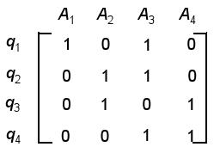

Vertical Fragmentation . . .

- Attribute Affinity Matrix : Denotes the frequency of two attributes A_{i} and A_{j} with respect to a set of queries Q = (q₁, . . . , q_{n}):
X X
aﬀ (A_{i}, A_{j} ) = ( ref _{l}(q_{k} )acc_{l}(q_{k} ))
_{k:} ^{use(q}k ^{,A}i ^{)=1,} sites l
use(q_{k} ,A_{j} )=1

where
– ref _{l}(q_{k} ) is the cost (= number of accesses to (A_{i}, A_{j} )) of query q_{K} at site l

– acc_{l}(q_{k} ) is the frequency of query q_{k} at site l

Vertical Fragmentation . . .

- Example (contd.): Let the cost of each query be ref _{l}(q_{k} ) = 1, and the frequency acc_{l}(q_{k} ) of the queries be as follows:

Site1 |  | Site2 |  | Site3
acc₁ | (q₁) = 15 | acc₂ | (q₁) = 20 | acc₃ | (q₁) = 10
acc₁ | (q₂) = 5 | acc₂ | (q₂) = 0 | acc₃ | (q₂) = 0
acc₁ | (q₃) = 25 | acc₂ | (q₃) = 25 | acc₃ | (q₃) = 25
acc₁ | (q₄) = 3 | acc₂ | (q₄) = 0 | acc₃ | (q₄) = 0

- Attribute affinity matrix aﬀ (A_{i}, A_{j} ) =
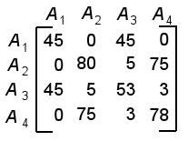

– e.g., aﬀ (A₁, A₃) = | 1 |  | 3
– e.g., aﬀ (A₁, A₃) = | k=1 |  | _{l=1} ^{acc}l ^{(q}k ⁾ ⁼ ^{acc}1 |  | (q₁) + acc₂(q₁) + acc₃ | (q₁) = 45
to access both |  |  |  | A₁ and A₃)
(q₁ is the only query ^{P} |  | P |  | A₁ and A₃)

Vertical Fragmentation . . .

- Take the attribute affinity matrix (AA) and reorganize the attr ibute orders to form clusters where the attributes in each cluster demonstrate high affini ty to one another.

- Bond energy algorithm (BEA) has been suggested to be useful for that purpose for several reasons:

– It is designed specifically to determine groups of similar it ems as opposed to a linear ordering of the items.

– The final groupings are insensitive to the order in which item s are presented.

– The computation time is reasonable (O(n²), where n is the number of attributes)

- BEA:

– Input: AA matrix

– Output: Clustered AA matrix (CA)

– Permutation is done in such a way to maximize the following global affinity mesaure (affinity of A_{i} and A_{j} with their neighbors):

n n
 | X X
AM = | aff(A_{i}, A_{j} )[aff(A_{i}, A_{j−1}) + aff(A_{i}, A_{j+1}) +
 | i=1 j=1
 | aff(A_{i−1}, A_{j} ) + aff(A_{i+1}, A_{j} )]

Vertical Fragmentation . . .

- Example (contd.): Attribute Affinity Matrix C A after running the BEA
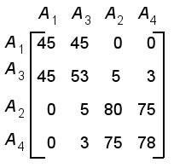

– Elements with similar values are grouped together, and two clusters can be identified

– An additional partitioning algorithm is needed to identify the clusters in C A

∗ Usually more clusters and more than one candidate partitioning, thus additional steps are needed to select the best clustering.

– The resulting fragmentation after partitioning (P N O is added in P ROJ₂ explicilty as key):

P ROJ₁ = {P N O, BU DGET }
P ROJ₂ = {P N O, P N AM E, LOC}

Correctness of Vertical Fragmentation

- Relation R is decomposed into fragments R₁, R₂, . . . , R_{n}

– e.g., P ROJ = {P N O, BU DGET , P N AM E, LOC} into
P ROJ₁ = {P N O, BU DGET } and P ROJ₂ = {P N O, P N AM E, LOC}

- Completeness

– Guaranteed by the partitioning algortihm, which assigns each attribute in A to one

partition

- Reconstruction

– Join to reconstruct vertical fragments

– R = R₁ ⋊⋉ · · · ⋊⋉ R_{n} = P ROJ₁ ⋊⋉ P ROJ₂

- Disjointness

– Attributes have to be disjoint in VF. Two cases are distinguished:

∗ If tuple IDs are used, the fragments are really disjoint

∗ Otherwise, key attributes are replicated automatically by the system ∗ e.g., P N O in the above example

Mixed Fragmentation

- In most cases simple horizontal or vertical fragmentation of a DB schema will not be sufficient to satisfy the requirements of the applications.

- Mixed fragmentation (hybrid fragmentation): Consists of a horizontal fragment followed by a vertical fragmentation, or a vertical fragmentation followed by a horizontal fragmentation

- Fragmentation is defined using the selection and projection operations of relational algebra:

^{σ}p(ΠA₁,...,A_{n} (^{R}))
ΠA₁,...,A_{n} (^{σ}p(^{R}))

Replication and Allocation

- Replication: Which fragements shall be stored as multiple copies?

– Complete Replication

∗ Complete copy of the database is maintained in each site

– Selective Replication

∗ Selected fragments are replicated in some sites

- Allocation: On which sites to store the various fragments?

– Centralized

∗ Consists of a single DB and DBMS stored at one site with users distributed across the network

– Partitioned

∗ Database is partitioned into disjoint fragments, each fragment assigned to one site

Replication . . .

•

•

Replicated DB

– fully replicated : each fragment at each site

– partially replicated : each fragment at some of the sites

Non-replicated DB (= partitioned DB)

– partitioned : each fragment resides at only one site

- Rule of thumb:
– If | read only queries | ≥ 1, then replication is advantageous, otherwise replication may
– If | update queries
cause problems

Replication . . .

- Comparison of replication alternatives
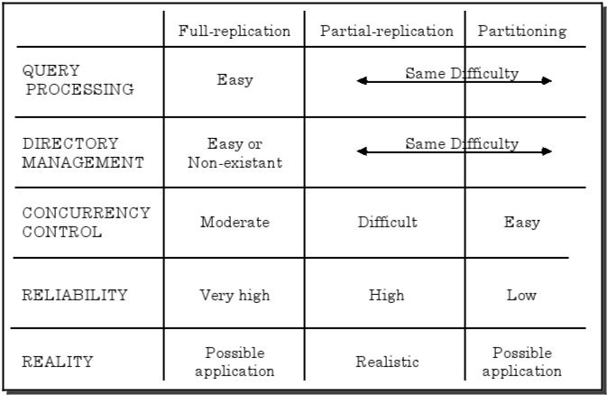

Fragment Allocation

- Fragment allocation problem

– Given are:

– fragments F = {F₁, F₂, ..., F_{n}}
– network sites S = {S₁, S₂, ..., S_{m}}
– and applications Q = {q₁, q₂, ..., q_{l} }

– Find: the ”optimal” distribution of F to S

- Optimality

– Minimal cost

∗ Communication + storage + processing (read and update) ∗ Cost in terms of time (usually)

– Performance

∗ Response time and/or throughput

– Constraints

∗ Per site constraints (storage and processing)

Fragment Allocation . . .

- Required information

– Database Information

∗ selectivity of fragments ∗ size of a fragment

– Application Information

∗ RR_{ij} : number of read accesses of a query q_{i} to a fragment F_{j}
∗ U R_{ij} : number of update accesses of query q_{i} to a fragment F_{j}
∗ u_{ij} : a matrix indicating which queries updates which fragments,
∗ r_{ij} : a similar matrix for retrievals ∗ originating site of each query

– Site Information

∗ U SC_{k} : unit cost of storing data at a site S_{k}

∗ LP C_{k} : cost of processing one unit of data at a site S_{k}

– Network Information

∗ communication cost/frame between two sites ∗ frame size

Fragment Allocation . . .

- We present an allocation model which attempts to

– minimize the total cost of processing and storage

– meet certain response time restrictions

- General Form:

min(Total Cost)

– subject to

∗ response time constraint ∗ storage constraint

∗ processing constraint

- Functions for the total cost and the constraints are presented in the next slides.

- Decision variable x_{ij}

(
1 if fragment Fi is stored at site Sj
x_{ij} =
0 otherwise

Fragment Allocation . . .

- The total cost function has two components: storage and query processing.
X X X
T OC = ST C_{jk} + QP C_{i}
S_{k} ∈S F_{j} ∈F q_{i} ∈Q

– Storage cost of fragment F_{j} at site S_{k} :

ST C_{jk} = U SC_{k} ∗ size(F_{i}) ∗ x_{ij}

where U SC_{k} is the unit storage cost at site k

– Query processing cost for a query q_{i} is composed of two components: ∗ composed of processing cost (PC) and transmission cost (TC)

QP C_{i} = P C_{i} + T C_{i}

Fragment Allocation . . .

- Processing cost is a sum of three components:

– access cost (AC), integrity contraint cost (IE), concurency control cost (CC)

P C_{i} = AC_{i} + I E_{i} + C C_{i}

– Access cost :
X X
AC_{i} = (U R_{ij} + RR_{ij} ) ∗ x_{ij} ∗ LP C_{k}
s_{k} ∈S F_{j} ∈F

where LP C_{k} is the unit process cost at site k

– Integrity and concurrency costs :

∗ Can be similarly computed, though depends on the specific con straints

- Note: AC_{i} assumes that processing a query involves decomposing it into a set of subqueries, each of which works on a fragment, ...,

– This is a very simplistic model

– Does not take into consideration different query costs depending on the operator or different algorithms that are applied

Fragment Allocation . . .

- The transmission cost is composed of two components:

– Cost of processing updates (TCU) and cost of processing retrievals (TCR)

T C_{i} = T C U_{i} + T C R_{i}

– Cost of updates :

∗ Inform all the sites that have replicas + a short confirmation message back

X X
T C U_{i} = u_{ij} ∗ (update message cost + acknowledgment cost)
S_{k} ∈S F_{j} ∈F

– Retrieval cost :

∗ Send retrieval request to all sites that have a copy of fragments that are needed + sending back the results from these sites to the originating site.

X
T C R_{i} = min ∗(cost of retrieval request + cost of sending back the result)
S_{k} ∈S
F_{j} ∈F

Fragment Allocation . . .

- Modeling the constraints

– Response time constraint for a query q_{i}

execution time of q_{i} ≤ max. allowable response time for q_{i}

– Storage constraints for a site S_{k}
X
storage requirement of F_{j} at S_{k} ≤ storage capacity of S_{k}
F_{j} ∈F

– Processing constraints for a site S_{k}
X
processing load of q_{i} at site S_{k} ≤ processing capacity ofS_{k}
q_{i} ∈Q

Fragment Allocation . . .

- Solution Methods

– The complexity of this allocation model/problem is NP-complete

– Correspondence between the allocation problem and similar problems in other areas

∗ Plant location problem in operations research ∗ Knapsack problem

∗ Network flow problem

– Hence, solutions from these areas can be re-used

– Use different heuristics to reduce the search space

∗ Assume that all candidate partitionings have been determined together with their associated costs and benefits in terms of query processing.

      - The problem is then reduced to find the optimal partitioning a nd placement for each relation

∗ Ignore replication at the first step and find an optimal non-re plicated solution

      - Replication is then handeled in a second step on top of the previous non-replicated solution.

Conclusion

- Distributed design decides on the placement of (parts of the) data and programs across the sites of a computer network

- On the abstract level there are two patterns: Top-down and Bottom-up

- On the detail level design answers two key questions: fragmentation and

allocation/replication of data
– Horizontal fragmentation is defined via the selection opera tion σ_{p}(R)

∗ Rewrites the queries of each site in the conjunctive normal form and finds a

minimal and complete set of conjunctions to determine fragmentation
– Vertical fragmentation via the projection operation π_{A}(R)

∗ Computes the attribute affinity matrix and groups “similar” attributes together

– Mixed fragmentation is a combination of both approaches

- Allocation/Replication of data

– Type of replication: no replication, partial replication, full replication

– Optimal allocation/replication modelled as a cost function under a set of constraints

– The complexity of the problem is NP-complete

– Use of different heuristics to reduce the complexity

